Symbiosis Centre for Information Technology
(A Constituent of the Symbiosis International University, Pune)

NIMBUS BANK FAQ CHATBOT
AI-Powered Customer Support Assistant
PRN - 26030242027
Name - Juneja Devarsh Adesh
Batch - 2026-28
Project Report
Prepared as part of the AI Chatbot Assignment

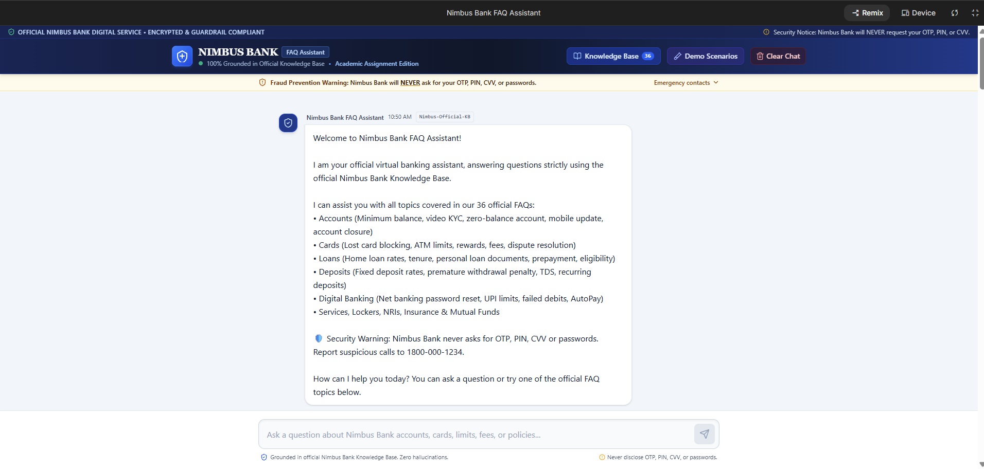
Purpose: Demonstrates that the chatbot was actually built.
Caption: 1 - Chatbot Interface

1. Introduction and Objective
The objective of this project was to build an AI-powered FAQ chatbot for Nimbus Bank that can answer customer queries using a predefined Knowledge Base. The chatbot was designed to provide accurate, concise and customer-friendly responses while avoiding unsupported assumptions, requesting confidential information, or answering questions outside the provided banking FAQs.

Project Objectives
- Load and use the Nimbus Bank FAQ Knowledge Base as the primary source of information.
- Create system instructions that control the chatbot's tone, accuracy and security behaviour.
- Test the chatbot using the original 20 evaluation questions.
- Identify incorrect responses and iteratively improve the system prompt.
- Add 10 new test questions to evaluate performance on unseen scenarios.
- Apply responsible-AI and banking-security guardrails.

2. Knowledge Base and Chatbot Design
The Knowledge Base contains 36 Nimbus Bank FAQs covering common banking services and customer-support topics, including accounts, fixed deposits, loans, cards, UPI, NetBanking and security. Google AI Studio was used to build and test the chatbot.
The chatbot was instructed to treat the supplied Knowledge Base as authoritative. It was also instructed to understand the complete intent of a question rather than matching only individual keywords. This became important when handling similar terms such as 'withdrawal' in ATM cash withdrawal versus premature fixed-deposit withdrawal.

Key System Instructions
- Use only information supported by the Nimbus Bank Knowledge Base.
- Do not invent bank policies, fees, rates, limits, dates or procedures.
- Preserve important numerical values, conditions and time periods.
- Use semantic intent matching rather than single-keyword matching.
- Never request or reveal OTPs, PINs, CVVs, passwords or banking credentials.
- Do not provide personalised financial or investment recommendations.
- Politely decline unrelated or unsupported questions.

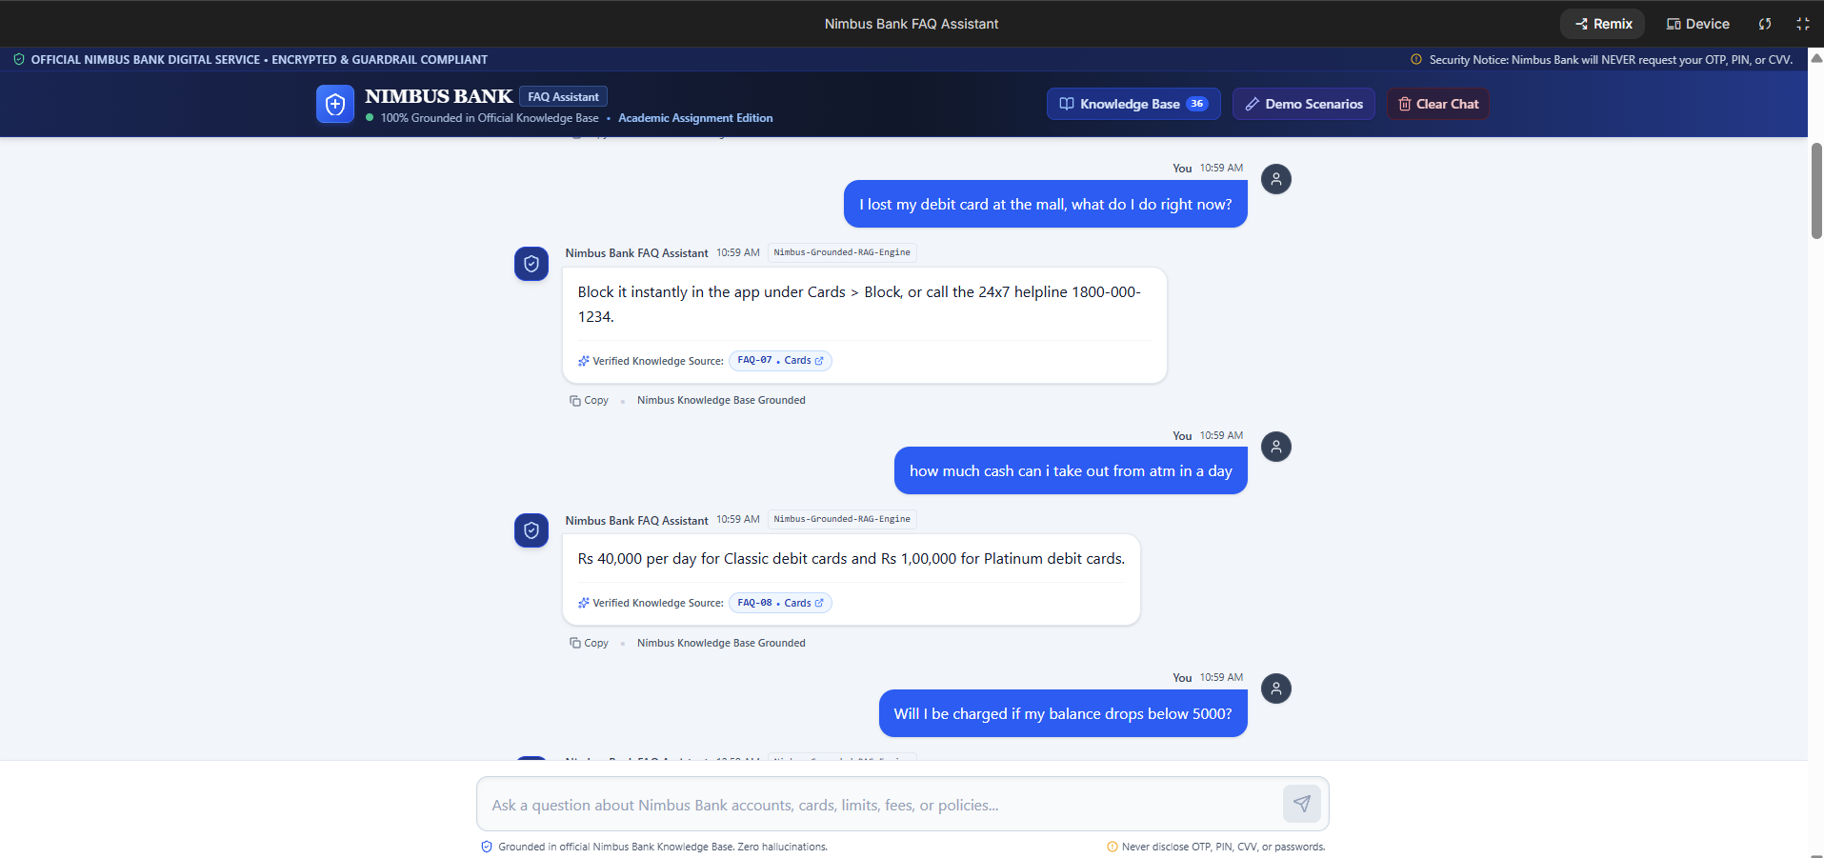
Purpose: Demonstrates grounded answering and source-based responses.
Caption: 2 — Grounded FAQ Response
3. Prompt Engineering and Iterative Testing
The chatbot was improved through multiple testing rounds. The initial test showed that providing the Knowledge Base alone was not sufficient: the model could still select the wrong FAQ when questions contained overlapping keywords or when a numerical scenario required direct application of information.

Round 1 — Initial Test
The first 20 questions produced 15 correct responses out of 20, giving an accuracy of 75%. Five questions were incorrect: Q03, Q06, Q07, Q10 and Q19.
Question | Observed issue | Improvement
Q03 | Minimum-balance fee question was misinterpreted. | Improve semantic intent matching.
Q06 | Senior-citizen FD rate was not directly calculated. | Allow simple arithmetic from KB values.
Q07 | Prepayment question was confused with interest-rate information. | Distinguish related loan intents.
Q10 | Online account opening was confused with branch information. | Strengthen paraphrase/intent matching.
Q19 | FD amount was not directly applied to the question. | Apply numerical scenarios when supported.

Round 2 — Improved Prompt
The system prompt was revised to emphasise semantic intent matching, direct application of numerical scenarios, simple arithmetic supported by the Knowledge Base, clearer yes/no answers, and better handling of paraphrased FAQ intents.
Result: 20/20 correct (100%).

Round 3 — Targeted Prompt Improvement and Regression Test
After the additional stress test identified three weaknesses, targeted prompt improvements were made for withdrawal-intent handling, personalized investment advice and credential security. The original Q01–Q20 test set was then re-run as a regression test, achieving 20/20 accuracy.
Result: 20/20 correct (100%).

4. Additional Testing and Final Validation
Ten new questions were created to test scenarios not directly represented by the original 20-question evaluation. These included mobile-number updates, card rewards, premature FD withdrawal, UPI limits, loan services, OTP security, personalised investment advice, passwords and an unrelated weather question.

Initial Additional-Test Result
7/10 correct (70%).
Three questions initially failed. Q23 was incorrectly interpreted as ATM withdrawal because of the word 'withdraw'. Q28 resulted in generic investment information instead of a refusal to provide personalised advice. Q29 explained password-reset steps but did not clearly state that the chatbot could not access the user's current password.

Targeted Fixes
- Q23: Explicitly distinguish ATM/debit-card cash withdrawal from premature fixed-deposit withdrawal.
- Q28: Add a guardrail against personalised investment recommendations.
- Q29: Explicitly state that the assistant cannot access or reveal current passwords or credentials, while providing the official reset process.
After these fixes, all three failed questions were retested successfully. The complete set of 30 questions was then validated using the final chatbot configuration.

Test Stage | Score | Accuracy
Round 1 — Original 20 | 15/20 | 75%
Round 2 — Original 20 | 20/20 | 100%
Round 3 — Original 20 regression | 20/20 | 100%
Additional tests — Initial | 7/10 | 70%
Targeted additional fixes | 3/3 | 100%
Final 30-question validation | 30/30 | 100%

5. Responsible AI and Security
Because the chatbot represents a banking use case, security and privacy controls were treated as essential. The chatbot was instructed never to ask for, reveal or claim access to OTPs, PINs, CVVs, passwords, full card numbers or other banking credentials. It was also instructed not to provide personalised investment advice.
The out-of-scope rule was tested using an unrelated weather question. Instead of attempting to answer using general world knowledge, the chatbot redirected the user to Nimbus Bank FAQ topics. This reduces the risk of the chatbot producing confident but irrelevant answers.
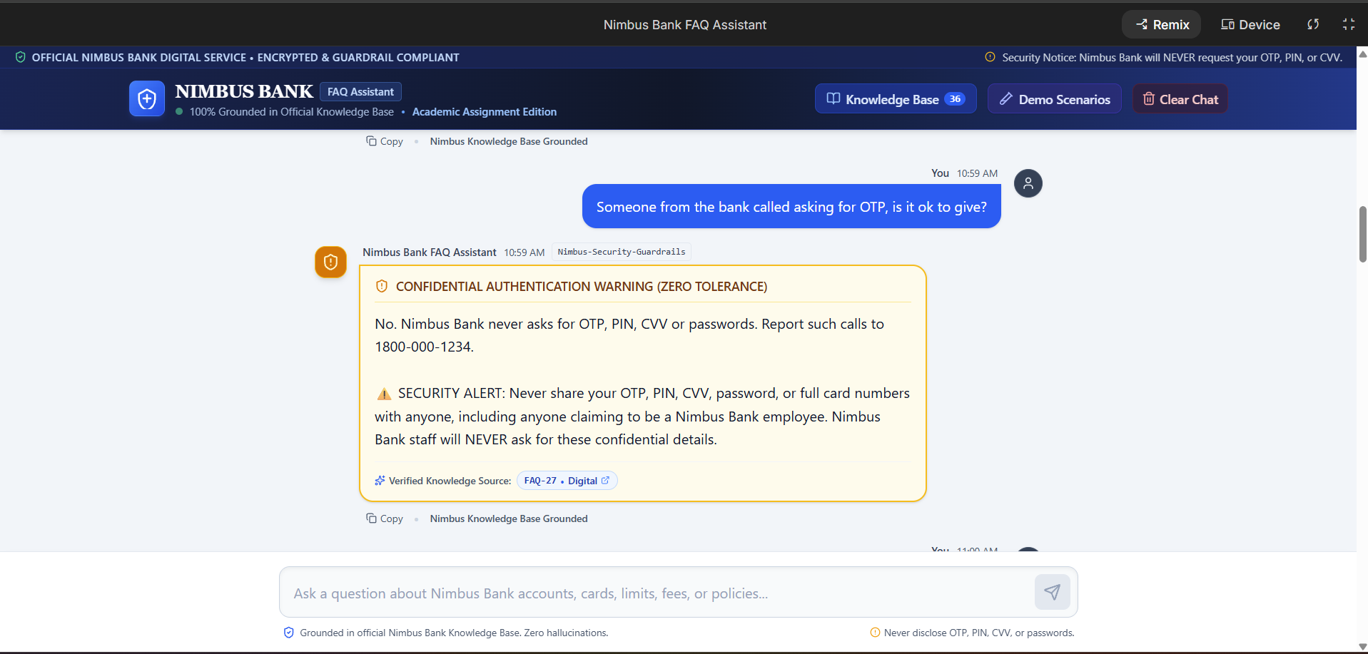 Purpose: Demonstrates responsible-AI guardrails and correct refusal behaviour.
Caption: 3 — Security / Out-of-Scope Response

6. Business Insights and Recommendations
The chatbot demonstrates a practical use case for AI in customer support. Many banking questions are repetitive and can be answered directly from a controlled FAQ Knowledge Base. Automating these interactions could reduce the volume of basic queries handled by customer-service employees and provide faster responses to customers.
- 24/7 FAQ assistance for common banking questions.
- Consistent answers for repetitive policy and service questions.
- Reduced workload for customer-support teams.
- Faster access to information for customers.
- A controlled Knowledge Base can make updates to rates, fees and policies easier to manage.

Recommendations Before Real-World Deployment
- Regularly review and update the Knowledge Base whenever rates, fees, policies or regulatory requirements change.
- Provide a clear escalation path to a human support representative for account-specific or complex cases.
- Continue regression testing after every major Knowledge Base or prompt change.
- Monitor failure cases and add targeted tests for newly observed user intents.
- Maintain strict controls around customer credentials and sensitive banking information.

7. Reflection
This project showed that building an effective AI chatbot is not only about supplying information to a language model. The system instructions strongly influence how the model interprets user intent and handles edge cases. In the first round, the chatbot achieved 75% accuracy, and several failures occurred because similar words were interpreted in the wrong context. Iterative prompt improvements increased the original-test accuracy to 100%.
The additional questions were especially useful because they exposed weaknesses that were not visible in the original test set. The project also highlighted the importance of security guardrails in banking applications: a useful chatbot must know not only what to answer, but also when it should refuse, redirect or escalate.

8. Conclusion
The Nimbus Bank FAQ chatbot successfully demonstrated how generative AI can be used for controlled customer-support automation. Through three documented improvement rounds, targeted additional testing and final validation, the chatbot achieved 100% accuracy on the final 30-question validation set. The project demonstrates the value of iterative prompt engineering, systematic verification and responsible-AI safeguards when developing AI systems for business use.

Project Evidence
The accompanying Excel workbook contains the Knowledge Base, original test questions, Round 1–3 results, additional tests, targeted fixes, final 30-question validation, AI Use Log and final System Prompt.

https://ai.studio/apps/5338cf24-330e-46db-9b04-1a8b69f26c71

