**FIFA 23 ANALYSIS USING SAS**

libname project "/home/u61868407/Server Data";

/*********************************************/

proc import datafile="/home/u61868407/Server Data/Fifa 23 Players Data.csv"

out=project.Data

dbms=csv replace;

SHEET="Fifa 23 Players Data";

run;

proc import datafile="/home/u61868407/Server Data/Player_Details.csv"

out=project.Datata

dbms=csv replace;

SHEET="Player Details";

run;

proc import datafile="/home/u61868407/Server Data/Player_Statistics.csv"

out=project.Datatata

dbms=csv replace;

SHEET="Player Statistics";

run;

/*********************************************/

proc sort DATA = project.datata;

by FullName;

run;

proc sort DATA = project.datatata;

by FullName;

run;

proc print data = project.datata (OBS=5);

run;

proc print data = project.datatata (OBS=5);

run;

data work.results;

Merge project.datata project.datatata;

By FullName;

Run;

title1 "Merged Dataset";

footnote1 "***********";

proc print data = work.results(OBS=10);

run;

title1;

footnote1;

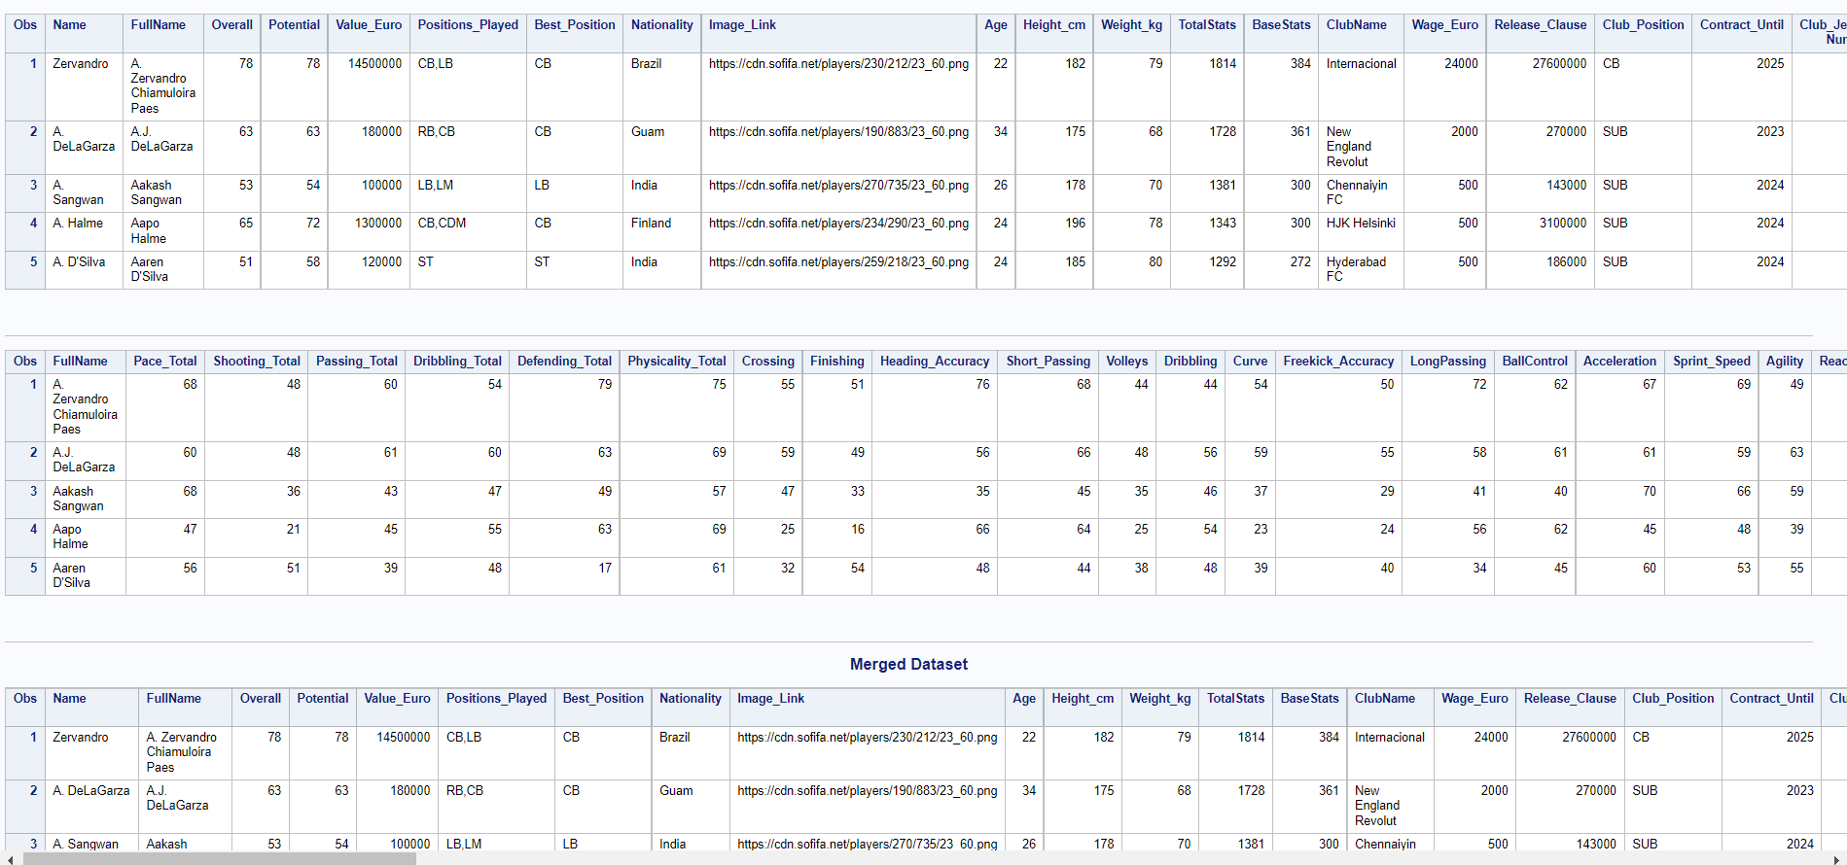

/*********************************************/

data work.result;

set project.Data;

if Potential>=90 then class=1;

else if 85<= Potential <=89 then class=2;

else if 80<=Potential<=84 then class=3;

else class=4;

run;

proc format;

value classtype

1='World Class'

2='Professional'

3='Semi-pro'

4='Amateur';

run;

title1 "Number of Players by Class(Potential)";

footnote1 "***********";

proc freq data=work.result;

table class / nocum;

format class classtype.;

label class = 'Class';

run;

title1;

footnote1;

/*********************************************/

title1 "Number of Players by National Team";

footnote1 "***********";

proc freq data=work.result order=freq;

table national_team_name / nocum maxlevels=20;

run;

title1;

footnote1;

title1 "Number of Players by Club Name";

footnote1 "***********";

proc freq data=work.result order=freq;

table clubname / nocum maxlevels=20;

run;

title1;

footnote1;

/*********************************************/

proc sort data=project.Data

out=work.positionprice;

By descending value_euro;

data work.expensiveposition;

set work.positionprice;

where best_position="ST";

keep FullName Value_euro;

run;

title1 "Most Expensive Player by Position (Ex. ST)";

footnote1 "***********";

proc print data=work.expensiveposition (obs=10);

format value_euro euro15.2;

run;

title1;

footnote1;

/*********************************************/

title1 "Average Value by Position";

footnote1 "***********";

proc means data=project.data mean;

var value_euro;

class best_position;

run;

title1;

footnote1;

/*********************************************/

title1 "Positional average value for National Teams";

footnote1 "***********";

proc means data=project.data mean;

var Overall;

class national_team_name best_position;

run;

title1;

footnote1;

/*********************************************/

title1 "Histogram for Age Distribution for England Team";

footnote1 "***********";

proc univariate data=project.Data noprint;

histogram Age/kernel;

where Nationality = "England";

run;

title1;

footnote1;

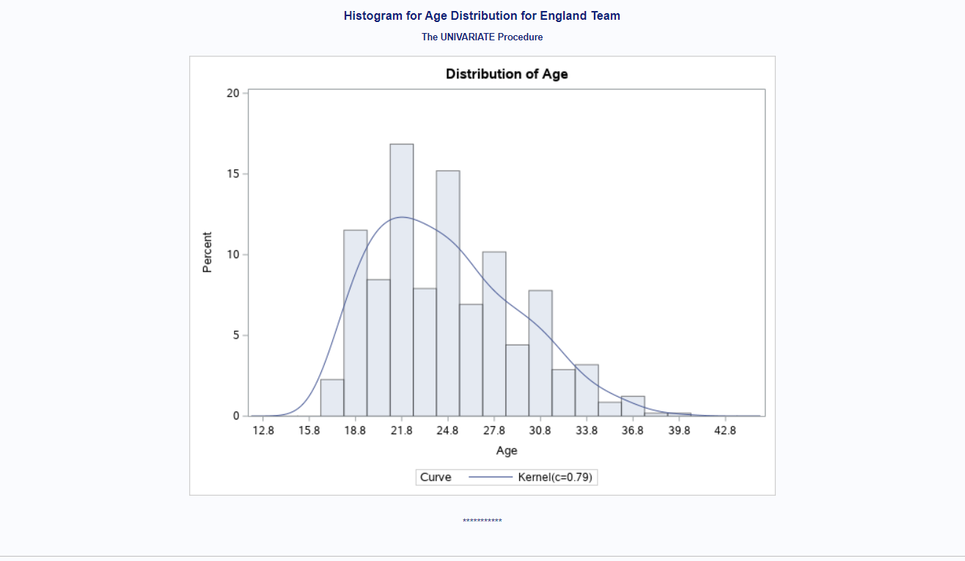

/*********************************************/

title1 "Players in club by nationality";

footnote1 "***********";

proc sgplot data = project.data;

title height=8pt "Bar-Plots for Nationality Where club name is Chelsea";

vbar nationality / filattrs = (color=CX3870c4 transparency = 0.5);

where clubname = "Chelsea";

yaxis grid;

run;

title;

title1;

footnote1;

/*********************************************/

data work.weakfoot;

set project.Data;

if Weak_Foot_Rating=3 then WeakFoot="Adequate";

else if Weak_Foot_Rating>=4 and Weak_Foot_Rating<=5 then WeakFoot="Strong";

else if Weak_Foot_Rating<=2 then WeakFoot="Weak";

else class="Not Defined";

run;

title1 "Weak Foot Strength Count";

footnote1 "***********";

proc freq data=work.weakfoot;

table WeakFoot / nocum;

run;

title1;

footnote1;

/*********************************************/

title1 "Summary of Wages";

footnote1 "***********";

proc summary data=project.data print;

var wage_euro;

run;

title1;

footnote1;

/*********************************************/

proc freq data= work.result;

where class in(1,2) and ClubName;

tables ClubName*class / nocol norow nopercent;

format class classtype.;

run;

/*********************************************/

title1 "Weak Foot and Skill Ratings above 4";

footnote1 "***********";

data work.foot;

set project.Data;

where Weak_Foot_Rating>=4 and Skill_Moves>=4;

where same clubname = "FC Barcelona" or clubname="Paris Saint-Germain" or clubname="Manchester City";

format Value_Euro euro15.2;

keep Weak_Foot_Rating Skill_Moves FullName Overall Value_Euro ClubName;

run;

proc sort data= work.foot;

BY ClubName descending value_euro;

run;

proc print data=work.foot noobs;

By Clubname;

run;

title1;

footnote1;

/*********************************************/

title1 "Top 10 fastest players";

footnote1 "***********";

data work.output;

set project.data;

Speed= (pace_total + acceleration + sprint_speed)/3;

If speed >90;

Keep speed FullName;

run;

Proc sort data=work.output;

By descending speed;

run;

Proc print data=work.output (obs=10);

run;

title1;

footnote1;

/*********************************************/

title2 "Total wages spent by club";

footnote2 "***********";

Proc sort data=project.data

Out=work.temp;

By ClubName;

Run;

Data work.wagetotal;

Set work.temp;

By ClubName;

if first.ClubName then total_spent=0;

total_spent + Wage_Euro;

If last.ClubName;

Keep ClubName total_spent;

Run;

proc sort data=work.wagetotal;

by descending total_spent;

run;

Proc print data=work.wagetotal (obs=10);

Format total_spent euro15.2;

Run;

title2;

footnote2;

