# Mobile Application Development Project

**Problem Statement**

To implement a fitness application named FITNESS IDEA which allows the user to add their food intake details according to different dishes and also track different exercises which the user performs. The application asks the user for gender, height, weight, age details and shows the Daily calories requirement of the user with the help of the BMR formula. The application also shows the graphical data of the food/calories which the user intakes on a particular day.

**Number of modules and their respective details:**

6 modules

* Diary
* Profile
* Dishes
* Exercise
* Statistic

1. **The text narrative or user story**

When the user opens the application it shows the Dairy page where the user can enter their food intake details as well as the exercise details which was performed by the user in a days time. The applications asks for the users Gender, Height, Weight, Age details and calculates the calories a user should intake with the help of BMR formula to maintain the same weight. The Dishes pages lets the user add/edit/delete the various food items according to their needs. The Exercise page lets the user add/edit/delete the exercise as per their needs. The Statistics page show the graphical representation of the food/calories intake of the user on the given day. The exit button lets the user to exit the application.

**2. Project scope**

This application helps the user to calculate the food intake as well as exercise details and compares it with the daily calorie count of the user calculated by the application on the basis of users personal details.

**3. Technical specifications**

**Diary-** When the user clicks on the diary icon the app takes the user to the diary page where the user need to add daily exercise details and the food intake detail so that the application can calculate the gap between the calories consumed by the user and the calories burnt by the user when compared to the Calories intake which is suggest to the user via the application on the basis of his BMR. User Can add Notes As per his requirements.

**Profile-** When the user clicks on the profile icon on the application takes the user to the profile section and the user is asked to enter his/her details like Sex, Height, Weight and Age after entering these details the application calculates the Daily Calorie amount the user can consume with the help of the Algorithm.

**Dishes-** This page contains the variety of dishes and the user can edit the given dishes and the calories a particular dish contains in a specific quantity of dish. Here the user can also add and delete dishes and the calorie of that dish.

**Exercises-** This page contains the various exercise and the user can add new exercises and the calories burnt is calculated via the application with the help of formula which comprises of weight of the person , duration of time for which the exercises is performed in seconds and the quanties of sets. User can also add and delete exercises according to the need of the user.

**Statistics-** When the user clicks on the statistic icon the application tales user to the screen where the application show the graph of the various food dishes which the consumer has consumed throughout the day on a particular day.

1. **Sketches and wireframes**

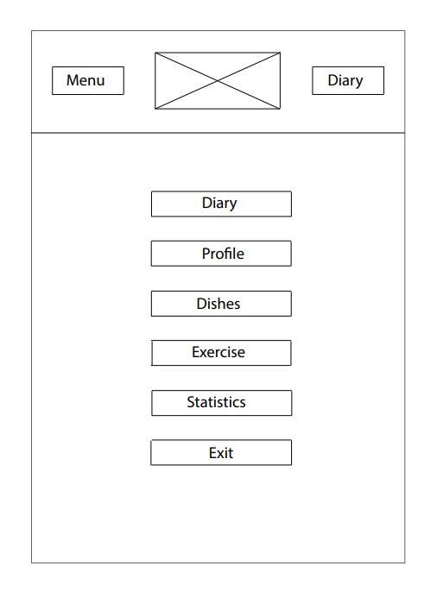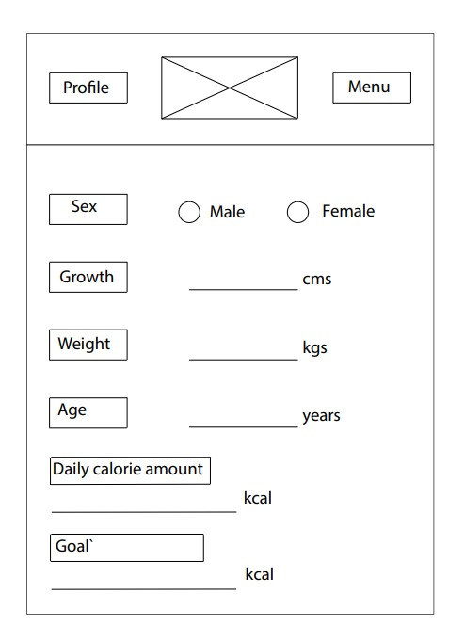

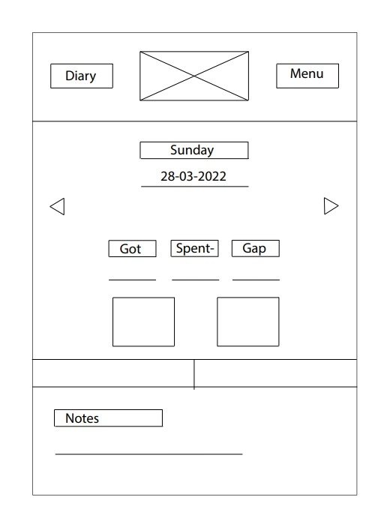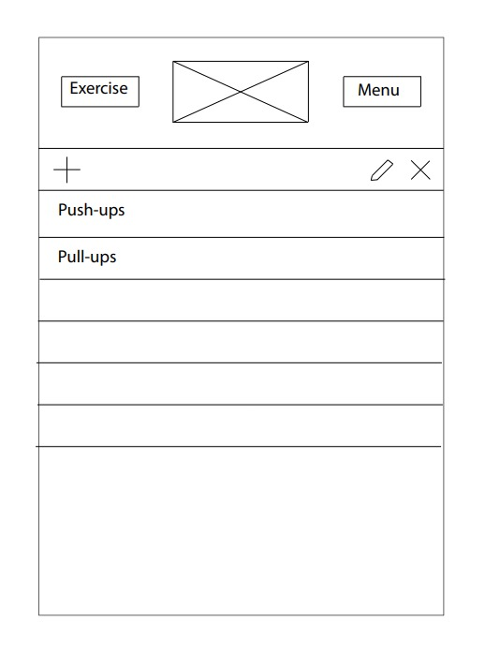

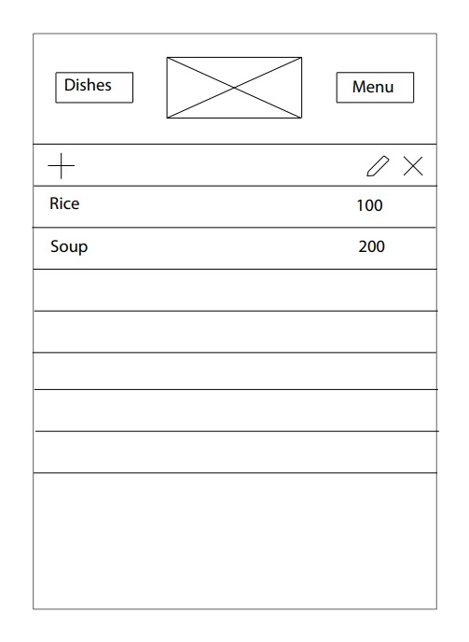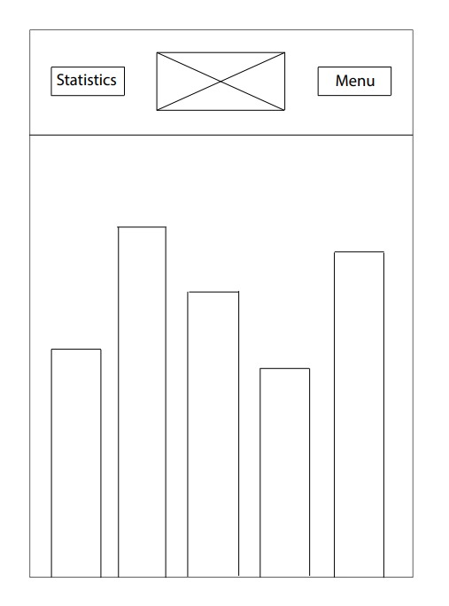

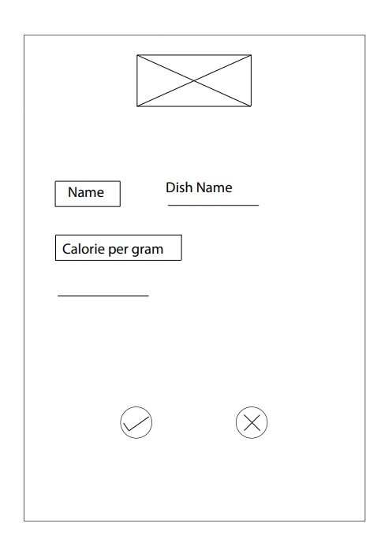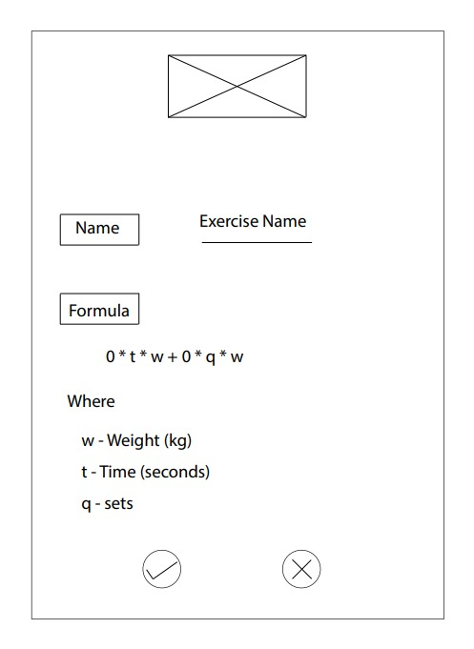

1. **Asset creation**



1. **Putting everything together in a workflow document.**

**XML Codes**

1. activity_diary.xml

<?xml version="1.0" encoding="utf-8"?>  
<android.support.design.widget.CoordinatorLayout  
 xmlns:android="http://schemas.android.com/apk/res/android"  
 xmlns:tools="http://schemas.android.com/tools"  
 android:layout_width="match_parent"  
 android:layout_height="match_parent"  
 android:fitsSystemWindows="true"  
 tools:context=".activities.DiaryActivity">  
  
  
 <include layout="@layout/content_diary" />  
</android.support.design.widget.CoordinatorLayout>

1. activity_dish.xml

<?xml version="1.0" encoding="utf-8"?>  
<LinearLayout xmlns:android="http://schemas.android.com/apk/res/android"  
 xmlns:app="http://schemas.android.com/apk/res-auto"  
 xmlns:tools="http://schemas.android.com/tools"  
 style="@style/background_style"  
 tools:context="com.vladnamik.developer.activities.DishActivity">  
  
 <RelativeLayout  
 style="@style/header_style"  
 android:layout_height="130dp">  
  
 <ImageView  
 android:id="@+id/imageView4"  
 android:layout_width="108dp"  
 android:layout_height="76dp"  
 android:layout_marginStart="140dp"  
 android:layout_marginLeft="140dp"  
 android:layout_marginTop="21dp"  
 android:layout_marginEnd="140dp"  
 android:layout_marginRight="140dp"  
 android:layout_marginBottom="21dp"  
 app:srcCompat="@drawable/logo" />  
  
 <TextView  
 style="@style/header_text"  
 android:layout_width="95dp"  
 android:layout_height="37dp"  
 android:layout_alignParentStart="true"  
 android:layout_alignParentLeft="true"  
 android:layout_alignParentTop="true"  
 android:layout_alignParentEnd="true"  
 android:layout_alignParentRight="true"  
 android:layout_alignParentBottom="true"  
 android:layout_marginStart="15dp"  
 android:layout_marginLeft="15dp"  
 android:layout_marginTop="44dp"  
 android:layout_marginEnd="290dp"  
 android:layout_marginRight="290dp"  
 android:layout_marginBottom="44dp"  
 android:text="@string/dishes"  
 android:textStyle="bold"></TextView>  
  
 <Button  
 android:id="@+id/from_dishes_to_menu"  
 style="@style/header_button"  
 android:layout_width="107dp"  
 android:layout_height="35dp"  
 android:layout_alignParentStart="true"  
 android:layout_alignParentLeft="true"  
 android:layout_alignParentTop="true"  
 android:layout_alignParentEnd="true"  
 android:layout_alignParentRight="true"  
 android:layout_alignParentBottom="true"  
 android:layout_marginStart="263dp"  
 android:layout_marginLeft="263dp"  
 android:layout_marginTop="44dp"  
 android:layout_marginEnd="40dp"  
 android:layout_marginRight="40dp"  
 android:layout_marginBottom="44dp"  
 android:text="Menu"></Button>  
 </RelativeLayout>  
  
 <RelativeLayout  
 android:layout_width="match_parent"  
 android:layout_height="60dp"  
 android:orientation="horizontal"  
 android:background="@color/my_db_menu_color"  
 android:id="@+id/db_dish_menu">  
 <ImageButton  
 android:layout_width="40dp"  
 android:layout_height="40dp"  
 android:background="@null"  
 android:scaleType="centerInside"  
 android:layout_marginLeft="8dp"  
 android:layout_marginStart="8dp"  
 android:layout_centerVertical="true"  
 android:id="@+id/db_dish_add"  
 android:onClick="onCreateDish"  
 android:src="@drawable/add_item"  
 android:contentDescription="@string/create" />  
  
 <ImageButton  
 android:id="@+id/db_dish_delete"  
 android:layout_width="48dp"  
 android:layout_height="48dp"  
 android:layout_alignParentEnd="true"  
 android:layout_alignParentRight="true"  
 android:layout_centerVertical="true"  
 android:layout_marginEnd="8dp"  
 android:layout_marginRight="8dp"  
 android:background="@null"  
 android:contentDescription="@string/delete"  
 android:onClick="onDeleteDish"  
 android:scaleType="centerInside"  
 android:src="@drawable/delete_item" />  
  
 <ImageButton  
 android:id="@+id/db_dish_edit"  
 android:layout_width="48dp"  
 android:layout_height="48dp"  
 android:layout_centerVertical="true"  
 android:layout_marginEnd="16dp"  
 android:layout_marginRight="16dp"  
 android:layout_toStartOf="@id/db_dish_delete"  
 android:layout_toLeftOf="@id/db_dish_delete"  
 android:background="@null"  
 android:contentDescription="@string/edit"  
 android:onClick="onEditDish"  
 android:scaleType="centerInside"  
 android:src="@drawable/edit" />  
 </RelativeLayout>  
 <ListView  
 android:layout_width="wrap_content"  
 android:layout_height="wrap_content"  
 android:divider="#242424"  
 android:dividerHeight="1dp"  
 android:id="@+id/dish_list_view"/>  
</LinearLayout>

1. Activity_dishes_editor.xml

<?xml version="1.0" encoding="utf-8"?>  
<LinearLayout  
 xmlns:android="http://schemas.android.com/apk/res/android"  
 xmlns:app="http://schemas.android.com/apk/res-auto"  
 xmlns:tools="http://schemas.android.com/tools"  
 style="@style/background_style"  
 tools:context="com.vladnamik.developer.activities.ExerciseActivity"  
 >  
  
 <RelativeLayout  
 style="@style/header_style"  
 android:layout_height="130dp">  
  
 <ImageView  
 android:id="@+id/imageView10"  
 android:layout_width="108dp"  
 android:layout_height="76dp"  
 android:layout_marginStart="140dp"  
 android:layout_marginLeft="140dp"  
 android:layout_marginTop="21dp"  
 android:layout_marginEnd="140dp"  
 android:layout_marginRight="140dp"  
 android:layout_marginBottom="21dp"  
 app:srcCompat="@drawable/logo" />  
  
 <TextView  
 style="@style/header_text"  
 android:layout_width="93dp"  
 android:layout_height="35dp"  
 android:layout_alignParentStart="true"  
 android:layout_alignParentLeft="true"  
 android:layout_alignParentTop="true"  
 android:layout_alignParentEnd="true"  
 android:layout_alignParentRight="true"  
 android:layout_alignParentBottom="true"  
 android:layout_marginStart="15dp"  
 android:layout_marginLeft="15dp"  
 android:layout_marginTop="44dp"  
 android:layout_marginEnd="275dp"  
 android:layout_marginRight="275dp"  
 android:layout_marginBottom="44dp"  
 android:text="@string/exercises"  
 android:textStyle="bold"></TextView>  
  
 <Button  
 android:id="@+id/from_exercises_to_menu"  
 style="@style/header_button"  
 android:layout_alignParentStart="true"  
 android:layout_alignParentLeft="true"  
 android:layout_alignParentTop="true"  
 android:layout_alignParentEnd="true"  
 android:layout_alignParentRight="true"  
 android:layout_alignParentBottom="true"  
 android:layout_marginStart="263dp"  
 android:layout_marginLeft="263dp"  
 android:layout_marginTop="44dp"  
 android:layout_marginEnd="40dp"  
 android:layout_marginRight="40dp"  
 android:layout_marginBottom="44dp"  
 android:text="Menu"></Button>  
 </RelativeLayout>  
 <RelativeLayout  
 android:layout_width="match_parent"  
 android:layout_height="60dp"  
 android:orientation="horizontal"  
 android:background="@color/my_db_menu_color"  
 android:id="@+id/db_exercise_menu">  
 <ImageButton  
 android:layout_width="40dp"  
 android:layout_height="40dp"  
 android:background="@null"  
 android:scaleType="centerInside"  
 android:layout_marginLeft="8dp"  
 android:layout_marginStart="8dp"  
 android:layout_centerVertical="true"  
 android:id="@+id/db_exercise_add"  
 android:onClick="onCreateExercise"  
 android:src="@drawable/add_item"  
 android:contentDescription="@string/create"/>  
 <ImageButton  
 android:layout_width="40dp"  
 android:layout_height="40dp"  
 android:background="@null"  
 android:scaleType="centerInside"  
 android:layout_centerVertical="true"  
 android:layout_alignParentRight="true"  
 android:layout_alignParentEnd="true"  
 android:layout_marginRight="8dp"  
 android:layout_marginEnd="8dp"  
 android:id="@+id/db_exercise_delete"  
 android:onClick="onDeleteExercise"  
 android:src="@drawable/delete_item"  
 android:contentDescription="@string/delete"/>  
 <ImageButton  
 android:layout_width="40dp"  
 android:layout_height="40dp"  
 android:background="@null"  
 android:scaleType="centerInside"  
 android:layout_centerVertical="true"  
 android:layout_toLeftOf="@id/db_exercise_delete"  
 android:layout_toStartOf="@id/db_exercise_delete"  
 android:layout_marginRight="16dp"  
 android:layout_marginEnd="16dp"  
 android:id="@+id/db_exercise_edit"  
 android:onClick="onEditExercise"  
 android:src="@drawable/edit"  
 android:contentDescription="@string/edit"/>  
 </RelativeLayout>  
 <ListView  
 android:layout_width="wrap_content"  
 android:layout_height="wrap_content"  
 android:id="@+id/exercise_list_view">  
 </ListView>  
</LinearLayout>

1. Activity_exercise.xml

<?xml version="1.0" encoding="utf-8"?>  
<LinearLayout  
 xmlns:android="http://schemas.android.com/apk/res/android"  
 xmlns:app="http://schemas.android.com/apk/res-auto"  
 xmlns:tools="http://schemas.android.com/tools"  
 style="@style/background_style"  
 tools:context="com.vladnamik.developer.activities.ExerciseActivity"  
 >  
  
 <RelativeLayout  
 style="@style/header_style"  
 android:layout_height="130dp">  
  
 <ImageView  
 android:id="@+id/imageView10"  
 android:layout_width="108dp"  
 android:layout_height="76dp"  
 android:layout_marginStart="140dp"  
 android:layout_marginLeft="140dp"  
 android:layout_marginTop="21dp"  
 android:layout_marginEnd="140dp"  
 android:layout_marginRight="140dp"  
 android:layout_marginBottom="21dp"  
 app:srcCompat="@drawable/logo" />  
  
 <TextView  
 style="@style/header_text"  
 android:layout_width="93dp"  
 android:layout_height="35dp"  
 android:layout_alignParentStart="true"  
 android:layout_alignParentLeft="true"  
 android:layout_alignParentTop="true"  
 android:layout_alignParentEnd="true"  
 android:layout_alignParentRight="true"  
 android:layout_alignParentBottom="true"  
 android:layout_marginStart="15dp"  
 android:layout_marginLeft="15dp"  
 android:layout_marginTop="44dp"  
 android:layout_marginEnd="275dp"  
 android:layout_marginRight="275dp"  
 android:layout_marginBottom="44dp"  
 android:text="@string/exercises"  
 android:textStyle="bold"></TextView>  
  
 <Button  
 android:id="@+id/from_exercises_to_menu"  
 style="@style/header_button"  
 android:layout_alignParentStart="true"  
 android:layout_alignParentLeft="true"  
 android:layout_alignParentTop="true"  
 android:layout_alignParentEnd="true"  
 android:layout_alignParentRight="true"  
 android:layout_alignParentBottom="true"  
 android:layout_marginStart="263dp"  
 android:layout_marginLeft="263dp"  
 android:layout_marginTop="44dp"  
 android:layout_marginEnd="40dp"  
 android:layout_marginRight="40dp"  
 android:layout_marginBottom="44dp"  
 android:text="Menu"></Button>  
 </RelativeLayout>  
 <RelativeLayout  
 android:layout_width="match_parent"  
 android:layout_height="60dp"  
 android:orientation="horizontal"  
 android:background="@color/my_db_menu_color"  
 android:id="@+id/db_exercise_menu">  
 <ImageButton  
 android:layout_width="40dp"  
 android:layout_height="40dp"  
 android:background="@null"  
 android:scaleType="centerInside"  
 android:layout_marginLeft="8dp"  
 android:layout_marginStart="8dp"  
 android:layout_centerVertical="true"  
 android:id="@+id/db_exercise_add"  
 android:onClick="onCreateExercise"  
 android:src="@drawable/add_item"  
 android:contentDescription="@string/create"/>  
 <ImageButton  
 android:layout_width="40dp"  
 android:layout_height="40dp"  
 android:background="@null"  
 android:scaleType="centerInside"  
 android:layout_centerVertical="true"  
 android:layout_alignParentRight="true"  
 android:layout_alignParentEnd="true"  
 android:layout_marginRight="8dp"  
 android:layout_marginEnd="8dp"  
 android:id="@+id/db_exercise_delete"  
 android:onClick="onDeleteExercise"  
 android:src="@drawable/delete_item"  
 android:contentDescription="@string/delete"/>  
 <ImageButton  
 android:layout_width="40dp"  
 android:layout_height="40dp"  
 android:background="@null"  
 android:scaleType="centerInside"  
 android:layout_centerVertical="true"  
 android:layout_toLeftOf="@id/db_exercise_delete"  
 android:layout_toStartOf="@id/db_exercise_delete"  
 android:layout_marginRight="16dp"  
 android:layout_marginEnd="16dp"  
 android:id="@+id/db_exercise_edit"  
 android:onClick="onEditExercise"  
 android:src="@drawable/edit"  
 android:contentDescription="@string/edit"/>  
 </RelativeLayout>  
 <ListView  
 android:layout_width="wrap_content"  
 android:layout_height="wrap_content"  
 android:id="@+id/exercise_list_view">  
 </ListView>  
</LinearLayout>

1. Activity_exercise_editor.xml

<?xml version="1.0" encoding="utf-8"?>  
<LinearLayout  
 xmlns:android="http://schemas.android.com/apk/res/android"  
 xmlns:app="http://schemas.android.com/apk/res-auto"  
 xmlns:tools="http://schemas.android.com/tools"  
 android:layout_width="match_parent"  
 android:layout_height="match_parent"  
 android:paddingLeft="@dimen/activity_horizontal_margin"  
 android:paddingRight="@dimen/activity_horizontal_margin"  
 android:paddingTop="@dimen/activity_vertical_margin"  
 android:paddingBottom="@dimen/activity_vertical_margin"  
 style="@style/background_style"  
 android:orientation="vertical"  
 tools:context="com.vladnamik.developer.activities.ExerciseEditorActivity">  
  
 <ImageView  
 android:id="@+id/imageView"  
 android:layout_width="match_parent"  
 android:layout_height="100dp"  
 android:layout_marginStart="45dp"  
 android:layout_marginLeft="45dp"  
 android:layout_marginTop="21dp"  
 android:layout_marginEnd="45dp"  
 android:layout_marginRight="45dp"  
 android:layout_marginBottom="21dp"  
 app:srcCompat="@drawable/logo" />  
  
 <ScrollView  
 android:layout_width="match_parent"  
 android:layout_height="wrap_content">  
  
 <LinearLayout  
 android:layout_width="match_parent"  
 android:layout_height="wrap_content"  
 android:orientation="vertical">  
  
 <LinearLayout  
 android:layout_width="wrap_content"  
 android:layout_height="wrap_content"  
 android:layout_marginTop="30dp"  
 android:orientation="horizontal">  
  
 <TextView  
 android:layout_width="wrap_content"  
 android:layout_height="wrap_content"  
 android:text="Name:"  
 android:textColor="@color/my_text_color"  
 android:textSize="24sp"  
 android:textStyle="bold" />  
  
 <EditText  
 android:id="@+id/exercise_editor_exercise_name"  
 android:layout_width="wrap_content"  
 android:layout_height="wrap_content"  
 android:layout_marginStart="10dp"  
 android:layout_marginLeft="10dp"  
 android:hint="@string/exercise_name"  
 android:textColor="@color/my_text_color"  
 android:textColorHint="@color/my_text_color"  
 android:textSize="22sp" />  
 </LinearLayout>  
  
 <TextView  
 android:layout_width="wrap_content"  
 android:layout_height="wrap_content"  
 android:layout_marginTop="20dp"  
 android:text="Formula:"  
 android:textColor="@color/my_text_color"  
 android:textSize="24sp"  
 android:textStyle="bold" />  
  
 <LinearLayout  
 android:layout_width="wrap_content"  
 android:layout_height="wrap_content"  
 android:layout_marginStart="20dp"  
 android:layout_marginLeft="20dp"  
 android:layout_marginTop="10dp"  
 android:orientation="horizontal">  
  
 <EditText  
 android:id="@+id/exercise_editor_t_coeff"  
 android:layout_width="wrap_content"  
 android:layout_height="wrap_content"  
 android:inputType="number"  
 android:textColor="@color/my_text_color"  
 android:textSize="22sp"  
 tools:text="0" />  
  
 <TextView  
 android:layout_width="wrap_content"  
 android:layout_height="wrap_content"  
 android:text="@string/exercise_formula_p1"  
 android:textColor="@color/my_text_color"  
 android:textSize="22sp" />  
  
 <EditText  
 android:id="@+id/exercise_editor_q_coeff"  
 android:layout_width="wrap_content"  
 android:layout_height="wrap_content"  
 android:inputType="number"  
 android:textColor="@color/my_text_color"  
 android:textSize="22sp"  
 tools:text="0" />  
  
 <TextView  
 android:layout_width="wrap_content"  
 android:layout_height="wrap_content"  
 android:text="@string/exercise_formula_p2"  
 android:textColor="@color/my_text_color"  
 android:textSize="22sp" />  
 </LinearLayout>  
  
 <TextView  
 android:layout_width="wrap_content"  
 android:layout_height="wrap_content"  
 android:layout_marginTop="40dp"  
 android:text="@string/exercise_formula_description"  
 android:textColor="@color/my_text_color"  
 android:textSize="22sp" />  
  
 <TextView  
 android:layout_width="wrap_content"  
 android:layout_height="wrap_content"  
 android:layout_marginStart="20dp"  
 android:layout_marginLeft="20dp"  
 android:layout_marginTop="20dp"  
 android:text="@string/exercise_formula_description_weight"  
 android:textColor="@color/my_text_color"  
 android:textSize="22sp" />  
  
 <TextView  
 android:layout_width="wrap_content"  
 android:layout_height="wrap_content"  
 android:layout_marginStart="20dp"  
 android:layout_marginLeft="20dp"  
 android:layout_marginTop="20dp"  
 android:text="@string/exercise_formula_description_time"  
 android:textColor="@color/my_text_color"  
 android:textSize="22sp" />  
  
 <TextView  
 android:layout_width="wrap_content"  
 android:layout_height="wrap_content"  
 android:layout_marginStart="20dp"  
 android:layout_marginLeft="20dp"  
 android:layout_marginTop="20dp"  
 android:text="@string/exercise_formula_description_quantity"  
 android:textColor="@color/my_text_color"  
 android:textSize="22sp" />  
 </LinearLayout>  
 </ScrollView>  
  
 <RelativeLayout  
 android:layout_width="216dp"  
 android:layout_height="wrap_content"  
 android:layout_marginStart="75dp"  
 android:layout_marginLeft="75dp"  
 android:layout_marginTop="40dp"  
 android:layout_marginEnd="75dp"  
 android:layout_marginRight="75dp"  
 android:layout_marginBottom="40dp">  
  
 <ImageButton  
 android:id="@+id/exercise_editor_cancel_button"  
 android:layout_width="60dp"  
 android:layout_height="60dp"  
 android:layout_marginStart="61dp"  
 android:layout_marginLeft="61dp"  
 android:layout_toEndOf="@id/exercise_editor_OK_button"  
 android:layout_toRightOf="@id/exercise_editor_OK_button"  
 android:background="@null"  
 android:contentDescription="@string/cancel"  
 android:scaleType="centerInside"  
 android:src="@drawable/cancel_button" />  
  
 <ImageButton  
 android:id="@+id/exercise_editor_OK_button"  
 android:layout_width="60dp"  
 android:layout_height="60dp"  
 android:layout_marginStart="20dp"  
 android:layout_marginLeft="20dp"  
 android:background="@null"  
 android:contentDescription="@string/set"  
 android:scaleType="centerInside"  
 android:src="@drawable/ok_button" />  
 </RelativeLayout>  
</LinearLayout>

1. Activity_my_menu.xml

<?xml version="1.0" encoding="utf-8"?>  
<LinearLayout xmlns:android="http://schemas.android.com/apk/res/android"  
 xmlns:tools="http://schemas.android.com/tools"  
 xmlns:app="http://schemas.android.com/apk/res-auto"  
 tools:context="com.vladnamik.developer.activities.MyMenuActivity"  
 app:layout_behavior="@string/appbar_scrolling_view_behavior"  
 style="@style/background_style">  
  
 <RelativeLayout  
 style="@style/header_style"  
 android:layout_height="130dp">  
  
 <ImageView  
 android:id="@+id/imageView12"  
 android:layout_width="108dp"  
 android:layout_height="76dp"  
 android:layout_marginStart="140dp"  
 android:layout_marginLeft="140dp"  
 android:layout_marginTop="21dp"  
 android:layout_marginEnd="140dp"  
 android:layout_marginRight="140dp"  
 android:layout_marginBottom="21dp"  
 app:srcCompat="@drawable/logo" />  
  
 <TextView  
 style="@style/header_text"  
 android:layout_width="60dp"  
 android:layout_height="32dp"  
 android:layout_alignParentStart="true"  
 android:layout_alignParentLeft="true"  
 android:layout_alignParentTop="true"  
 android:layout_alignParentEnd="true"  
 android:layout_alignParentRight="true"  
 android:layout_alignParentBottom="true"  
 android:layout_marginStart="40dp"  
 android:layout_marginLeft="40dp"  
 android:layout_marginTop="44dp"  
 android:layout_marginEnd="275dp"  
 android:layout_marginRight="275dp"  
 android:layout_marginBottom="44dp"  
 android:text="@string/menu"  
 android:textStyle="bold"></TextView>  
  
 <Button  
 android:id="@+id/from_menu_to_diary"  
 style="@style/header_button"  
 android:layout_width="101dp"  
 android:layout_height="33dp"  
 android:layout_alignParentStart="true"  
 android:layout_alignParentLeft="true"  
 android:layout_alignParentTop="true"  
 android:layout_alignParentEnd="true"  
 android:layout_alignParentRight="true"  
 android:layout_alignParentBottom="true"  
 android:layout_marginStart="263dp"  
 android:layout_marginLeft="263dp"  
 android:layout_marginTop="44dp"  
 android:layout_marginEnd="40dp"  
 android:layout_marginRight="40dp"  
 android:layout_marginBottom="45dp"  
 android:text="To Diary >"></Button>  
 </RelativeLayout>  
 <ScrollView  
 android:layout_width="match_parent"  
 android:layout_height="match_parent"  
 android:id="@+id/scroll_view_menu">  
 <LinearLayout  
 android:layout_width="match_parent"  
 android:layout_height="wrap_content"  
 android:layout_gravity="center"  
 android:orientation="horizontal">  
 <View  
 android:layout_width="match_parent"  
 android:layout_height="match_parent"  
 android:layout_weight=".16"/>  
 <LinearLayout  
 android:layout_width="match_parent"  
 android:layout_height="match_parent"  
 android:orientation="vertical"  
 android:layout_weight=".1">  
 <Button  
 android:id="@+id/from_menu_to_diary_menu"  
 style="@style/menu_button"  
 android:text="@string/diary"  
 >  
 </Button>  
 <Button  
 android:id="@+id/from_menu_to_profile"  
 style="@style/menu_button"  
 android:text="@string/profile"  
 >  
 </Button>  
 <Button  
 android:id="@+id/from_menu_to_dishes"  
 style="@style/menu_button"  
 android:text="@string/dishes"  
 >  
 </Button>  
 <Button  
 android:id="@+id/from_menu_to_exercises"  
 style="@style/menu_button"  
 android:text="@string/exercises"  
 >  
 </Button>  
 <Button  
 android:id="@+id/from_menu_to_statistic"  
 style="@style/menu_button"  
 android:text="@string/statistic"  
 >  
 </Button>  
 <Button  
 android:id="@+id/exit"  
 style="@style/menu_button"  
 android:text="@string/exit"  
 android:onClick="onExitButton"  
 >  
 </Button>  
 </LinearLayout>  
 <View  
 android:layout_width="match_parent"  
 android:layout_height="match_parent"  
 android:layout_weight=".16"/>  
 </LinearLayout>  
 </ScrollView>  
</LinearLayout>

1. Activity_pick_dish.xml

<?xml version="1.0" encoding="utf-8"?>  
<LinearLayout  
 xmlns:android="http://schemas.android.com/apk/res/android"  
 xmlns:app="http://schemas.android.com/apk/res-auto"  
 xmlns:tools="http://schemas.android.com/tools"  
 android:layout_width="match_parent"  
 android:layout_height="match_parent"  
 android:paddingLeft="@dimen/activity_horizontal_margin"  
 android:paddingRight="@dimen/activity_horizontal_margin"  
 android:paddingTop="@dimen/activity_vertical_margin"  
 android:paddingBottom="@dimen/activity_vertical_margin"  
 tools:context="com.vladnamik.developer.activities.PickDishActivity"  
 android:orientation="vertical"  
 style="@style/background_style">  
  
 <ImageView  
 android:id="@+id/imageView6"  
 android:layout_width="match_parent"  
 android:layout_height="100dp"  
 android:layout_marginStart="45dp"  
 android:layout_marginLeft="45dp"  
 android:layout_marginTop="21dp"  
 android:layout_marginEnd="45dp"  
 android:layout_marginRight="45dp"  
 android:layout_marginBottom="21dp"  
 app:srcCompat="@drawable/logo" />  
  
 <RelativeLayout  
 android:layout_width="match_parent"  
 android:layout_height="60dp"  
 android:layout_marginBottom="20dp"  
 style="@style/header_style">  
 <TextView  
 android:layout_width="wrap_content"  
 android:layout_height="wrap_content"  
 android:text="@string/pick_dish"  
 android:textSize="20sp"  
 android:layout_centerVertical="true"  
 android:id="@+id/pick_dish_picked_dish_name"  
 android:textColor="@color/my_text_color"/>  
 <EditText  
 android:layout_width="wrap_content"  
 android:layout_height="wrap_content"  
 android:textSize="16sp"  
 tools:text="0"  
 android:inputType="number"  
 android:onClick="onSetPickedDishWeight"  
 android:textColor="@color/my_text_color"  
 android:layout_centerVertical="true"  
 android:layout_marginRight="20dp"  
 android:layout_marginEnd="20dp"  
 android:id="@+id/pick_dish_picked_dish_weight"  
 android:layout_alignParentRight="true"  
 android:layout_alignParentEnd="true"/>  
 <TextView  
 android:layout_width="wrap_content"  
 android:layout_height="wrap_content"  
 android:text="@string/grams"  
 android:textColor="@color/my_text_color"  
 android:layout_centerVertical="true"  
 android:textSize="16sp"  
 android:layout_alignParentRight="true"  
 android:layout_alignParentEnd="true"/>  
 </RelativeLayout>  
  
 <ListView  
 android:id="@+id/pick_dish_list"  
 android:layout_width="wrap_content"  
 android:layout_height="350dp"  
 android:layout_weight="0.1"></ListView>  
  
 <RelativeLayout  
 android:layout_width="216dp"  
 android:layout_height="wrap_content"  
 android:layout_marginStart="75dp"  
 android:layout_marginLeft="75dp"  
 android:layout_marginTop="40dp"  
 android:layout_marginEnd="75dp"  
 android:layout_marginRight="75dp"  
 android:layout_marginBottom="40dp"  
 android:layout_weight="0.25"  
 android:gravity="bottom">  
  
 <ImageButton  
 android:id="@+id/pick_dish_OK_button"  
 android:layout_width="60dp"  
 android:layout_height="60dp"  
 android:layout_marginStart="20dp"  
 android:layout_marginLeft="20dp"  
 android:background="@null"  
 android:contentDescription="@string/set"  
 android:scaleType="centerInside"  
 android:src="@drawable/ok_button" />  
  
 <ImageButton  
 android:id="@+id/pick_dish_cancel_button"  
 android:layout_width="60dp"  
 android:layout_height="60dp"  
 android:layout_marginStart="60dp"  
 android:layout_marginLeft="60dp"  
 android:layout_toEndOf="@id/pick_dish_OK_button"  
 android:layout_toRightOf="@id/pick_dish_OK_button"  
 android:background="@null"  
 android:contentDescription="@string/cancel"  
 android:scaleType="centerInside"  
 android:src="@drawable/cancel_button" />  
 </RelativeLayout>  
  
</LinearLayout>

1. Activity_pick_exercise.xml

<?xml version="1.0" encoding="utf-8"?>  
<LinearLayout  
 xmlns:android="http://schemas.android.com/apk/res/android"  
 xmlns:app="http://schemas.android.com/apk/res-auto"  
 xmlns:tools="http://schemas.android.com/tools"  
 android:layout_width="match_parent"  
 android:layout_height="match_parent"  
 android:paddingLeft="@dimen/activity_horizontal_margin"  
 android:paddingRight="@dimen/activity_horizontal_margin"  
 android:paddingTop="@dimen/activity_vertical_margin"  
 android:paddingBottom="@dimen/activity_vertical_margin"  
 tools:context="com.vladnamik.developer.activities.PickDishActivity"  
 android:orientation="vertical"  
 style="@style/background_style">  
  
 <ImageView  
 android:id="@+id/imageView9"  
 android:layout_width="match_parent"  
 android:layout_height="100dp"  
 android:layout_marginStart="45dp"  
 android:layout_marginLeft="45dp"  
 android:layout_marginTop="21dp"  
 android:layout_marginEnd="45dp"  
 android:layout_marginRight="45dp"  
 android:layout_marginBottom="21dp"  
 app:srcCompat="@drawable/logo" />  
  
 <RelativeLayout  
 android:layout_width="match_parent"  
 android:layout_height="60dp"  
 android:layout_marginBottom="20dp"  
 style="@style/header_style">  
  
 <TextView  
 android:id="@+id/pick_exercise_picked_exercise_name"  
 android:layout_width="wrap_content"  
 android:layout_height="wrap_content"  
 android:layout_centerVertical="true"  
 android:text="@string/pick_exercise"  
 android:textColor="@color/my_text_color"  
 android:textSize="20sp"  
 android:textStyle="bold" />  
 <EditText  
 android:layout_width="wrap_content"  
 android:layout_height="wrap_content"  
 android:textSize="16sp"  
 tools:text="0"  
 android:inputType="number"  
 android:onClick="onSetPickedExercise"  
 android:textColor="@color/my_text_color"  
 android:layout_centerVertical="true"  
 android:id="@+id/pick_exercise_picked_exercise_time"  
 android:layout_toRightOf="@id/pick_exercise_picked_exercise_name"  
 android:layout_toEndOf="@id/pick_exercise_picked_exercise_name"  
 android:layout_marginLeft="20dp"  
 android:layout_marginStart="20dp"/>  
 <TextView  
 android:layout_width="wrap_content"  
 android:layout_height="wrap_content"  
 android:text="@string/seconds"  
 android:textSize="16sp"  
 android:layout_centerVertical="true"  
 android:id="@+id/pick_exercise_picked_exercise_time_text"  
 android:layout_toRightOf="@id/pick_exercise_picked_exercise_time"  
 android:layout_toEndOf="@id/pick_exercise_picked_exercise_time"  
 android:textColor="@color/my_text_color"/>  
 <EditText  
 android:layout_width="wrap_content"  
 android:layout_height="wrap_content"  
 android:textSize="16sp"  
 tools:text="0"  
 android:inputType="number"  
 android:onClick="onSetPickedExercise"  
 android:textColor="@color/my_text_color"  
 android:layout_centerVertical="true"  
 android:id="@+id/pick_exercise_picked_exercise_quantity"  
 android:layout_toRightOf="@id/pick_exercise_picked_exercise_time_text"  
 android:layout_toEndOf="@id/pick_exercise_picked_exercise_time_text"  
 android:layout_marginLeft="0dp"  
 android:layout_marginStart="0dp"/>  
 <TextView  
 android:layout_width="wrap_content"  
 android:layout_height="wrap_content"  
 android:text="@string/times"  
 android:textSize="16sp"  
 android:layout_centerVertical="true"  
 android:id="@+id/pick_exercise_picked_exercise_quantity_text"  
 android:layout_toRightOf="@id/pick_exercise_picked_exercise_quantity"  
 android:layout_toEndOf="@id/pick_exercise_picked_exercise_quantity"  
 android:textColor="@color/my_text_color"/>  
 </RelativeLayout>  
  
 <ListView  
 android:id="@+id/pick_exercise_list"  
 android:layout_width="wrap_content"  
 android:layout_height="350dp"  
 android:layout_weight="0.1"></ListView>  
  
 <RelativeLayout  
 android:layout_width="216dp"  
 android:layout_height="wrap_content"  
 android:layout_marginStart="75dp"  
 android:layout_marginLeft="75dp"  
 android:layout_marginTop="40dp"  
 android:layout_marginEnd="75dp"  
 android:layout_marginRight="75dp"  
 android:layout_marginBottom="40dp"  
 android:layout_weight="0.25"  
 android:gravity="bottom">  
  
 <ImageButton  
 android:id="@+id/pick_exercise_OK_button"  
 android:layout_width="60dp"  
 android:layout_height="60dp"  
 android:layout_marginStart="20dp"  
 android:layout_marginLeft="20dp"  
 android:background="@null"  
 android:contentDescription="@string/set"  
 android:scaleType="centerInside"  
 android:src="@drawable/ok_button" />  
  
 <ImageButton  
 android:id="@+id/pick_exercise_cancel_button"  
 android:layout_width="60dp"  
 android:layout_height="60dp"  
 android:layout_marginStart="60dp"  
 android:layout_marginLeft="60dp"  
 android:layout_toEndOf="@id/pick_exercise_OK_button"  
 android:layout_toRightOf="@id/pick_exercise_OK_button"  
 android:background="@null"  
 android:contentDescription="@string/cancel"  
 android:scaleType="centerInside"  
 android:src="@drawable/cancel_button" />  
 </RelativeLayout>  
  
</LinearLayout>

1. Activity_profile.xml

<?xml version="1.0" encoding="utf-8"?>  
<LinearLayout xmlns:android="http://schemas.android.com/apk/res/android"  
 xmlns:app="http://schemas.android.com/apk/res-auto"  
 xmlns:tools="http://schemas.android.com/tools"  
 tools:context="com.vladnamik.developer.activities.ProfileActivity"  
 style="@style/background_style"  
 android:id="@+id/profile_main_view">  
  
 <RelativeLayout  
 style="@style/header_style"  
 android:layout_height="130dp">  
  
 <ImageView  
 android:id="@+id/imageView7"  
 android:layout_width="108dp"  
 android:layout_height="76dp"  
 android:layout_marginStart="140dp"  
 android:layout_marginLeft="140dp"  
 android:layout_marginTop="21dp"  
 android:layout_marginEnd="140dp"  
 android:layout_marginRight="140dp"  
 android:layout_marginBottom="21dp"  
 app:srcCompat="@drawable/logo" />  
  
 <TextView  
 style="@style/header_text"  
 android:layout_width="76dp"  
 android:layout_height="32dp"  
 android:layout_alignParentStart="true"  
 android:layout_alignParentLeft="true"  
 android:layout_alignParentTop="true"  
 android:layout_alignParentEnd="true"  
 android:layout_alignParentRight="true"  
 android:layout_alignParentBottom="true"  
 android:layout_marginStart="20dp"  
 android:layout_marginLeft="20dp"  
 android:layout_marginTop="44dp"  
 android:layout_marginEnd="275dp"  
 android:layout_marginRight="275dp"  
 android:layout_marginBottom="44dp"  
 android:text="@string/profile"  
 android:textStyle="bold"></TextView>  
  
 <Button  
 android:id="@+id/from_profile_to_menu"  
 style="@style/header_button"  
 android:layout_alignParentStart="true"  
 android:layout_alignParentLeft="true"  
 android:layout_alignParentTop="true"  
 android:layout_alignParentEnd="true"  
 android:layout_alignParentRight="true"  
 android:layout_alignParentBottom="true"  
 android:layout_marginStart="263dp"  
 android:layout_marginLeft="263dp"  
 android:layout_marginTop="44dp"  
 android:layout_marginEnd="40dp"  
 android:layout_marginRight="40dp"  
 android:layout_marginBottom="44dp"  
 android:text="Menu"></Button>  
 </RelativeLayout>  
 <ScrollView  
 android:layout_width="match_parent"  
 android:layout_height="match_parent">  
 <RelativeLayout  
 android:layout_width="match_parent"  
 android:layout_height="wrap_content">  
  
 <TableLayout  
 android:id="@+id/profile_table_layout"  
 android:layout_width="match_parent"  
 android:layout_height="match_parent"  
 android:paddingTop="50dp">  
  
 <TableRow style="@style/table_row_profile_style">  
  
 <TextView  
 style="@style/first_text_in_row_profile_style"  
 android:text="@string/sex" />  
  
 <RadioGroup  
 android:id="@+id/profile_radio_group"  
 android:orientation="horizontal">  
  
 <RadioButton  
 android:id="@+id/profile_man_radio_button"  
 android:layout_width="wrap_content"  
 android:layout_height="wrap_content"  
 android:checked="true"  
 android:onClick="onGenderRadioButtonClick"  
 android:text="@string/male"  
 android:textColor="@color/my_text_color" />  
  
 <RadioButton  
 android:id="@+id/profile_woman_radio_button"  
 android:layout_width="wrap_content"  
 android:layout_height="wrap_content"  
 android:layout_marginStart="10dp"  
 android:layout_marginLeft="10dp"  
 android:onClick="onGenderRadioButtonClick"  
 android:text="@string/female"  
 android:textColor="@color/my_text_color" />  
 </RadioGroup>  
 </TableRow>  
  
 <TableRow style="@style/table_row_profile_style">  
  
 <TextView  
 style="@style/first_text_in_row_profile_style"  
 android:text="@string/growth" />  
  
 <EditText  
 android:id="@+id/profile_height"  
 android:inputType="number"  
 android:onClick="onHeightChangeButtonClick"  
 android:textColor="@color/my_text_color"  
 tools:text="175" />  
  
 <TextView  
 android:text="@string/centimeters"  
 android:textColor="@color/my_text_color" />  
 </TableRow>  
  
 <TableRow style="@style/table_row_profile_style">  
  
 <TextView  
 style="@style/first_text_in_row_profile_style"  
 android:text="@string/weight" />  
  
 <EditText  
 android:id="@+id/profile_weight"  
 style="@style/edit_text_profile_style"  
 android:onClick="onWeightChangeButtonClick"  
 tools:text="70" />  
  
 <TextView  
 android:text="@string/kilograms"  
 android:textColor="@color/my_text_color" />  
 </TableRow>  
  
 <TableRow style="@style/table_row_profile_style">  
  
 <TextView  
 style="@style/first_text_in_row_profile_style"  
 android:text="@string/age" />  
  
 <EditText  
 android:id="@+id/profile_age"  
 style="@style/edit_text_profile_style"  
 android:onClick="onAgeChangeButtonClick"  
 tools:text="18" />  
  
 <TextView  
 android:text="@string/years"  
 android:textColor="@color/my_text_color" />  
 </TableRow>  
 </TableLayout>  
 <TextView  
 style="@style/first_text_in_row_profile_style"  
 android:id="@+id/profile_optimal_kal"  
 android:layout_width="wrap_content"  
 android:layout_height="wrap_content"  
 android:layout_below="@id/profile_table_layout"  
 android:text="@string/daily_calorie_amount"  
 android:paddingTop="40dp"  
 />  
 <TextView  
 android:layout_width="wrap_content"  
 android:layout_height="wrap_content"  
 style="@style/first_text_in_row_profile_style"  
 android:id="@+id/profile_optimal_kal_number"  
 android:layout_margin="8dp"  
 android:text="@string/kilocalories"  
 android:textStyle="bold"  
 android:layout_below="@id/profile_optimal_kal"/>  
 <TextView  
 style="@style/first_text_in_row_profile_style"  
 android:id="@+id/profile_aim_kal"  
 android:layout_width="wrap_content"  
 android:layout_height="wrap_content"  
 android:layout_below="@id/profile_optimal_kal_number"  
 android:text="@string/calories_goal"/>  
 <LinearLayout  
 android:layout_width="match_parent"  
 android:layout_height="wrap_content"  
 android:layout_below="@id/profile_aim_kal"  
 android:layout_margin="8dp">  
 <EditText  
 android:layout_width="wrap_content"  
 android:layout_height="wrap_content"  
 style="@style/first_text_in_row_profile_style"  
 android:id="@+id/profile_aim_kal_number"  
 android:paddingRight="0dp"  
 android:paddingEnd="0dp"  
 android:paddingLeft="0dp"  
 android:paddingStart="0dp"  
 android:textStyle="bold"  
 android:inputType="number"  
 android:onClick="onAimCalorieChangeButtonClick"/>  
 <TextView  
 android:layout_width="wrap_content"  
 android:layout_height="wrap_content"  
 style="@style/first_text_in_row_profile_style"  
 android:text="@string/kilocalories"  
 android:textStyle="bold"  
 android:paddingRight="0dp"  
 android:paddingEnd="0dp"  
 android:paddingLeft="0dp"  
 android:paddingStart="0dp"  
 />  
 </LinearLayout>  
 </RelativeLayout>  
 </ScrollView>  
</LinearLayout>

1. Activity_statistic.xml

<?xml version="1.0" encoding="utf-8"?>  
<LinearLayout xmlns:android="http://schemas.android.com/apk/res/android"  
 xmlns:app="http://schemas.android.com/apk/res-auto"  
 xmlns:tools="http://schemas.android.com/tools"  
 style="@style/background_style"  
  
 <RelativeLayout  
 style="@style/header_style"  
 android:layout_height="130dp">  
  
 <ImageView  
 android:id="@+id/imageView5"  
 android:layout_width="108dp"  
 android:layout_height="76dp"  
 android:layout_marginStart="140dp"  
 android:layout_marginLeft="140dp"  
 android:layout_marginTop="21dp"  
 android:layout_marginEnd="140dp"  
 android:layout_marginRight="140dp"  
 android:layout_marginBottom="21dp"  
 app:srcCompat="@drawable/logo" />  
  
 <TextView  
 style="@style/header_text"  
 android:layout_width="88dp"  
 android:layout_height="37dp"  
 android:layout_alignParentStart="true"  
 android:layout_alignParentLeft="true"  
 android:layout_alignParentTop="true"  
 android:layout_alignParentEnd="true"  
 android:layout_alignParentRight="true"  
 android:layout_alignParentBottom="true"  
 android:layout_marginStart="10dp"  
 android:layout_marginLeft="10dp"  
 android:layout_marginTop="44dp"  
 android:layout_marginEnd="260dp"  
 android:layout_marginRight="260dp"  
 android:layout_marginBottom="31dp"  
 android:text="Statistics"  
 android:textStyle="bold"></TextView>  
  
 <Button  
 android:id="@+id/from_statistic_to_menu"  
 style="@style/header_button"  
 android:layout_width="98dp"  
 android:layout_height="37dp"  
 android:layout_alignParentStart="true"  
 android:layout_alignParentLeft="true"  
 android:layout_alignParentTop="true"  
 android:layout_alignParentEnd="true"  
 android:layout_alignParentRight="true"  
 android:layout_alignParentBottom="true"  
 android:layout_marginStart="263dp"  
 android:layout_marginLeft="263dp"  
 android:layout_marginTop="44dp"  
 android:layout_marginEnd="40dp"  
 android:layout_marginRight="40dp"  
 android:layout_marginBottom="44dp"  
 android:text="Menu"></Button>  
 </RelativeLayout>  
 <com.github.mikephil.charting.charts.BarChart  
 android:layout_width="match_parent"  
 android:layout_height="match_parent"  
 android:id="@+id/statistic_histogram">  
 </com.github.mikephil.charting.charts.BarChart>  
</LinearLayout>

Database.java

import android.content.ContentValues;  
import android.content.Context;  
import android.database.Cursor;  
import android.database.sqlite.SQLiteDatabase;  
import android.database.sqlite.SQLiteOpenHelper;  
  
import com.vladnamik.developer.entities.Day;  
import com.vladnamik.developer.entities.Dish;  
import com.vladnamik.developer.entities.Exercise;  
import com.vladnamik.developer.utils.MyDate;  
import com.vladnamik.developer.utils.Pair;  
  
import java.util.ArrayList;  
import java.util.HashMap;  
import java.util.Map;  
  
public class DataBase {  
 private static final String *DB_NAME* = "CalorieCounterDB2";  
 private static final int *DB_VERSION* = 1;  
  
 private static final String *DAYS_TABLE* = "days";  
 private static final String *EXERCISE_TABLE* = "exercises";  
 private static final String *DISH_TABLE* = "dishes";  
 private static final String *DAYS_EXERCISE_TABLE* = "days_exercises";  
 private static final String *DAYS_DISHES_TABLE* = "days_dishes";  
  
 public static final String *COLUMN_ID* = "_id";  
 public static final String *DAYS_COLUMN_DATE* = "date";  
 public static final String *DAYS_COLUMN_RECORD* = "record";  
 public static final String *EXERCISE_COLUMN_NAME* = "exercise";  
 public static final String *EXERCISE_COLUMN_QUANTITY_COEFF* = "quantity_coeff";  
 public static final String *EXERCISE_COLUMN_TIME_COEFF* = "time_coeff";  
 public static final String *DISH_COLUMN_NAME* = "dish";  
 public static final String *DISH_COLUMN_CALORIES_PER_100_GM* = "calories";  
 public static final String *DAYS_EXERCISE_COLUMN_TIME* = "time";  
 public static final String *DAYS_EXERCISE_COLUMN_QUANTITY* = "quantity";  
 public static final String *DAYS_DISH_COLUMN_WEIGHT* = "weight";  
  
 private static final String *sampleExercisesNames*[] = {"Pulling up the rear grip", "Push-ups", "Jumping rope", "Running on the spot", "Pulling up the front grip", "Squats"};  
 private static final int *sampleExercisesTimeCoeff*[] = {1, 1, 0, 0, 4, 6};  
 private static final int *sampleExercisesQuantityCoeff*[] = {12, 7, 4, 0, 0, 6};  
 private static final String *sampleDishesNames*[] = {"Rice", "Army noodles", "Potato", "Hot dog", "Tea", "Cucumbers", "Lemon", "Apple"};  
 private static final int *sampleDishesCalories*[] = {117, 248, 148, 44, 785, 154, 556, 232};  
  
  
 public static final int *MAX_RECORD_WIDTH* = 700;  
 public static int *dishSortId* = 0; // will allow to keep the sorting we need for dishes when updating the screen  
 public static int *exercisesSortId* = 0;  
  
 private static Context *context*;  
 private static DataBase *database*;  
 private static DBHelper *dbHelper*; // required to create and update the database  
 private static SQLiteDatabase *mDB*; // database management  
  
 private DataBase(Context context) {  
 DataBase.*context* = context;  
 *dbHelper* = new DBHelper(context, *DB_NAME*, null, *DB_VERSION*);  
 *mDB* = *dbHelper*.getWritableDatabase();  
 }  
  
 public static DataBase getDataBase(Context context) {  
 if (DataBase.*context* == null && *database* != null) {  
 *database*.close();  
 }  
 if (*database* == null || DataBase.*context* == null) {  
 *database* = new DataBase(context);  
 }  
 return *database*;  
 }  
  
 public void close() {  
 if (*dbHelper* != null)  
 *dbHelper*.close();  
 *database* = null;  
 *context* = null;  
 }  
  
  
 public Cursor getDishes() {  
 switch (*dishSortId*) {  
 case 1:  
 return *mDB*.query(*DISH_TABLE*, null, null, null, null, null, *DISH_COLUMN_NAME*);  
 case 2:  
 return *mDB*.query(*DISH_TABLE*, null, null, null, null, null, *DISH_COLUMN_CALORIES_PER_100_GM*);  
 }  
 return *mDB*.query(*DISH_TABLE*, null, null, null, null, null, null);  
 }  
  
 public Dish getDish(String name) {  
 Cursor cursor = *mDB*.query(*DISH_TABLE*, null, *DISH_COLUMN_NAME* + "='" + name + "'", null, null, null, null);  
 if (!cursor.moveToFirst())  
 return null;  
 else  
 return new Dish(cursor.getString(cursor.getColumnIndex(*DISH_COLUMN_NAME*)), cursor.getInt(cursor.getColumnIndex(*DISH_COLUMN_CALORIES_PER_100_GM*)));  
 }  
  
 public void addDish(String name, int calories) {  
 ContentValues cv = new ContentValues();  
 cv.put(*DISH_COLUMN_NAME*, name);  
 cv.put(*DISH_COLUMN_CALORIES_PER_100_GM*, calories);  
 *mDB*.insert(*DISH_TABLE*, null, cv);  
 }  
  
 public void addDish(Dish dish) {  
 addDish(dish.getName(), dish.getCaloriesPer100Gm());  
 }  
  
 public void updateDish(String name, int calories) {  
 ContentValues cv = new ContentValues();  
 cv.put(*DISH_COLUMN_NAME*, name);  
 cv.put(*DISH_COLUMN_CALORIES_PER_100_GM*, calories);  
 *mDB*.update(*DISH_TABLE*, cv, *DISH_COLUMN_NAME* + "='" + name + "'", null);  
 }  
  
 public void updateDish(Dish dish) {  
 updateDish(dish.getName(), dish.getCaloriesPer100Gm());  
 }  
  
 public void deleteDish(String name) {  
 *mDB*.delete(*DISH_TABLE*, *DISH_COLUMN_NAME* + "='" + name + "'", null);  
 *mDB*.delete(*DAYS_DISHES_TABLE*, *DISH_COLUMN_NAME* + "='" + name + "'", null);  
 }  
  
  
 public Cursor getExercises() {  
 switch (*exercisesSortId*) {  
 case 1:  
 return *mDB*.query(*EXERCISE_TABLE*, null, null, null, null, null, *EXERCISE_COLUMN_NAME*);  
 case 2:  
 return *mDB*.query(*EXERCISE_TABLE*, null, null, null, null, null, *EXERCISE_COLUMN_TIME_COEFF*);  
 case 3:  
 return *mDB*.query(*EXERCISE_TABLE*, null, null, null, null, null, *EXERCISE_COLUMN_QUANTITY_COEFF*);  
 }  
 return *mDB*.query(*EXERCISE_TABLE*, null, null, null, null, null, null);  
 }  
  
 public Exercise getExercise(String name) {  
 Cursor cursor = *mDB*.query(*EXERCISE_TABLE*, null, *EXERCISE_COLUMN_NAME* + "='" + name + "'", null, null, null, null);  
 if (!cursor.moveToFirst())  
 return null;  
 else  
 return new Exercise(cursor.getString(cursor.getColumnIndex(*EXERCISE_COLUMN_NAME*)), cursor.getInt(cursor.getColumnIndex(*EXERCISE_COLUMN_TIME_COEFF*)), cursor.getInt(cursor.getColumnIndex(*EXERCISE_COLUMN_QUANTITY_COEFF*)));  
  
 }  
  
 public void updateExercise(String name, int timeCoeff, int quantityCoeff) {  
 ContentValues cv = new ContentValues();  
 cv.put(*EXERCISE_COLUMN_NAME*, name);  
 cv.put(*EXERCISE_COLUMN_TIME_COEFF*, timeCoeff);  
 cv.put(*EXERCISE_COLUMN_QUANTITY_COEFF*, quantityCoeff);  
 *mDB*.update(*EXERCISE_TABLE*, cv, *EXERCISE_COLUMN_NAME* + "='" + name + "'", null);  
 }  
  
 public void updateExercise(Exercise exercise) {  
 updateExercise(exercise.getName(), exercise.getTimeCoefficient(), exercise.getQuantityCoefficient());  
 }  
  
 public void addExercise(String name, int timeCoeff, int quantityCoeff) {  
 ContentValues cv = new ContentValues();  
 cv.put(*EXERCISE_COLUMN_NAME*, name);  
 cv.put(*EXERCISE_COLUMN_TIME_COEFF*, timeCoeff);  
 cv.put(*EXERCISE_COLUMN_QUANTITY_COEFF*, quantityCoeff);  
 *mDB*.insert(*EXERCISE_TABLE*, null, cv);  
 }  
  
 public void addExercise(Exercise exercise) {  
 addExercise(exercise.getName(), exercise.getTimeCoefficient(), exercise.getQuantityCoefficient());  
 }  
  
 public void deleteExercise(String name) {  
 *mDB*.delete(*EXERCISE_TABLE*, *EXERCISE_COLUMN_NAME* + "='" + name + "'", null);  
 *mDB*.delete(*DAYS_EXERCISE_TABLE*, *EXERCISE_COLUMN_NAME* + "='" + name + "'", null);  
 }  
  
  
 public Cursor getDaysExercisesData() {  
 return *mDB*.query(*DAYS_EXERCISE_TABLE*, null, null, null, null, null, null);  
 }  
  
 public Cursor getAllDayExercises(MyDate date) {  
 Cursor cursor = *mDB*.query(*DAYS_EXERCISE_TABLE*, null, *DAYS_COLUMN_DATE* + "=" + date.getTime(), null, null, null, null);  
 if (cursor.moveToFirst())  
 return cursor;  
 else  
 return null;  
 }  
  
 public Cursor getDayExercise(MyDate date, String exerciseName) {  
 Cursor cursor = *mDB*.query(*DAYS_EXERCISE_TABLE*, null, *DAYS_COLUMN_DATE* + " = " + date.getTime() + " AND " + *EXERCISE_COLUMN_NAME* + " = '" + exerciseName + "'", null, null, null, null);  
 if (cursor.moveToFirst())  
 return cursor;  
 else  
 return null;  
 }  
  
 public void updateDayExercise(MyDate date, String exerciseName, int time, int quantity) {  
 ContentValues cv = new ContentValues();  
 cv.put(*DAYS_COLUMN_DATE*, date.getTime());  
 cv.put(*EXERCISE_COLUMN_NAME*, exerciseName);  
 cv.put(*DAYS_EXERCISE_COLUMN_QUANTITY*, quantity);  
 cv.put(*DAYS_EXERCISE_COLUMN_TIME*, time);  
 *mDB*.update(*DAYS_EXERCISE_TABLE*, cv, *DAYS_COLUMN_DATE* + " = " + date.getTime() + " AND " + *EXERCISE_COLUMN_NAME* + " = '" + exerciseName + "'", null);  
 }  
  
 public void addDayExercise(MyDate date, String exerciseName, int time, int quantity) {  
 if (time == 0 && quantity == 0)  
 return;  
 Cursor cursor = getDayExercise(date, exerciseName);  
 if (cursor == null) {  
 ContentValues cv = new ContentValues();  
 cv.put(*DAYS_COLUMN_DATE*, date.getTime());  
 cv.put(*EXERCISE_COLUMN_NAME*, exerciseName);  
 cv.put(*DAYS_EXERCISE_COLUMN_QUANTITY*, quantity);  
 cv.put(*DAYS_EXERCISE_COLUMN_TIME*, time);  
 *mDB*.insert(*DAYS_EXERCISE_TABLE*, null, cv);  
 } else {  
 updateDayExercise(date, exerciseName, time, quantity);  
 }  
 }  
  
 public void deleteDayExercise(MyDate date, String exerciseName) {  
 *mDB*.delete(*DAYS_EXERCISE_TABLE*, *DAYS_COLUMN_DATE* + " = " + date.getTime() + " AND " + *EXERCISE_COLUMN_NAME* + " = '" + exerciseName + "'", null);  
 }  
  
 public void deleteDayExercises(MyDate date) {  
 *mDB*.delete(*DAYS_EXERCISE_TABLE*, *DAYS_COLUMN_DATE* + " = " + date.getTime(), null);  
 }  
  
 public Cursor getDaysDishesData() {  
 return *mDB*.query(*DAYS_DISHES_TABLE*, null, null, null, null, null, null);  
 }  
  
 public Cursor getAllDayDishes(MyDate date) {  
 Cursor cursor = *mDB*.query(*DAYS_DISHES_TABLE*, null, *DAYS_COLUMN_DATE* + "=" + date.getTime(), null, null, null, null);  
 if (cursor.moveToFirst())  
 return cursor;  
 else  
 return null;  
 }  
  
 public Cursor getDayDish(MyDate date, String dishName) {  
 Cursor cursor = *mDB*.query(*DAYS_DISHES_TABLE*, null, *DAYS_COLUMN_DATE* + " = " + date.getTime() + " AND " + *DISH_COLUMN_NAME* + " = '" + dishName + "'", null, null, null, null);  
 if (cursor.moveToFirst())  
 return cursor;  
 else  
 return null;  
 }  
  
 public void updateDayDish(MyDate date, String dishName, int weight) {  
 ContentValues cv = new ContentValues();  
 cv.put(*DAYS_COLUMN_DATE*, date.getTime());  
 cv.put(*DISH_COLUMN_NAME*, dishName);  
 cv.put(*DAYS_DISH_COLUMN_WEIGHT*, weight);  
 *mDB*.update(*DAYS_DISHES_TABLE*, cv, *DAYS_COLUMN_DATE* + " = " + date.getTime() + " AND " + *DISH_COLUMN_NAME* + " = '" + dishName + "'", null);  
  
 }  
  
 public void addDayDish(MyDate date, String dishName, int weight) {  
 if (weight == 0)  
 return;  
 Cursor cursor = getDayDish(date, dishName);  
 if (cursor == null) {  
 ContentValues cv = new ContentValues();  
 cv.put(*DAYS_COLUMN_DATE*, date.getTime());  
 cv.put(*DISH_COLUMN_NAME*, dishName);  
 cv.put(*DAYS_DISH_COLUMN_WEIGHT*, weight);  
 *mDB*.insert(*DAYS_DISHES_TABLE*, null, cv);  
 } else {  
 updateDayDish(date, dishName, weight);  
 }  
 }  
  
 public void deleteDayDish(MyDate date, String dishName) {  
 *mDB*.delete(*DAYS_DISHES_TABLE*, *DAYS_COLUMN_DATE* + " = " + date.getTime() + " AND " + *DISH_COLUMN_NAME* + " = '" + dishName + "'", null);  
 }  
  
 public void deleteDayDishes(MyDate date) {  
 *mDB*.delete(*DAYS_DISHES_TABLE*, *DAYS_COLUMN_DATE* + " = " + date.getTime(), null);  
 }  
  
 public Cursor getDaysRecords() {  
 return *mDB*.query(*DAYS_TABLE*, null, null, null, null, null, null);  
 }  
  
 public Cursor getDayRecord(MyDate date) {  
 Cursor cursor = *mDB*.query(*DAYS_TABLE*, null, *DAYS_COLUMN_DATE* + "=" + date.getTime(), null, null, null, null);  
 if (!cursor.moveToFirst())  
 return null;  
 else  
 return cursor;  
 }  
  
 public void updateDayRecord(MyDate date, String record) {  
 ContentValues cv = new ContentValues();  
 cv.put(*DAYS_COLUMN_DATE*, date.getTime());  
 cv.put(*DAYS_COLUMN_RECORD*, record);  
 *mDB*.update(*DAYS_TABLE*, cv, *DAYS_COLUMN_DATE* + " = " + date.getTime(), null);  
 }  
  
 public void addDayRecord(MyDate date, String record) {  
 ContentValues cv = new ContentValues();  
 cv.put(*DAYS_COLUMN_DATE*, date.getTime());  
 cv.put(*DAYS_COLUMN_RECORD*, record);  
 *mDB*.insert(*DAYS_TABLE*, null, cv);  
 }  
  
 public void deleteDayRecord(MyDate date) {  
 *mDB*.delete(*DAYS_TABLE*, *DAYS_COLUMN_DATE* + " = " + date.getTime(), null);  
 }  
  
  
 public Day getDay(MyDate date) {  
 Day day = new Day(date);  
 if (getDayRecord(date) == null)  
 return day;  
 int cc = getDayRecord(date).getColumnIndex(*DAYS_COLUMN_RECORD*);  
 String rec = getDayRecord(date).getString(cc);  
 day.setRecord(rec);  
 Cursor cursor = getAllDayDishes(date);  
 if (cursor != null) {  
 do {  
 day.addDish(getDish(cursor.getString(cursor.getColumnIndex(*DISH_COLUMN_NAME*))), cursor.getInt(cursor.getColumnIndex(*DAYS_DISH_COLUMN_WEIGHT*)));  
 } while (cursor.moveToNext());  
 }  
 cursor = getAllDayExercises(date);  
 if (cursor != null) {  
 do {  
 day.addExercise(getExercise(cursor.getString(cursor.getColumnIndex(*EXERCISE_COLUMN_NAME*))), cursor.getInt(cursor.getColumnIndex(*DAYS_EXERCISE_COLUMN_TIME*)), cursor.getInt(cursor.getColumnIndex(*DAYS_EXERCISE_COLUMN_QUANTITY*)));  
 } while (cursor.moveToNext());  
 }  
 return day;  
 }  
  
 public void saveDay(Day day) {  
 MyDate date = day.getDate();  
 Cursor cursor;  
 cursor = getDayRecord(date);  
 if (cursor == null)  
 addDayRecord(date, day.getRecord());  
 else  
 updateDayRecord(date, day.getRecord());  
 cursor = getAllDayDishes(date);  
 if (cursor == null)  
 for (Map.Entry<Dish, Integer> dish : day.getDishes().entrySet())  
 addDayDish(date, dish.getKey().getName(), dish.getValue());  
 else {  
 deleteDayDishes(date);  
 for (Map.Entry<Dish, Integer> dish : day.getDishes().entrySet())  
 addDayDish(date, dish.getKey().getName(), dish.getValue());  
 }  
 cursor = getAllDayExercises(date);  
 if (cursor == null)  
 for (Map.Entry<Exercise, Pair<Integer, Integer>> exercise : day.getExercises().entrySet())  
 addDayExercise(date, exercise.getKey().getName(), exercise.getValue().first, exercise.getValue().second);  
 else {  
 deleteDayExercises(date);  
 for (Map.Entry<Exercise, Pair<Integer, Integer>> exercise : day.getExercises().entrySet())  
 addDayExercise(date, exercise.getKey().getName(), exercise.getValue().first, exercise.getValue().second);  
 }  
  
 }  
  
  
 private static class DBHelper extends SQLiteOpenHelper {  
 DBHelper(Context context, String dbName, SQLiteDatabase.CursorFactory factory, int version) {  
 super(context, dbName, factory, version);  
 }  
  
 @Override  
 public void onCreate(SQLiteDatabase db) {  
 db.execSQL("create table " + *DISH_TABLE* + " ( " + *COLUMN_ID* + " integer, " + *DISH_COLUMN_NAME* + " text primary key," + *DISH_COLUMN_CALORIES_PER_100_GM* + " integer not null" + ");"); // create table dishes  
 db.execSQL("create table " + *EXERCISE_TABLE* + " ( " + *COLUMN_ID* + " integer, " + *EXERCISE_COLUMN_NAME* + " text primary key, " + *EXERCISE_COLUMN_TIME_COEFF* + " integer default 0," + *EXERCISE_COLUMN_QUANTITY_COEFF* + " integer default 0" + ");"); // create table exercises  
 db.execSQL("create table " + *DAYS_DISHES_TABLE* + " ( " + *DAYS_COLUMN_DATE* + " integer, " + *DISH_COLUMN_NAME* + " text, " + *DAYS_DISH_COLUMN_WEIGHT* + " integer default 100," + "FOREIGN KEY(" + *DAYS_COLUMN_DATE* + ") REFERENCES " + *DAYS_TABLE* + "(" + *DAYS_COLUMN_DATE* + "), FOREIGN KEY(" + *DISH_COLUMN_NAME* + ") REFERENCES " + *DISH_TABLE* + "(" + *DISH_COLUMN_NAME* + ") " + ");");//create table days_dishes  
 db.execSQL("create table " + *DAYS_EXERCISE_TABLE* + " ( " + *DAYS_COLUMN_DATE* + " integer, " + *EXERCISE_COLUMN_NAME* + " text, " + *DAYS_EXERCISE_COLUMN_TIME* + " integer default 0," + *DAYS_EXERCISE_COLUMN_QUANTITY* + " integer default 0," + "FOREIGN KEY(" + *DAYS_COLUMN_DATE* + ") REFERENCES " + *DAYS_TABLE* + "(" + *DAYS_COLUMN_DATE* + "), FOREIGN KEY(" + *EXERCISE_COLUMN_NAME* + ") REFERENCES " + *EXERCISE_TABLE* + "(" + *EXERCISE_COLUMN_NAME* + ") " + ");");//create table days_exercises  
 db.execSQL("create table " + *DAYS_TABLE* + " ( " + *DAYS_COLUMN_DATE* + " integer primary key, " + *DAYS_COLUMN_RECORD* + " varchar(" + *MAX_RECORD_WIDTH* + ") default ''" + ");");//create table days  
 defaultFillExerciseTable(db); // fill table of exercises  
 defaultFillDishTable(db); // fill table of dishes  
 }  
  
 private void defaultFillExerciseTable(SQLiteDatabase db) {  
 ContentValues cv = new ContentValues();  
 for (int i = 0; i < *sampleExercisesNames*.length; i++) {  
 cv.put(*EXERCISE_COLUMN_NAME*, *sampleExercisesNames*[i]);  
 cv.put(*EXERCISE_COLUMN_TIME_COEFF*, *sampleExercisesTimeCoeff*[i]);  
 cv.put(*EXERCISE_COLUMN_QUANTITY_COEFF*, *sampleExercisesQuantityCoeff*[i]);  
 db.insert(*EXERCISE_TABLE*, null, cv);  
 }  
 }  
  
 private void defaultFillDishTable(SQLiteDatabase db) {  
 ContentValues cv = new ContentValues();  
 for (int i = 0; i < *sampleDishesNames*.length; i++) {  
 cv.put(*DISH_COLUMN_NAME*, *sampleDishesNames*[i]);  
 cv.put(*DISH_COLUMN_CALORIES_PER_100_GM*, *sampleDishesCalories*[i]);  
 db.insert(*DISH_TABLE*, null, cv);  
 }  
 }  
  
 @Override  
 public void onUpgrade(SQLiteDatabase db, int oldVersion, int newVersion) {  
 }  
 }  
  
 public static ArrayList<Map<String, Object>> cursorToArrayList(Cursor cursor) {  
 ArrayList<Map<String, Object>> data = new ArrayList<>();  
 if (cursor != null && cursor.moveToFirst()) {  
 do {  
 Map<String, Object> map = new HashMap<>();  
 for (String colName : cursor.getColumnNames()) {  
 map.put(colName, cursor.getString(cursor.getColumnIndex(colName)));  
 }  
 data.add(map);  
 } while (cursor.moveToNext());  
 }  
 return data;  
 }  
  
}