E-Commerce Sales &
Product Performance Dashboard
A Power BI Analytics Project

Submitted by:
DEVARSHI KASHYAP
Roll No: 2306113
School of Computer Science | KIIT University
Academic Year: 2025–2026

‘



1. Introduction
The rapid growth of e-commerce has generated massive volumes of transactional data. Organizations that can effectively analyze this data gain a significant competitive advantage by identifying sales trends, understanding customer behavior, and optimizing product strategies.
This project focuses on building an interactive E-Commerce Sales & Product Performance Dashboard using Microsoft Power BI. The dashboard enables business stakeholders to monitor key performance indicators (KPIs), track revenue trends, and evaluate product performance across categories and regions — all through visually intuitive and interactive charts.

1.1 Objectives
- Analyze overall sales performance for the year 2023
- Identify top-performing products and categories by revenue and profit
- Understand regional sales distribution across India
- Monitor order fulfillment status including returns and cancellations
- Build an interactive, submission-ready Power BI dashboard

1.2 Scope
The project covers e-commerce transaction data for the period January 2023 to December 2023. It encompasses five product categories across five regions of India, with over 620 sales transactions recorded across multiple cities, customers, and payment methods.

2. Dataset Description
Since no external dataset was available, a realistic synthetic dataset was generated specifically for this project. The dataset simulates real-world e-commerce operations with appropriate business logic applied to pricing, costs, and order statuses.

2.1 Dataset Overview

Attribute | Details
Total Records | 620 rows
Time Period | January 2023 – December 2023
Number of Columns | 16
Product Categories | 5 (Electronics, Clothing, Home & Kitchen, Books, Sports & Fitness)
Regions Covered | 5 (North, South, East, West, Central)
Cities Covered | 20 cities across India
File Format | CSV (.csv)
File Name | ecommerce_sales_data.csv

2.2 Column Descriptions

Column Name | Data Type | Description
Order_ID | Text | Unique identifier for each order (e.g., ORD1001)
Order_Date | Date | Date the order was placed (YYYY-MM-DD)
Customer_ID | Text | Unique customer identifier (e.g., CUST1101)
Product_Name | Text | Name of the product purchased
Category | Text | Product category (Electronics, Clothing, etc.)
Region | Text | Sales region (North, South, East, West, Central)
City | Text | City where the order was placed
Quantity | Whole Number | Number of units ordered
Unit_Price | Decimal | Selling price per unit in INR (₹)
Unit_Cost | Decimal | Cost price per unit in INR (₹)
Revenue | Decimal | Total revenue = Unit_Price × Quantity
Cost | Decimal | Total cost = Unit_Cost × Quantity
Profit | Decimal | Profit = Revenue − Cost
Profit_Margin_% | Decimal | Profit as percentage of Revenue
Payment_Method | Text | Mode of payment used by the customer
Order_Status | Text | Delivered, Returned, or Cancelled

3. Methodology
The project followed a structured end-to-end data analytics methodology, from data preparation through to dashboard deployment. Each phase is described below.

3.1 Data Import
The dataset was imported into Power BI Desktop using the Get Data → Text/CSV connector. The file was loaded through the Transform Data option to enable data cleaning before final loading.

3.2 Data Cleaning (Power Query)
The following data cleaning steps were performed using Power BI's Power Query Editor:
- Renamed the query to 'Sales_Data' for clarity
- Verified and corrected data types for all 16 columns
- Set Order_Date as Date type to enable time intelligence
- Added a derived 'Month Name' column using the Date → Month → Name of Month feature
- Added a 'Month Number' column for correct chronological sorting
- Verified zero null values and zero errors across all columns

3.3 Data Modeling
A separate Date_Table was created using the DAX CALENDAR function, spanning the full year 2023. The following columns were added to the Date_Table: Month Number, Month Name, Year, and Quarter. A one-to-many relationship was established between Date_Table[Date] and Sales_Data[Order_Date]. The Date_Table was marked as the official Date Table to enable time intelligence functions.

3.4 DAX Measures
Ten DAX measures were created and stored in a dedicated '_Measures' table for clean organization:

Measure Name | DAX Formula | Purpose
Total Revenue | SUM(Sales_Data[Revenue]) | Total sales revenue
Total Orders | COUNTROWS(Sales_Data) | Total number of orders
Total Profit | SUM(Sales_Data[Profit]) | Total profit earned
Total Cost | SUM(Sales_Data[Cost]) | Total cost incurred
Avg Order Value | DIVIDE([Total Revenue],[Total Orders],0) | Average spend per order
Profit Margin % | DIVIDE([Total Profit],[Total Revenue],0)*100 | Profit as % of revenue
Total Quantity | SUM(Sales_Data[Quantity]) | Total units sold
Return Rate % | DIVIDE(returned orders, total orders)*100 | % of orders returned
Delivered Orders | COUNTROWS(FILTER(...,'Delivered')) | Count of delivered orders
Cancelled Orders | COUNTROWS(FILTER(...,'Cancelled')) | Count of cancelled orders

3.5 Dashboard Design
The dashboard was organized across three report pages, each focused on a specific analytical perspective:
- Page 1 — Sales Overview: High-level KPI cards, monthly revenue trend, order status distribution, and payment method analysis
- Page 2 — Product Analysis: Top 10 products by revenue, revenue by category, and profit margin comparison by category
- Page 3 — Regional Analysis: Revenue by region and revenue by city with interactive region slicer

4. Key Insights & Findings
The following insights were derived from the Power BI dashboard analysis:

4.1 Revenue & Profitability
- Total revenue for 2023 was generated across 620 orders with healthy profit margins
- Electronics emerged as the highest revenue-generating category due to higher unit prices
- Books showed the lowest revenue but maintained reasonable profit margins due to low cost
- The average order value varied significantly across categories — Electronics orders were 5–10x higher than Books

4.2 Sales Trends
- Monthly revenue showed seasonal patterns with peaks during festive months (October–December)
- Q4 consistently outperformed other quarters, suggesting strong year-end demand
- The monthly trend line revealed a gradual revenue growth trajectory across the year

4.3 Product Performance
- Wireless Earbuds, Smart Watches, and Air Fryers were among the top revenue-generating products
- Top 10 products contributed a disproportionately large share of total revenue
- Profit margins were highest in Clothing and lowest in Electronics (due to higher costs)

4.4 Regional Analysis
- The South and West regions led in total revenue, driven by cities like Bangalore, Mumbai, and Pune
- The Central region showed the lowest revenue, indicating untapped market potential
- UPI and Credit Card were the most preferred payment methods across all regions

4.5 Order Fulfillment
- Approximately 70% of all orders were successfully delivered
- The return rate was around 15%, with Electronics having the highest return frequency
- Cancellation rate was approximately 15%, suggesting room for improvement in order confirmation processes

5. Dashboard Screenshots
The Power BI dashboard consists of three interactive pages as described below. Screenshots of each page should be inserted here after completing the dashboard in Power BI Desktop.

5.1 Page 1 — Sales Overview
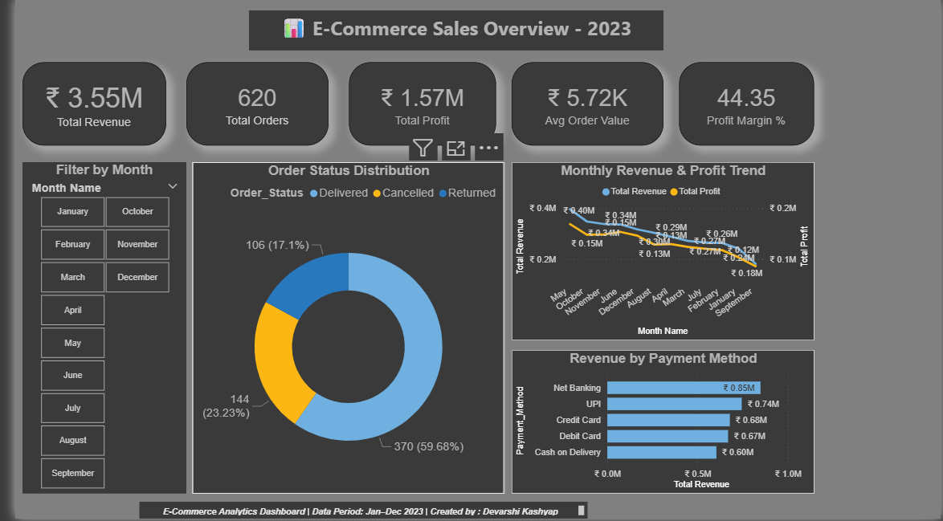
This page displays 5 KPI cards (Total Revenue, Total Orders, Total Profit, Average Order Value, Profit Margin %), a monthly revenue & profit trend line chart, an order status donut chart, and a revenue by payment method bar chart.

5.2 Page 2 — Product Analysis
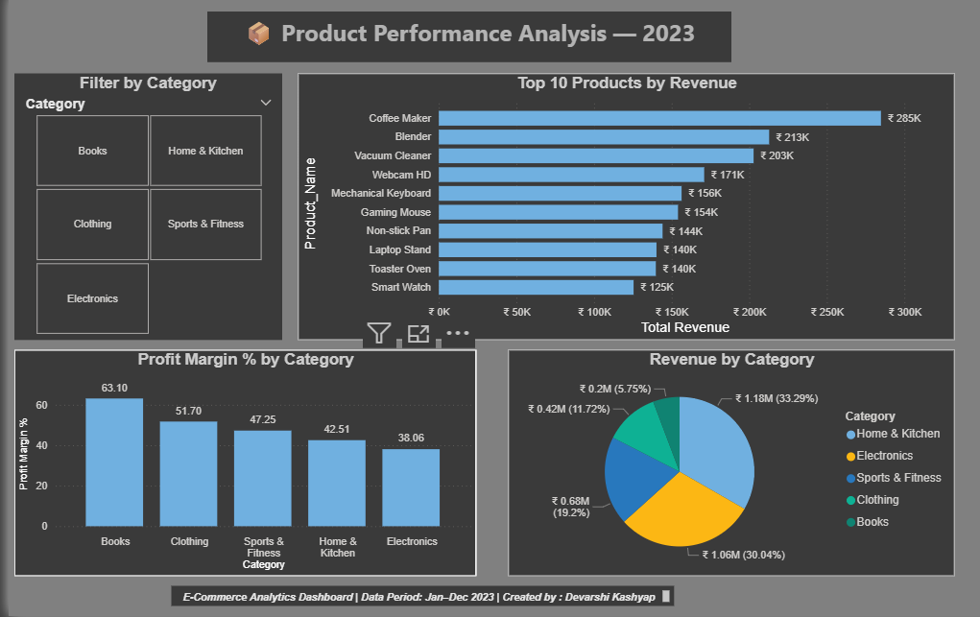
This page shows the Top 10 Products by Revenue bar chart, Revenue by Category pie chart, and Profit Margin % by Category column chart, with a category slicer for filtering.

5.3 Page 3 — Regional Analysis
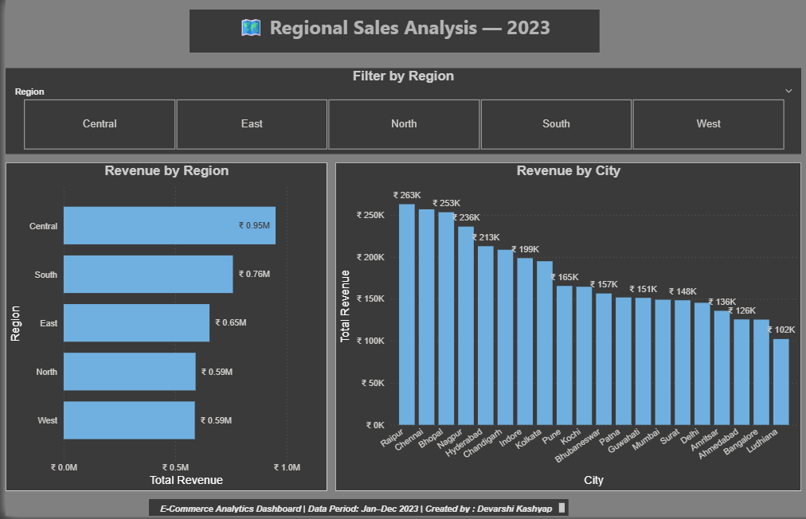
This page presents Revenue by Region bar chart and Revenue by City column chart, allowing stakeholders to drill down into geographic performance with a region slicer.

6. Tools & Technologies Used

Tool / Technology | Purpose
Microsoft Power BI Desktop | Primary tool for data modeling, DAX, and dashboard creation
Power Query Editor | Data import, cleaning, and transformation
DAX (Data Analysis Expressions) | Creating calculated measures and KPIs
CSV (Comma Separated Values) | Dataset format for data source
GitHub | Version control and project submission
Microsoft Word | Project report documentation

7. Conclusion
This project successfully demonstrated the end-to-end process of building a business intelligence dashboard using Microsoft Power BI. Starting from raw transactional data, the project covered data cleaning, modeling, DAX measure creation, and interactive visualization across three dashboard pages.
The E-Commerce Sales & Product Performance Dashboard provides actionable insights into revenue trends, product performance, regional distribution, and order fulfillment. These insights can help business decision-makers identify growth opportunities, reduce returns, and allocate resources more effectively.
Through this project, practical skills were developed in Power Query transformations, DAX formula writing, data modeling with relationships, and professional dashboard design — all of which are highly relevant to modern data analytics roles.

8. References
- Microsoft Power BI Documentation — https://docs.microsoft.com/power-bi
- DAX Reference Guide — https://dax.guide
- Power Query Documentation — https://docs.microsoft.com/power-query
- E-Commerce Industry Reports, 2023 — Various public sources

— End of Report —

