# Assessment Title: Web Programming Project

## Student Name: Ke Swen Lee

## Student ID: 30010827

## Date: 17/09/2020

### Development

The server used to run the website is xampp and the code is developed using Visual Studio Code. The database is stored in the server (the SQL script is attached in the folder). Below are the specifications and requirements of the project:

* Develop the application with PHP and MySQL
* Design the application
* Produce the prototype of the user interface in a visual format such as in images or template web site. Include website navigation hierarchy.
* Provide the database design, create database and validate it against the design, e.g. database structure
* Save your design separately before developing the application.
* Implement appropriate forms of user inputs and develop the application. Use HTLM forms elements with CSS for your design.
* Design separate web modules/components, e.g. header, footer modules to be included
* Develop the application. The application must:
* Have a search form, searchable by the title, genre, rating and year. For example, Search movies by genre (Comedy or SciFi) with Rating (PG) in 1995 or search movies by title with genre, or search by title only.
* Display the full details of each movie found. If no movie is found, the application will display a user-friendly message.
* Have an option to display a chart image of top 10 most frequently searched movies.
* Provide a test documentation
* Test your code against the PEAR code standard with an appropriate static analysis tool, e.g. PHP_CodeSniffer
* Fix the errors detected. E.g. you can use the PHP Code Beautifier utility
* Demonstrate software risk analysis and provide a simple report
* Identify potential software risks or problems, e.g. Possible invalid user inputs that cause unexpected behaviour? Is requirements incomplete? Security issues?
* Test and validate with sample inputs with screenshots. Test the logic of the contents of the application. Validate the consistency between the code and the software design. Include testing in various browsers, e.g. Chrome and Firefox.
* Provide an evidence that you adjusted your application base on the test.

### Prototype UI Design

This is the prototype of the website designed using Figma

Home Page

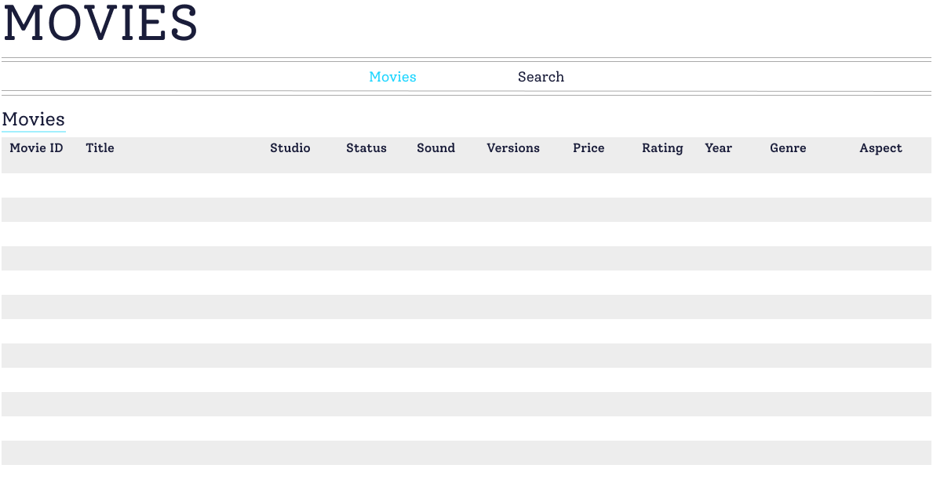

Search Page

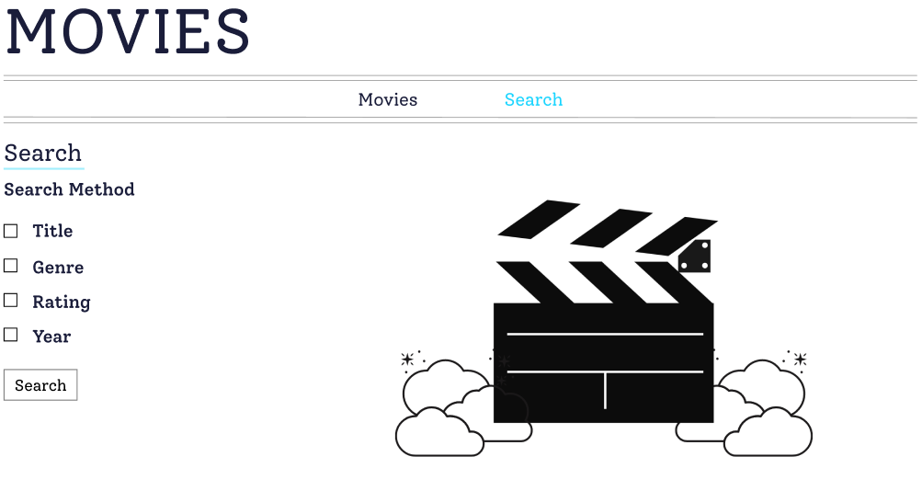

Statistic Page

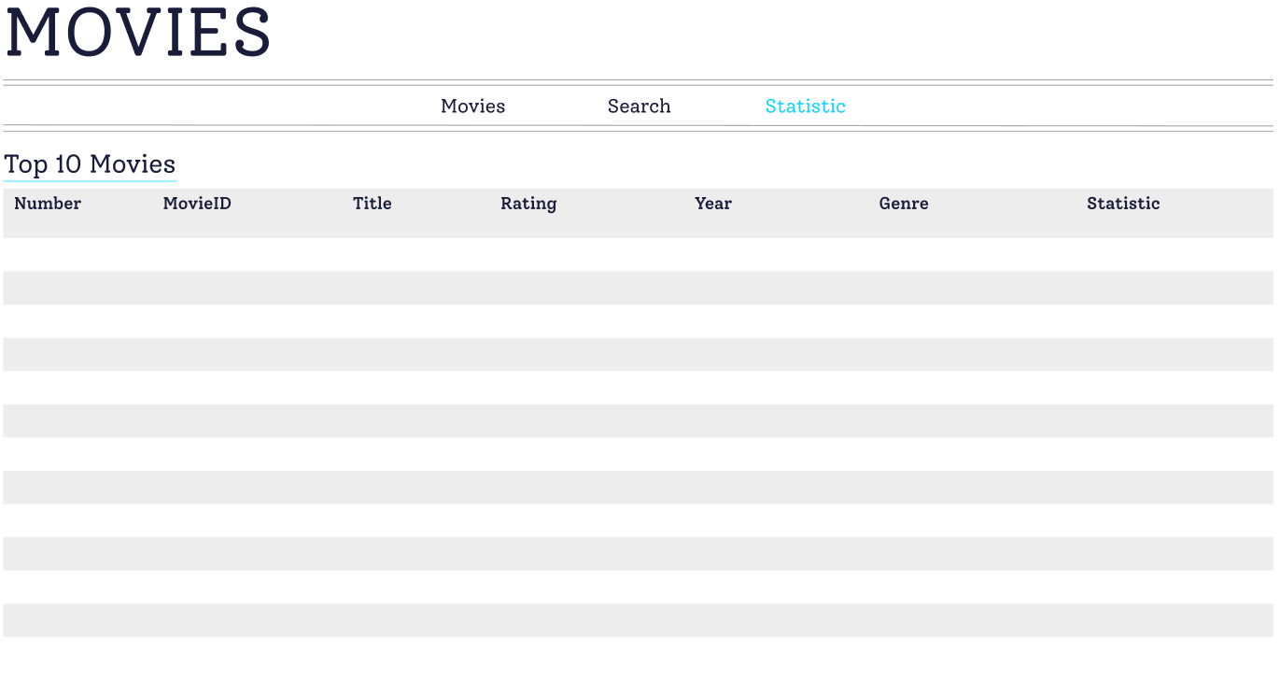



### Functional Design

This is an example of the output of the webpage.

Home Page

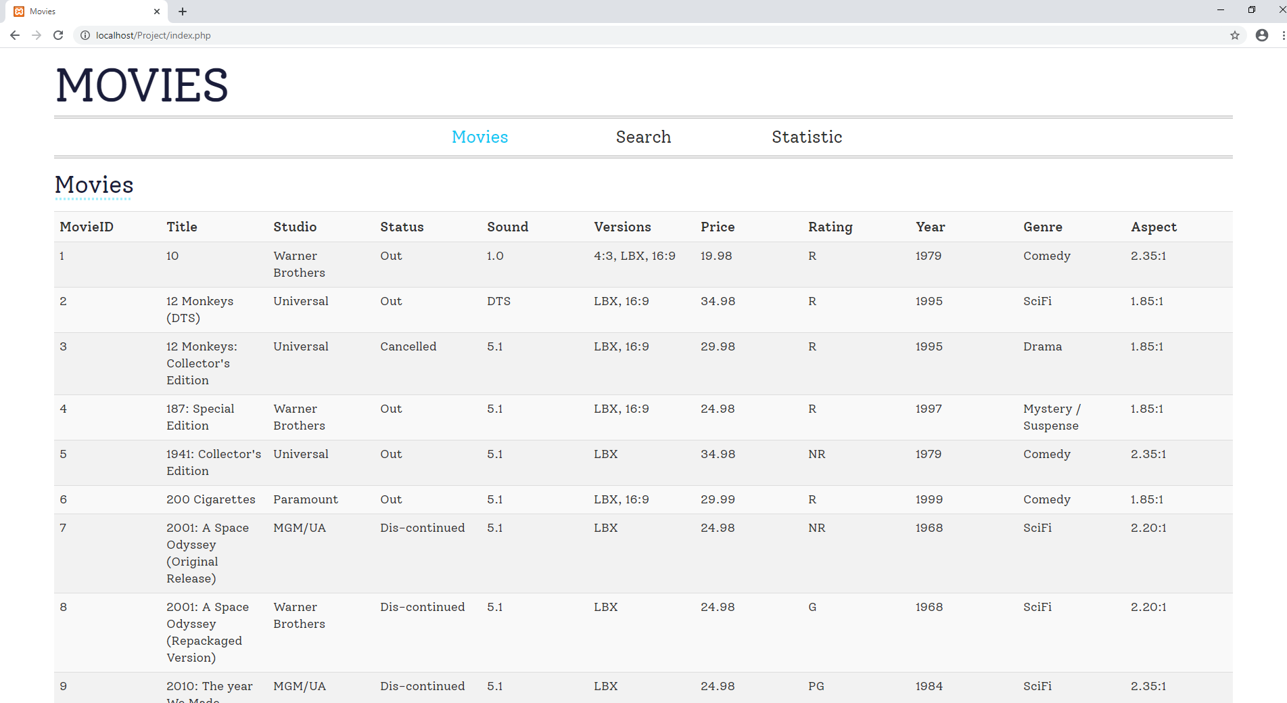

Search Pages

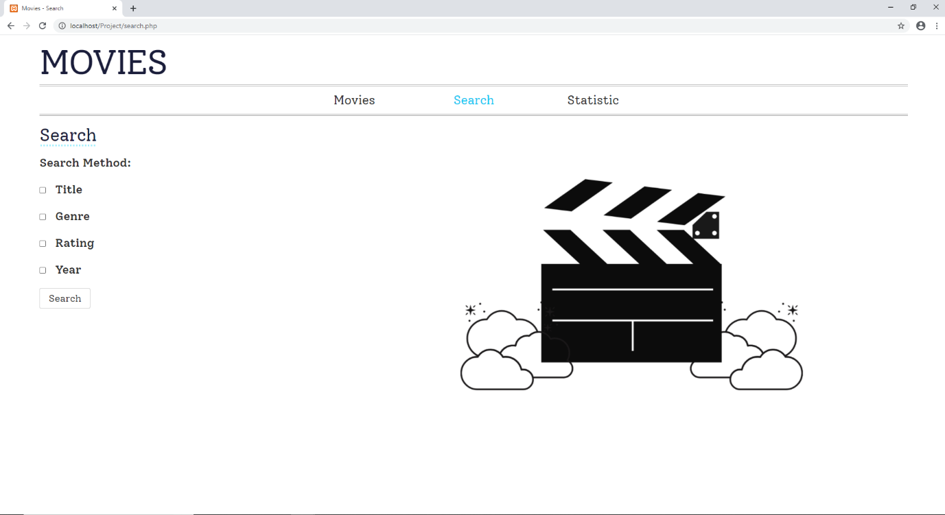

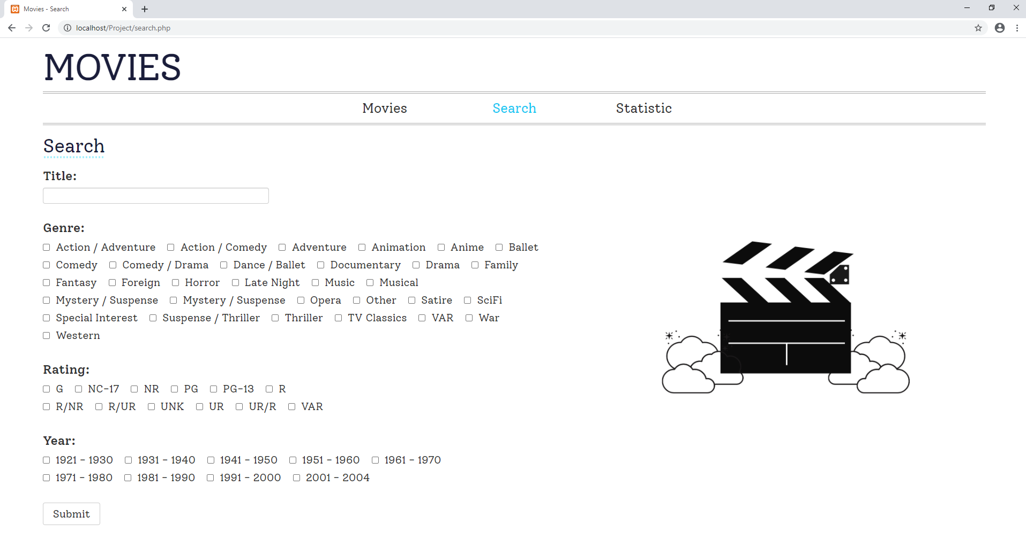

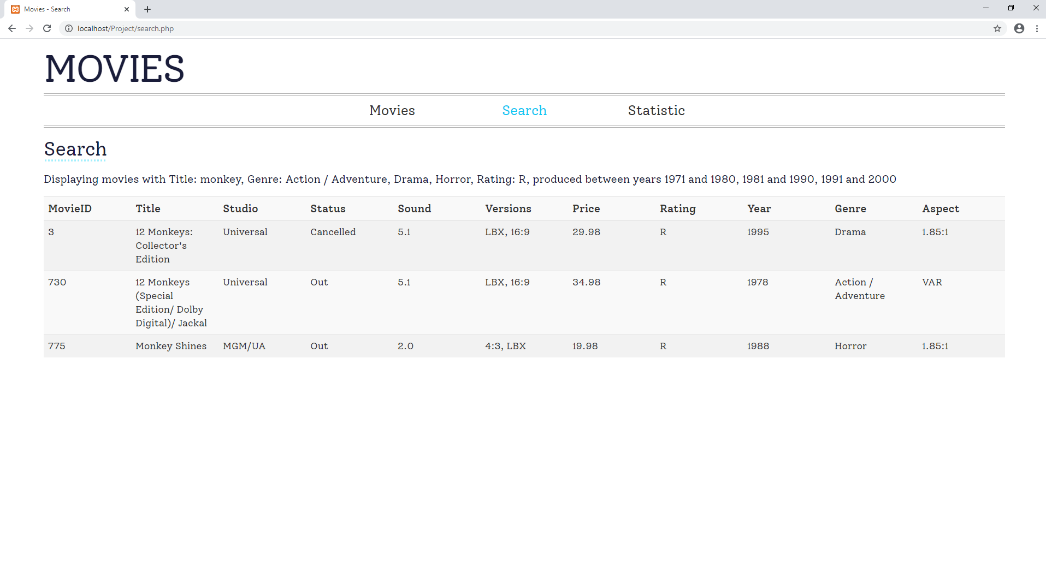

Statistics Page

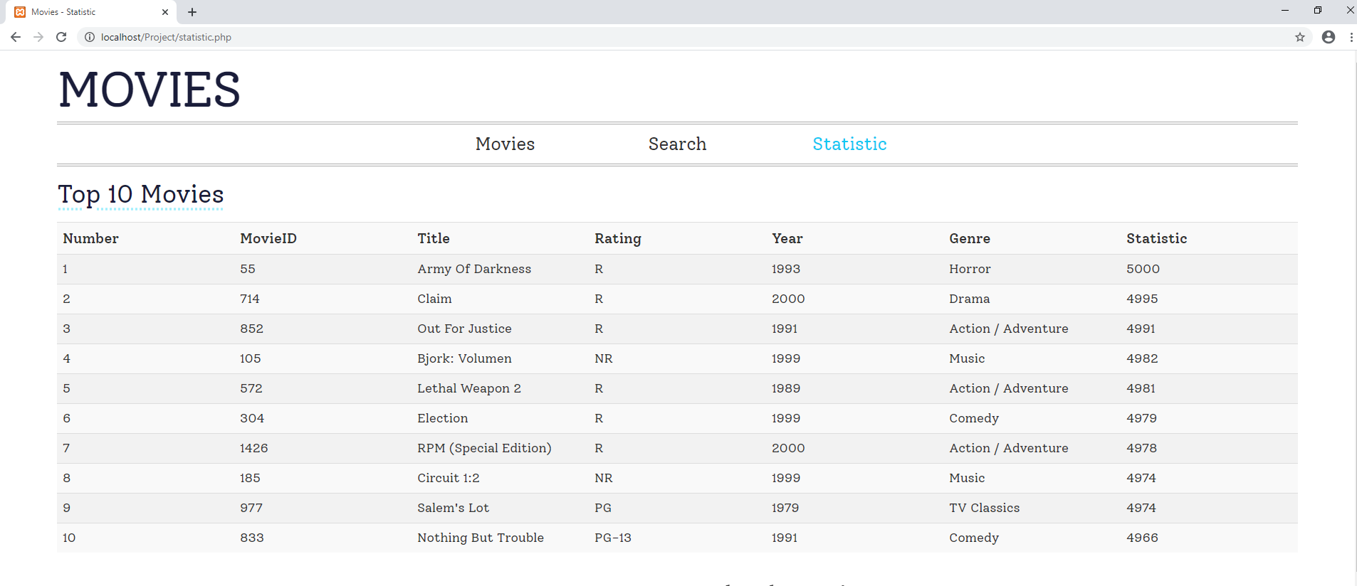

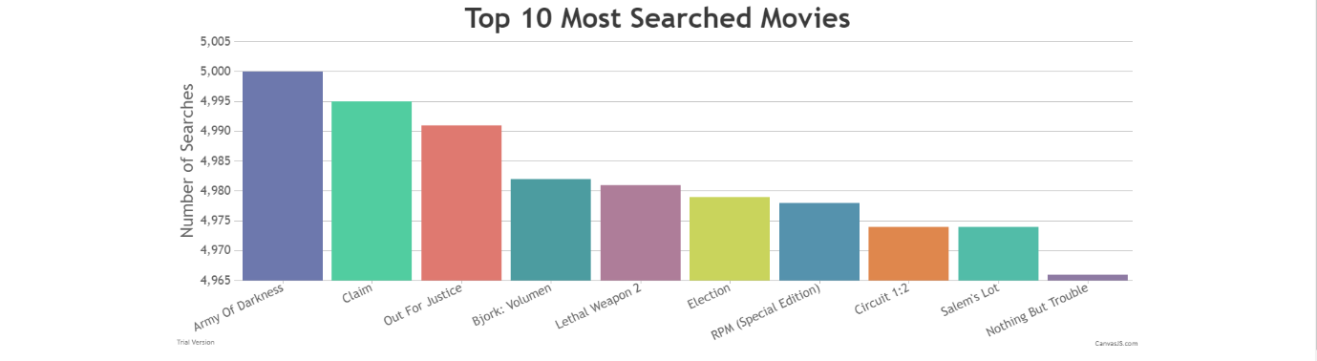

### Testing on Different Browsers

#### Google Chrome









#### Internet Explorer

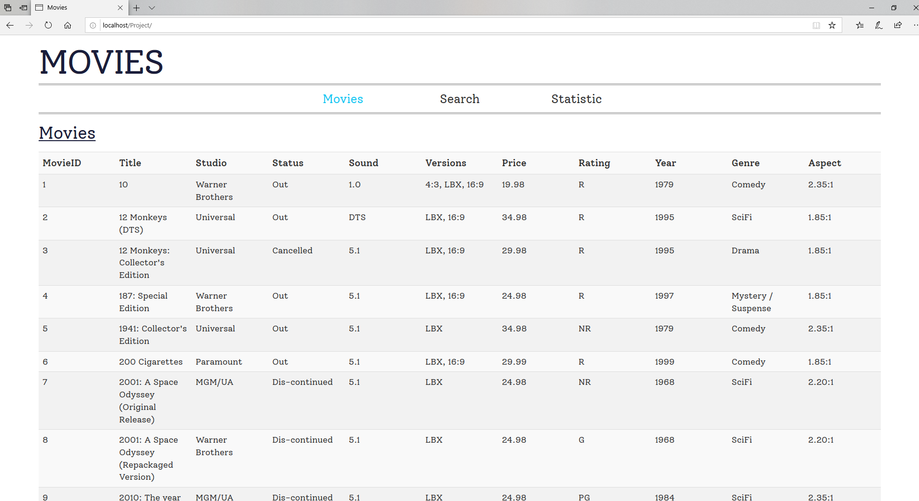

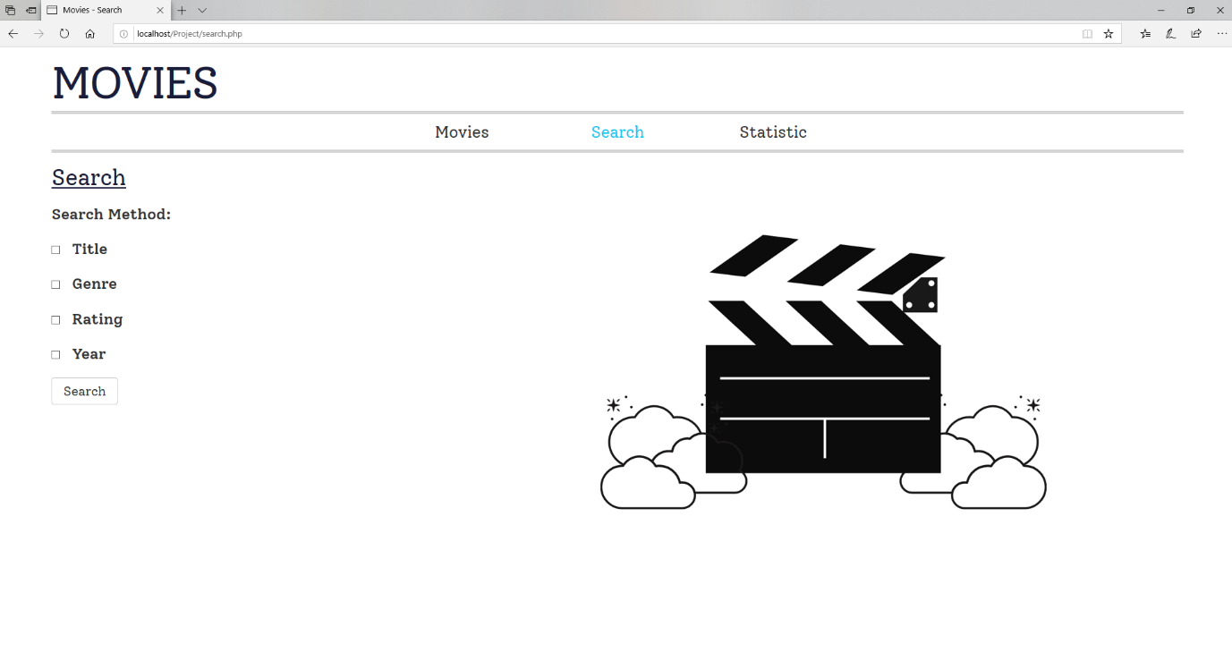

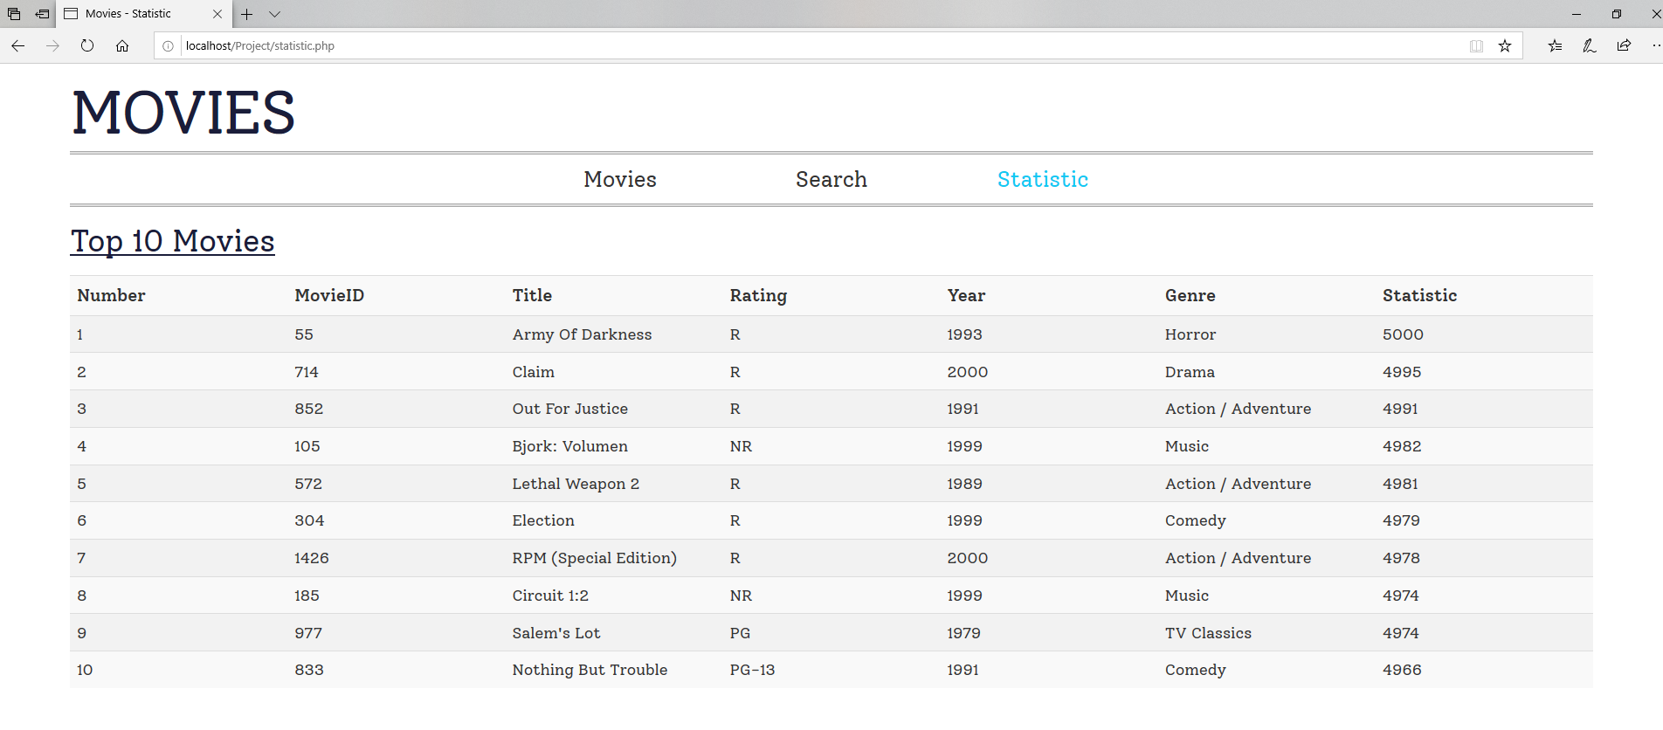

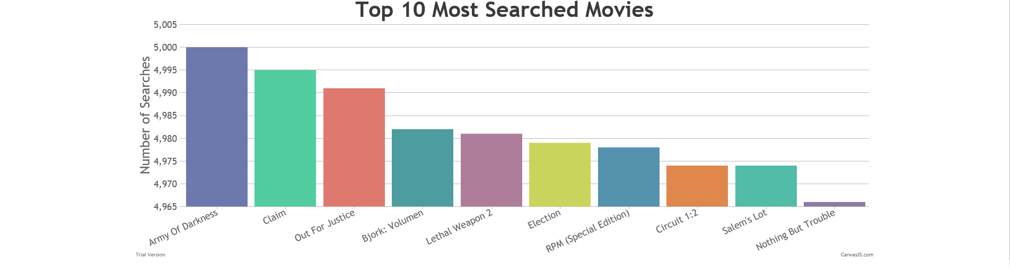

#### Mozilla Firefox

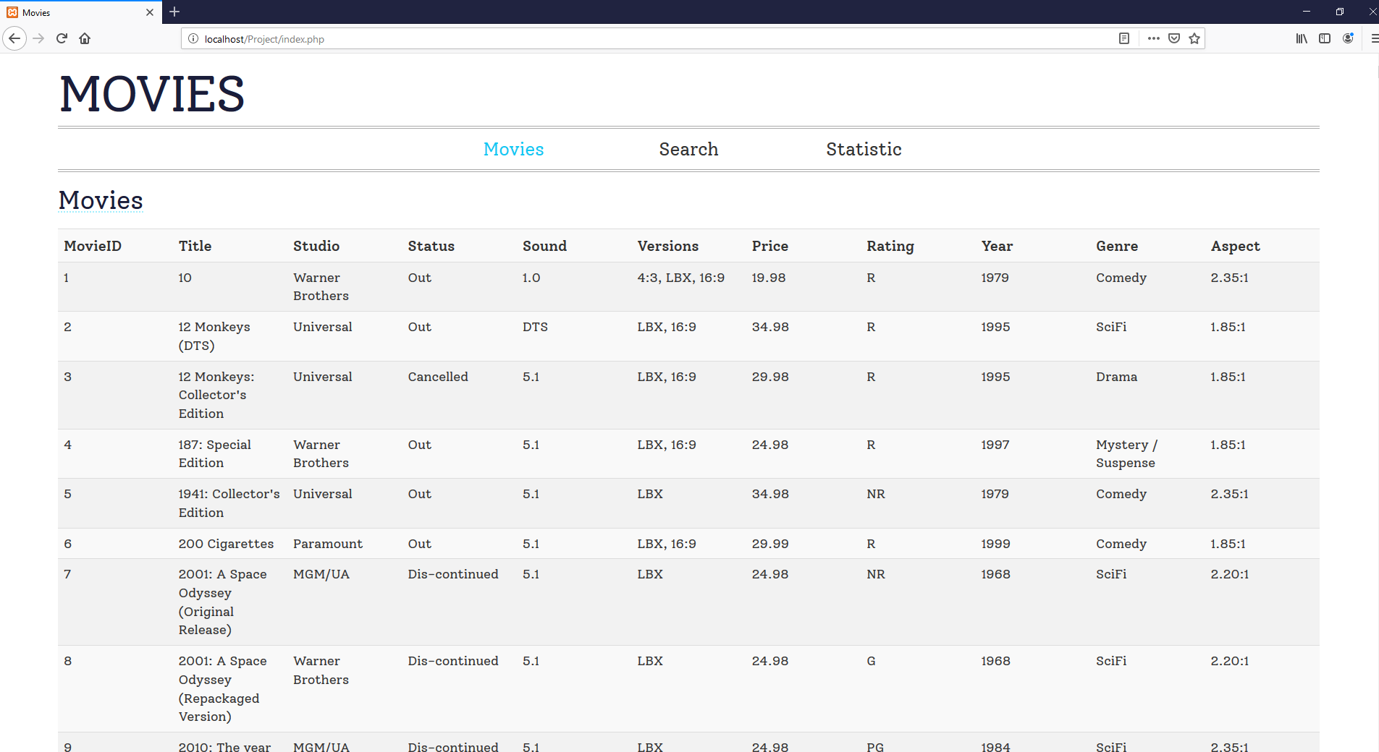

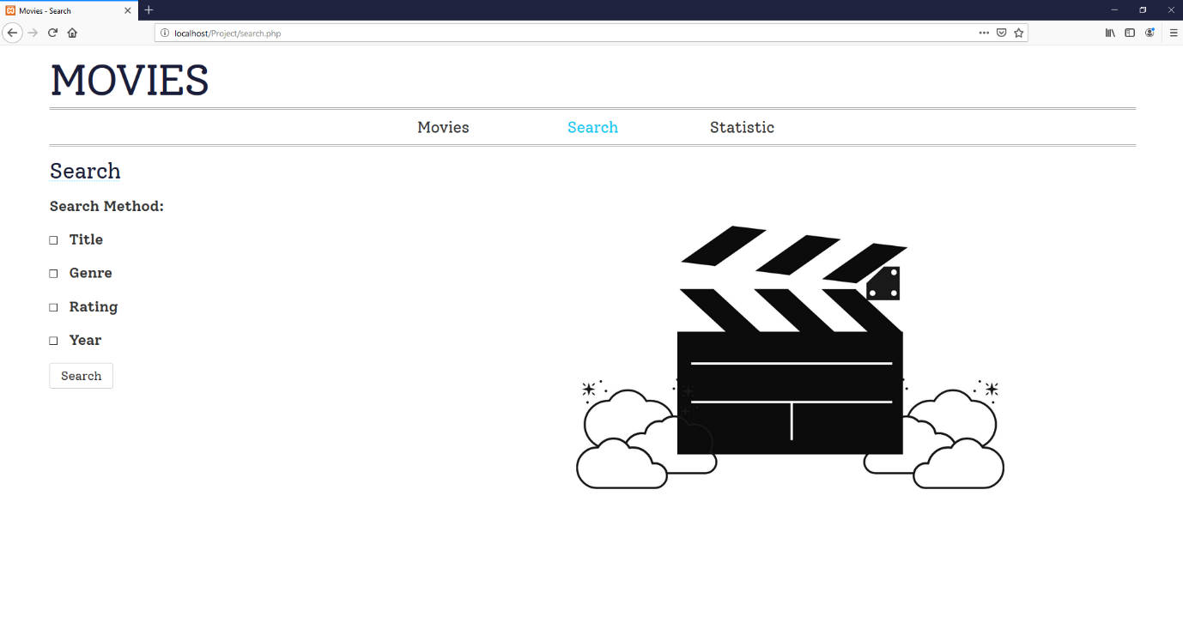

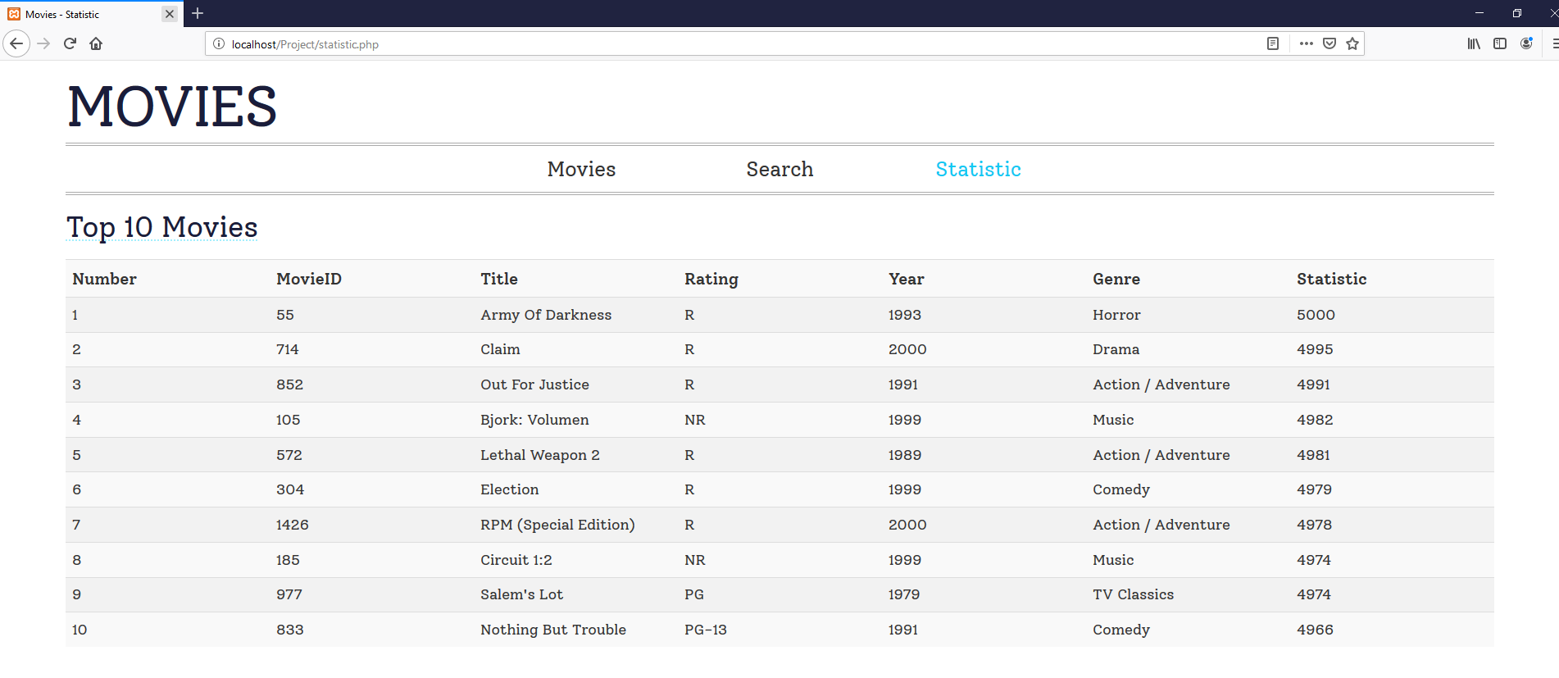

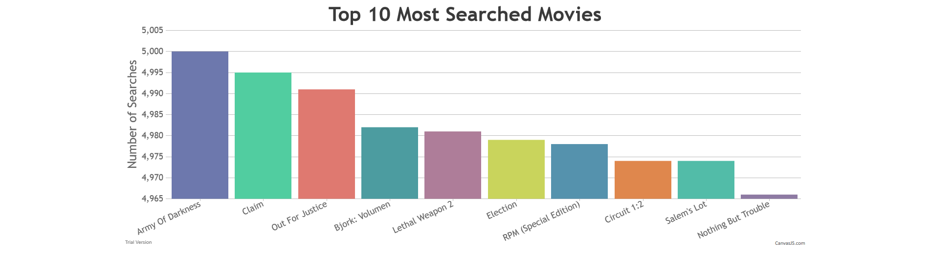

### PHP_CodeSniffer

There are 3 errors and 7 warnings in index.php (fixed).

There are 2 errors and 2 warnings in showAllMovies_scr.php (fixed).

There are 8 errors and 1 warning in connect.php (fixed).

There are 25 errors and 24 warnings in search.php (fixed).

There are 2 errors and 5 warnings in search_scr.php (fixed).

There is 1 error in myStyles.css (fixed).

The full pictures are attached in the folder.

### Software Risk Analysis

#### Invalid User Input

At first, the genre, rating and year was inputted by the user. However, there are only so many options. Therefore, checkboxes are implemented so that users can view the options they have. The labels are obtained from the database and not manually inputted. That way, if a new genre is added to the database, for example, the website will update automatically instead of having to input it manually.

#### Incomplete Requirements

If the user input is incomplete, for example, if the user submitted the form without selecting at least one filter, an error message is displayed

#### Security Issues

As logins and passwords are not implemented, the website is accessible by anyone who has the link to it. Everyone is able to search for movies but unable to change the database.