**Report**   
by *Devashish Panigrahi*

I'm Devashish Panigrahi, a Computer Science and Engineering student at Odisha University of Technology and Research. I’m passionate about AI/ML and DevOps because I believe that these technologies hold the key to solving many of today's most pressing challenges. My academic and project experiences have consistently driven me towards exploring innovative solutions in these areas.

I’m particularly drawn to Neophyte’s focus on innovative, cutting-edge projects, which align perfectly with my professional aspirations. The possibility of contributing to a team that values innovation, problem-solving, and continuous learning resonates with my professional goals.

**My Projects**

I have undertaken several projects that have strengthened my expertise in Machine Learning fields:

* **FireSafeBat:** In this project, I used Machine learning and Deep learning algorithms like FeedForward Neural Networks, Extreme Boosting and Gated Recurrent Unit Algorithms to predict the thermal runaway temperature of Li-Ion Battery and predicting the time of thermal runway based on time-series analysis. This experience allowed me to work hands-on with data preprocessing, model selection, and evaluation, significantly enhancing my understanding of practical applications.
* **PredMacDamage:** In my project, I utilized machine learning and deep learning algorithms, including multi-class classification techniques, to predict the remaining useful life of a machine and the time window of failure. I specifically employed LSTM networks to achieve these predictions.

**Technical Skills and Tools**

My technical proficiency includes a strong command of multiple programming languages, including C, C++, JavaScript, HTML, CSS, and PostgreSQL. I have worked with frameworks like Flutter and I am familiar with tools such as GitHub and VSCode.

In terms of AI/ML, while I consider myself a beginner, I have gained valuable experience through my projects. I am continually expanding my knowledge in this area through self-study and online courses.

Regarding DevOps and Cloud Computing, I have completed the PwC Cloud Bootcamp, where I gained hands-on experience with cloud technologies such as AWS, Jenkins, Docker, and Azure. This training has further strengthened my skills in cloud computing and DevOps tools, complementing my existing expertise in software development and system integration.

My ability to quickly learn and adapt is one of my strengths, allowing me to keep up with the fast-paced advancements in these fields and effectively tackle new challenges with innovative solutions.

**Problem-Solving and Collaboration**

I like to approach problems carefully and providing the optimised approach out of all the possible approaches available for the problem. I have a LeetCode, a Data Structure practicing Platform rating of nearly 1800, placing me in the top 8% of users. I’ve maintained a consistent problem-solving streak for over 220 days, demonstrating my dedication and strong algorithmic skills.

I thrive in collaborative environments and have always enjoyed working in cross-functional teams.

Here is my performance in Leetcode Platform:

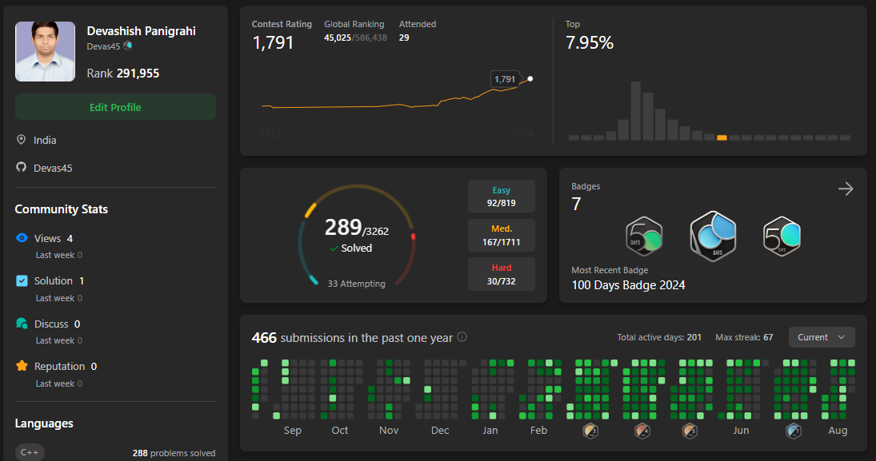

**My Story**

My academic journey in Computer Science and Engineering has been one of constant learning and growth. From mastering the fundamentals to applying complex algorithms in practical scenarios, I have developed a strong interest in AI/ML and DevOps. I am excited about the opportunity to bring my Problem-Solving ability and passion to Neophyte, where I believe I can contribute meaningfully to your innovative projects. I am particularly eager to learn and apply my skills in DevOps and Cloud Computing, a field that fascinates me and where I see immense potential for impact.

Lastly, I believe my skills and passion make me a good fit for Neophyte. I’m excited about the chance to contribute and learn more in the fields of AI/ML, DevOps and Cloud Computing.