DEPENDENCY RISK ANALYZER
Software Supply Chain Security using C++ Data Structures and OSV
  - Course Project Report
Prepared from the implementation and test results described during the project walkthrough.

Abstract
Dependency Risk Analyzer is a desktop-local web application that combines a C++ data-structures engine, a Flask backend, a browser dashboard, and the Open Source Vulnerabilities (OSV) API. It reads a dependency relationship file, constructs a directed dependency graph, traverses it using BFS and DFS, queries OSV for selected package versions, and presents a report with heuristic risk/trust scores. Additional C++ structures demonstrated include a max-heap, sorting and searching routines, a hash table, a stack, and a queue. The dashboard supports text-file uploads and shows the analyzer's report.

1. Problem Statement
Software projects rely on third-party packages, and developers need a convenient way to inspect dependency relationships and check known vulnerability records for selected package versions. Manually reviewing these inputs and results can be tedious. This project demonstrates a single workflow that connects dependency graph analysis with vulnerability lookup and data-structure-based prioritization.

2. Objectives
- Represent project dependencies as a directed graph.
- Demonstrate graph traversal using Breadth-First Search (BFS) and Depth-First Search (DFS).
- Query OSV using ecosystem, package name, and version information.
- Calculate illustrative package risk and trust scores.
- Prioritize packages with a max-heap and demonstrate sorting, searching, hashing, stack, and queue operations.
- Provide a browser dashboard connected to a Flask API and the C++ executable.
- Validate uploads and restore original input files after temporary analysis inputs are used.

3. System Architecture
The browser dashboard sends requests to Flask. Flask validates optional uploads, serializes analyses with a threading lock, temporarily writes supplied input text to the analyzer's input files, runs analyzer.exe as a subprocess, captures the output, and restores original files in a finally block. The C++ process builds the dependency graph and queries OSV through curl.exe. The resulting report is returned to the browser as JSON.
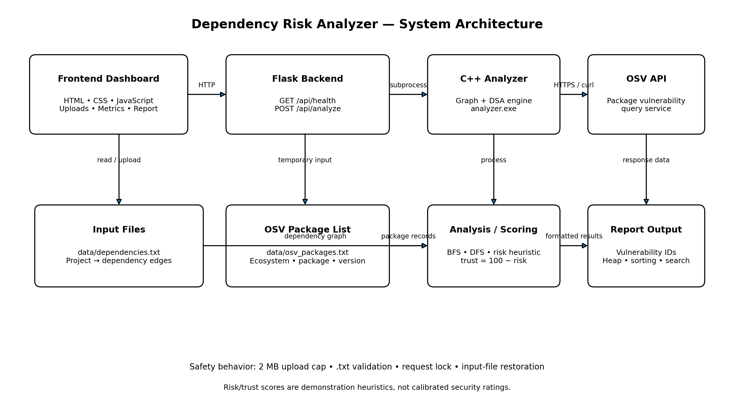

4. Technology Stack
- C++17: graph and data-structure implementation, analysis logic, risk report.
- Flask: local HTTP backend, health endpoint, analysis endpoint, upload handling.
- HTML, CSS, JavaScript: browser-based dashboard and report display.
- OSV API: package-version vulnerability query service.
- curl.exe: HTTPS request transport from the C++ client.
- Windows Command Prompt and MSYS2 UCRT64 g++: development and compilation environment.

5. Input Data
Dependency relationships (data/dependencies.txt):
- Project React
- Project Express
- React Axios
- React Lodash
- Express Lodash
- Axios OpenSSL
OSV package input (data/osv_packages.txt):
- npm lodash 4.17.20
- npm axios 0.21.0
- npm express 4.17.1

6. Data Structures and Algorithms
- Directed graph: Represents edges from a parent/project component to a dependency.
- BFS: Visits reachable nodes level by level from the starting node.
- DFS: Explores a path before backtracking.
- Max-heap: Ranks scored packages by risk priority.
- Sorting: Produces risk-ordered and name-ordered package lists.
- Searching: Demonstrates linear search and binary search on a name-sorted list.
- Hash table: Stores and retrieves package information by package name.
- Stack: Demonstrates last-in, first-out (LIFO) behavior.
- Queue: Demonstrates first-in, first-out (FIFO) behavior.

7. Vulnerability Lookup and Risk Heuristic
The application sends ecosystem, package, and version data to OSV. In the observed run, lodash 4.17.20 returned 5 vulnerability records, axios 0.21.0 returned 25, and express 4.17.1 returned 2. The total was 32 records across 3 successful queries, with 0 failed queries in that run. These are observed API results from the test session, not permanent package facts; OSV data can change.
The demonstrated score formulas are:
Risk = min(100, vulnerability_count × 25 + dependency_depth × 5)
Trust = 100 − risk
These formulas are demonstration heuristics only. They are not calibrated security ratings and should not be used alone to make production security decisions. Vulnerability records must be checked for affected version ranges and applicability.

8. Backend and Input Safety
- GET /api/health reports backend status and whether the analyzer and input files exist.
- POST /api/analyze runs the C++ analyzer and returns JSON containing success/message/report on success.
- The Flask application limits combined upload size to 2 MB.
- Uploads must have a .txt extension and be UTF-8 text; zero-byte uploads are rejected.
- A threading lock prevents concurrent requests from simultaneously replacing shared input files.
- Original files are backed up in memory for the request and restored in a finally block.
- The subprocess has a 180-second timeout; curl requests use a 10-second connection timeout and 30-second maximum request time.

9. Testing and Observed Results
Test | Observed result
Default C++ analysis | Passed: 6 valid dependency lines, 0 invalid lines; BFS and DFS output produced.
OSV normal query run | Passed: 3 successful queries, 0 failed queries, 32 matching records reported in the observed run.
Dashboard custom dependency upload | Passed: custom input was analyzed.
Dashboard custom OSV package upload | Passed: uploaded package list was processed; original input was restored.
Invalid dependency lines | Passed: invalid lines were reported while valid lines were processed.
Empty upload | Passed as validation: backend rejected the zero-byte file with a clear error.
Blank-line dependency file | Passed: blank lines were ignored and two valid dependency lines were processed.
Oversized upload | Passed: dashboard displayed the configured 2 MB upload-limit error.
Invalid file extension | Passed: non-.txt upload was rejected.
Health endpoint | Passed: status ok and all three file/executable checks true.
Direct analysis API | Passed: POST /api/analyze returned success true and the full C++ report.
Input restoration | Passed: both original input files matched their expected contents after analysis.
OSV rejected request | Passed: invalid ecosystem caused HTTP 400 from OSV, was reported as a failed query, and the original package file was restored.
Network outage / concurrency stress | Not yet tested as a real outage or stress test.

10. Limitations
- The score formula is heuristic and not security-calibrated.
- The demonstrated package list is manually supplied; the current workflow is not yet a complete parser for every ecosystem lockfile.
- OSV request failures are reported, but a true network outage and prolonged timeout scenario remain unverified.
- Concurrency protection is implemented with a lock but has not been load-tested.
- A vulnerability record count alone does not establish whether a package installation is exploitable; affected version ranges and dependency context matter.
- The local Flask server is intended for a course demonstration and has not been assessed as a public production deployment.

11. Future Enhancements
- Add lockfile parsers for npm, PyPI, and Maven formats.
- Show vulnerability severity, affected version ranges, references, and remediation guidance where available.
- Add dependency path visualization and exportable HTML/PDF/CSV reports.
- Build automated unit and integration tests for network errors, malformed API responses, timeout behavior, and concurrent requests.
- Improve risk scoring using explainable factors and documented validation rather than raw vulnerability count alone.
- Add persistent test fixtures and CI compilation/testing.

12. Conclusion
Dependency Risk Analyzer demonstrates how core data structures and algorithms can be combined with a live vulnerability-data service and a web interface. The observed tests show the main analysis workflow working across C++, Flask, and the browser dashboard, including several input-validation and error-handling paths. The project is suitable as a course demonstration when its heuristic scoring and remaining test limitations are clearly disclosed.

