**ELECTROTHON**

**AgriSense**

Prototype representation:

**Step 1**:Sensing of factors like pH,moisture and temperature

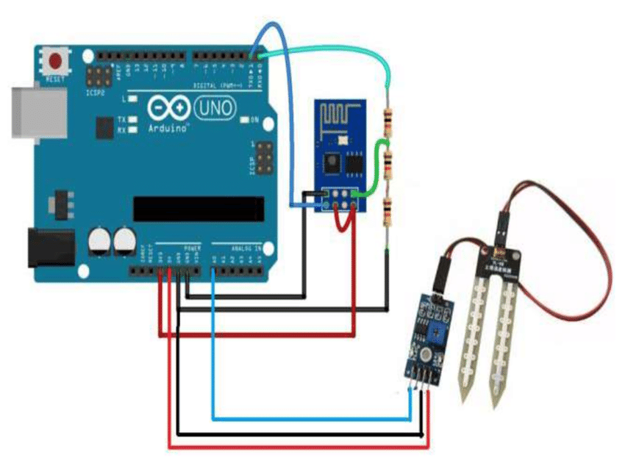

Interface of pH,moisture and temperature sensor with **Arduino** (*Collects and transfers raw data from soil)

**Step 2:**

**Step 3:Displaying the processed data in the app**

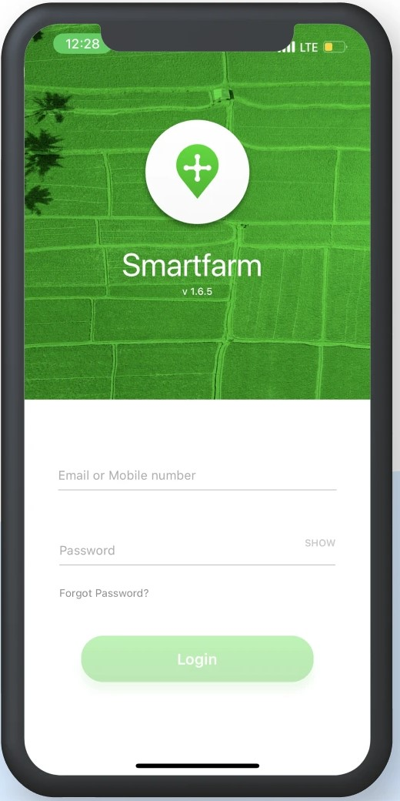

**An App with login credentials for viewing the results**

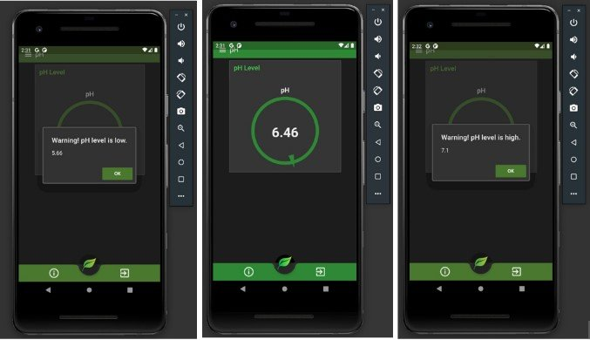

**App showing information such as pH,temperature to the user**

**Step 4:**

**Based on the Analysis the app suggests what crops to grow in a given area**

