**Industrial Internship Report on**

**”Data Science and Machine Learning”**

**Prepared by**

**[DEVASHREE DHAGAT]**

|  |
| --- |
| *Executive Summary* |
| This report provides details of the Industrial Internship provided by upskill Campus and The IoT Academy in collaboration with Industrial Partner UniConverge Technologies Pvt Ltd (UCT).  This internship was focused on a project/problem statement provided by UCT. We had to finish the project including the report in 6 weeks’ time.  My project was **CROP AND WEED DETECTION**. In this project crop and weed are detected using the images given in the dataset.  This internship gave me a very good opportunity to get exposure to Industrial problems and design/implement solution for that. It was an overall great experience to have this internship. |

**Table of Contents**

1 Preface 3

2 Introduction 5

2.1 About UniConverge Technologies Pvt Ltd 5

i. UCT IoT Platform 5

2.2 About upskill Campus (USC) 9

2.3 The IoT Academy 11

2.4 Objectives of this Internship program 11

2.5 Reference 11

2.6 Glossary 11

3 Problem Statement 12

4 Existing and Proposed solution 13

4.1 Code submission (Github link) https://github.com/Devashree10/Upskill_Campus/blob/main/CROPANDWEEDDETECTION.ipynb 14

4.2 Report submission (Github link) https://github.com/Devashree10/Upskill_Campus/blob/main/CROPANDWEEDDETECTION_DEVASHREE_USC_UCT.pdf 14

5 Proposed Design/ Model 15

6 Performance Test 15

6.1 Performance Outcome 16

7 My learnings 16

8 Future work scope 17

# Preface

**Summary of the whole 6 weeks’ work:**

In this internship of 6 weeks, we have been given the overview of the company UniConverge Technologies, and the field in which I have been doing the internship that is Data Science and Machine Learning. Later, we have been introduced with the problem statement. Then I have followed the program as per the format.

**About need of relevant Internship in career development:**

In the development of career, internship plays a vital role. Through internship one gets practical knowledge of the respective field. One gets to know about real world problems and learn how to handle them and get the solution of them.

**Brief about Your project/problem statement:**

Problem: Weed is an unwanted thing in agriculture. Weed use the nutrients, water, land and many more things that might have gone to crops. Which results in less production of the required crop. The farmer often uses pesticides to remove weed which is also effective but some pesticides may stick with crop and may causes problems for humans.

Aim: We aim to develop a system that only sprays pesticides on weed and not on the crop Which will reduce the mixing problem with crops and reduce the waste of pesticides.

**Opportunity given by USC/UCT:**

Upskill Campus and UniConverge Technologies have given great opportunity to upgrade my skills and knowledge in the field of data science and machine learning. Have given the chance to showcase my skills in the real-world problem. They have vast knowledge and understanding about the new technologies by keeping themselves updated. I have learnt a lot from this internship and USC/UCT have given me such a great opportunity.

**How Program was planned:**

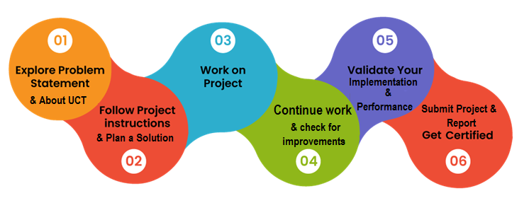

**Your Learnings and overall experience:**

After joining this internship of 6 weeks, I was quite confident about myself for putting step into the corporate world to face and handle problems which are getting faced by people in their day-to-day life.

I have gained knowledge of data science, machine learning, their algorithms like OpenCV, Deep learning, etc.

It was really an overwhelming experience and feels so grateful for the opportunity.

**Thanks to Respected Kaushlendra Singh Sir, Apurv Sir, Archana Mam, and all the team of Upskill Campus, UniConverge Technologies and Edunet Foundation**, for giving me the opportunity to showcase my skills and upgrade my knowledge in the field of data science and machine learning.

**Your message to your juniors and peers:**

My message to my juniors and peers is that you should be always focused towards your goal and always do what makes you feel happy and satisfied.

# Introduction

## About UniConverge Technologies Pvt Ltd

A company established in 2013 and working in Digital Transformation domain and providing Industrial solutions with prime focus on sustainability and RoI.

For developing its products and solutions it is leveraging various**Cutting Edge Technologies e.g. Internet of Things (IoT), Cyber Security, Cloud computing (AWS, Azure), Machine Learning, Communication Technologies (4G/5G/LoRaWAN), Java Full Stack, Python, Front end**etc.

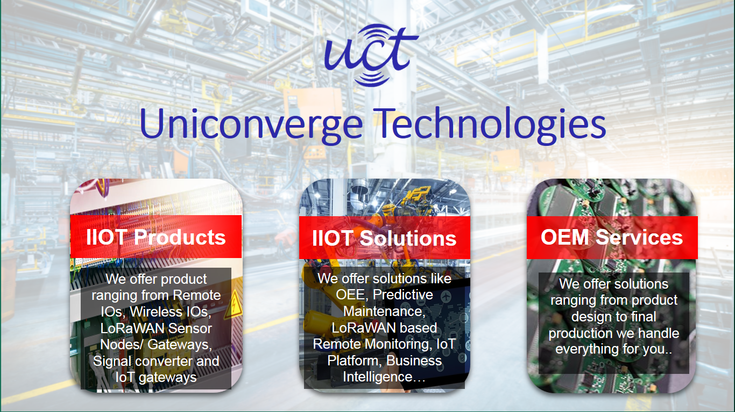

1. UCT IoT Platform **(****)**

**UCT Insight** is an IOT platform designed for quick deployment of IOT applications on the same time providing valuable “insight” for your process/business. It has been built in Java for backend and ReactJS for Front end. It has support for MySQL and various NoSql Databases.

* It enables device connectivity via industry standard IoT protocols - MQTT, CoAP, HTTP, Modbus TCP, OPC UA
* It supports both cloud and on-premises deployments.

It has features to  
• Build Your own dashboard  
• Analytics and Reporting  
• Alert and Notification  
• Integration with third party application (Power BI, SAP, ERP)  
• Rule Engine





1. **Smart Factory Platform (****)**

Factory watch is a platform for smart factory needs.

It provides Users/ Factory

* with a scalable solution for their Production and asset monitoring
* OEE and predictive maintenance solution scaling up to digital twin for your assets.
* to unleased the true potential of the data that their machines are generating and helps to identify the KPIs and improve them.
* A modular architecture that allows users to choose the service that they what to start and then can scale to more complex solutions as per their demands.

Its unique SaaS model helps users to save time, cost, and money.



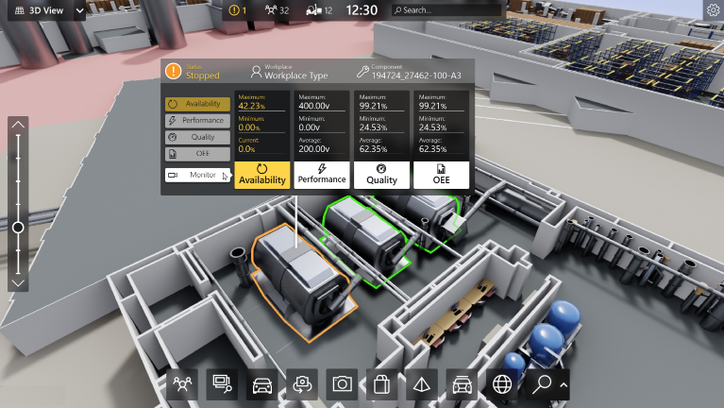

1. 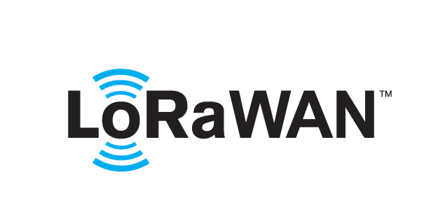 based Solution

UCT is one of the early adopters of LoRAWAN teschnology and providing solution in Agritech, Smart cities, Industrial Monitoring, Smart Street Light, Smart Water/ Gas/ Electricity metering solutions etc.

1. Predictive Maintenance

UCT is providing Industrial Machine health monitoring and Predictive maintenance solution leveraging Embedded system, Industrial IoT and Machine Learning Technologies by finding Remaining useful life time of various Machines used in production process.



## About upskill Campus (USC)

Upskill Campus along with The IoT Academy and in association with Uniconverge technologies has facilitated the smooth execution of the complete internship process.

USC is a career development platform that delivers **personalized executive coaching** in a more affordable, scalable, and measurable way.



Seeing need of upskilling in self-paced manner along-with additional support services e.g. Internship, projects, interaction with Industry experts, Career growth Services

<https://www.upskillcampus.com/>

Upskill Campus aiming to upskill 1 million learners in next 5 year

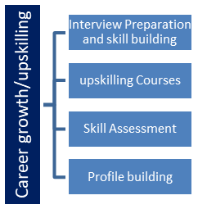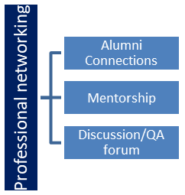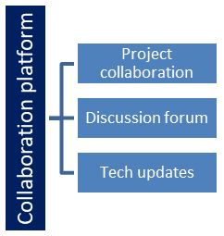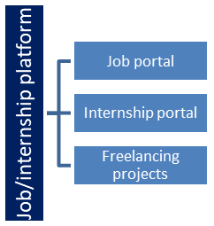

## The IoT Academy

The IoT academy is EdTech Division of UCT that is running long executive certification programs in collaboration with EICT Academy, IITK, IITR and IITG in multiple domains.

## Objectives of this Internship program

The objective for this internship program was to

 ☛ get practical experience of working in the industry.

 ☛ to solve real world problems.

 ☛ to have improved job prospects.

 ☛ to have Improved understanding of our field and its applications.

 ☛ to have Personal growth like better communication and problem solving.

## Reference

[1] Edunet Foundation through Code Unnati Program

## Glossary

|  |  |
| --- | --- |
| Terms | Acronym |
| Upskill Campus | UCS |
| UniConverge Technologies | UCT |
| Convolutional Neural Network | CNN |
| Computer Vision | CV |
| Internet of Things | IoT |

# Problem Statement

Weed is an unwanted thing in agriculture. Weed use the nutrients, water, land and many more things that might have gone to crops. Which results in less production of the required crop. The farmer often uses pesticides to remove weed which is also effective but some pesticides may stick with crop and may causes problems for humans.

Aim: We aim to develop a system that only sprays pesticides on weed and not on the crop Which will reduce the mixing problem with crops and reduce the waste of pesticides.

In this project, a model is built using machine learning algorithms to detect the crops and weed from the image using the dataset. As through which the fertilizers and pesticides should only stick on weed.

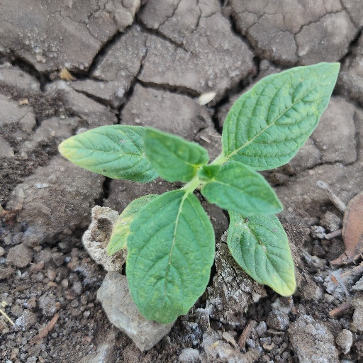

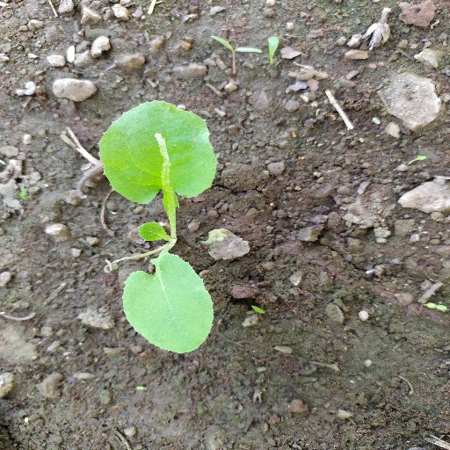

# Existing and Proposed solution

One of the existing solutions is the FarmBot used for the basic agricultural activities such as watering or seeding, to more advanced and complex tasks such as differencing between crops and weeds. This weed detection system is the focus of this project. It is programmed to take pictures of the crop and process them by a manually activated weed-detection software application from FarmBot where the processing is done based on the colors and location of the elements of the picture.

This solution has some limitations, Firstly, having to manually activate the weed detector application does not reduce the amount of human labor as much as intended. Secondly, basing the detection on colors is not accurate due to the possibility of a change of lighting or the similarity of colors between weed and plants, among other things. Finally, basing the existence of a weed on the location where the FarmBot has previously planted a seed, does not consider a situation where the FarmBot does not necessarily know where all the seeds are located.

As to solve the limitations of the existing solution there is a system which run on machine learning algorithms with the help of deep learning and computer vision so that we can overcome this problem easily.

In this project there is improvement in terms of human labor, time consumption and increment in accuracy.

## Code submission (Github link) <https://github.com/Devashree10/Upskill_Campus/blob/main/CROPANDWEEDDETECTION.ipynb>

## Report submission (Github link) <https://github.com/Devashree10/Upskill_Campus/blob/main/CROPANDWEEDDETECTION_DEVASHREE_USC_UCT.pdf>

# Proposed Design/ Model

Architecture:

Identification and Classification

Image acquisition

Pre-processing

Feature extraction

Classification

# Performance Test

This is very important part and defines why this work is meant of Real industries, instead of being just academic project.

In Machine learning model there are some constraints to keep in mind while developing a model using algorithms of deep learning, CNN, etc.

Some restrictions are there including more transparency, bias and discrimination, over and under fitting, ethical consideration, accuracy, efficiency, quality of data, etc.

Some constraints to followed contains:

* Make sure your pipeline is solid end to end.
* Start with a reasonable objective.
* You should be clearly about what you are building.
* The testing part should be very efficient.

These are some constraints which should be there in any developer’s mind. The constraints have the capability to make the model best or worst. They play a very important role in any real-world projects.

## Performance Outcome

I have used juypter notebook with anaconda environment.

The model detects the crops and weeds from the images and has 82% of accuracy. Using deep learning algorithms and object detection process, the model has been able to detect crop and weed.

# My learnings

I am so grateful and overwhelmed for this opportunity of being the part the upskill campus and UniConverge Technologies through showcasing my skills and implementing the knowledge to the real-world problems.

I have learnt so many new methods, ways of solving the problems, have gained the information about the field of advanced technology.

My results of the projects and perspective towards them became more accurate, more precise.

Thank you.

# Future work scope

This model is quite accurate at this stage but can improve its accuracy and efficiency.

Some of the areas in the emerging technologies requires in depth research efforts as global climate change also affects crop-weed interaction. Like this, many areas directly or indirectly affect the agricultural environment and the crops and weeds.