Name: Devasy Patel

Roll No.: 20BCE057

Subject: Computer Network

Subject Code:2CS502

Practical: 2

Aim: Experiments on Packet capture tool: Wireshark to understand the features of wireshark as a packet capture tool and understand encapsulation of information. Also study effect of few network commands.

Step 1: First Download and install Wireshark.

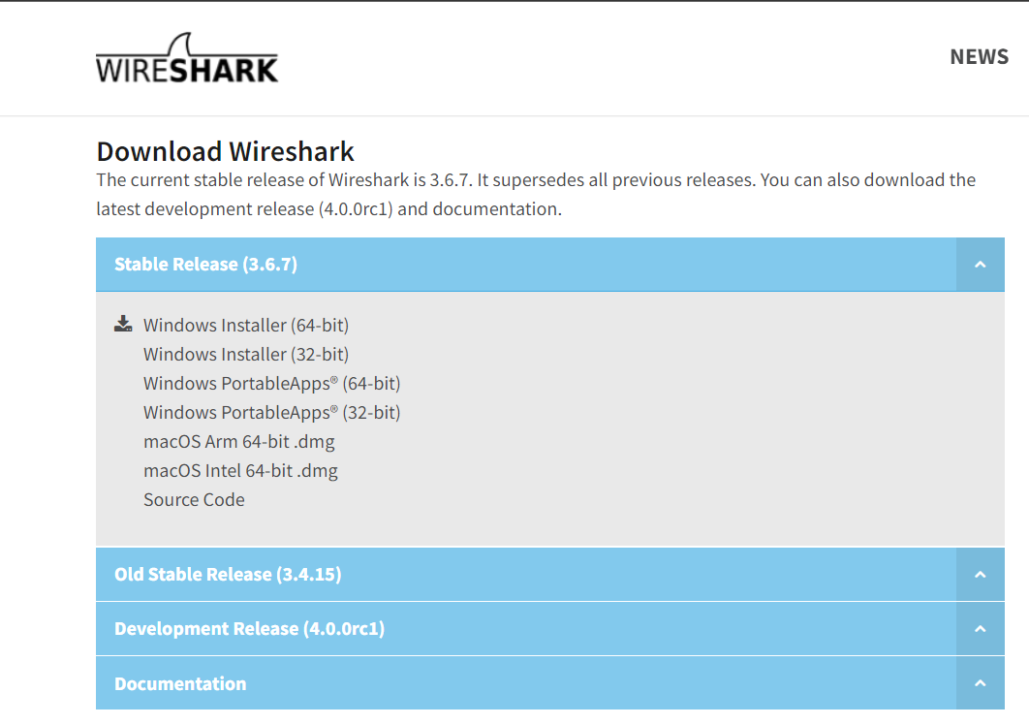

Step 2: Open Wireshark.

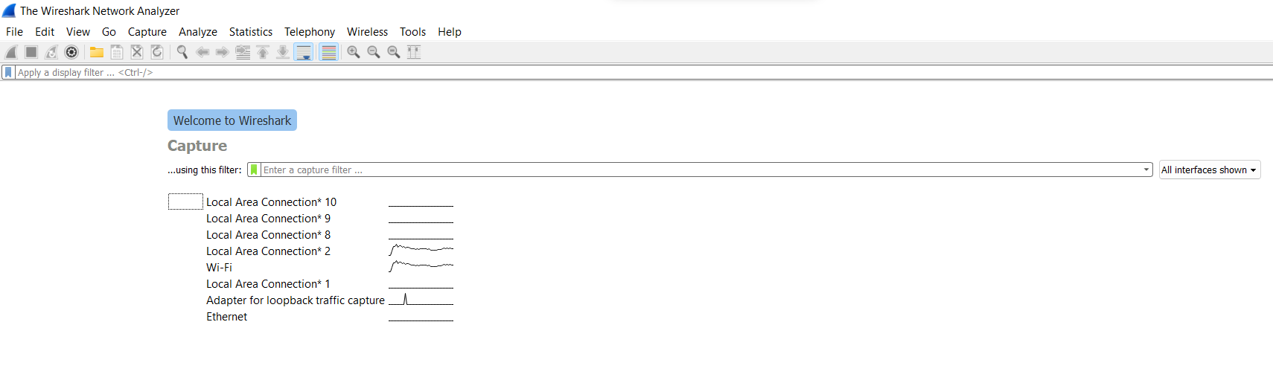

Step 3: Then Click on Wi-Fi Option(If device is connected by Ethernet then Click on Ethernet Option).

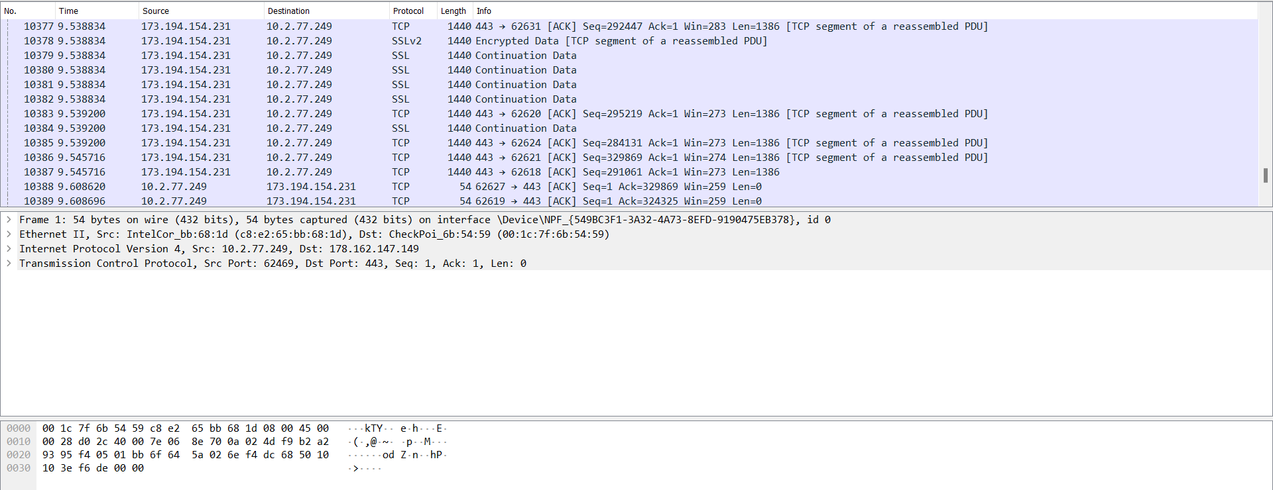

Step 4: choose Resolution Protocol option.

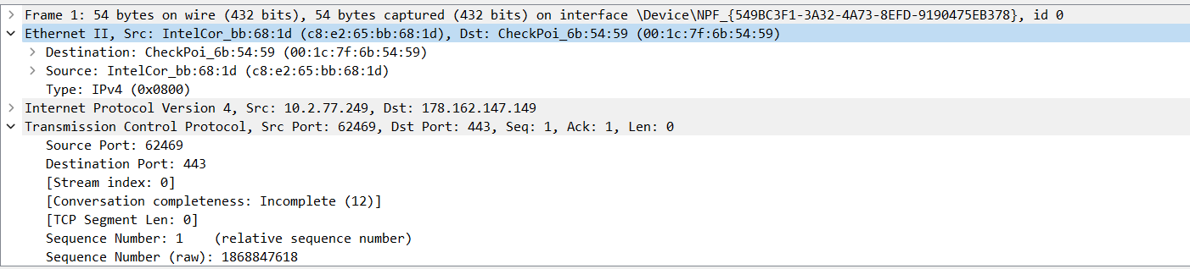

So, we find the mac address which is d8:e2:65:bb:68:1f.

conclusion: By this Practical We find Mac Address by Using Wireshark.