Name: Devasy Patel

Roll No.: 20BCE057

Course Code: 2CS502

Name: Computer Networks

Practical No.: 3

_____________________________________________________________________________________

**USING HUB**

STEP 1- Take a hub and connect 4 devices to it.

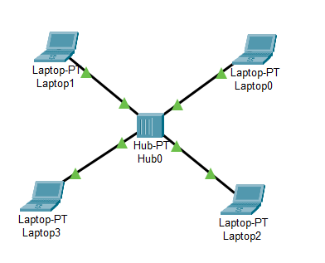

STEP 2-Now put in the configuration for each device.

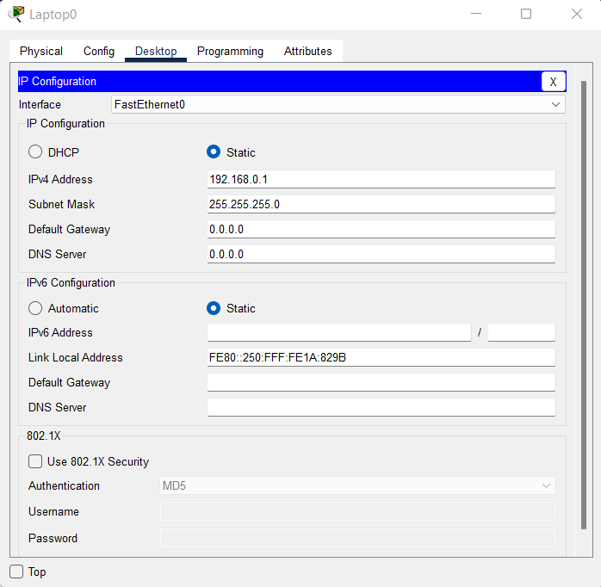

do this individually on all 4 devices.

STEP 3-Now check whether the connections made are successful.

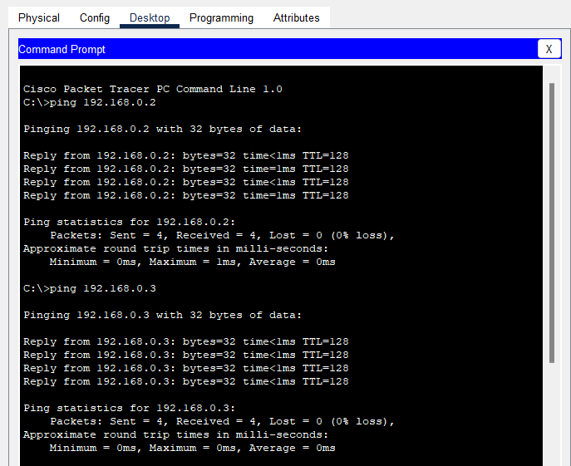

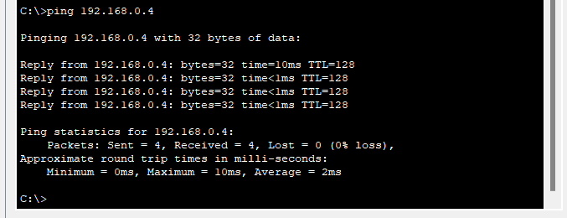

Conclusion: Connections were successful.

**USING SWITCH**

STEP 1- Take a switch and connect 4 devices with it.

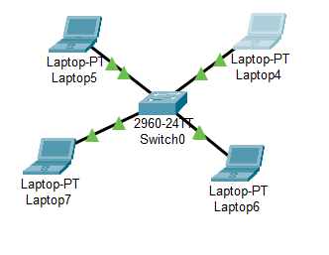

Step 2-Now put in the configuration for each device.

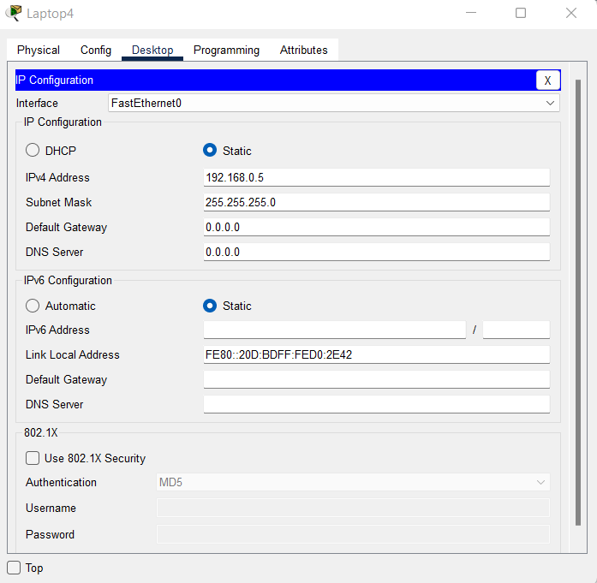

Do the same with 4 devices.

Step-3 - Check all the connections

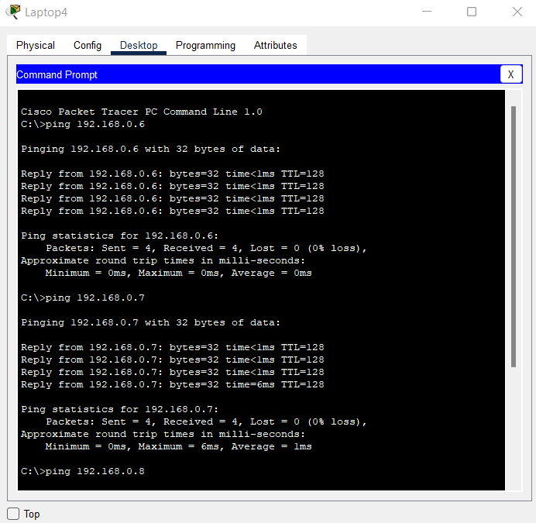

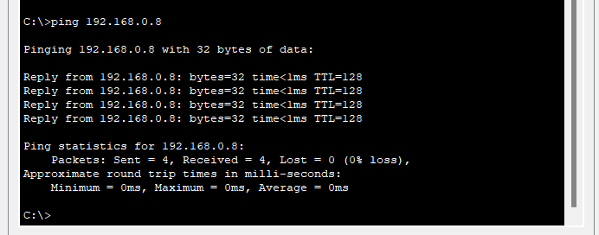

Conclusion -the connection were made.

**USING BOTH Hub AND Switch**

Step 1- Connect Switch and hub.

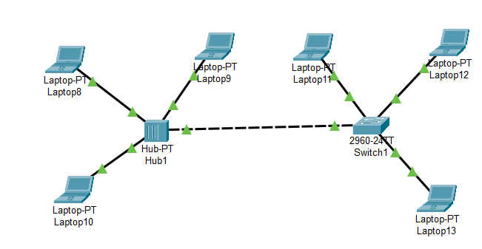

Step 2- Now put in the configuration for all the devices.

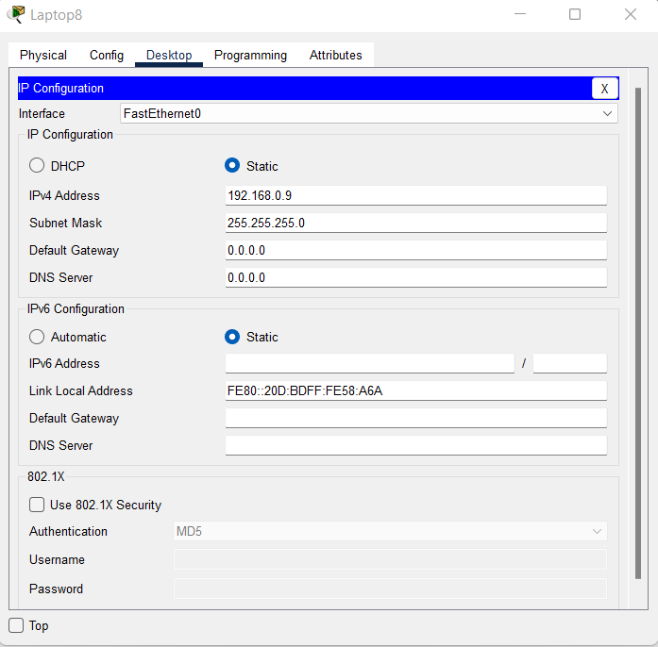

Step 3-Try to send a signal from devices connected to hub to a device connected to switch.

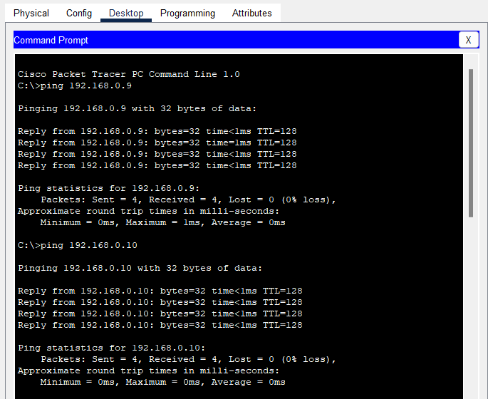

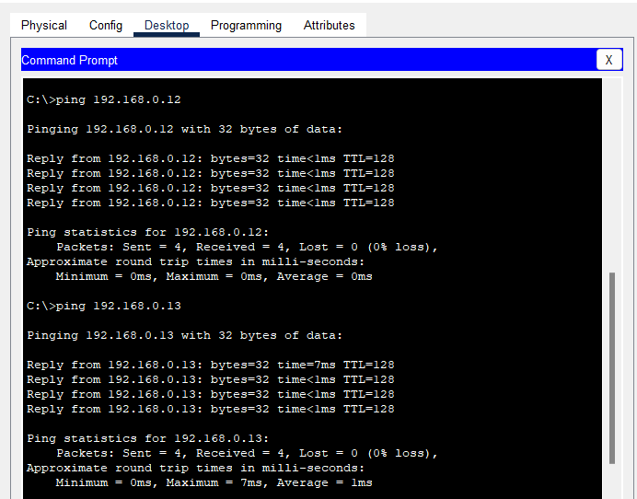

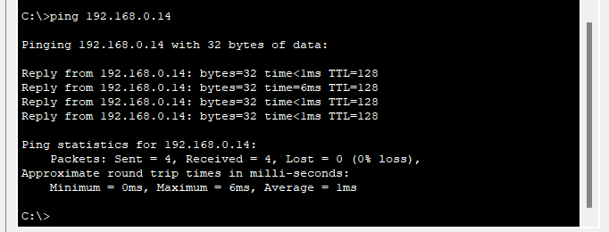

Conclusion: The connections have been established.