Practical 6

Name: Devasy Patel

Roll No.: 20BCE057

Aim Implementation of wireless

LAN using Cisco Packet Tracer

Step1: Established Given structure using components.

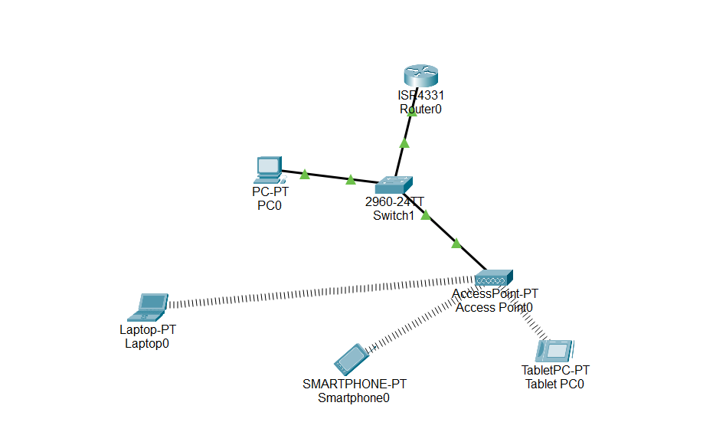

Step 2: Connect the Laptop device with the access point.

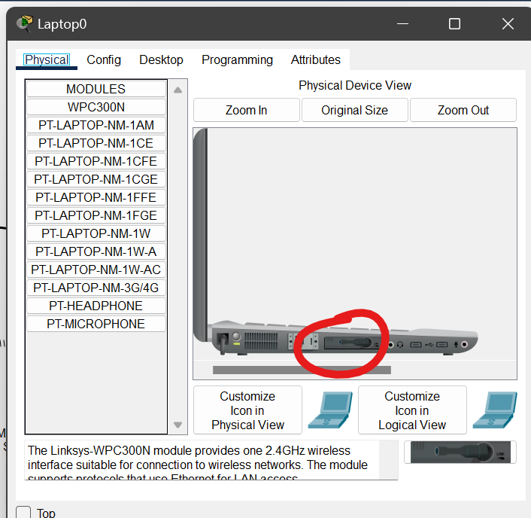

Step 3: Set IP configuration to all device. The router will act as the default gateway for all the devices in network.

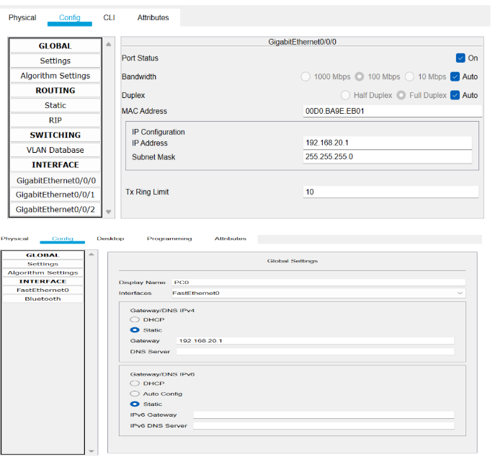

Step 4: By clicking on the PC wireless option connect to the access point/Network

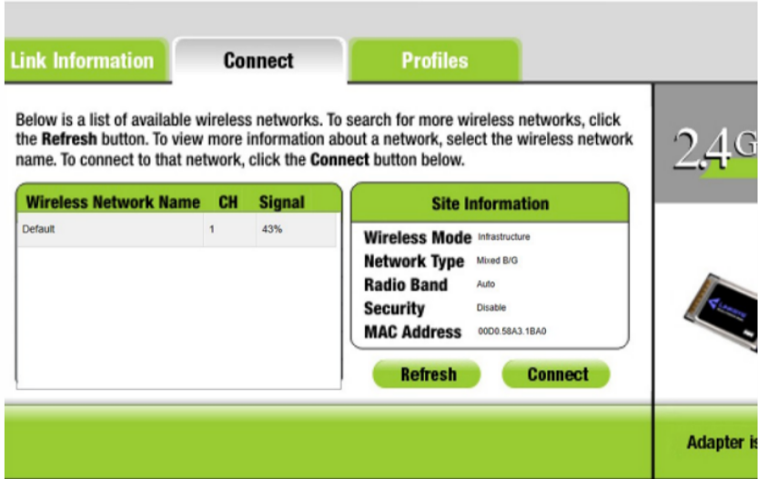

Simulation:

