PRACTICAL 5

NAME: Devasy Patel

ROLL NO.: 20BCE057

**AIM**

**Virtual LAN: Simulate Virtual LAN configuration using CISCO Packet Tracer**

**Simulation.**

**STEP 1: Create 3 departments using 9 computers.**

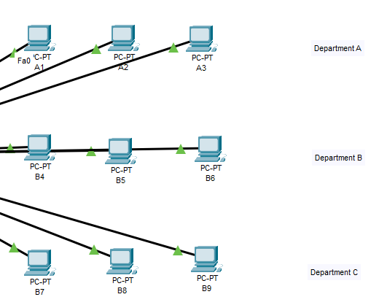

**STEP 2: Give config. to each computer.**

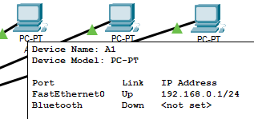

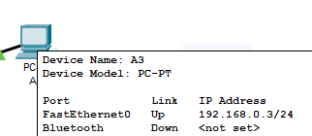

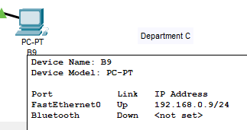

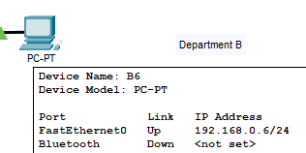

**STEP 3: Create 3 VLAN using switch's Config.**

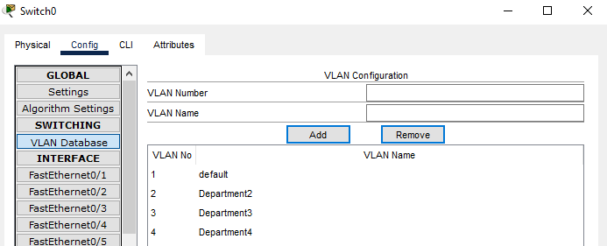

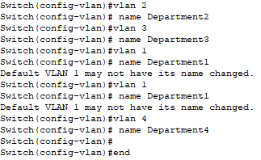

**STEP 4: Give 3 departments its own VLAN configuration with the help of Fast Ethernet INTERFACE.**

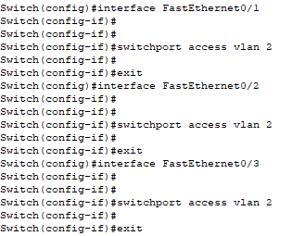

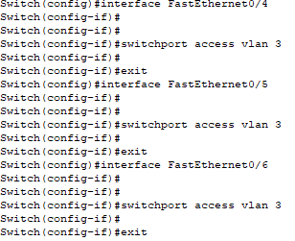

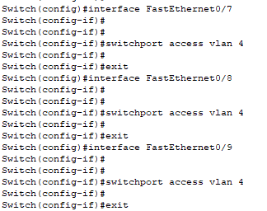

**STEP 5: Try giving signal to same Department. (Ping 1 from 3)**

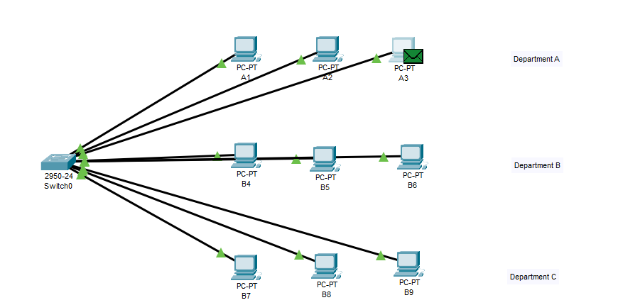

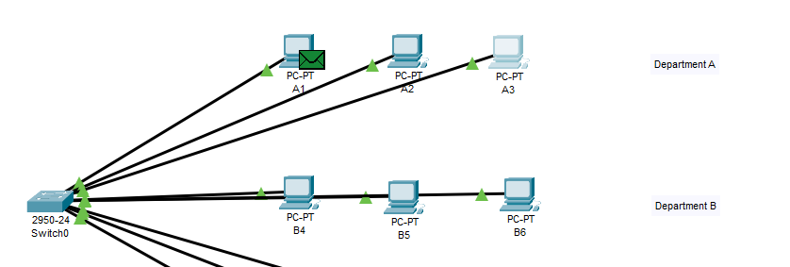

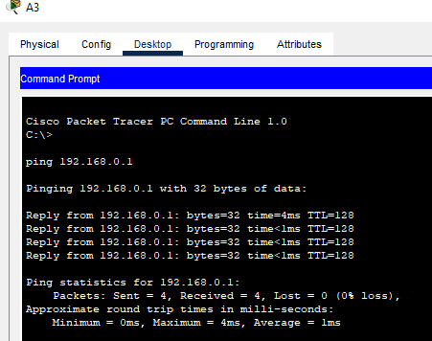

**STEP 6: Try giving signal to different Department. (Ping 7 from 3)**

