Natural Language Processing

Roll No. and Name: 20BCE057 Devasy Patel

Practical 1:

Task 1: Explore Libraries of NLP (NLTK, spaCy, Gensim) and

compare them

Task 2: Explore Regular Expressions and validate Email using RegEx

Task 3: List Features and Limitations of ELIZA and have a conversation with ELIZA

Task 1: Explore Libraries of NLP (NLTK, spaCy, Gensim) and compare them

|  |  |  |  |
| --- | --- | --- | --- |
| Feature | NLTK | spaCy | Gensim |
| USP | Most well known, and full NLP library | Fastest and most optimized NLP library | Known for topic and vector space modeling for document similarity analysis |
| Used for | NLP Research and Education | Production level NLP Applications | Large Scale NLP Applications |
| Scalability | Can be used for small to medium-scale applications | Can be used for large-scale applications | Good for large-scale applications |
| Fullness | Full NLP library, provides tools for almost all NLP tasks with plenty of approaches to each task | Almost a Full NLP, it has highly optimized tools for every NLP task | Not a Full NLP library, and does not have enough tools to do all NLP tasks, it is accompanied by some other library like previous 2. |
| Performance | Slow as compared to SpaCy and Gensim | Fast and efficient, as it contains the most efficient and optimized tools. | Fast and Scalable |

|  |  |  |  |
| --- | --- | --- | --- |
| Processing | NLTK returns lists of string as output | spaCy is object oriented, it returns objects as output | Gensim used word vector model |
| Word Vectors | No integrated Word Vectors | Provides word vectors | Provides word vectors |
| Tokenization | Yes | Yes | Yes |
| Sentence Segmentation | Yes | Yes | Yes |
| Part-of-Speech Tagging | Yes | Yes | No |
| Named Entity Recognition | Yes | Yes | No |
| Dependency Parsing | Yes | Yes | No |
| Semantic Reasoning | Yes | No | No |

Task 2: Explore Regular Expressions and validate Email using RegEx

Nirma University Student email RegEx:

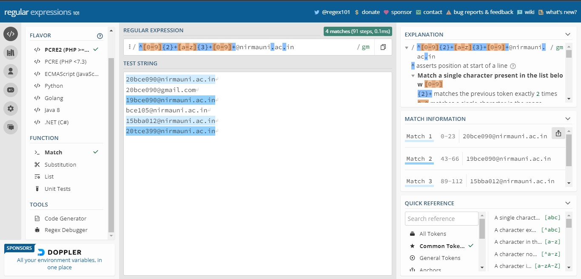

Explanation of the Regex:

* The string should start with any 2 digits, that would represent the year of admission of the student who holds that roll number.
* This would be followed by the 3 characters, which would represent 1. the institute, 2. The branch, for eg: bce represent b-> ITNU, ce->computer engineering
* This would be followed by any number of numbers which would represent the branch roll number of the student.
* The end will we @nirmauni.ac.in

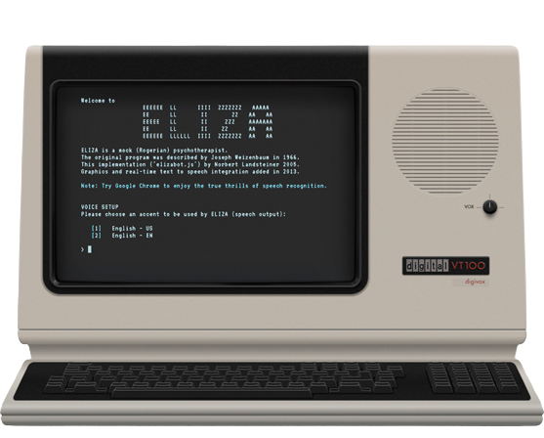Task 3: List Features and Limitations of ELIZA and have a conversation with ELIZA

ELIZA is a fairly basic chatbot (basically a NLP program) for Rogerian psychotherapy.

ELIZA was created from 1964 to 1966 at MIT AI Lab by Joseph Weizenbaum.

ELIZA was a pioneering effort in the field of conversational AI and had a significant impact on subsequent developments in the field. It inspired the development of other chatbots and natural language processing tools that continue to be used today.

My conversion with ELIZA:

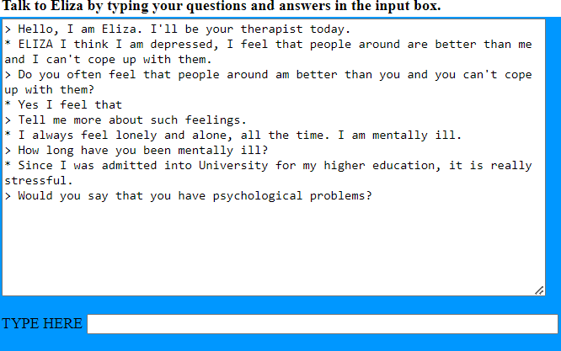

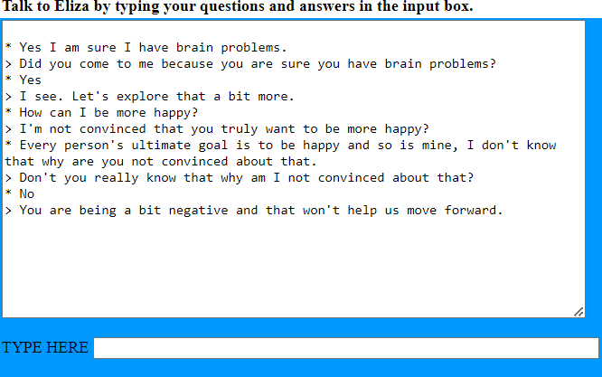

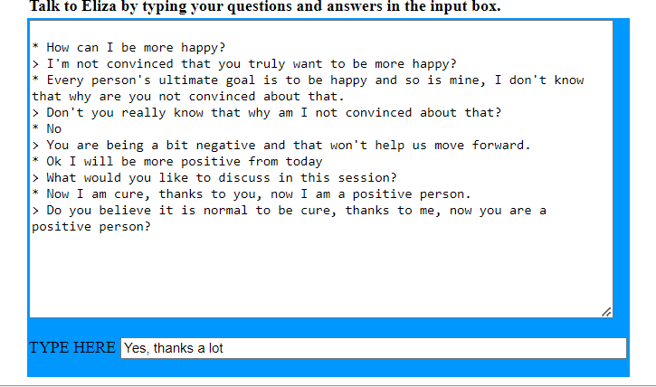

Features of ELIZA:

* Natural Language Processing: ELIZA was designed to simulate human-like conversation using natural language processing techniques. It used pattern matching and substitution to generate responses to user inputs.
* Simple Interface: ELIZA had a simple text-based interface that allowed users to type in responses to its questions.
* Rule-Based System: ELIZA's conversational flow was based on a set of rules that were predefined in the program. The rules were designed to mimic the conversational patterns of a Rogerian therapist, using open-ended questions and reflective statements to encourage users to talk about their feelings.

Limitations of ELIZA:

* Minimal Contextual Understanding: ELIZA did not have a deep understanding of the context of a conversation. It relied on superficial pattern matching to generate responses, which often led to non sequiturs or irrelevant responses.
* Limited Vocabulary: ELIZA had a limited vocabulary and was not capable of understanding complex sentences or nuances in meaning. It relied on simple keyword matching to generate responses.
* Limited Domain: ELIZA was designed to simulate a Rogerian therapist and was limited to conversational topics related to mental health and personal problems. It was not capable of discussing topics outside of this domain.