**Roll No: 20BCE057**

**Name: Devasy Patel**

**Course Code: 2CS702**

**Practical No: 6**

**Aim: Configure the number of mappers and reducers to execute practical 4 and 5. Evaluate the results and prepare a report on performance**

**Output:**

Mapreudcer function for prac-4

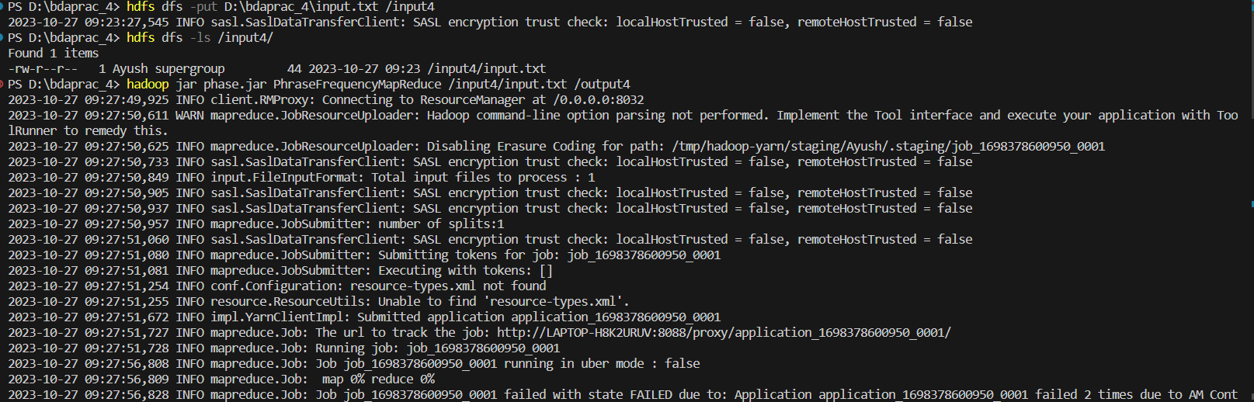

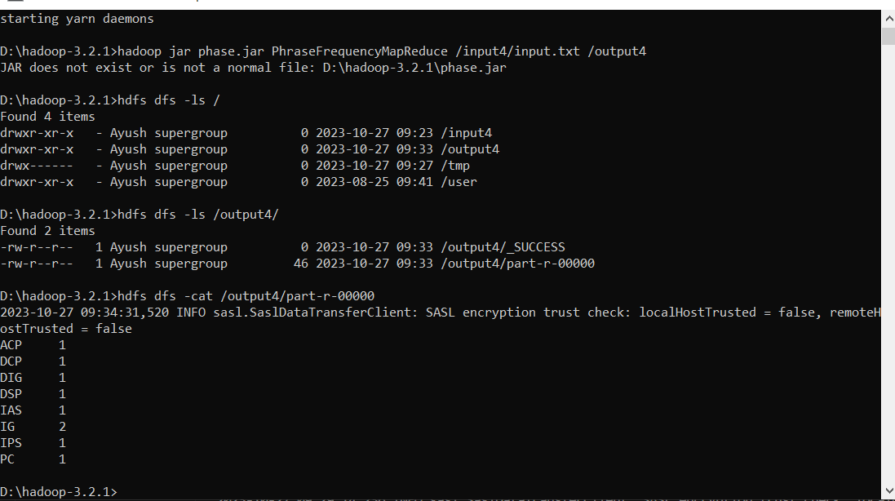

Mapreducer function for prac-5

