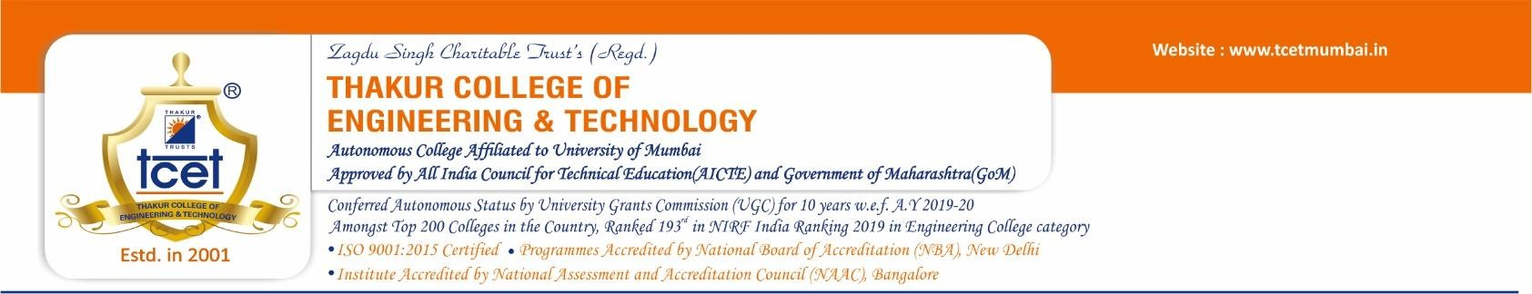

**CERTIFICATE**

|  |  |  |  |  |  |  |  |  |
| --- | --- | --- | --- | --- | --- | --- | --- | --- |
| This is to certify that Devavrat Singh Bisht (18-COMPA09-22), Nitisha Pradhan (18-COMPA59-22), the students of Second Year Computer Engineering at Thakur College of Engineering and Technology, have satisfactorily completed the requirements of the PROJECT under Employability Skills Development Programme-2020 while working on “Online Rental House Web Portal”.   |  |  |  |  | | --- | --- | --- | --- | | **Mr. Nitin Harane T&P Coordinator** | **Mr. Amol Dapkekar Training Coordinator** | **Dr. Zahir Aalam Professor (TPO)** | **Dr. B. K. Mishra Principal** | | **Internal Examiner:**  **Signature with Date: ……………..**  **Name: ……………………………..**  PLACE: Mumbai DATE: | | **External Examiner:**  **Signature with Date: …………..**  **Name: …………………………..** | | |