**ONLINE RENTAL HOUSE WEB PORTAL**

Devavrat Singh Bisht

SE COMP A 09

Thakur College of Engineering and Technology

Mumbai-400101 INDIA

Nitisha Pradhan

SE COMP A 59

Thakur College of Engineering and Technology

Mumbai-400101 INDIA

**EXECUTIVE SUMMARY**

The project Online Rental House Web Portal was made using the MVC (model-controller-view) architecture in Eclipse with Tomcat Server and MariaDB. The portal connects brokers/owners to the potential buyers. This web portal is the place where the owners can put up their house for rent and thus, reach a wider audience for business. The buyers can view all the houses available for rent or lease and accordingly select a suitable house. The buyers and brokers can then connect to seal the deal.

**PROBLEM STATEMENT**

Online Rental House Web Portal: Online Rental House Web Portal is an internet portal dedicated to meet the consumers’ needs in the Real Estate industry. A majority of unpleasant issues faced by landlords and tenants seem to grow due to lack of communication. Many a time landlord can’t find a suitable tenant or tenants can’t find a suitable house and landlord. Fortunately, finding appropriate house or tenant doesn't take much effort and it all starts with one basic idea: communication. Online Rental House Web Portal provides the solution by offering the ability to share about vacant house for rent and tenants can look over these houses to find the one suitable to them and then contact the landlord. The goal of the portal is to create a better approachable environment between tenants and landlord. The portal is designed to support both tenants and landlords by giving them the ability to upload or find information about house on rent.

**DESCRIPTION**

Online Rental House Web Portal is an internet portal dedicated to meet the consumers’ needs in the Real Estate industry. It is a portal where Property Owners, Brokers, Tenants and Investors can exchange information and get in touch with other interested parties. It features commercial and residential properties for sale, rent and lease. The properties, rates, locations, property news and also major events and happenings are also featured on the portal.

The web portal provides a Login Page where the broker/owner can login to view/add houses on rent. The portal provides the functionality of letting the broker add a house for rent or sale. He has to enter all the details regarding the house like the address, deposit amount, rent, duration for which the house is being offered for renting and the total surface area of the house. The broker also has to enter his details like name, contact number and email through which potential buyers can communicate with him.

The portal also accommodates the needs of the buyers. A potential buyer can log on to the portal to view all the available houses on rent. As the portal displays all the details of the houses like rent, deposit and additional information; the potential buyer can decide the most suitable house according to his/her needs. He/she can then contact the broker or the owner for further negotiations and discussion.

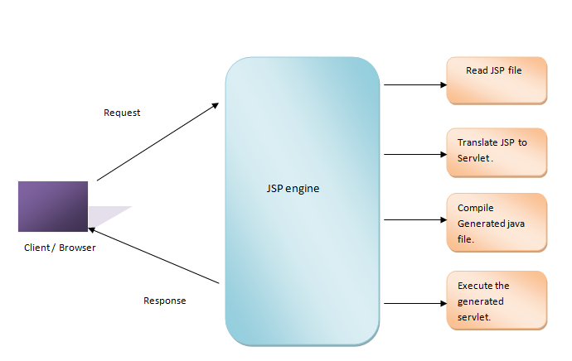

Fig 1. Working of JSP

**IMPLEMENTATION**

**Software Requirements:**

Program used: Eclipse Integrated Environment

Front-End: HTML, CSS

Script: Javascript

Server-side Script: Java Server Pages (JSP)

Programming Languages: Java

Server: Apache Tomcat Server

Database: MariaDB

Implementation is done using Eclipse integrated development environment along with Apache Tomcat Server and MariaDB as server and database respectively. Java Server Pages (JSP) files are used for building the User Interface (UI). The JSP files are basically the HTML and CSS code for the UI along with Java code for the backend. These JSPs are used to send various requests to the Servlets.

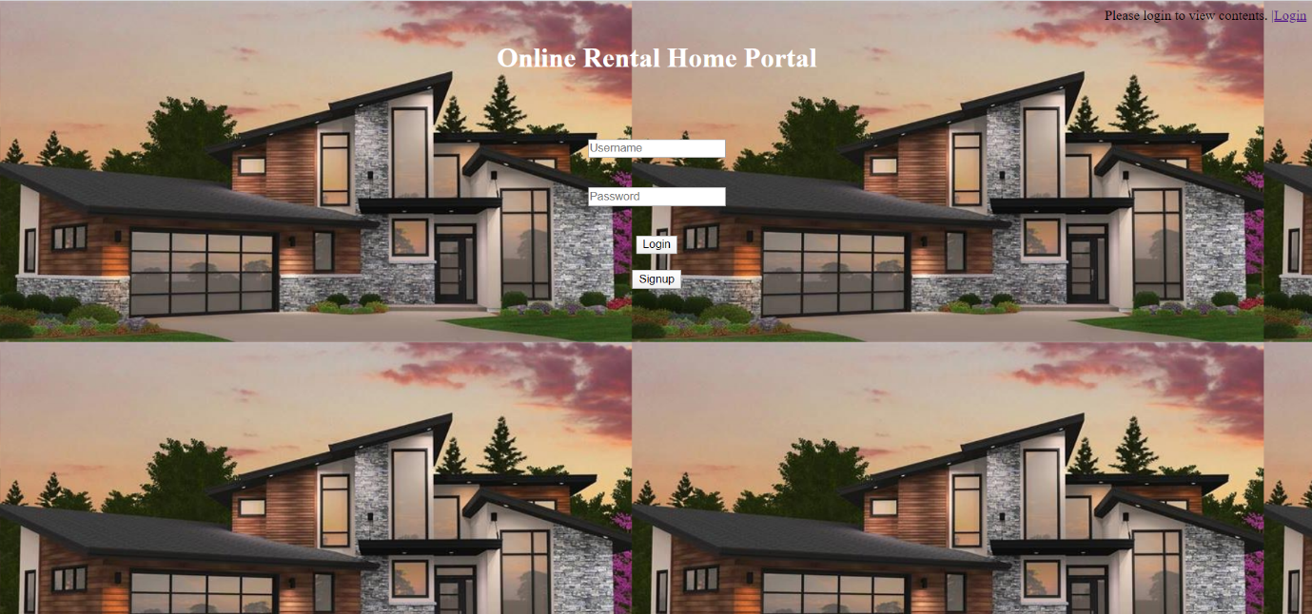

Login Window

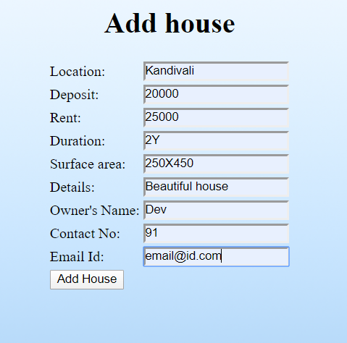

Window to Add House

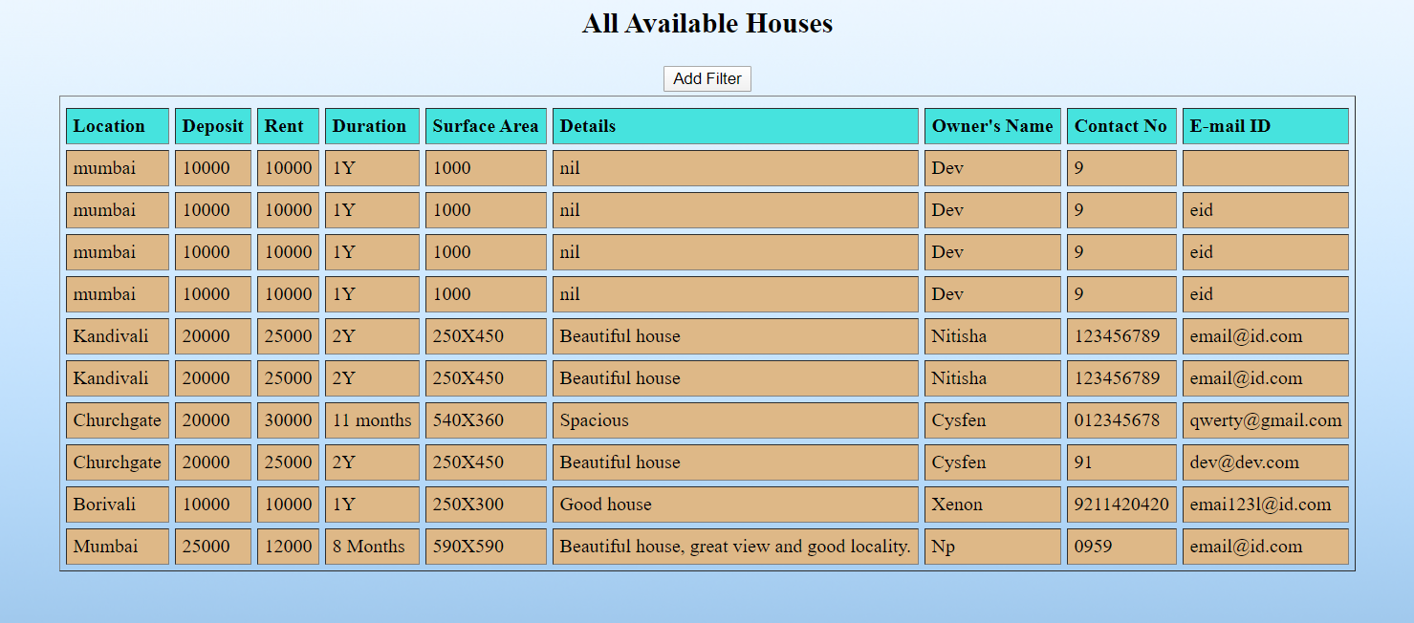

List of Available House

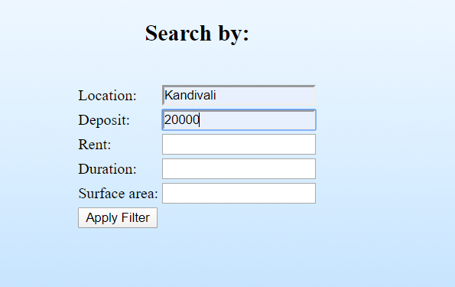

Applying Filters

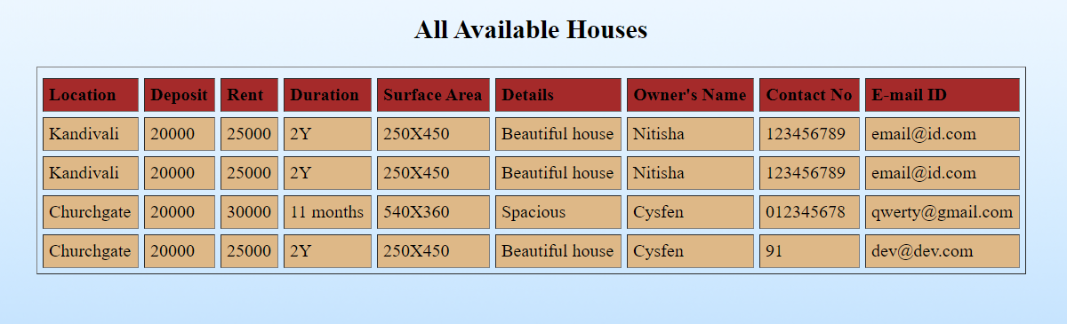

List of Houses after applying Filters

A Java servlet is a Java software component that extends the capabilities of a server. Servlets contain the necessary Java program to connect the web portal to the database. This can also be achieved by having these java programs in the JSP files itself.

Connection to the database is done by providing the location of the database along with the ID and password of the database. The connection also requires certain jar files to be present inside the lib file. These jar files contain SQL connectors and other related extensions that do the work at the backend.

When a user interacts with the web page the data is stored in variables inside the JSPs and then these JSPs send the data to Servlets and depending on the received data Servlets take appropriate actions.

**CONCLUSION**

The project Online Rental House Web Portal has been made using JSP Servlets, Tomcat Server and MariaDB in Eclipse. The web portal acts like an interface between the broker/owner and the potential buyers. The details of the owner and the house to be rented are stored in the database and displayed to the buyers who can then communicate with the owner for further discussion. This project helps users to find house of their choice and necessity, also it enables them to bypass the brokers and thus save money.

**REFERENCES**

* ESD Program, January 2020
* YouTube tutorial of Code Insight Academy
* [www.geeksforgeeks.com](http://www.geeksforgeeks.com)
* [www.99acres.com](http://www.99acres.com)
* [www.magicbricks.com](http://www.magicbricks.com)