Credit Card Fraud Detection using Machine Learning

1. Introduction
This project explores the application of Artificial Intelligence (AI) and Machine Learning (ML) techniques in cybersecurity,
specifically in detecting fraudulent credit card transactions. Fraud detection is a vital application of ML as it helps
financial institutions minimize losses and protect customers. The project uses Logistic Regression and Random Forest
classifiers to analyze transaction data and detect anomalies.

2. Project Methodology
The project follows these main steps:
1. Data Collection and Preprocessing
2. Exploratory Data Analysis (EDA)
3. Model Building and Training
4. Model Evaluation and Comparison

3. Libraries Used
• pandas – For data manipulation and analysis.
• numpy – For numerical computations and array handling.
• matplotlib – For visualizing data through plots and graphs.
• seaborn – For advanced data visualization with heatmaps and correlation plots.
• scikit-learn – For implementing machine learning algorithms and performance evaluation.
• imbalanced-learn – For handling imbalanced datasets using resampling techniques.

4. Key Functions Used
• read_csv() – Loads the dataset into a pandas DataFrame.
• train_test_split() – Divides the dataset into training and testing subsets.
• fit() – Trains the machine learning model using training data.
• predict() – Generates predictions on test data.
• confusion_matrix() – Evaluates model performance by comparing actual vs predicted values.
• classification_report() – Displays precision, recall, F1-score, and accuracy metrics.
• heatmap() – Visualizes correlations and confusion matrices.

5. Data Analysis and Visualization
The dataset is highly imbalanced, with a significantly larger number of normal transactions compared to fraudulent ones.
This imbalance is visualized through various plots, including transaction counts, amount distribution, and feature correlation heatmap.
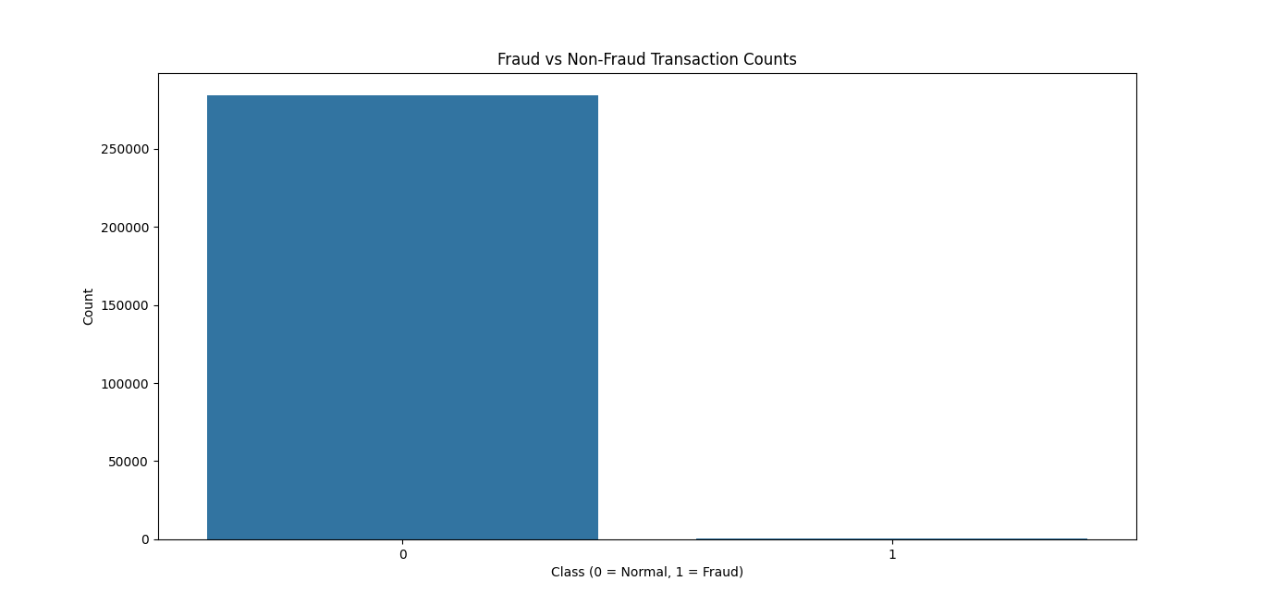
Figure 1: Fraud vs Non-Fraud Transaction Counts
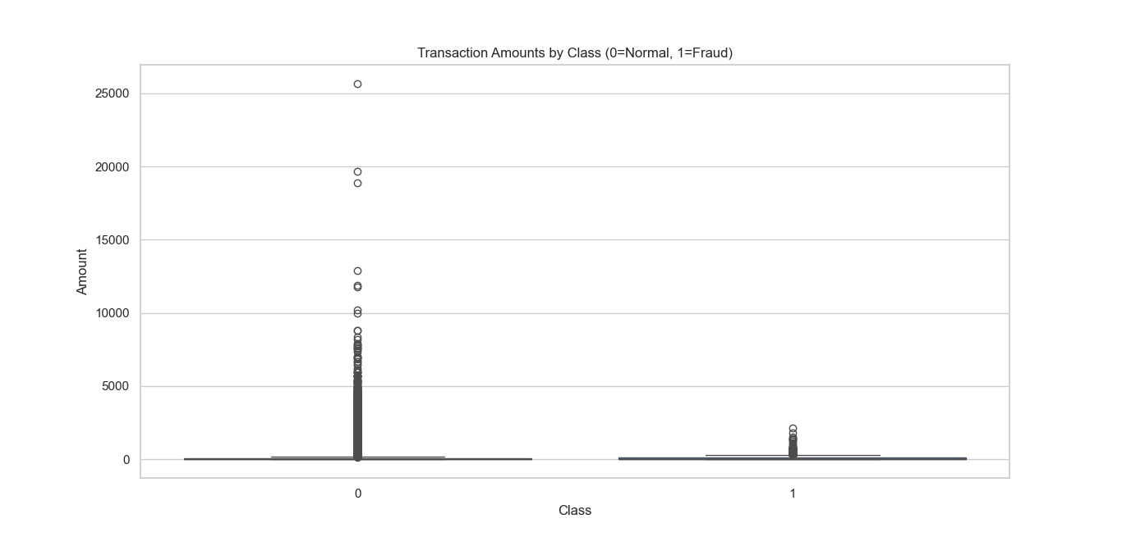
Figure 2: Transaction Amounts by Class
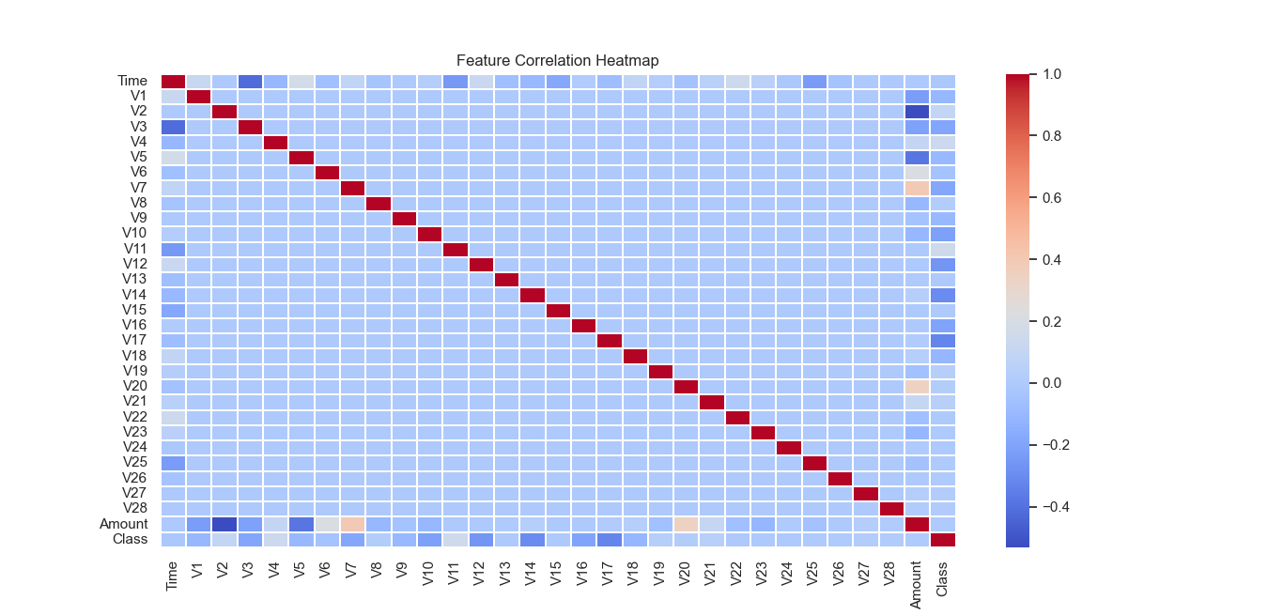
Figure 3: Feature Correlation Heatmap

6. Model Training and Evaluation
Two machine learning algorithms were used for classification — Logistic Regression and Random Forest.
Both models were trained using the training dataset and evaluated on the test set. Confusion matrices
were generated to visualize model performance.
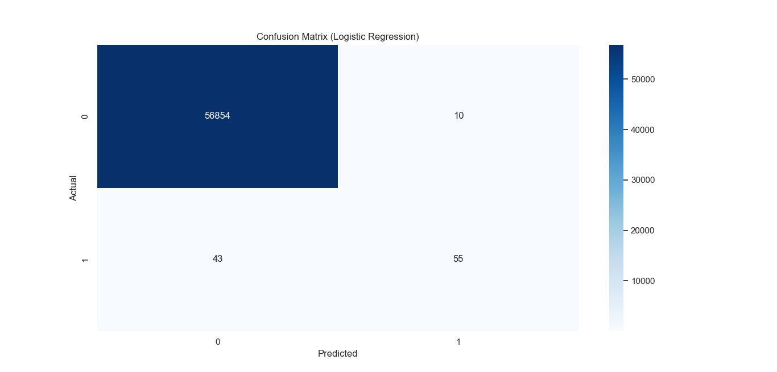
Figure 4: Confusion Matrix (Logistic Regression)
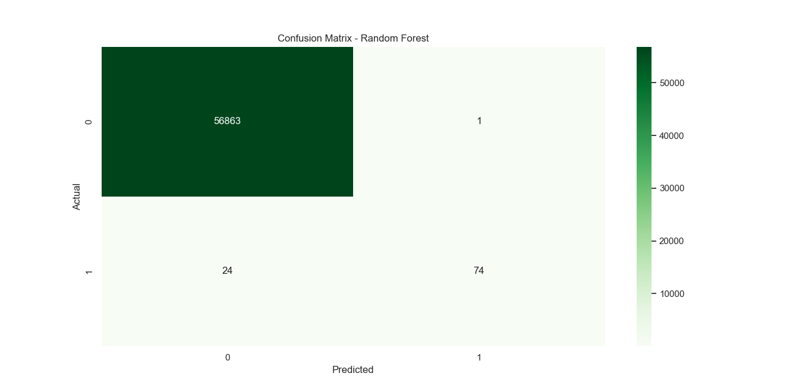
Figure 5: Confusion Matrix (Random Forest)

7. Model Comparison
Model | Accuracy | Precision | Recall | F1 Score | AUC
Logistic Regression | 0.9991 | 0.8462 | 0.5612 | 0.6748 | -
Random Forest | 0.9991 | 0.99 | 0.76 | 0.86 | -
From the table, it is evident that the Random Forest model performs better in terms of precision, recall,
and F1 score, making it more reliable for fraud detection, especially in identifying fraudulent transactions.

8. Conclusion
This project demonstrates how AI and machine learning techniques can effectively be used in cybersecurity applications
like fraud detection. Logistic Regression provides a simple baseline, while Random Forest, being an ensemble method,
offers better performance and robustness against class imbalance. Proper data preprocessing, visualization, and model
evaluation are crucial in achieving reliable and accurate fraud detection systems.

