1. Onboarding flow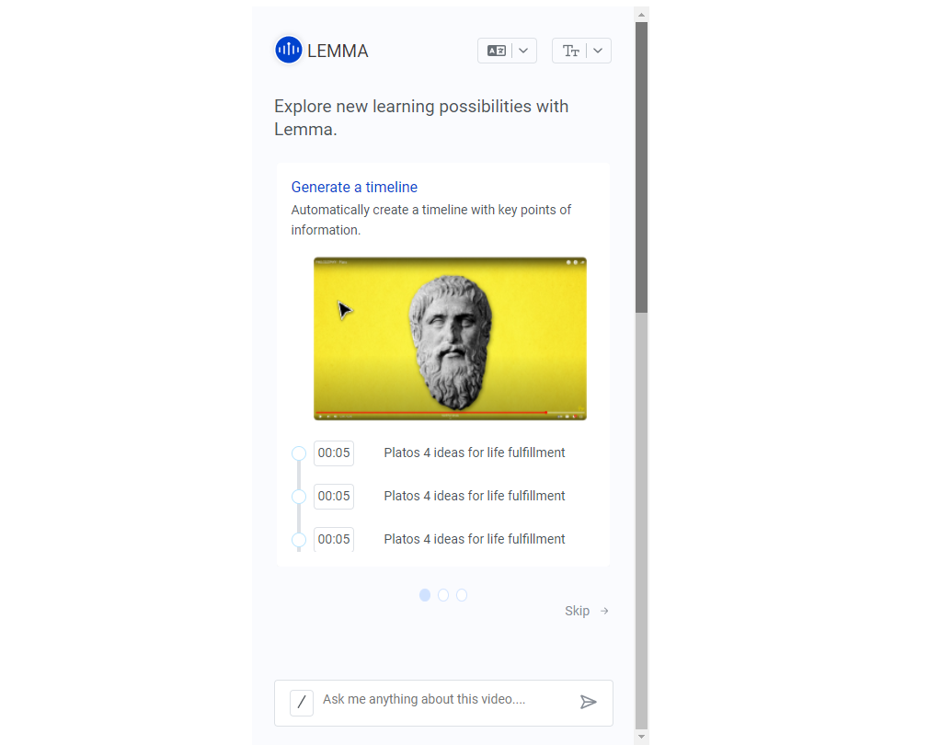

Completed

1. Google Auth Sign up flow

First page complete I’ll complete it

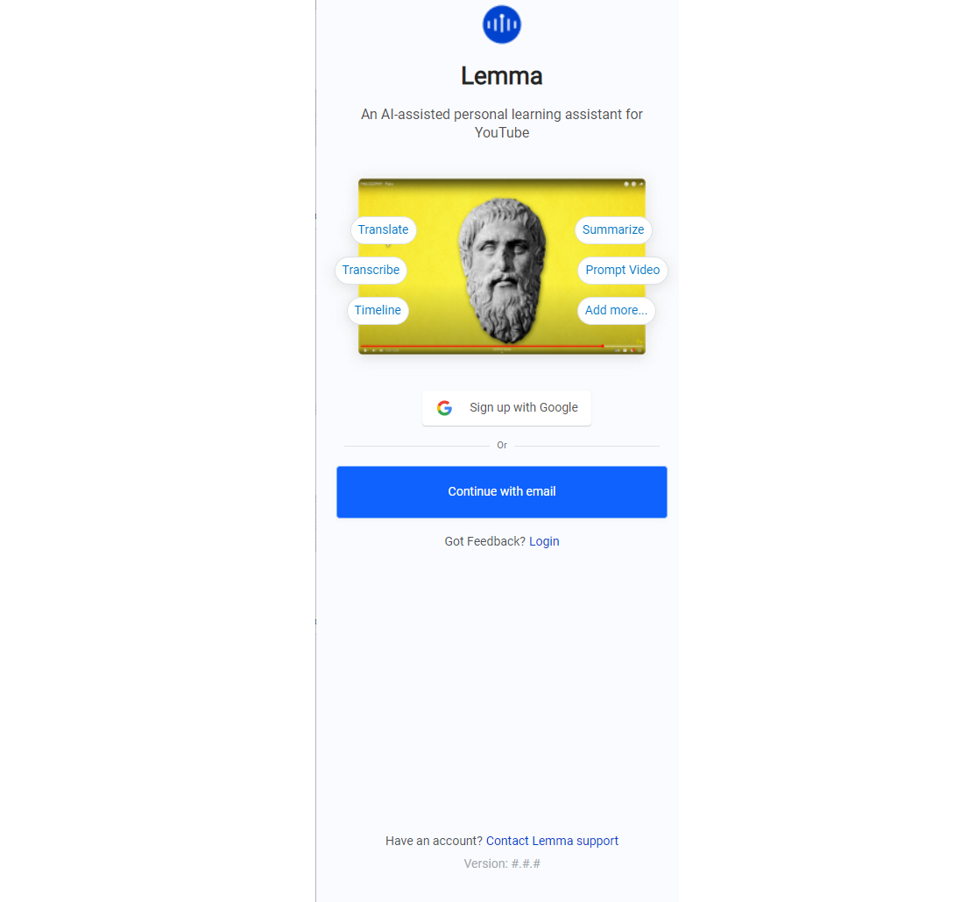

1. Manual Sign Up flow

I’ll do that

1. Change Avatar flow

Complete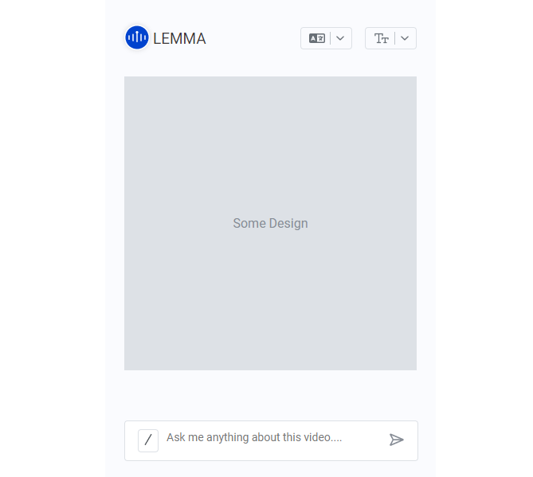

1. Input Prompt

Frontend complete, Answer will be from backend that use chatGPT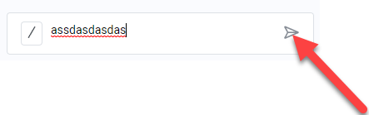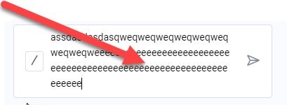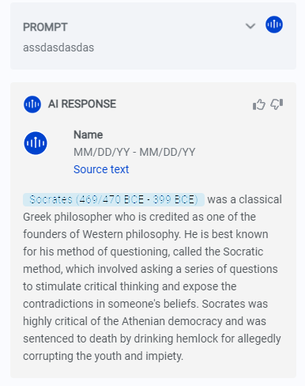

1. Action Drawer/Timeline/Summarise/Transribe/Collapse All

Complete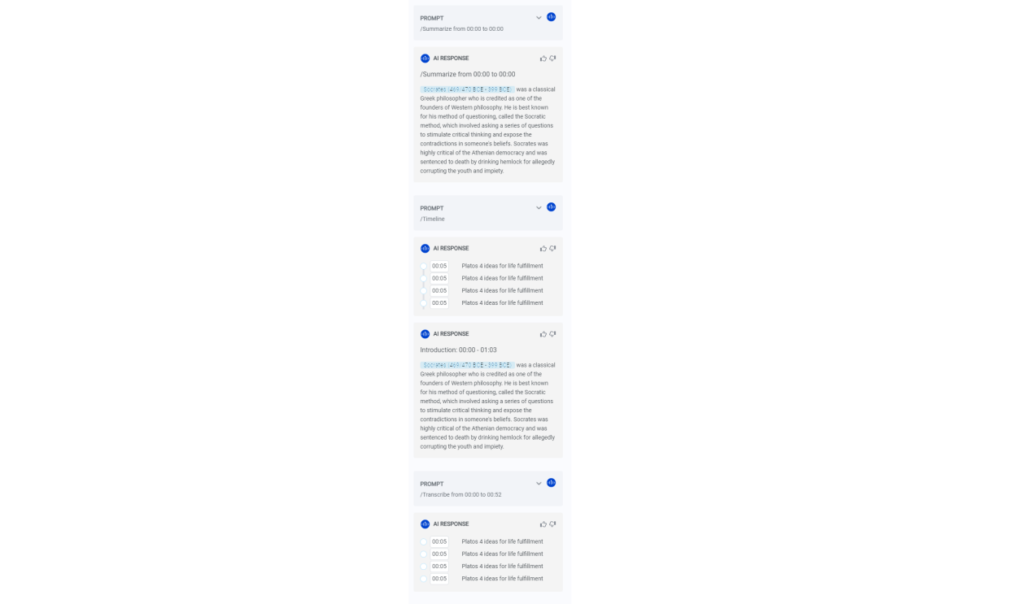

1. Login+Gauth

This is backend using database

1. Password Recovery

Database

1. React components check-in

I don’t know exactly about it

1. Accessibility

After build all frontend