|  |
| --- |
| GROUP 1  Game Design Document |
| **February 04, 2023** |

# **Title Page**

1. Game Name

Chromashot

1. Team

Cole Sarno

Sairam Soundararajan

Colby Snodgrass

Joseph Thill

David Toyloy

1. Date of Last Update

03/07/2023

# **Game Overview**

1. Game Concept

Arcade style game, with a sci-fi theme. The player will be able to move the ship horizontally to avoid projectiles/enemy ships while trying to fire their own projectiles to destroy the enemy ships. Players will also be able to pick up various power-ups to give them additional features such as a shield for absorbing damage.

1. Target Audience

Anyone able to use a computer.

1. Genre(s)

Fixed Arcade Shooter

Sci-fi

1. Game Flow Summary – How does the player move through the game? Include both the interface and the game itself.

The player will play through progressively more difficult waves of enemies. Multiple enemy types will be implemented with slightly different behavior.

1. Look and Feel – What is the basic look and feel of the game? What is the visual style?

The game will have a retro/arcade look. We are going with a pixel art style to give the game that retro look. The game should feel challenging but not so challenging that it discourages the player from playing.

# **Gameplay**

1. Objectives – What are the objectives of the game?

The objective of the game is to survive as long as possible as waves of enemies spawn at the top of the screen. The secondary objective is to try and shoot down as many alien ships as possible while trying to avoid obstacles.

1. Game Progression

The game will progress through waves of enemies. Elite enemies will spawn at intervals of waves.

1. Play Flow – How does the game flow for the game player?

The game continuously flows from one wave to another with a short break in-between. Art and music will be created to emphasize this flow. At the end the player will be given the choice to try again for a higher score or quit.

# **Mechanics**

1. Rules – What are the rules, both implicit and explicit?

Players can move horizontally and shoot projectiles. Players will start with three lives and each time they are hit with a projectile or enemy ship, they lose one life. When the player runs out of lives then the game ends.

1. Physics

Gravity will not have an effect for this project however a rigid body system will be utilized to detect collisions. Projectile will be faster than ships.

1. Player Movement

Player can move horizontally using WASD keys or the arrow keys on the keyboard. Movement should feel responsive with little to no input lag.

1. Power Ups

* Shield
* Dual Rockets

# **Game World**

1. General look and feel of world

Sci-fi theme will be utilized when designing the game art, music, and mechanics.

# **Characters**

1. **Player Ship**
2. **Enemy Ships**
   1. Standard Enemy Ships
   2. Elite Enemy Ships
   3. The Voyager (Boss)

# **Interface**

1. HUD (Heads Up Display)

* Number of lives
* Score

1. Menus

* Title Menu
* Pause Menu

1. Camera Model

The camera for the game will be static with the objects in view moving in and out of view. Backgrounds will scroll vertically to simulate movement.

1. Supported Input

* Mouse and Keyboard
* Gamepad (Xbox/Play Station Controller)

1. Controls

**Mouse & Keyboard**

Move Right

Move Left Move Right

Fire Laser

# **Audio**

1. Music

The music is produced by Sairam using a software called Mixcraft 9. The main menu will have a steady techno track in A minor. The first in-game music is a Drum & Bass track in E minor and is faster than the main menu music. As the level gets harder, the music will change to a much faster and intense track.

1. Sound Effects

Sound effects will either be created or obtained through open licensed assets.

# **Game Art**

1. Game View Ratio

3:4 aspect ratio.

1. Intended Sprite Size

Sprites will be 16 x 16 in size.

1. Color Scheme

Bright, strong pixelated color to contrast the darkness of space.

# **Budget**

This project will focus on the delivery of the final product. No monetization is being done on our game and no spending will be required thus we are expecting a budget of zero.

# **Timeline**

Start: 01/17/2023 End: 03/07/2023

|  |  |  |  |  |  |  |  |  |  |  |  |
| --- | --- | --- | --- | --- | --- | --- | --- | --- | --- | --- | --- |
| Week | Notes | Mon | Notes | Tue | Notes | Wed | Notes | Thu | Notes | Fri | Sat/Sun |
| Week  1 | Form Groups | 16 | Begin Work on Project Plan | 17 |  | 18 | Discussed Audio/Music needed for project | 19 |  | 20 | 21/22  Weekly Meeting  Setup GitHub Repo |
| Week  2 |  | 23 | Project Plan Deadline | 24 |  | 25 |  | 26 |  | 27 | 28/29  Weekly Meeting |
| Week  3 |  | 30 | -User Guide and Test Plan Deadline  -Peer Review 1 | 31 |  | 1 |  | 2 |  | 3 | 4/5  Weekly Meeting |
| Week  4 |  | 6 | -Designing Website and Game | 7 |  | 8 |  | 9 |  | 10 | 11/12  Weekly Meeting |
| Week  5 |  | 13 | Phase I  -Peer Review 2 | 14 |  | 15 |  | 16 | -Phase I Prototype Testing | 17 | 18/19  Weekly Meeting |
| Week  6 | -Game Prototype-Website Prototype | 20 | Phase II  -Peer Review 3 | 21 |  | 22 |  | 23 | -Phase II Testing | 24 | 25/26  Weekly Meeting |

|  |  |  |  |  |  |  |  |  |  |  |  |
| --- | --- | --- | --- | --- | --- | --- | --- | --- | --- | --- | --- |
| Week  7 | -Add Assets to the Game and Website | 27 | Phase III | 28 |  | MAR 1 |  | 2 | -Phase III testing | 3 | 4/5  Weekly Meeting |
| Week  8 | -Fine Tune Game  -Finalize Website | 6 | Final Report Deadline | 7 |

# **Website Outline**

1. **Home Page**
   * Game Title
   * Short description of game.
   * Link to download the game
2. **Game Updates Page**
   * Developers can post updates about game development.
   * Post Requirements:
     + Name
     + Date
     + Description
3. **Report Bug Page**
   * Players can report bugs with the game.
   * Post Requirements:
     + Date
     + Description of bug.
4. **About Page**
   * List all team member roles and expertise.

Toolbar will be added to page templates for navigating the website.

**Homepage Design**

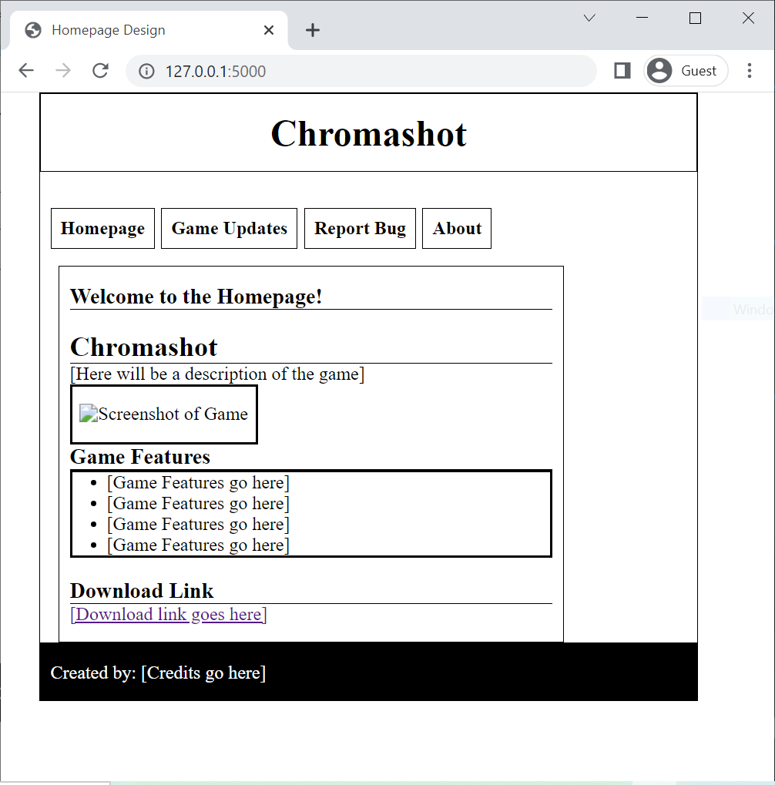

# **Game UML**

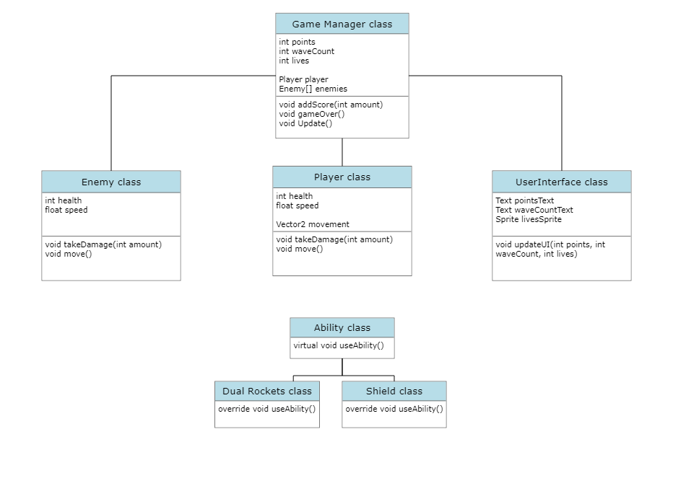

**Meeting Notes (02/05/2023):**

* We discussed how we wanted the game and website to look as well as how we want the game to play.
* Focused on discussing the flow of the game and the rules.
* Sairam will be making another track for more difficult waves.
* Joe set a sprite size of 16 x 16 for the art.
* Colby discussed mechanics of player movement and projectiles
* We all discussed possible power-ups to enhance the player experience.
* We also discussed size ratio of screen.
* Created a website outline and descriptions of what is on each page.
* Sairam will reach out to Cole about splitting up the web design based on outline.