**#100daysofcode**

**DAY 11 /100**

Continuing with the project……

Today I have added search functionality. It is a simple search functionality for now. I will add the search filter and other functions later. I have also tried to add little styling but I have focused mostly on the data fetching part. I am also thinking about adding a feature of sorting the movies by ratings and ascending / descending alphabetical order and all other sorting features. I will also add the functionality of switching from light mode to dark mode.

Today’s Completed Tasks : -

* Adding a Searching functionality
* Styling a little bit

That’s it for today……!!!!!!

**Code :**

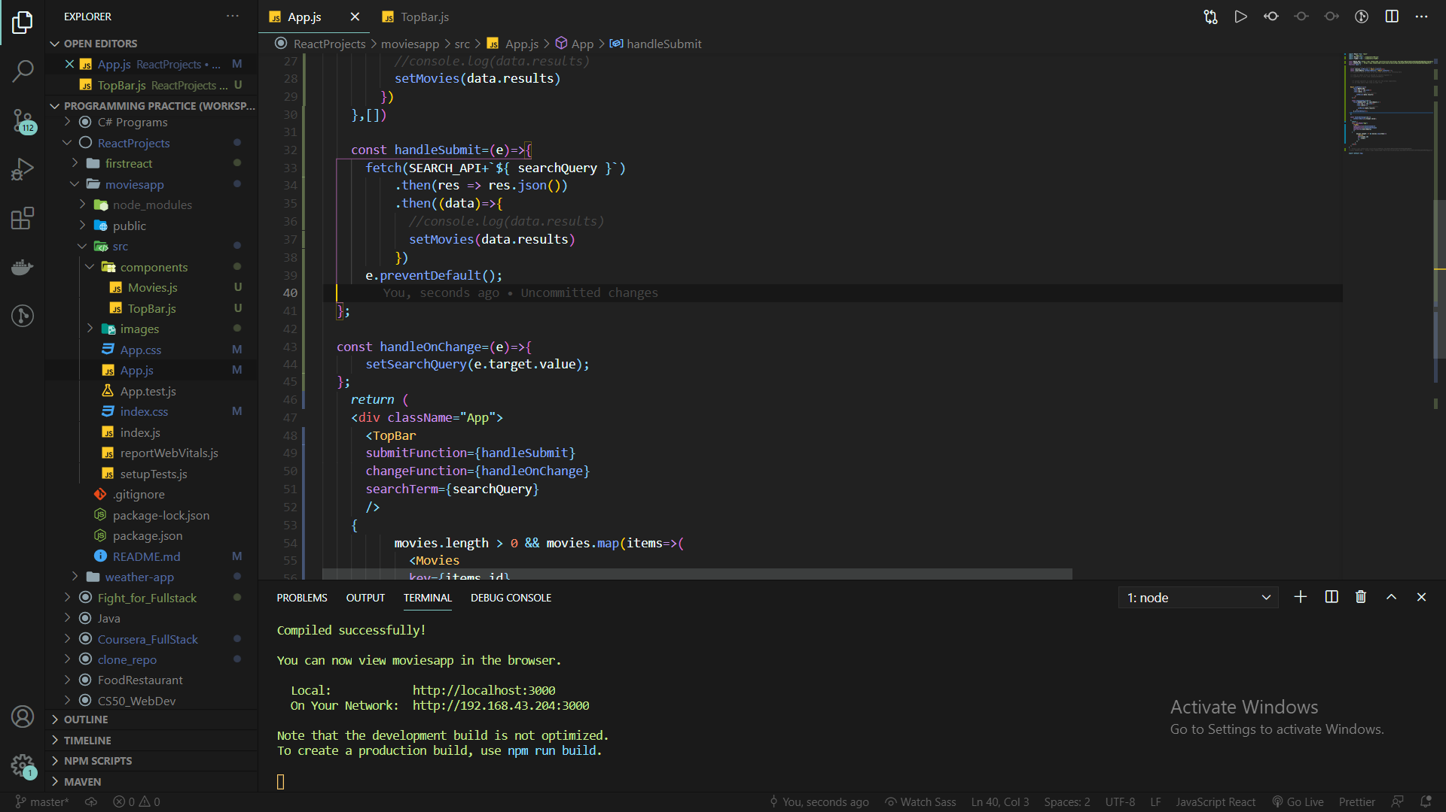

**Result : -**

