**#100daysofcode**

**DAY 12 /100**

I had some problem with my laptop so I was not able to do coding for few days…..

But Now I am back.

Today I added sorting feature to my project. Now user will be able to sort the movies in ascending and descending order. It has some bugs but still it is working (a little bit).

Also today I learned and tried Material-UI. It is a simple and customizable component library to build faster, beautiful, and more accessible React applications.

That’s it for today but I will try post daily from now on.

**Code :**

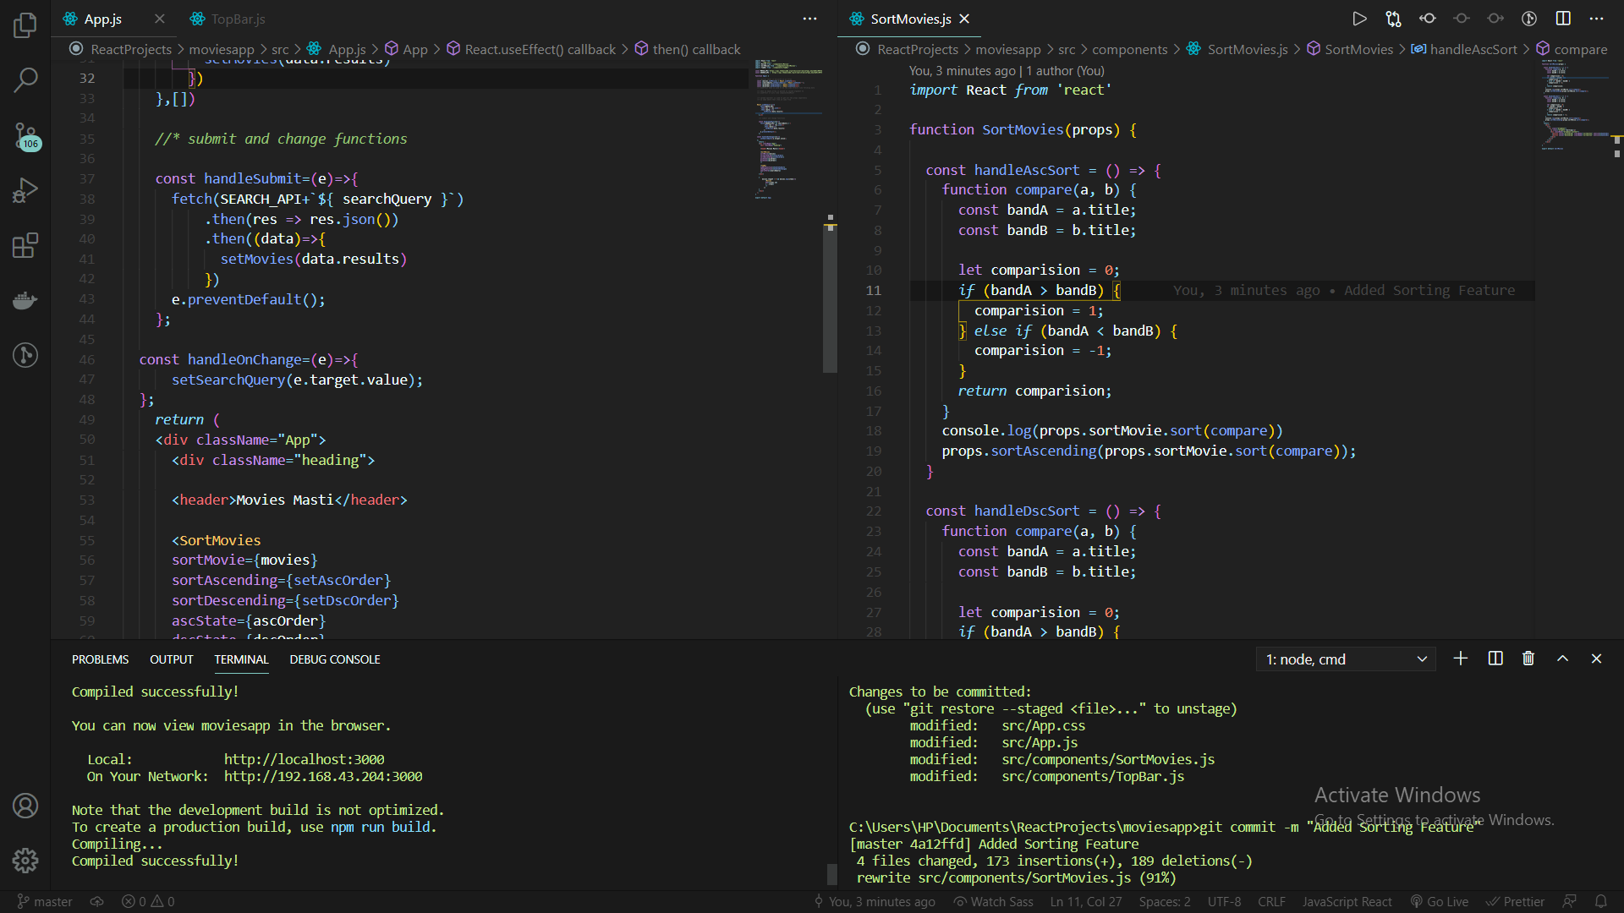

**Output :**

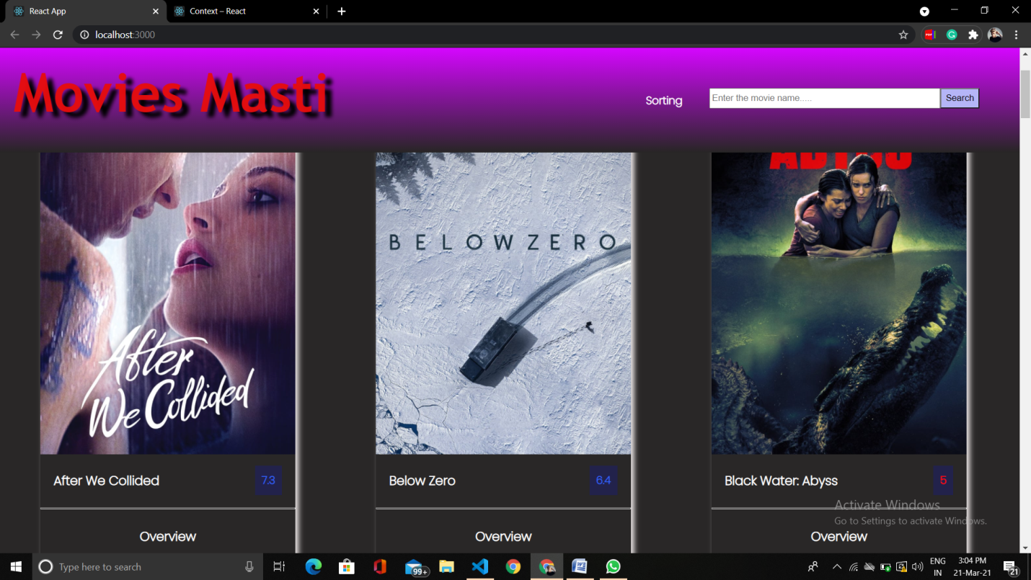

**Hackerrank :**

