Modules | FICO | Sub Modules | Customer Payment Processing
Reported by | Santosh Kr. Jha | Date | 21.11.2025
Processed by | Arkabrata Sarkar, Girendra Maikap , Nisha Jha | Change Request no | GM0004
SAP Change Request No. | DS4K902689 (12.11.2025) | Ticket no | N.A

Brief Description of the Business Requirement: Customer Payment Auto Uploader
Existing Scenario | New Scenario | Action Details
The customer payments against bill were processed manually through F-28 tcode. | All new part payments will be processed through the BDC program just by uploading an excel file in the program. | User manual for ZFI_INCPAY (F-28)  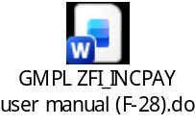

TEST STEPS BY CONSULTANT:
Step | Business Process Steps | T code | Master Data used | Unit Test Result | Tester | Remarks
1 | Invoice creation & and payment processing | FBL5N, FB70 &  F-28 | Customer Balance | Pass | Arkabrata Sarkar | Tested in 130
TEST DOC |  |  |  | 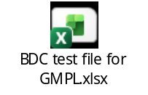
Approved By: Rakesh Kr Agrwal
Comments: Pass

TEST STEPS BY USER DEPT (GMPL)
Step | Business Process Steps | T code | User Acceptance Test Result | Tester (USER) | Remarks
1 | Processing of customer payment | ZFI_INCPAY | Pass | Santosh Kr Jha | Pass

ATTACHEMENTS (Test Document): | Test Approval email attached from GMPL SAP Team, date 03.11.2025  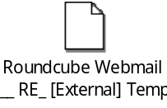
Approved By: GMPL Accounts Team (Santosh Kr Jha)
Comments: Pass (Email)

TECHNICAL (ABAP) CHANGES BY IT/ABAP:

ATTACHEMENTS (ABAP Test Document): | 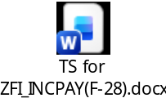

Final Approval for Transport to PROD:
Comments:

