ATANU JANA
HTML FRONT-END DEVELOPER

CONTACT

+091635 65682

placement@webskittersacademy.in
Shirsha, Kolla, Chandrakona, Paschim Medinipur, 721201
https://tinyurl.com/28p89pme

SKILLS

PROFILE

Aspiring Front-End Web Developer with a passion for creating visually appealing and user-friendly websites. Currently seeking a junior position to apply my skills in HTML, CSS, and JavaScript while learning from industry professionals. Eager to contribute fresh ideas and collaborate on innovative projects.

PERSONAL PROJECT/S

Project Name : Job Find- Job Portal Site Github Link : https://tinyurl.com/2y845lqe

- HTML5
- CSS3
- jQuery
- Jaascript
Project Description :
Dynamic Job Listings: JavaScript DOM manipulation was used to dynamically render job data.
Interactive Filters: To provide a customized user experience, search and filter features (role, location, and experience) were implemented.
Mobile-First Design: Made sure that media queries and responsive layouts (Flex box/Grid) worked across devices.
Implementation: Publicly accessible via GitHub Pages.


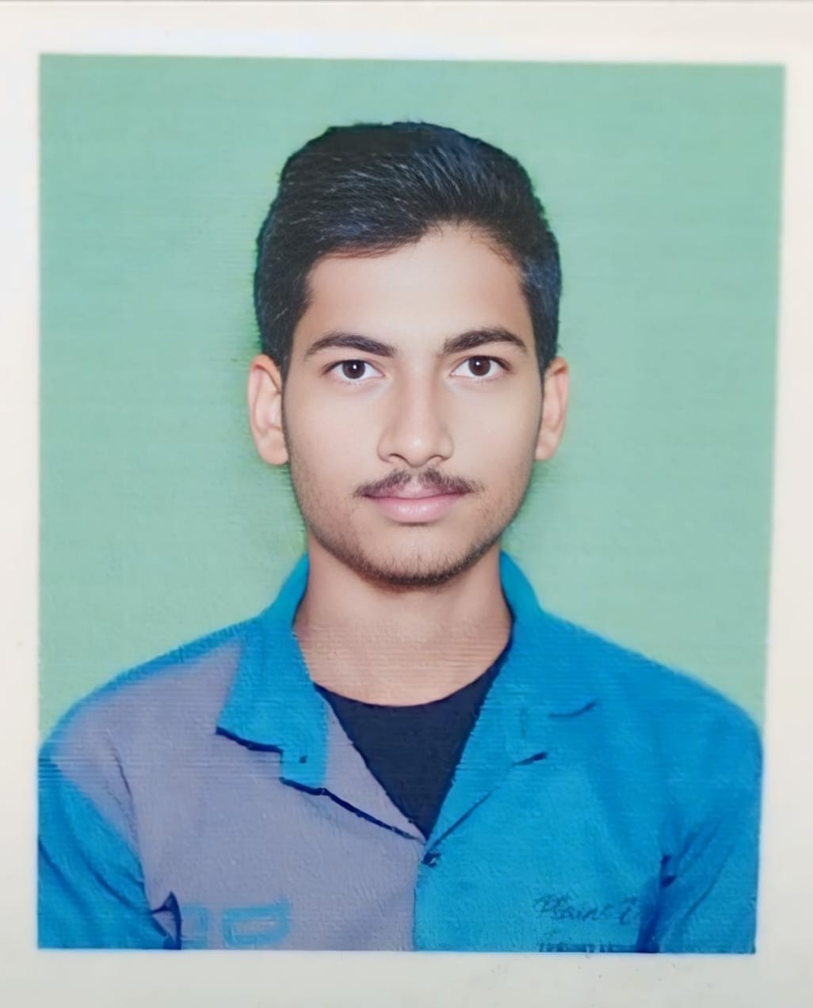




- Bootstrap
- Figma
- PSD
- GIT & GITHUB

CERTIFICATES

- HTML FRONTEND DEVELOPMENT

LANGUAGES

- English
- Hindi
- Bengali

INTEREST

- Watching Movie
- Playing Cricket
- Listening Music

PERSONAL INFO

DOB : 13/07/2003
Marital Status : Single
EDUCATIONAL QUALIFICATION

Bachelor of Arts
Pursuing

Higher Secondary Examination, WBHSE
2022

Secondary Examination, WBHSE
2020

