SYSTEM ARCHITECTURE DOCUMENT
Unity/C# AR Simulation • ASP.NET Core API • MongoDB • Blockchain
PROJECT BASELINE v2.0 | September 2026 | ARCHITECTURE — UPDATED
Reference concept: https://www.youtube.com/watch?v=nL7Elpg_EkE
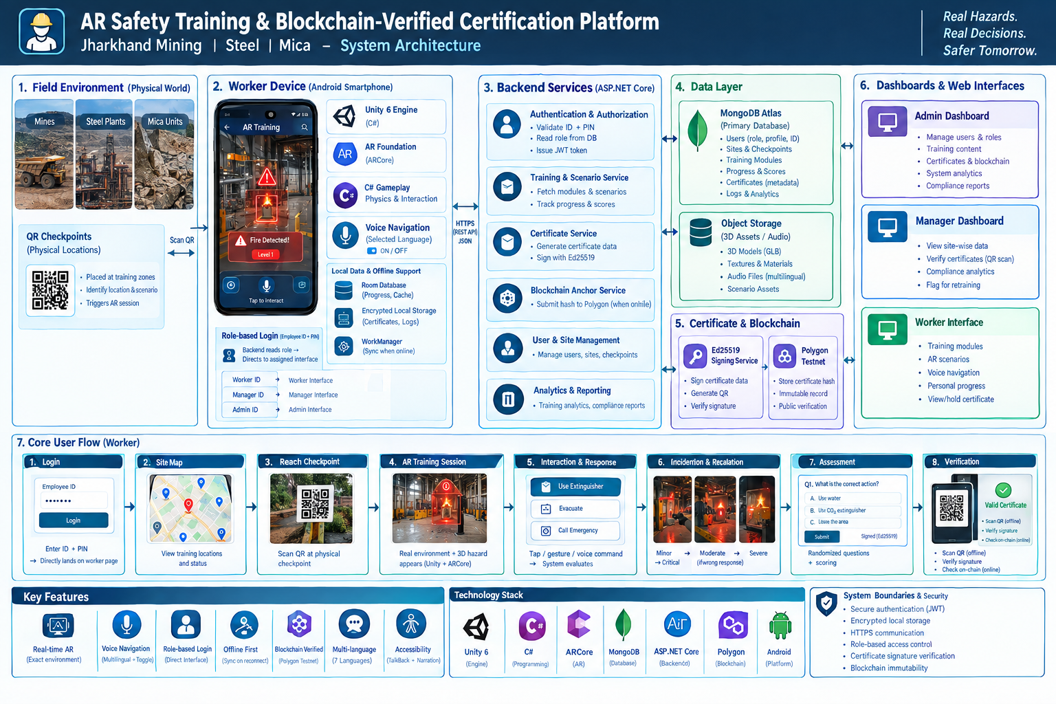
ARCHITECTURE DECISION
Unity is the simulation engine. C# is responsible for gameplay, interaction, state, physics orchestration, scoring and UI behavior. MongoDB is the backend system of record accessed only through a secured API. The client never connects directly to MongoDB.

1. Logical Architecture
Layer | Components | Responsibility
Experience | Unity UI, Voice Navigation, localization, AR camera | Worker interaction and accessibility
AR Runtime | AR Foundation, ARCore provider, plane detection, raycasting, depth when supported | Real-world tracking and spatial placement
Simulation | C# Scenario Controller, physics, interaction detectors, escalation state machine | The core reference-video-style training behavior
Local Data | Offline cache, local attempt store, sync queue | Run and record training without internet
API | ASP.NET Core REST API, authentication, authorization | Business logic, validation, sync and management
Database | MongoDB | Users, roles, training content, attempts, certificates and audits
Trust | Certificate signer, Ed25519 public key, blockchain anchor service | Credential authenticity and public timestamp/integrity anchor
Management | Admin and Manager dashboards | Operational control, verification and compliance

2. End-to-End Flow
1. User enters employee ID and authentication factor.
2. API validates identity and retrieves role from MongoDB.
3. API returns signed session/claims including role and permissions.
4. Unity opens Worker, Manager or Admin interface automatically; no role picker.
5. Worker selects assigned training and scans physical checkpoint QR.
6. Checkpoint metadata selects site/zone/module and the appropriate scenario package.
7. Unity starts AR Foundation session; supported planes/raycast/depth features are configured.
8. C# simulation instantiates virtual assets, enables physics and starts scenario timing.
9. Worker actions are evaluated by interaction and physics systems; escalation state updates.
10. Attempt evidence is stored locally and queued for API sync.
11. On sync, server validates result and requests Ed25519 certificate signing.
12. Certificate hash is optionally anchored to Polygon and returned to the platform for verification.

3. AR Runtime
AR Foundation provides Unity-facing abstractions for trackable environment features, while the platform provider supplies the device-specific AR implementation. Plane detection and raycast/hit-test logic are used for object placement; depth is an optional enhancement on compatible devices and should be feature-detected rather than assumed. See official Unity AR Foundation and Google ARCore documentation referenced in Section 11.
Subsystem | Implementation
ARSession | Manages AR session lifecycle.
ARPlaneManager | Detect/update usable horizontal/vertical planes.
ARRaycastManager | Find placement/hit positions from screen input against trackables.
Depth Manager | Enable depth only on supported devices; use for improved occlusion/placement when available.
Scene Anchor Manager | Creates and maintains scenario anchors and parent transforms.
Object Pool | Pools common effects/objects to reduce runtime allocation.
Quality Manager | Adjusts particle density, shadow quality, LOD and post-processing based on device profile.

4. C# Simulation Architecture
C# service/class group | Responsibility
ScenarioController | Owns scenario lifecycle and high-level state.
IncidentStateMachine | Transitions Minor→Moderate→Severe→Critical→Catastrophic or resolution states.
InteractionSystem | Receives touch/gesture/input events and maps them to action commands.
PhysicsActionSystem | Applies forces, collisions, rigidbody state and safety consequences.
HazardController | Controls fire/smoke/gas/equipment behavior and configuration.
AssessmentController | Scores action correctness, timing and required sequence.
VoiceNavigationController | Speaks UI labels/hints in current language, handles queue/debounce and toggle.
LocalizationService | Resolves localized strings/audio assets.
SessionRecorder | Creates structured attempt logs and sync payloads.
OfflineSyncService | Persists and retries sync events.

5. Identity & Routing
MongoDB stores the role assignment; ASP.NET Core returns the role in authenticated claims. The Unity client uses an interface router: worker → WorkerHomeScene; manager → ManagerHomeScene; admin → AdminHomeScene where a mobile-admin experience is required. Authorization is duplicated server-side for every protected endpoint.
NO ROLE SELECTION
Role selection is removed from the UX. Admin assigns role in the database. The employee ID determines which experience is loaded after authentication.

6. MongoDB Design
Collection | Indexes / constraints | Notes
users | unique employeeId; role enum | Core identity/role record.
checkpoints | unique siteId+qrValue | Physical location binding.
scenarios | moduleId + version | Version content so historic attempts remain reproducible.
attempts | unique attemptId; employeeId+createdAt | Append-oriented training evidence.
certificates | unique certificateId; employeeId+moduleId | Credential state and blockchain reference.
auditLogs | actorId+timestamp | Administrative traceability.

MongoDB supports flexible document models, embedding or referencing related data according to access patterns, and schema/versioning strategies. The platform should still enforce application-level validation for security-sensitive fields. See MongoDB documentation referenced in Section 11.

7. Voice Navigation Architecture
Stage | Behavior
UI tap | Unity EventSystem/interaction handler identifies the control.
Label resolve | LocalizationService gets the selected-language display label and optional short hint.
Speech choice | Native Android TTS bridge where supported; bundled audio clip fallback for languages/devices without suitable TTS.
Queue | VoiceNavigationController cancels/replaces stale announcements and prevents overlap.
Toggle | User preference is stored locally and synchronized to profile when possible.
AR | Critical action confirmations may be spoken without changing the visual simulation.

8. Security Boundaries
- Unity APK is an untrusted client.
- MongoDB is private; only API/service accounts can access it.
- Certificate private key is isolated from clients.
- Public blockchain contains only non-PII certificate integrity data.
- Role and permission checks are enforced on the server for every protected operation.
- Audit logs capture role changes and certificate operations.

9. Technology Stack
Area | Technology
Engine | Unity 6 family selected for project compatibility
Language | C#
AR | Unity AR Foundation + Android ARCore provider
Backend | ASP.NET Core Web API
Database | MongoDB / MongoDB Atlas
Auth | JWT/access-token based API authentication; employee ID + credential
Storage | Object storage/CDN for 3D/audio assets
Blockchain | Polygon testnet for development; production network decided later
Certificate | Ed25519 signature + QR payload
Version Control | Git + GitHub

10. Failure Handling
Failure | Fallback
No network | Use local cache; queue training results.
Tracking poor | Prompt user to move/scan environment; pause scenario timer where appropriate.
Unsupported AR device | Block AR session with clear device compatibility message and non-AR informational fallback.
Voice unavailable | Show visual UI; use bundled audio where applicable.
TTS language missing | Use localized prerecorded audio or instruct user to install voice data.
Sync conflict | Server validates version and idempotency key; preserve local evidence until acknowledged.
Certificate signer unavailable | Training remains complete locally; certificate remains Pending Sync.

11. Official Technical References
- Unity AR Foundation manual: https://docs.unity3d.com/Manual/com.unity.xr.arfoundation.html
- AR Foundation plane detection/raycast references: https://docs.unity3d.com/ja/Packages/com.unity.xr.arfoundation@5.1/api/UnityEngine.XR.ARFoundation.ARPlaneManager.html
- ARCore supported devices: https://developers.google.com/ar/devices
- ARCore depth: https://developers.google.com/ar/develop/depth
- ARCore Unity hit-test guide: https://developers.google.com/ar/develop/unity-arf/hit-test/developer-guide
- MongoDB data modeling: https://www.mongodb.com/docs/manual/data-modeling/

