UI / UX DESIGN SPECIFICATION
Direct Role Routing • AR-first Interface • Selected-Language Voice Navigation
PROJECT BASELINE v2.0 | September 2026 | UI/UX — UPDATED
Reference concept: https://www.youtube.com/watch?v=nL7Elpg_EkE
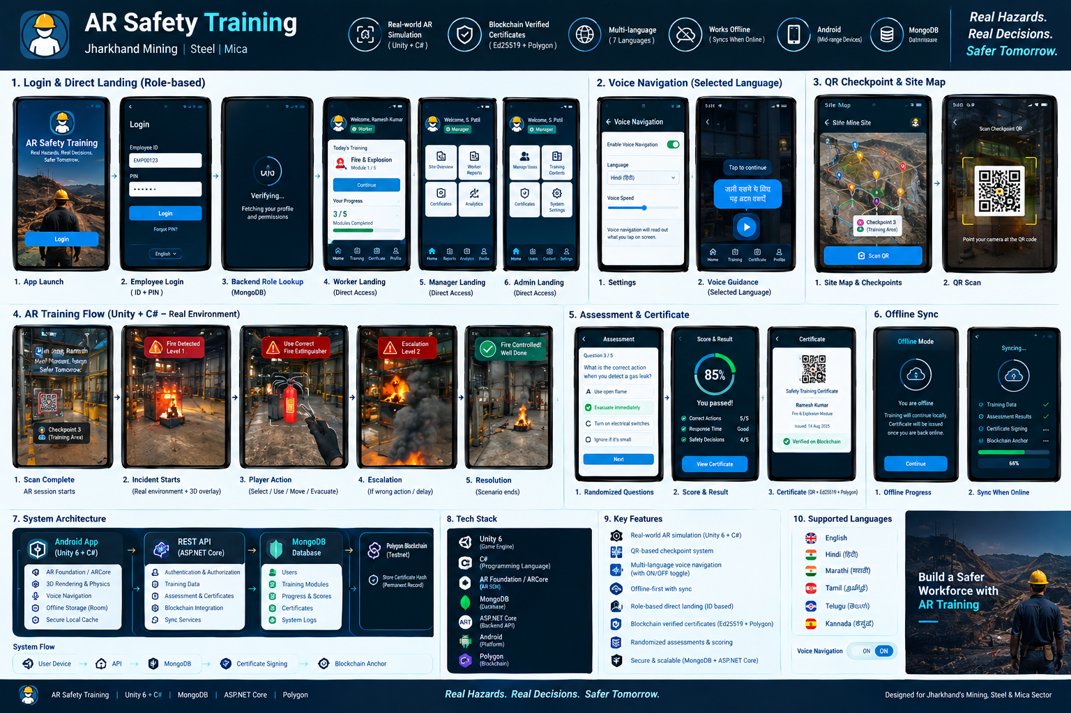

1. UX Foundation
- The interface is designed around entering and performing an AR simulation, not around game mechanics.
- No Pokémon GO-inspired visuals or terminology are used.
- Primary actions are large, high-contrast, icon-supported and voice-announced when Voice Navigation is ON.
- Role choice is removed after login; the backend decides the interface.
- In AR, UI remains readable without covering critical hazards.

2. Screen Map
Screen | Purpose
Splash | Brand and app initialization.
Language / Accessibility | Select language and Voice Navigation setting if not already stored; each language option can be announced.
Login | Employee ID + PIN/credential. No role selection.
Worker Home | Assigned training, progress, certificates, settings.
Manager Home | Roster, compliance, certificate verification, retraining flags.
Admin Home | Users, roles, sites, modules, scenarios, analytics, configuration.
Site / Checkpoint | Operational list/map of training checkpoints; not gamified.
QR Scanner | Scan physical checkpoint QR.
AR Training | Reference-video-style camera + 3D hazard/equipment interaction.
Scenario Result | Score, mistakes, timing, completion state.
Certificate | Signed QR credential and status.
Settings | Language, Voice Navigation, content narration, sync and text size.

3. Login & Direct Role Landing
Login is intentionally simple: Employee ID + PIN/credential → API authentication → role lookup → direct landing. The visible product never asks “Are you a Worker/Manager/Admin?”
Identity record | Landing
role = worker | Worker Home
role = manager | Manager Home
role = admin | Admin Console

4. Voice Navigation UX
Interaction | Speech behavior
Tap Training | “Training — your assigned safety modules.”
Tap Certificates | “Certificates — view your safety certificates.”
Tap Start Training | “Start Training — begin the safety simulation.”
Tap Extinguisher | “Extinguisher selected.”
Tap Evacuate | “Evacuate selected.”
Voice OFF | No automatic speech; touch/visual interaction remains.

5. Language Behavior
- Language selection is application-level and persists.
- All visible training/UI labels are localized.
- Voice Navigation follows the same selected language.
- Santali may use prerecorded UI/audio prompts where TTS is unavailable.
- A language switch updates labels and subsequent voice prompts consistently; stale audio from the old language is cancelled.

6. AR UI Layout
Zone | Rule
Top status | Hazard/state + optional timer; never hide the simulated hazard.
Center view | 3D scenario and interactive objects.
Bottom action tray | Contextual actions; large touch targets.
Voice indicator | Small status control showing Voice Navigation ON/OFF, not a persistent intrusive panel.
Safety feedback | Color/icon + optional spoken message; text remains available.

7. Accessibility
- TalkBack compatibility for blind/low-vision users remains required at Android UI boundaries.
- Icon + text labels are used together where possible.
- Voice Navigation provides tap feedback for users who have difficulty reading.
- Text size and contrast settings are adjustable.
- Voice feedback must be short enough not to delay critical simulation actions.

8. UX States
State | Visible response
Loading | Progress indicator + spoken “Loading” when Voice Navigation is ON if applicable.
Tracking | “Move phone slowly to scan the area.”
Ready | “Training ready. Tap Start Training.”
Escalating | Prominent hazard level and clear next action.
Success | Resolution feedback + score summary.
Offline | Offline badge + clear sync state.
Certificate pending | “Training complete. Certificate will be issued when connected.”

9. Visual System
Token | Value
Primary | Deep navy / #0B1F33
Action | Blue / #1769AA
Success | Green / #2E7D32
Warning | Gold / #F2B134
Critical | Red / #C62828
Background | Light blue-grey / #EAF2F8
Typeface | Aptos/Inter-like sans-serif; localization-compatible
Shape | 8–16 px rounded cards, clear iconography, strong touch affordances

10. UI Acceptance Criteria
- No role-selection screen exists after login.
- A test worker ID opens Worker Home directly.
- A test manager ID opens Manager Home directly.
- Voice Navigation ON causes tapped controls to be spoken in the selected language.
- Voice Navigation OFF stops automatic tap announcements.

