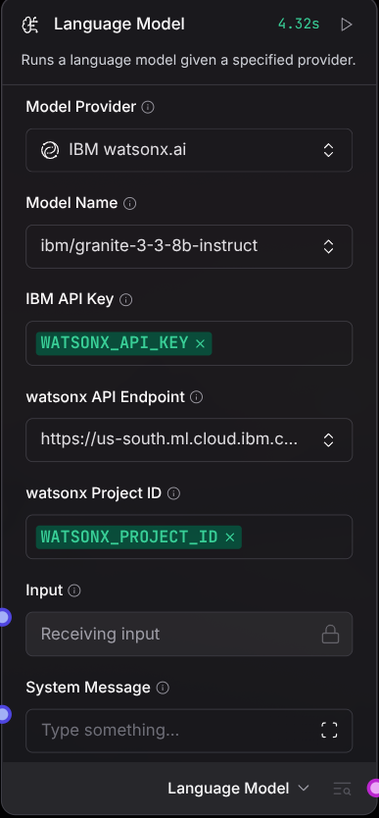

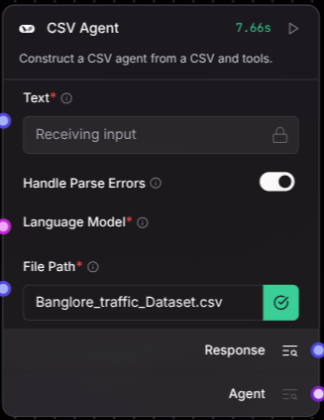
Language Model: Summarizes data for the CSV Agent
This is a Watsonx IBM-Granite-3.3-8b-instruct model.

CSV Agent:this agent takes dataset of traffic as csv input and pass this to llm model

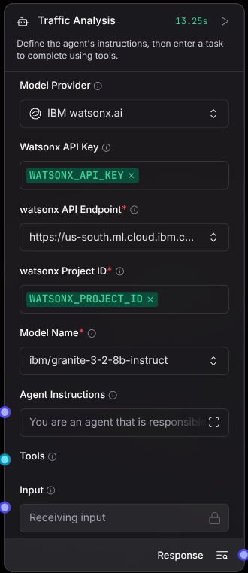

This it the traffic analysis agent, that summarizes historical data and uses real-time data to update users about traffic situations near his area.

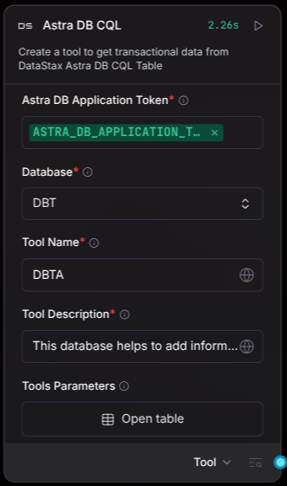

This is the Astra DB CQL, a vector index database responsible for collection and storage of real time data.

