VISVESVARAYA TECHNOLOGICAL UNIVERSITY
“JnanaSangama”, Belgaum -590014, Karnataka.



MOBILE APPLICATION DEVELOPMENT REPORT
on

Skill-It
Submitted by

SHASHANK SHANTHARAM NAYAK(1BM23CS313)
SOHAM HATHI(1BM23CS335)
SRUSHTI SUNKAD (1BM23CS341)

Under the Guidance of
Rashmi H.
Assistant Professor, BMSCE
in partial fulfillment for the award of the degree of
BACHELOR OF ENGINEERING
in
COMPUTER SCIENCE AND ENGINEERING



B.M.S. COLLEGE OF ENGINEERING
(Autonomous Institution under VTU)
BENGALURU-560019
Feb-2025 to June-2025

B. M. S. College of Engineering,
Bull Temple Road, Bangalore 560019
(Affiliated To Visvesvaraya Technological University, Belgaum)
Department of Computer Science and Engineering

CERTIFICATE
This is to certify that the project work entitled “SKIL-IT” carried out by SHASHANK SHANTHARAM NAYAK (1BM23CS313), SOHAM HATHI (1BM23CS335), SRUSHTI SUNKAD (1BM23CS341) who are bonafide students of B. M. S. College of Engineering. It is in partial fulfillment for the award of Bachelor of Engineering in Computer Science and Engineering of the Visveswaraiah Technological University, Belgaum during the year 2024-2025. The project report has been approved as it satisfies the academic requirements in respect of Mobile Application Development (23CS4AEMAD) work prescribed for the said degree.

Signature of the Guide Signature of the HOD
Rashmi H. Dr. Kavitha Sooda
Assistant Professor, Dept. of CSE Prof.& Head, Dept. of CSE
BMSCE, Bengaluru BMSCE, Bengaluru
External Viva
Name of the Examiner Signature with date

1._____________________________ ________________________

2. _____________________________ _________________________

B.M.S. College of EngineerinG
DEPARTMENT OF COMPUTER SCIENCE AND ENGINEERING

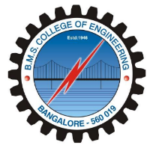

DECALARATION

We, SHASHANK SHANTHARAM NAYAK (1BM23CS313),SOHAM HATHI (1BM23CS335), SRUSHTI SUNKAD (1BM23CS341), students of 4th Semester, B.E, Department of Computer Science and Engineering, B. M. S. College of Engineering, Bangalore, hereby declare that, this Mobile Application Development entitled "Skill-It" has been carried out by us under the guidance of Rashmi H., Assistant Professor, Department of CSE, B. M. S. College of Engineering, Bangalore during the academic semester Feb-2025 to June-2025

We also declare that to the best of our knowledge and belief, the development reported here is not from part of any other report by any other students.

Signature
SHASHANK SHANTHARAM NAYAK (1BM23CS313)
SOHAM HATHI (1BM23CS335)
SRUSHTI SUNKAD (1BM23CS341)

ABSTRACT

In today’s rapidly evolving educational environment, students often face challenges in finding peers with complementary skills for collaborative learning and project development. Traditional learning systems lack efficient peer-to-peer engagement, limiting opportunities for practical skill application and real-world collaboration.
Skill-It addresses this gap by offering a centralized digital platform for college-to-college skill exchange. The platform enables students to connect, learn, teach, and grow by sharing their knowledge and interests. With secure Google SSO login, personalized profiles, and intuitive skill management features, users can easily discover like-minded peers and initiate meaningful collaborations.
Built using modern technologies like Flutter for the frontend, PostgreSQL and Spring Boot for the backend, and Firestore for database management, Skill-It ensures a smooth and responsive user experience. This platform empowers students to enhance their learning through interaction, cooperation, and mutual skill development—fostering a stronger and more connected academic community.

TABLE OF CONTENTS

SL No | Topics | Page Nos
1 | Introduction | 6
2 | Hardware and Software Requirements | 7
3 | Design Layouts: Screen Shots of Mobile App / Webpages | 8
4 | Database Table screen shots | 12
5 | Conclusion and Future Work | 14

Chapter 1
INTRODUCTION
In the current academic landscape, collaboration and skill-sharing are essential for holistic student development. However, students often struggle to find peers with complementary skills, especially beyond their own college boundaries. Traditional learning environments tend to emphasize individual performance and theoretical knowledge, limiting opportunities for practical, peer-driven growth.
Skill-It aims to bridge this gap by providing a centralized platform for college-to-college skill exchange. It empowers students to connect based on shared interests and expertise, encouraging real-time collaboration, learning, and teaching. By leveraging modern technologies and a user-friendly interface, Skill-It fosters a vibrant, collaborative academic network that extends beyond institutional limits.
Skill-It is developed to overcome this challenge by offering a centralized, interactive platform for skill exchange among college students. Unlike conventional platforms that focus only on showcasing individual profiles, Skill-It emphasizes meaningful interaction, knowledge sharing, and collaborative growth. Students can sign up using secure Google Single Sign-On (SSO), create personalized profiles, list their skills and interests, and connect with peers who match their learning or project needs.
The platform is designed with an intuitive user interface and developed using modern technologies like Flutter (for frontend), PostgreSQL and Spring Boot (for backend). These tools ensure a seamless, scalable, and responsive experience for users.
By bridging institutional boundaries and enabling real-time collaboration, Skill-It not only enhances practical learning but also fosters a culture of teamwork, innovation, and continuous skill development among students.

Chapter 2
Hardware and Software Requirements

2.1 Hardware Requirements
- CPU: Quad-Core processor (Intel Core i5 or AMD Ryzen 5 equivalent)
- RAM: 16 GB DDR4 RAM
- Storage: 512 GB SSD (Solid-State Drive)
- Graphics: Integrated graphics (Intel Iris or AMD Radeon equivalent)
- Display: 22-inch Full HD (1080p) monitor
- Operating System: 64-bit version of Windows 10 or Linux (Ubuntu or equivalent) with kernel 6.11.x above
- Internet Connection: High-speed internet connection (at least 100 Mbps)

2.2 Software Requirements
- OS: Windows/Linux
- Front-End: Flutter by Google. [3]
- Backend: Spring Boot Framework, Google OAuth API [1]
- Server: Spring Boot Framework
- IDE: Android Studio, Visual Studio Code, Vim terminal editor
- Target Devices: Android 29 SDK compatible phones (Android 10).

Chapter 3
Design Layouts: Screen Shots of Mobile App / Webpages
2.1: Login Webpage
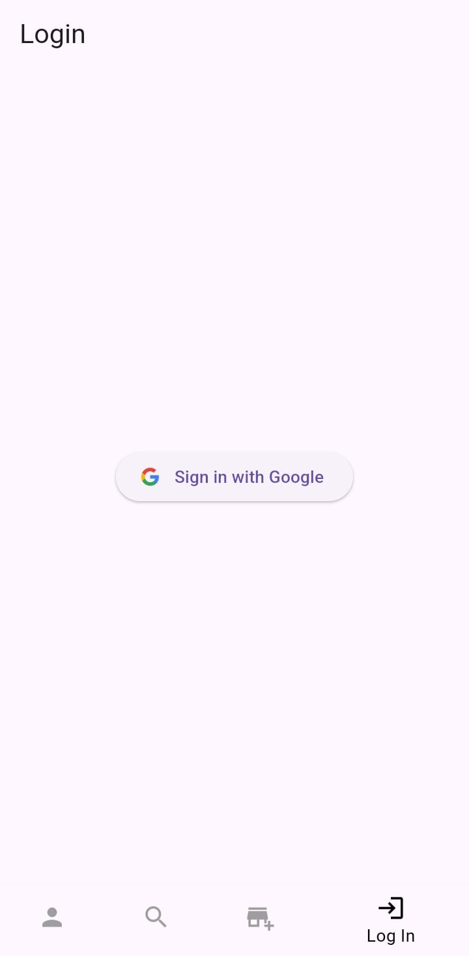
Fig.1 Login Screen
2.2: Profile Page
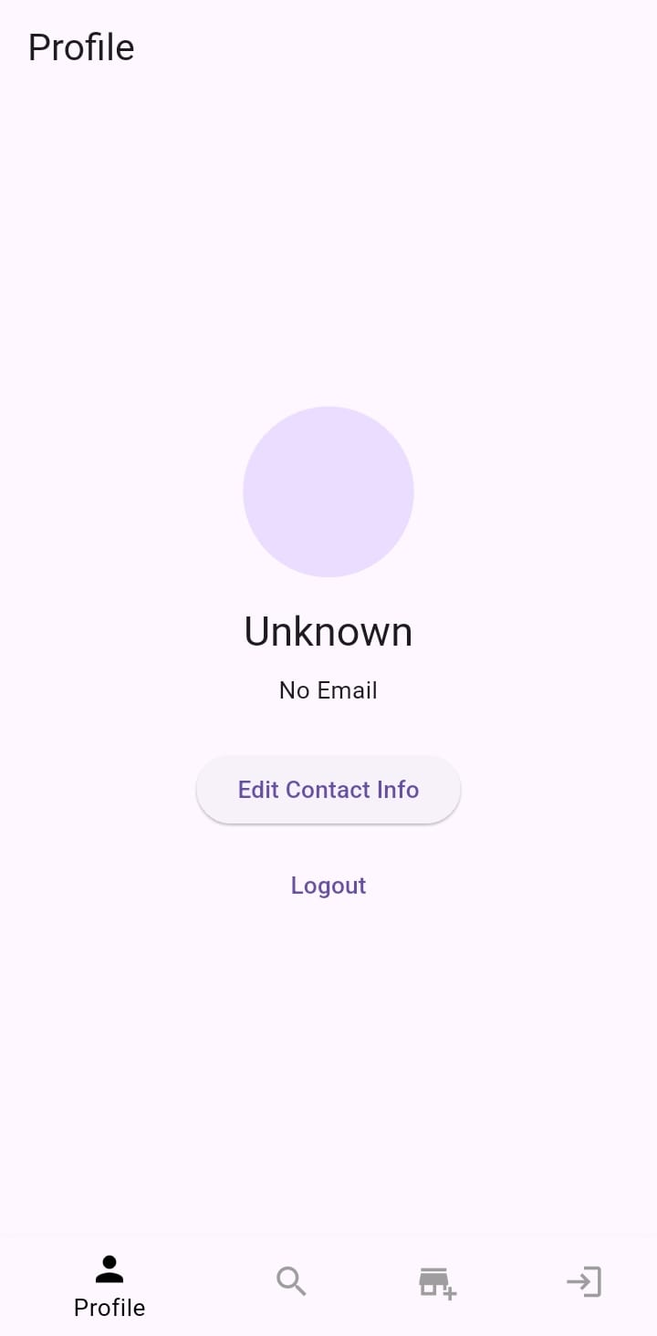
Fig.2 Profile Screen
2.3: Hire Page
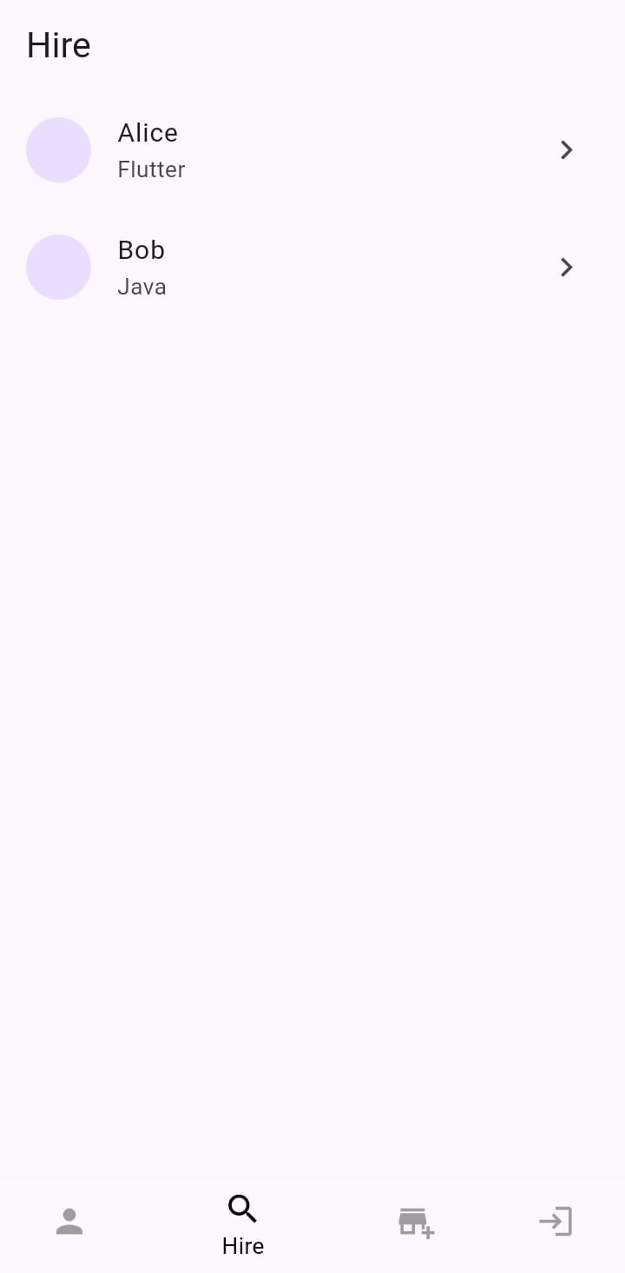

Fig.3 Hire Page
2.4: Apply Page
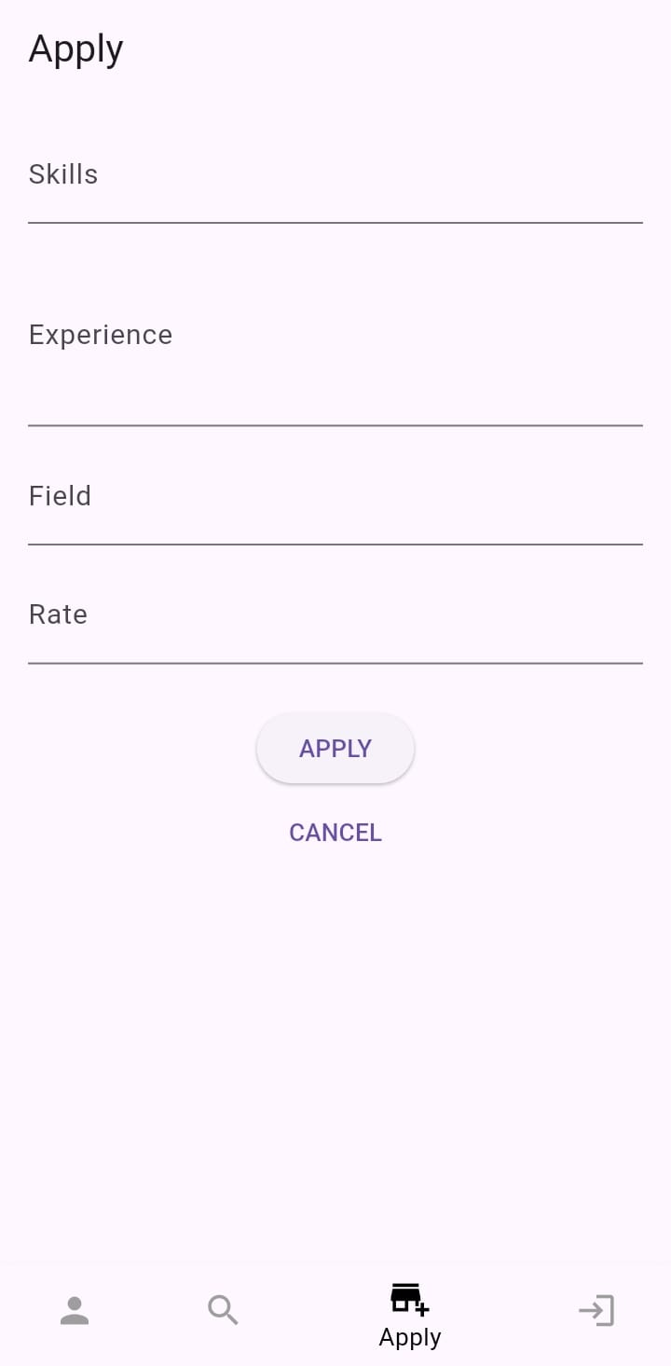
Fig. 4 Apply Page
Chapter 4
Database Table Screen shots

3.1.1. Users Database Table: Description
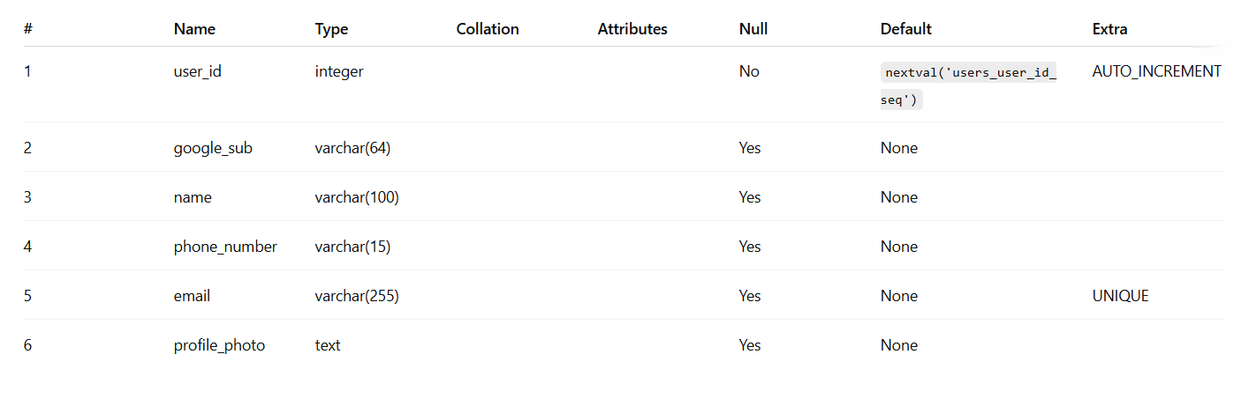

3.1.2 Skills Database Table: Description
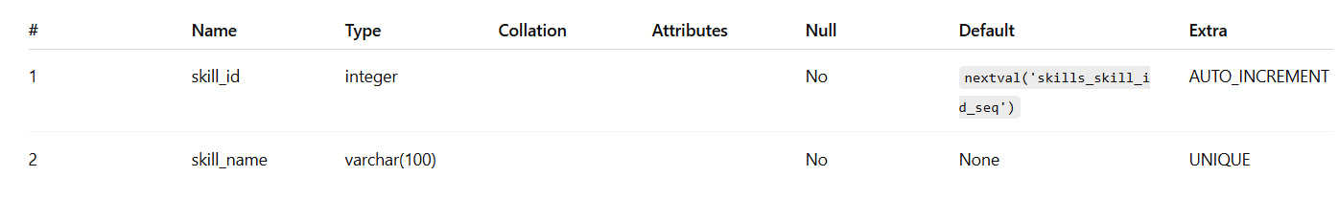

3.2.1. User Skills Database Table: Description
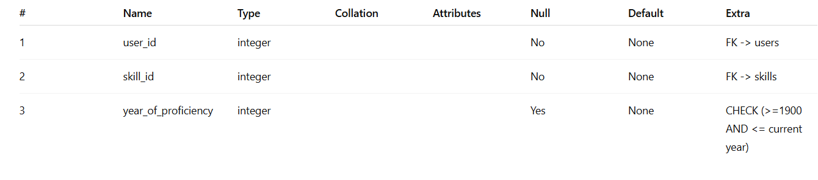

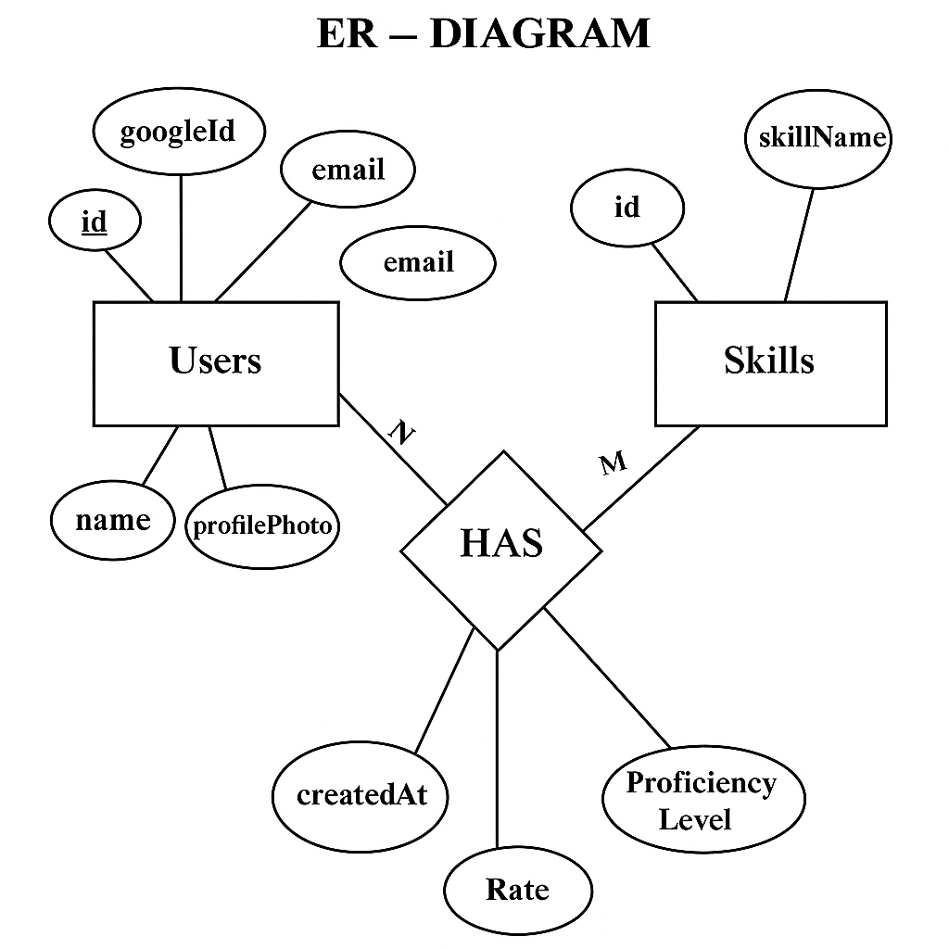

Fig 3.1: ER diagram of Employee Database

Chapter 5
5.1 Conclusion
Skill-It presents an innovative solution to a common problem faced by college students—finding the right peers to learn from, collaborate with, and grow alongside. By providing a centralized platform for skill exchange, it fosters a dynamic learning environment that extends beyond institutional boundaries. The integration of modern technologies ensures a user-friendly, secure, and scalable system capable of handling real-time interactions.

Through features like personalized profiles, skill discovery, and peer connection, Skill-It promotes not only academic development but also the spirit of cooperation and community. Ultimately, it empowers students to take charge of their learning journey, enabling them to build networks, enhance their skills, and prepare for real-world challenges through collaboration and shared growth.

5.2 Future Works
1. AI-Powered Skill Matching:
Implement AI algorithms to automatically suggest the best peer connections based on users' skill sets, learning goals, and activity patterns.

2. Gamification Elements:
Add badges, levels, and rewards to encourage active participation, skill sharing, and collaboration among users.

3. Project and Team Management Tools:
Introduce features that allow users to form teams, assign tasks, track progress, and manage collaborative projects within the platform.
4. Integration with Job and Internship Platforms:
Partner with hiring platforms to provide internship and freelance opportunities based on users' skills and collaboration history.

5. Cross-College Events and Challenges:
Organize virtual hackathons, workshops, and competitions to increase engagement and give students real-world project experience.

6. Video Chat and Collaboration Suite:
Add built-in video conferencing, shared whiteboards, and document collaboration tools to support more seamless interaction.

7. Skill Verification and Endorsements:
Enable users to endorse each other’s skills or upload proof of work, increasing credibility and trust within the community.

8. Mobile App Deployment:
Launch full-featured Android and iOS apps for greater accessibility and engagement on the go.

References
[1] Spring Boot. ‘Spring Boot Documentation’. Retrieved from https://docs.spring.io.
[2] PostgreSQL. ‘PostgreSQL Documentation’. Retrieved from https://postgresql.org/docs.
[3] Flutter. ‘Flutter Documentation’. Retrieved from https://flutter.dev/docs.

