## VISVESVARAYA TECHNOLOGICAL UNIVERSITY

**“Jnana Sangama”, Belgaum -590014, Karnataka.**



## FULLSTACK WEB DEVELOPMENT PROJECT REPORT On

**SKILL – IT**

**Submitted by**

SHASHANK SHANTHARAM NAYAK (1BM23CS313)

SANATH S SHETTY (1BM23CS297)

SRUJAN K R(1BM23CS340)

SUMANTH S SHETTY(1BM23CS348)

**Under the Guidance of  
Srushti CS   
Assistant Professor**

**in partial fulfillment for the award of the degree of**

## BACHELOR OF ENGINEERING

**in**

## COMPUTER SCIENCE AND ENGINEERING



**B.M.S. COLLEGE OF ENGINEERING**

**(Autonomous Institution under VTU) BENGALURU-560019**

**2024 - 2025**

**B. M. S. College of Engineering,**

**Bull Temple Road, Bangalore 560019**

(Affiliated To Visvesvaraya Technological University, Belgaum)

**Department of Computer Science and Engineering**



**CERTIFICATE**

This is to certify that the project work entitled “SKILL-IT” carried out by SHASHANK SHATHARAM NAYAK (1BM23CS313), SANATH S SHETTY(1BM23CS297), SRUJAN   
K R(1BM23CS340), SUMANTH S SHETTY(1BM23CS348), who are bonafide students of   
B. M. S. College of Engineering. It is in partial fulfillment for the award of Bachelor of Engineering in Computer Science and Engineering of the Visveswaraya Technological University, Belgaum during the year 2024. The project report has been approved as it satisfies the academic requirements in respect of Full Stack Web Development(23CS3AEFWD) work prescribed for the said degree.

|  |  |
| --- | --- |
| Signature of the Guide  Srushti CS  Assistant Professor | Signature of the HOD  Dr. Kavitha Sooda  Professor and Head  Dept. of CSE |
| B.M.S. College Of Engineering  Bengaluru | B.M.S. College Of Engineering  Bengaluru |
|  | |
| Name of the Examiner | Signature with date |

## B.M.S. COLLEGE OF ENGINEERING DEPARTMENT OF COMPUTER SCIENCE AND ENGINEERING



**DECALARATION**

We**,** SHASHANK SHANTARAM NAYAK **(**1BM23CS313**),** SANATH S SHETTY (1BM23CS297), SRUJAN K R(1BM23CS340), SUMANTH S SHETTY(1BM23CS348), students of **3rd Semester, B.E, Department of Computer Science and Engineering, BMS College of Engineering, Bangalore,** hereby declare that this Full Stack Web Development project entitled **"Skill-It"** has been carried out by us under the guidance of **Srushti C S,** Assistant Professor, Department of CSE, B.M.S College of Engineering, Bangalore**,** during the academic semester **Sept 2024 - Jan 2025.**

We also declare that, to the best of our knowledge and belief, the development reported here is not a part of any other report by any other students.

Signature

SHASHANK SHANTHARAM NAYAK (1BM23CS313)

SANATH S SHETTY (1BM23CS297)

SRUJAN K R(1BM23CS340)

SUMANTH S SHETTY(1BM23CS348)

**TABLE OF CONTENTS**

|  |  |  |
| --- | --- | --- |
| **Serial**  **No.** | **TITLE** | **PAGE**  **NO.** |
| 1 | **Introduction** | 5 |
| 1.1 | Overview | 6 |
| 1.2 | Motivation | 6 |
| 2 | **Software Requirement Specification** | 7 |
| 2.1 | Hardware Requirements | 7 |
| 2.2 | Software Requirements | 7 |
| 3 | **ER diagram of the project** | 8 |
| 4 | **Schema of project** | 9 |
| 5 | **User Interface Design** | 10-13 |
| 6 | **References** | 14 |

# Full Stack Web Development Project Report : Skill-It website

This report documents the development of a Skill-It website, a full-stack web application designed for the connection between people interested in sharing or obtaining specific skills online. It aims to provide an overview of the project's objectives, design, implementation, and future considerations. The report will explore the project's technical aspects, including the software and hardware requirements, database design, and user interface development. In addition, it will highlight the motivation behind the project, the challenges encountered during development, and potential areas for future enhancements.

Our goal with Skill-It is to bridge the gap between individuals seeking to share new skills and those willing to call their expertise. We envision a platform that fosters collaboration, innovation, and growth. Through this project, we aim to demonstrate the power of technology in connecting people and creating opportunities.

We wanted to build a simple yet powerful space where users can share their skills and others can easily find learning opportunities. The platform includes features such as user profiles, skill uploads, and search functions, making it easier for users to discover new skills or offer their expertise.

Technically, the website was built using a combination of frontend and backend technologies. For the backend, we used Node.js and Express.js to handle the server-side logic, and for the frontend, we used React.js to create a smooth and responsive user interface. MongoDB was chosen as the database to store user data, skills, and other relevant information. The goal was to ensure that the platform could handle a large number of users and scale as needed.

# Project Overview and Motivation

The Skill-It Website project represents a practical application of full-stack web development principles, if you are a service client looking for an expert or a service provider looking for clients The project's objective is to develop a website that allows recruit a person based on the requirements of the client based on the skills of the user. Our platform connects skilled individuals with clients who need their expertise. Users can create profiles showcasing their skills, experience, and projects. Clients can search for specific skills, browse profiles, and contact potential candidates for interviews.

Moreover, the project provides an opportunity to explore innovative design and development approaches, contributing to the advancement of web development skills within the team.

The idea for this project came from the growing competition in the tech industry. We wanted to create a platform where talented individuals can connect with businesses that need their skills. It’s a place where people can showcase their abilities, get noticed, and discover exciting new opportunities without unnecessary barriers.

This project also gave us a chance to learn and try out creative design and development techniques. It helped us grow as developers while working as a team to build something meaningful.

The Skill-It website is more than just a project. It is a way of showing how technology can bring people together. We’ve combined real-world functionality with modern tools to create a platform that’s easy to use and makes finding the right connections simple. We hope this project inspires others to take pride in their skills and build strong professional relationships.

# Software Requirements Specification

# OS: Windows/Linux

# Front-End: React JS Framework, HTML, CSS

# Backend: Node.js framework, Google OAuth API,

# Server: Node.js framework

# IDE: Visual Studio Code, Vim terminal editor

# Hardware Requirements Specification

# CPU: Quad-Core processor (Intel Core i5 or AMD Ryzen 5 equivalent)

# RAM: 16 GB DDR4 RAM

# Storage: 512 GB SSD (Solid-State Drive)

# Graphics: Integrated graphics (Intel Iris or AMD Radeon equivalent)

# Display: 22-inch Full HD (1080p) monitor

# Operating System: 64-bit version of Windows 10 or Linux (Ubuntu or equivalent) with kernel 6.11.x above

# 7. Internet Connection: High-speed internet connection (at least 100 Mbps)

**ER – DIAGRAM:**

**googleId**

**Rate**

**createdAt**

**Proficiency Level**

**createdAt**

**skillName**

**id**

**N**

**M**

**email**

**HAS**

**profilePhoto**

**name**

**Skills**

**Users**

**id**

**SCHEMA:**

**Users**

|  |  |  |  |  |
| --- | --- | --- | --- | --- |
| **id** | **googleId** | **email** | **profilePhoto** | **createdAt** |

**Skills**

|  |  |
| --- | --- |
| **id** | **skillName** |

**Has**

|  |  |  |  |  |
| --- | --- | --- | --- | --- |
| **uid** | **sid** | **proficiencyLevel** | **createdAt** | **rate** |

**USER INTERFACE DESIGN**

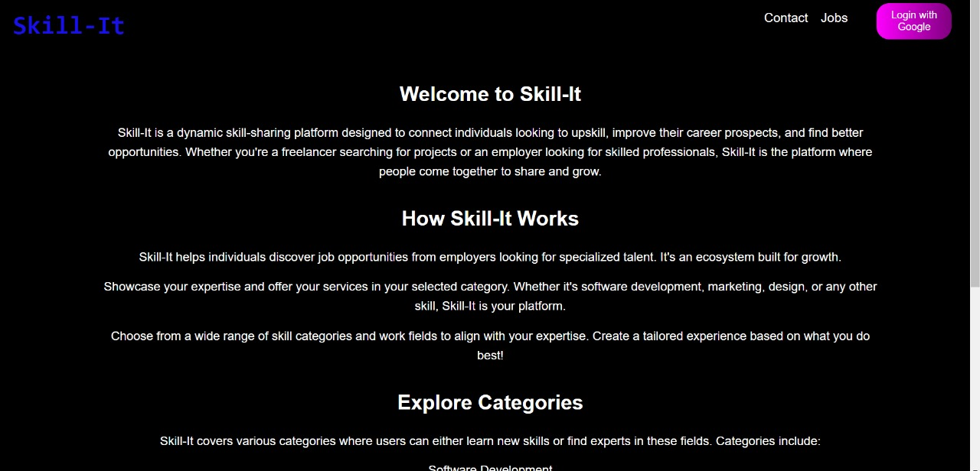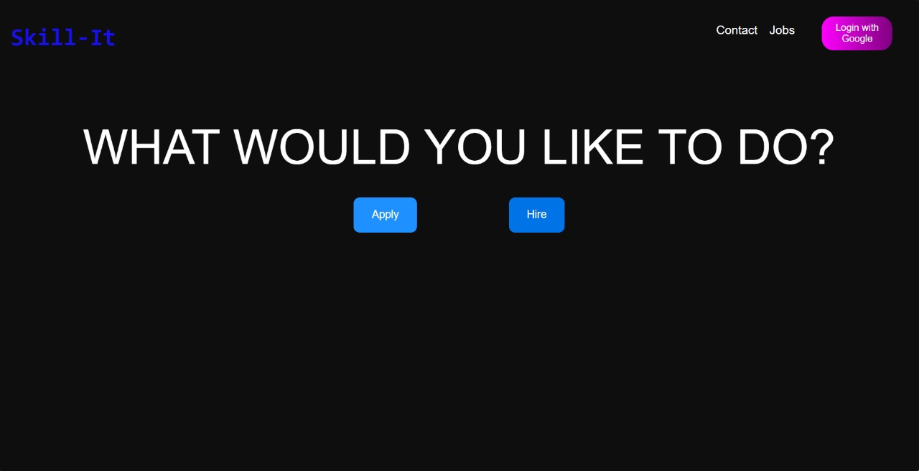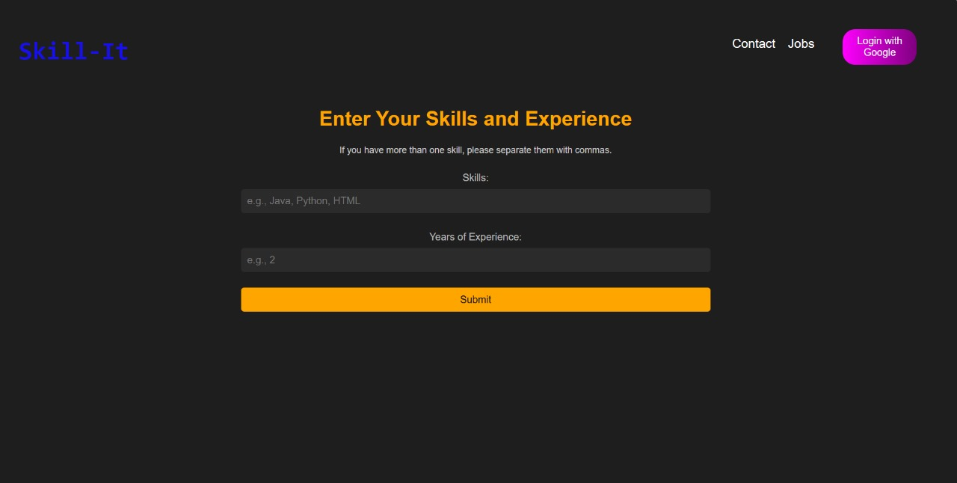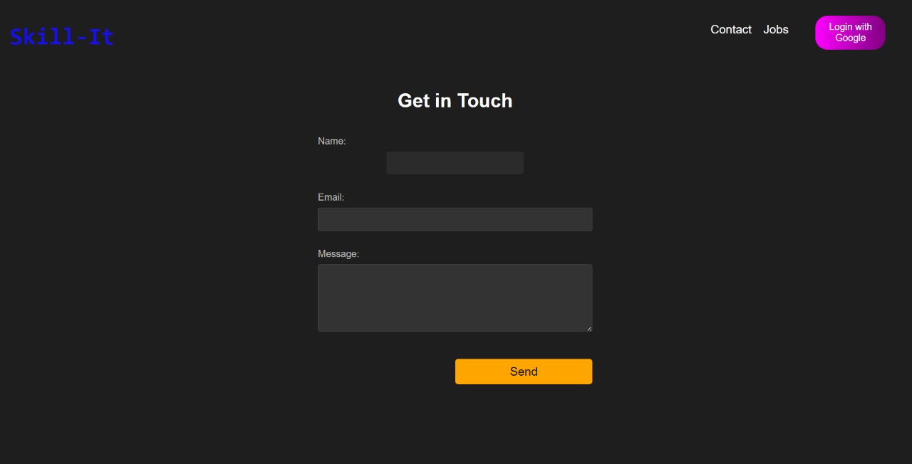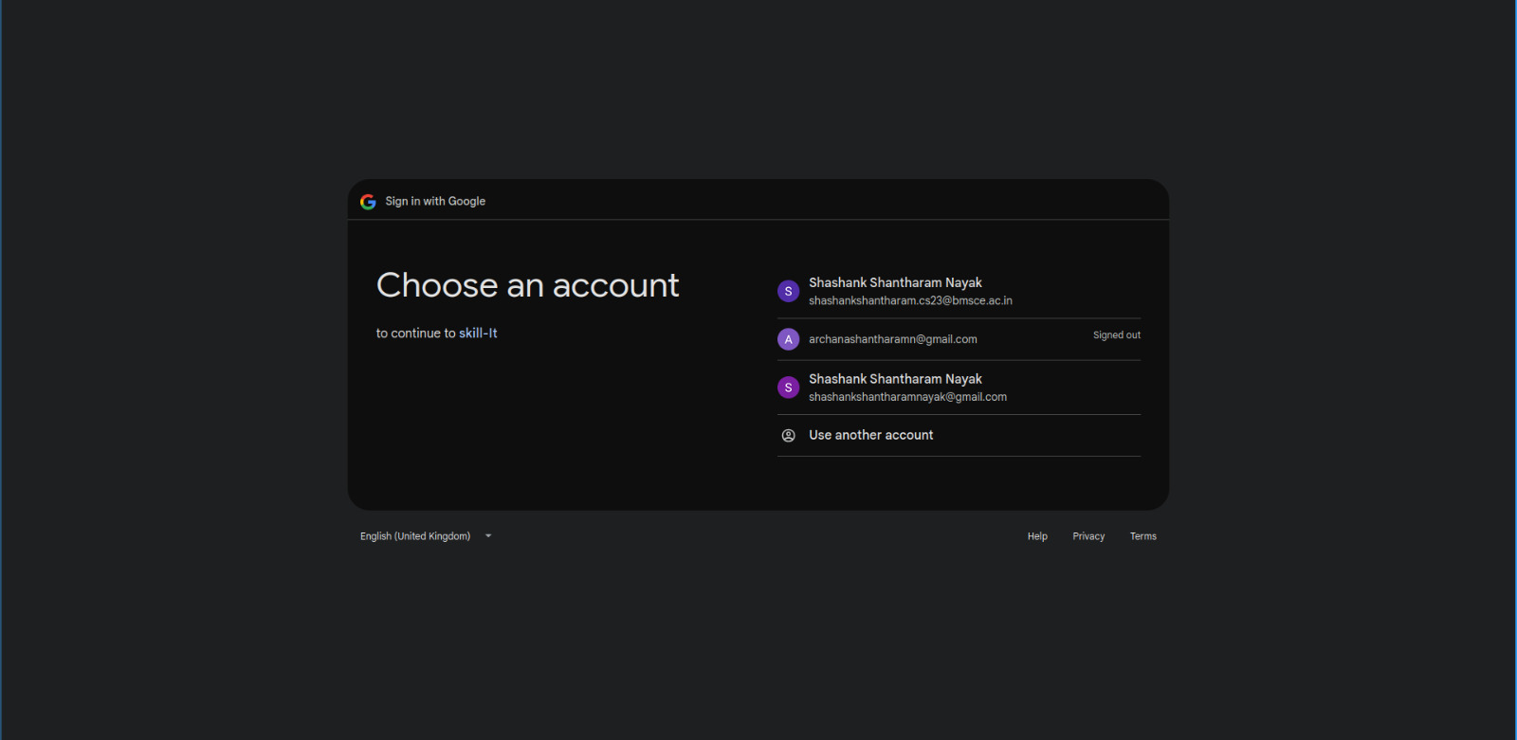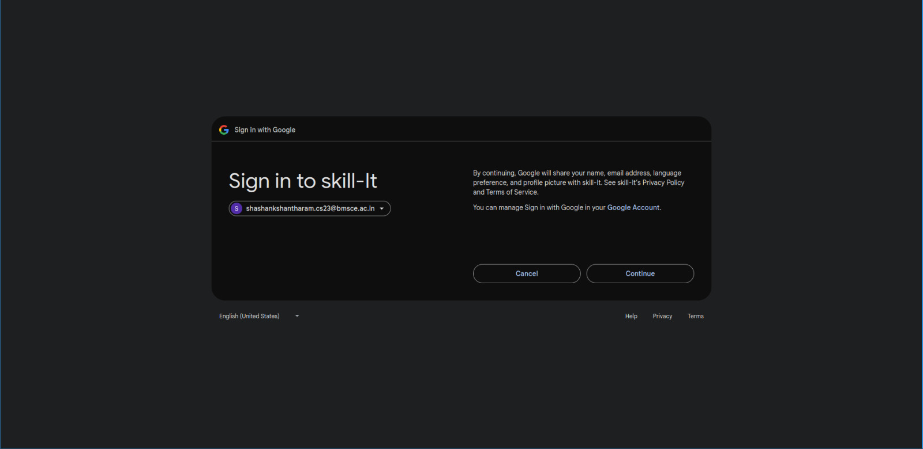

**References**

1. <https://youtu.be/CgkZ7MvWUAA?si=3Bs6X4tvlQrYHcqO>

Channel: Bro code

What we learnt

* Components in React are the building blocks of an application. The course illustrates how to create and use functional components, including manipulating their states using hooks like useState
* React is a JavaScript library used for building user interfaces through components. This course provides a comprehensive introduction for beginners, covering foundational concepts before moving onto advanced topics.etc

1. <https://youtu.be/PkZNo7MFNFg?si=lXFWslU4yAgz7OrY>

Channel: freeCodeCamp.org

What we learnt

* JavaScript can be run in web browsers without installation, using developers' tools and JavaScript editors. The video demonstrates how to run scripts in environments like CodePen and Scrimba
* Functions, including how to create them, return values, and both global and local scope, are explained. Higher-order functions and the concept of callbacks, promises, and arrow functions are also introduced. etc

1. [www.w3schools.com](http://www.w3schools.com)

Here we practiced syntax for better execution by our side