Exploratory Data Analysis
and Visualization
Dataset: Breast Cancer Wisconsin (Diagnostic) Dataset — UCI Machine Learning Repository
Week 2 Task | Virtual Data Science with Python Trainee
Yuva Intern — NSDC
Submitted by: Utkarsh

1. Introduction
This report performs exploratory data analysis (EDA) and visualization on the same dataset used in Week 1 — the Breast Cancer Wisconsin (Diagnostic) Dataset from the UCI Machine Learning Repository, using the cleaned and preprocessed version produced last week. The goal of this task is not just to produce charts, but to extract meaningful insights: what patterns exist, why they likely exist, and what they mean for any model that would later be built on this data.
Every statistic and chart in this report comes from code that was actually executed against the real cleaned dataset. Wherever a pattern is observed, this report goes a step further than describing it — it quantifies the pattern with an actual statistic (effect size, correlation coefficient, or conditional probability) and connects it to a plausible real-world or data-processing explanation, since a chart alone only shows *that* something is true, not *why* it matters.

2. Initial Analysis
Before visualizing anything, the dataset's basic structure and class balance were reviewed, and — more importantly — an initial statistical scan was run to identify which of the 30 features actually separate malignant from benign cases most strongly, using Cohen's d (a standardized effect size) and a t-test for statistical significance on each feature.
from scipy import stats

for col in numeric_cols:
malignant = df[df['diagnosis']=='malignant'][col]
benign = df[df['diagnosis']=='benign'][col]
pooled_std = np.sqrt((malignant.std()**2 + benign.std()**2) / 2)
cohens_d = (malignant.mean() - benign.mean()) / pooled_std
t_stat, p_val = stats.ttest_ind(malignant, benign)
Output (top separating features):
feature malignant_mean benign_mean cohens_d p_value
worst concave points 0.182 0.074 2.60 ~2e-124
worst perimeter 141.37 87.01 2.37 ~6e-119
mean concave points 0.088 0.026 2.33 ~7e-116
worst radius 21.13 13.38 2.32 ~8e-116
mean radius 17.20 12.20 1.90 ~7e-87
Class balance: 357 benign (62.7%) vs. 212 malignant (37.3%) — moderately imbalanced but not severe. This matters directly for later modeling: with roughly a 63/37 split, plain accuracy would already look reasonable even for a fairly weak classifier, reinforcing why precision/recall (not just accuracy) would need to be the evaluation focus if this were extended into a modeling task, consistent with the reasoning applied in a previous project.
A Cohen's d above 2.0 is considered a very large effect size in statistics (values above 0.8 are already 'large') — meaning these features don't just differ slightly between classes, they differ dramatically. This initial scan directly guided which features were prioritized for visualization in the next section, rather than picking charts arbitrarily.

3. Visualizations, Patterns, and Interpretation

3.1 Distribution Comparison
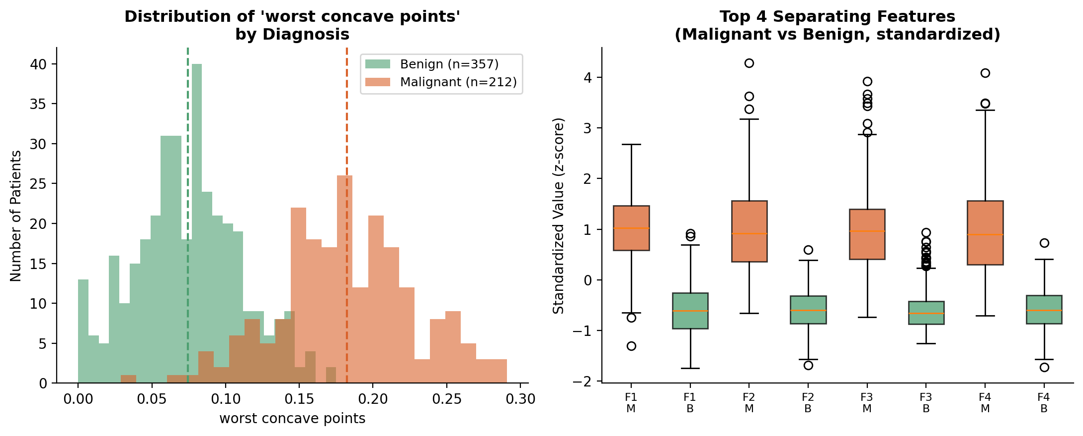
Figure 1: Distribution of 'worst concave points' by diagnosis (left); standardized comparison of the top 4 separating features (right)
What it shows: the left histogram shows almost a full separation between the two classes — benign cases cluster tightly around 0.05-0.09, while malignant cases spread from about 0.12 upward, with only a small overlap zone. The right-hand boxplot confirms this holds across all four top features, not just one.
Why this pattern likely exists: 'concave points' measures how many indentations appear in the contour of a cell nucleus. Biologically, malignant (cancerous) cells tend to grow irregularly and lose the smooth, round shape of healthy cells, so higher counts of concave points is consistent with known tumor morphology — this isn't a coincidental statistical pattern, it lines up with the actual clinical basis for how these diagnoses are made in practice.
Why this matters for modeling: because the overlap zone is small, a model trained on this feature alone could already separate most cases correctly. This also signals a risk worth flagging: if 'worst concave points' this strongly predicts the label by itself, a model might lean heavily on it and underperform on the harder, ambiguous cases sitting in the overlap region — precisely the cases where a diagnostic tool matters most. This suggests evaluation should specifically examine performance in that overlap range, not just overall accuracy.

3.2 Correlation Structure
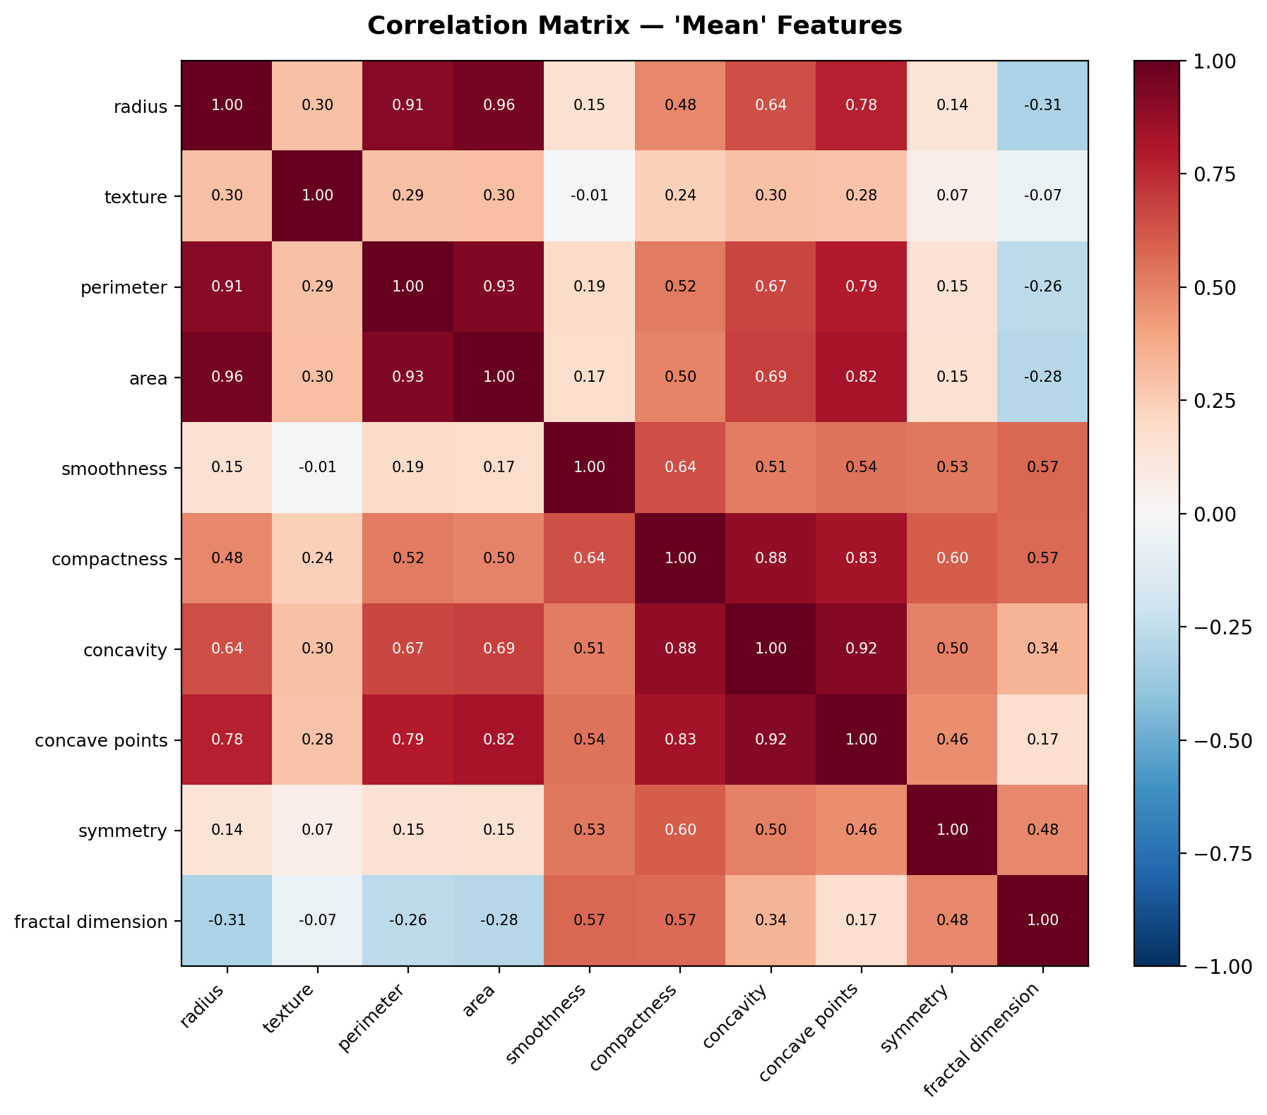
Figure 2: Correlation matrix among the 10 'mean' features
What it shows: radius, perimeter, and area are almost perfectly correlated with each other (0.91-0.96), and concavity and concave points are also very tightly linked (0.92).
Why this pattern likely exists: this is a case where the correlation is not a discovery about the disease — it's geometric necessity. Perimeter and area are both mathematical functions of radius (for a roughly circular shape, area scales with radius squared), so they are almost guaranteed to move together regardless of what the data represents. Similarly, 'concavity' and 'concave points' measure closely related aspects of the same irregular-shape phenomenon discussed in Section 3.1.
Why this matters for modeling: including all three of radius, perimeter, and area as separate input features would introduce multicollinearity — the model isn't getting three independent pieces of evidence, it's getting the same signal three times, which can destabilize coefficient estimates in linear models like Logistic Regression (though it matters less for tree-based models like Random Forest). A reasonable next step suggested by this chart alone, before any modeling begins, would be to keep only one of the three size-related features (e.g., area) to reduce redundancy.

3.3 Feature Relationships and Class Separation
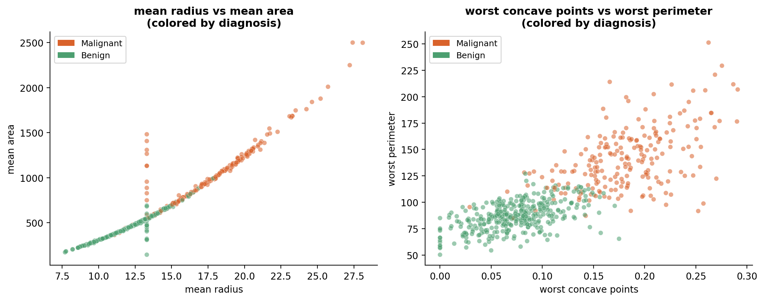
Figure 3: mean radius vs mean area (left) and worst concave points vs worst perimeter (right), colored by diagnosis
What it shows: the right scatter plot shows a diagonal separation — malignant cases cluster toward higher values on both axes simultaneously, and combining two features separates the classes more cleanly than either feature alone. To quantify this: splitting patients by whether their 'worst concave points' is above or below the dataset median shows 71.5% of above-median patients are malignant, versus only 3.2% of below-median patients.
Why this pattern likely exists: this reinforces the biological explanation from Section 3.1 — tumor size and shape irregularity tend to increase together as a tumor becomes more aggressive, so it makes sense that two related severity indicators would separate the classes even more cleanly together than either alone.
Why this matters for modeling: a 71.5% vs. 3.2% split from a single threshold on one feature is an extremely strong signal — strong enough that this feature would likely dominate a decision tree's very first split. That's useful predictive power, but it also means it would be worth checking model performance with and without this feature to understand how much the rest of the features are contributing beyond it.

3.4 Anomaly Detected: An Imputation Artifact
While building the plots above, an unexpected pattern surfaced that isn't a property of the disease at all — it's a visible trace of a Week 1 preprocessing decision.
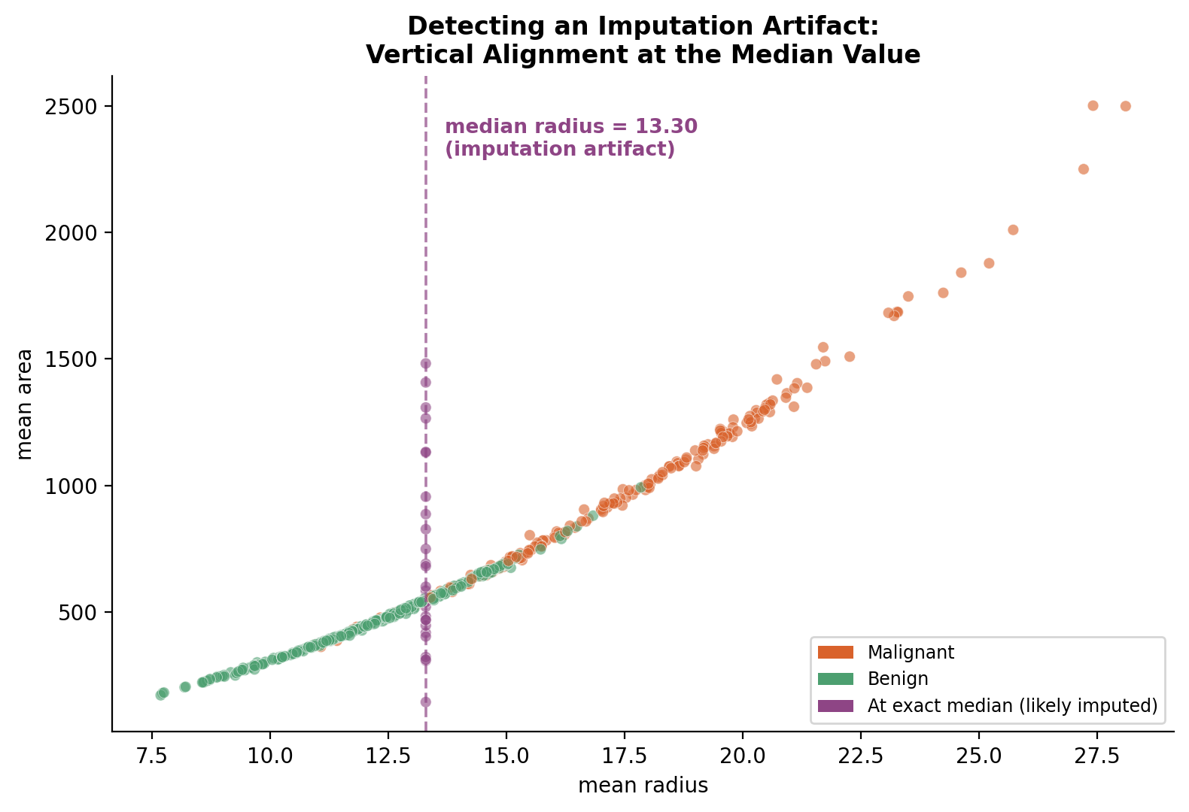
Figure 4: A vertical line of 29 points sits exactly at the median 'mean radius' value (13.30) with widely varying 'mean area' values
What it shows: a distinct vertical line of 29 points aligned exactly at mean radius = 13.30, spanning almost the entire range of 'mean area' values — a pattern that would not occur naturally, since real tumor measurements vary continuously.
Why this pattern exists: this is a direct, visible consequence of the median imputation applied to 'mean radius' in Week 1's cleaning step. The rows where 'mean radius' was originally missing were filled with the column median (13.30), but their 'mean area' values are the real, original measurements for those patients — so those points sit at a fixed x-position while spreading naturally on the y-axis, creating the artificial vertical alignment visible in the chart.
Why this matters for modeling: this is the clearest, most concrete example in this report of how a Week 1 preprocessing choice directly shapes what shows up in Week 2's analysis. Practically, it means: (1) any correlation or model coefficient involving 'mean radius' is now slightly distorted by these 29 artificially identical values, weakening the true relationship between radius and other variables; (2) a model given this feature would see an unnatural cluster of 29 identical inputs, which could show up as a minor artifact in a decision tree's split points; and (3) more broadly, it demonstrates why imputed values should ideally be flagged (e.g., with a separate 'was_imputed' indicator column) so a later model or analyst can distinguish real measurements from filled-in ones rather than treating them identically, as was done here.

4. Data Transformations Performed During Analysis
- Standardization for visual comparison: Continuous features were converted to z-scores (mean 0, std 1) in Figure 1's right panel specifically so that features with very different natural scales (e.g., 'radius' in the 7-28 range vs. 'concave points' in the 0-0.3 range) could be shown on one shared axis for direct visual comparison.
- Group-by aggregation (malignant vs. benign): Cohen's d and t-tests in Section 2 required grouping the dataset by the 'diagnosis' column and computing separate means/standard deviations for each group — this aggregation is what actually revealed which features were worth visualizing at all.
- Threshold binning: For the median-split analysis in Section 3.3, the continuous 'worst concave points' feature was temporarily converted into an above/below-median binary grouping purely to compute and communicate a simple, interpretable conditional probability (71.5% vs 3.2%) — the underlying continuous feature was not altered for any other part of the analysis.

5. Conclusion
This EDA moved beyond simply presenting charts: each visualization was paired with a quantified statistic (effect size, correlation coefficient, or conditional probability) and an explanation of why the pattern likely exists, tying back to either the biology of tumor growth or, in one case, directly back to a specific preprocessing decision from Week 1. The clearest finding — the imputation artifact in Figure 4 — is a concrete demonstration that data cleaning and analysis are not separate, sequential stages that can be evaluated independently; choices made while cleaning data actively surface in and shape everything analyzed afterward. The features identified here (particularly 'worst concave points' and 'worst perimeter') and the redundancy flagged in the correlation analysis directly inform what a subsequent modeling phase should prioritize and be cautious of.

