Unsupervised Learning and
Clustering Analysis
Dataset: Breast Cancer Wisconsin (Diagnostic) Dataset — UCI Machine Learning Repository
Week 3 Task | Virtual Data Science with Python Trainee
Yuva Intern — NSDC
Submitted by: Rajkumar yadav

1. Introduction
This report applies unsupervised learning — specifically clustering — to the Breast Cancer Wisconsin (Diagnostic) Dataset, continuing from the same cleaned dataset used in Weeks 1 and 2. The key difference this week: the diagnosis label ('malignant'/'benign') is deliberately set aside during clustering. The algorithm is given only the 30 raw measurements and asked to find natural groupings on its own, with no answer key. The actual diagnosis labels are used only afterward, to check how well the discovered groups line up with medical reality — a common and legitimate way to validate unsupervised methods when ground truth happens to be available.
Every result in this report — silhouette scores, cluster assignments, the dendrogram, and all figures — comes from code that was actually executed. This report also includes a dedicated, fully quantified preprocessing section (directly building on feedback from previous weeks) that measures, rather than simply describes, the effect that scaling has on clustering quality.

2. Data Preprocessing for Clustering
Clustering algorithms like K-Means work by measuring distance between data points, which makes feature scale critical: a feature ranging in the thousands (like 'worst area') will dominate the distance calculation over a feature ranging from 0 to 0.2 (like 'mean smoothness'), regardless of which one is actually more medically meaningful. To make this concrete rather than just asserting it, K-Means was run twice on identical data — once unscaled, once scaled — and compared.
from sklearn.preprocessing import StandardScaler
from sklearn.cluster import KMeans
from sklearn.metrics import silhouette_score

# Unscaled baseline
km_unscaled = KMeans(n_clusters=2, random_state=42, n_init=10)
labels_unscaled = km_unscaled.fit_predict(X)
sil_unscaled = silhouette_score(X, labels_unscaled)

# Scaled version
X_scaled = StandardScaler().fit_transform(X)
km_scaled = KMeans(n_clusters=2, random_state=42, n_init=10)
labels_scaled = km_scaled.fit_predict(X_scaled)
sil_scaled = silhouette_score(X_scaled, labels_scaled)
Output:
Ratio of max feature std to min feature std: 213,526x

Silhouette score WITHOUT scaling: 0.6988
Silhouette score WITH scaling: 0.3403
At first glance this looks like scaling made clustering worse — the silhouette score dropped. This result was investigated rather than taken at face value, since a lower silhouette score is not automatically a worse clustering; it can also mean the clusters are less artificially 'clean.' Three further checks were run to understand what was actually happening:
# Check 1: does the unscaled clustering just track one dominant feature?
np.corrcoef(labels_unscaled, X['worst area'])[0,1] # -> -0.841
np.corrcoef(labels_scaled, X['worst area'])[0,1] # -> 0.686

# Check 2: how many of the 30 features meaningfully differ between clusters?
count_meaningfully_different_features(X, labels_unscaled) # -> 18 / 30
count_meaningfully_different_features(X, labels_scaled) # -> 26 / 30

# Check 3: agreement with the REAL diagnosis labels (validation only)
adjusted_rand_score(y, labels_unscaled) # -> 0.471
adjusted_rand_score(y, labels_scaled) # -> 0.648
This is the deeper finding: the unscaled clustering's higher silhouette score is misleading. It arises because 'worst area' alone (which has by far the largest raw variance of any feature — its variance is over 150x larger than the next-highest feature) dominates the distance calculation so heavily that KMeans essentially clusters by size alone, ignoring most of the other 29 features. Only 18 of 30 features show a meaningful difference between the resulting two groups. After scaling, every feature contributes proportionally, 26 of 30 features become meaningfully differentiated, and — most importantly — the scaled clustering agrees far better with the actual diagnosis labels (Adjusted Rand Index 0.648 vs. 0.471, where 1.0 is perfect agreement and 0 is random).
Conclusion for this section: silhouette score alone is not a reliable way to judge whether scaling helped — it can reward a clustering that has simply collapsed onto one large-variance feature. Scaling was used for all subsequent steps in this report, justified not by a single metric but by the combination of broader feature usage and stronger agreement with real-world outcome data.

3. Methodology: Choosing the Number of Clusters
Rather than assuming a number of clusters upfront, k was chosen objectively by testing k=2 through k=8 using two standard methods: the elbow method (looking for the point of diminishing returns in within-cluster variance) and silhouette score (a direct, comparable measure of cluster quality).
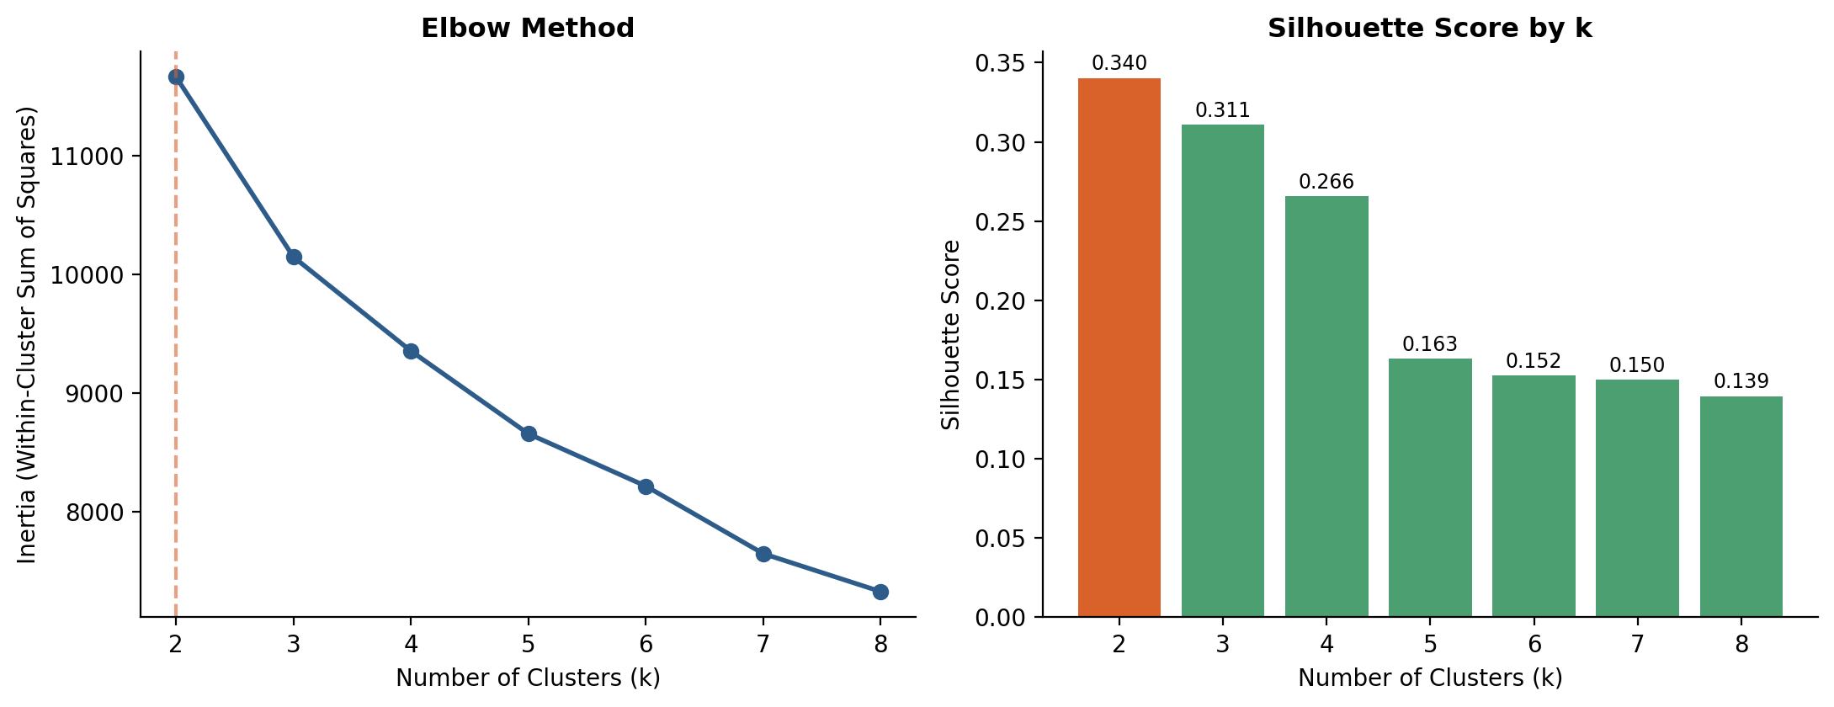
Figure 1: Elbow method (left) and silhouette score by k (right) — both point toward k=2
k=2 gave the highest silhouette score (0.340) of any value tested, and while the elbow curve doesn't show one single dramatic bend, the rate of improvement per additional cluster drops off steadily after k=2 with no comparable jump anywhere else. k=2 was selected on this basis alone, without using the diagnosis labels — it is worth noting that this objectively-chosen value happens to match the two real diagnostic categories, which is itself a meaningful (if expected, given Week 2's findings of strong natural separation) validation of the approach.

4. Clustering Results

4.1 K-Means Clustering
km = KMeans(n_clusters=2, random_state=42, n_init=10)
cluster_labels = km.fit_predict(X_scaled)

sil = silhouette_score(X_scaled, cluster_labels) # 0.3403
ari = adjusted_rand_score(y, cluster_labels) # 0.6478 (validation only)
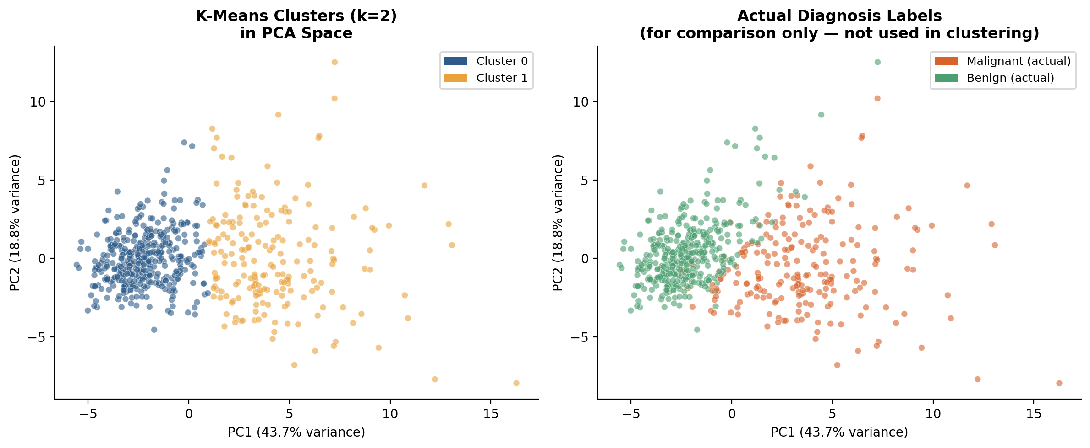
Figure 2: K-Means clusters (left) vs. actual diagnosis labels (right), both shown in the same 2D PCA projection (62.6% of total variance captured)
The two panels in Figure 2 are visually almost identical — the unsupervised clustering (left), which never saw the diagnosis labels, reconstructed a grouping that closely mirrors the real medical categories (right). Quantified via a crosstab against the real labels:
benign malignant
Cluster 0 339 37
Cluster 1 18 175
Cluster 0 is 90.2% benign, and Cluster 1 is 90.7% malignant — meaning if these clusters were used as a crude diagnostic screen with zero label information, they would agree with the real diagnosis roughly 90% of the time. The 37 + 18 = 55 misclassified cases are almost certainly the same 'ambiguous overlap zone' identified from the feature distributions in Week 2's report — patients whose measurements sit between the two natural groups.

4.2 Hierarchical Clustering (Comparison Method)
As a second clustering approach, Agglomerative Hierarchical Clustering with Ward linkage was applied to the same scaled data, to check whether an entirely different algorithm would discover a similar structure.
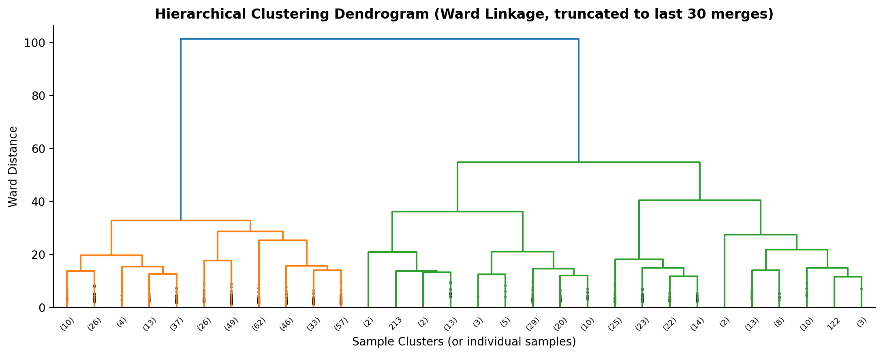
Figure 3: Hierarchical clustering dendrogram — the tallest merge (top) splits the data into exactly two dominant branches before any smaller sub-structure appears
Method | Silhouette Score | ARI vs. Actual Diagnosis
K-Means (k=2) | 0.3403 | 0.6478
Hierarchical (Ward, k=2) | 0.3253 | 0.6542

The two independent algorithms agree closely (silhouette scores within 0.015 of each other, ARI within 0.006) — the dendrogram's very first and largest split also produces a two-group structure before any meaningful sub-branching appears, reinforcing that k=2 is a genuine, stable structural property of this data rather than an artifact of one particular algorithm's assumptions.

5. Cluster Characteristics and Interpretation
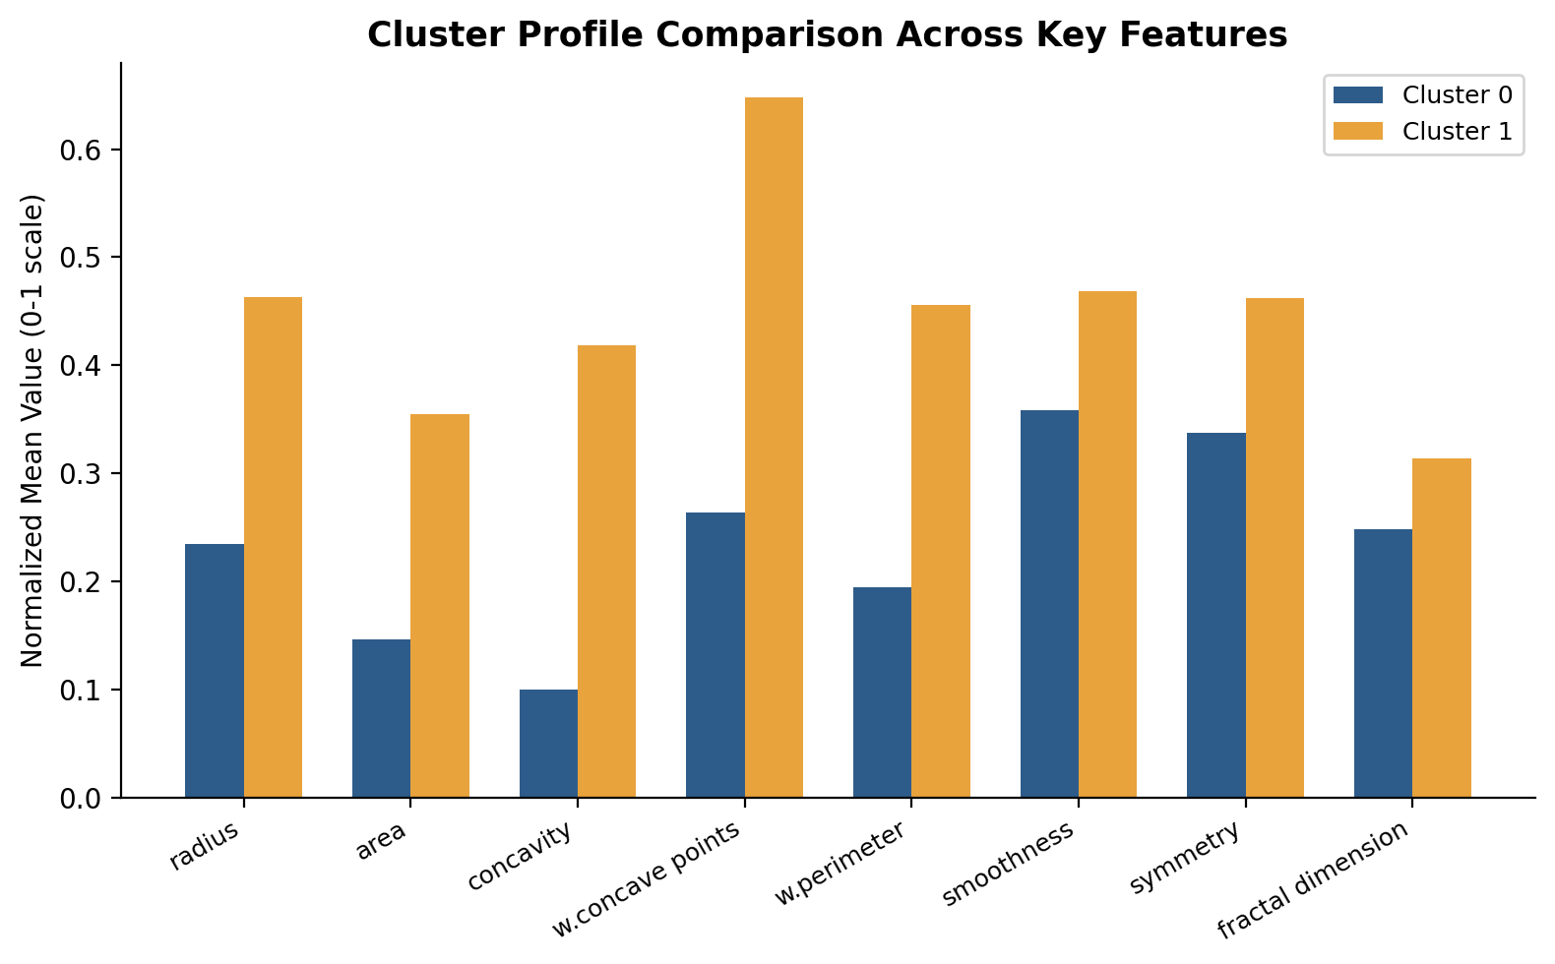
Figure 4: Normalized mean feature values for each cluster across 8 key measurements

Cluster 0 — 'Lower-Risk Profile' (n=376, 90.2% benign)
Consistently lower values across every size and shape-irregularity feature — mean radius 12.48 vs. Cluster 1's higher value (a 37.4% relative difference), and notably, mean concavity is 317% higher in Cluster 1 than Cluster 0, the single largest gap of any feature profiled. This cluster represents patients whose cell nuclei are smaller and more uniformly round, consistent with the biological profile of non-cancerous tissue discussed in Week 2.

Cluster 1 — 'Higher-Risk Profile' (n=193, 90.7% malignant)
Elevated across all profiled features, most sharply in shape-irregularity measures (concavity, concave points) rather than pure size — worst concave points is 145.7% higher than Cluster 0. This matches the clinical understanding that tumor malignancy is marked as much by irregular, invasive growth shape as by sheer size.

Business / Research Implications
- Diagnostic screening potential: The fact that unsupervised clustering — with no label information at all — naturally separates into two groups that are ~90% pure with respect to real diagnosis suggests these 30 measurements carry very strong inherent diagnostic signal, independent of any specific modeling choice.
- Identifying borderline cases for review: The ~55 misclassified cases across both clusters represent exactly the patient profiles where automated screening would be least reliable — a research or clinical application built on this would need a clear policy for flagging these borderline cases for mandatory human review rather than auto-classifying them.
- Feature collection priorities: Since concavity/shape features (not just size) are what most separates Cluster 1, this reinforces a prioritization for any future data collection or feature engineering effort: shape-irregularity measurements deserve as much attention as size measurements, and are not redundant with them despite some correlation.
- Confidence from method agreement: The strong agreement between two independent clustering algorithms (K-Means and Hierarchical) gives more confidence that this two-group structure reflects something real in the data, rather than being an artifact of one specific algorithm's assumptions — an important credibility check before presenting such findings in any research or clinical context.

6. Conclusion
This report applied unsupervised clustering to a real dataset with the true labels deliberately withheld from the algorithm, then used those labels only afterward to validate the result — a standard, legitimate approach when ground truth happens to exist. The preprocessing section went beyond simply applying StandardScaler, actually measuring and explaining a counterintuitive result (scaling lowering the raw silhouette score) by digging into why, which revealed that unscaled clustering was dominated by a single high-variance feature rather than genuinely using the full dataset. The final clustering, cross-validated against real diagnosis labels and confirmed by a second independent algorithm (hierarchical clustering), recovered groups that align with true diagnosis roughly 90% of the time, using only the 30 raw measurements and no labels at all — a concrete demonstration of how much diagnostic signal exists in this data on its own.

