# Getting started with Autodesk View and Data API

**Pre-requisites**

Install Visual Studio 2012 or Visual Studio 2013

**Get Keys**

1. Log in <http://developer.autodesk.com> with your Autodesk ID. If you do not have an Autodesk ID, apply one in a minute.
2. Click [Access Key]

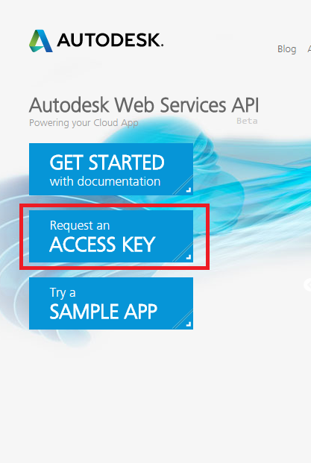

1. Register and Create an application

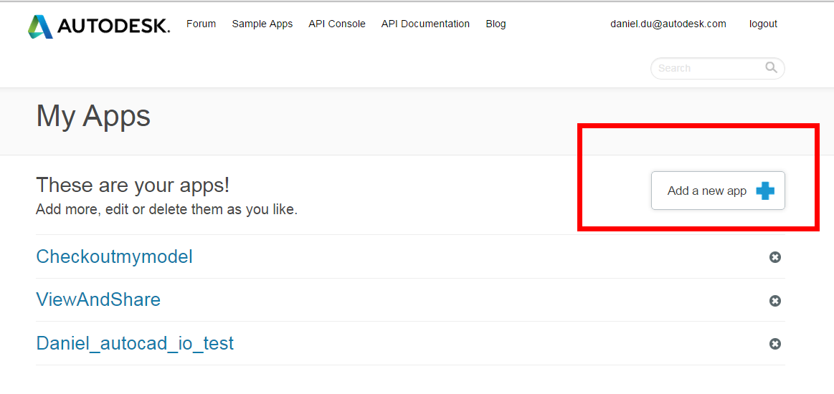

1. When creating an app, select product as “View and Data API”.
2. Fill in any URL for callback URL. It does not affect the registration currently.

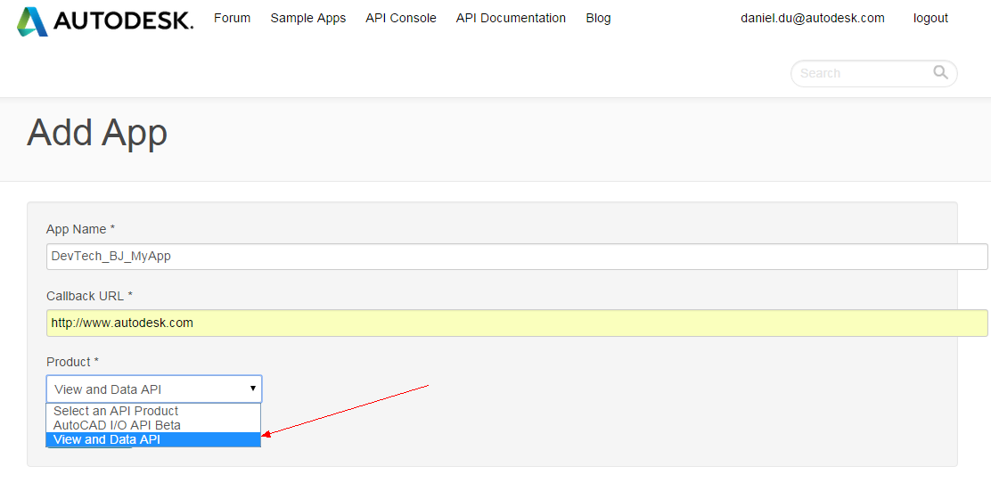

1. You will get the keys similar as below:

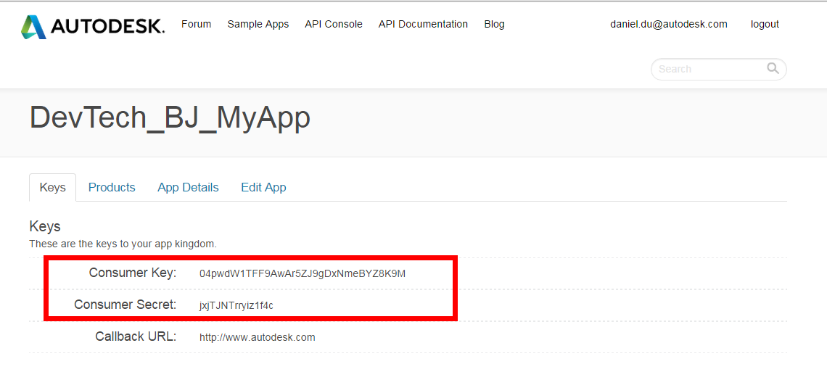

**Prepare models with utility**

To prepare viewable models, you need to upload and register your model with View and Data API, please refer to the [code samples](http://developer-autodesk.github.io/) on github.com for the workflow. For simplicity of this exercise, you can use utility to do this.

1. Download utility tool from

<https://github.com/Developer-Autodesk/workflow-dotnet-winform-view.and.data.api/>

[Clone in Desktop]: if you have Github client on your computer

[Download Zip]: if you do not have Github client. This allows you to download the project zip directly.

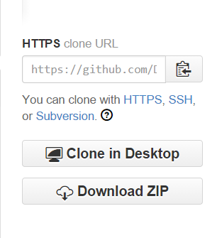

1. Build and run it

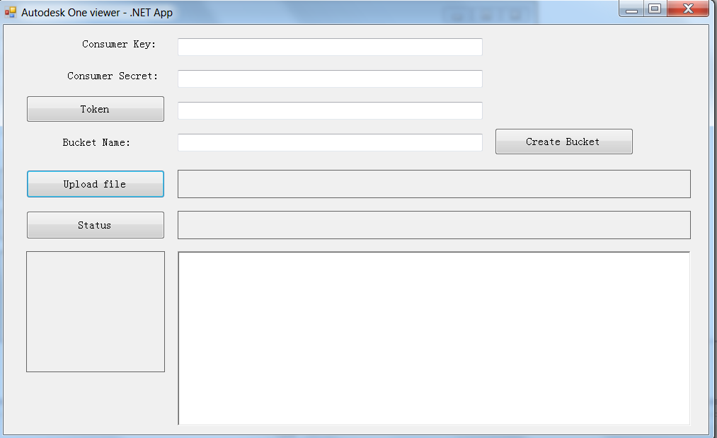

* 1. Input your own consumer key/secret key in the corresponding textboxes of the dialog
  2. Click [Token] to get access token
  3. Input a name for your bucket, it should be lower case characters and numbers, click [Create Bucket],
  4. Click [Upload File] to select a local file
  5. The log will appear in the status window. It will contain the URN of the uploaded file

**Note： the URN should start with “urn:”**

* 1. Click [Status] if you want to check the translating status.
  2. If everything works well, the thumbnail will appear.

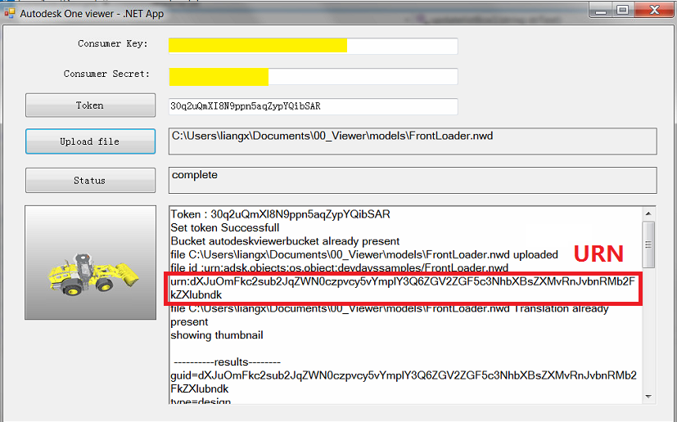

# TASK 1 – complete the basic web application with viewer

1. Open the web application **FirstViewerWebApp.sln**
2. Go to **default.aspx**, examine the page layout
   1. Add style sheet of “view and data web service” in <head> </head> tag:

  <!-- viewer-->  
    <link type="text/css"

rel="stylesheet"

href=<https://viewing.api.autodesk.com/viewingservice/v1/viewers/style.css>

/>

* 1. Add JavaScript library, just before </body> :

<script type="text/javascript"

src="https://developer.api.autodesk.com/viewingservice/v1/viewers/viewer3D.min.js">

</script>  
    <script src="Scripts/Viewer.js">

</script>

3. Go to **/Scripts/Viewer.js**

* 1. Add following JavaScript in the function **Initialize**：

 var urn = $('#urn').val();  
if (urn =='') {  
    urn = 'urn:dXJuOmFkc2sub2JqZWN0czpvcy5vYmplY3Q6ZGFuaWVsX3RyYW5zbGF0ZV9idWNrZXQzL0RyaWxsLmR3Zng=';  
}  
if (urn.substr(0,4) !=='urn:') {  
    urn = 'urn:' + urn;  
}  
   
var options = {  
    'document': urn,  
    'getAccessToken': getToken,  
    'refreshToken': getToken,  
};  
   
var viewerElement = document.getElementById('viewer');  
   
viewer = new Autodesk.Viewing.Private.GuiViewer3D(viewerElement,{});  
   
   
Autodesk.Viewing.Initializer(options, function () {  
    viewer.start();  
    loadDocument(viewer, options.document);  
});

* 1. Add more auxiliary JavaScript functions

    function loadDocument(viewer, documentId) {  
        // Find the first 3d geometry and load that.  
        Autodesk.Viewing.Document.load(documentId, function (doc) {// onLoadCallback  
            var geometryItems = [];  
            geometryItems = Autodesk.Viewing.Document.getSubItemsWithProperties(  
                doc.getRootItem(), {  
                'type': 'geometry',  
                'role': '3d'}, true);  
   
            if (geometryItems.length > 0) {  
                viewer.load(doc.getViewablePath(geometryItems[0]));  
            }  
        }, function (errorMsg) {// onErrorCallback  
            alert("Load Error: " + errorMsg);  
        });  
    }  
   
    // This method returns a valid access token   
    function getToken() {  
        // This method should fetch a token from a service you create to provide authentication.  
        // See the ADN Samples for examples of how to create such a service.  For example, see  
        // https://github.com/Developer-Autodesk/workflow-aspnet-webform-view.and.data.api/blob/master/ViewAndShare/ViewAndShare/GetAccessToken.ashx.cs  
        // This method might look something like:  
        var xmlHttp = null;  
        xmlHttp = new XMLHttpRequest();  
        xmlHttp.open("GET", "GetAccessToken.aspx", false);  
        xmlHttp.send(null);  
        var res = xmlHttp.responseText;  
        var newToken = JSON.parse(res);  
   
        if (newToken.error) {  
            console.log(newToken.error);  
            return '';  
   
        }  
        else {  
            return newToken.access_token;  
        }  
   
    }

4. Go to **Credentials.cs** , replace with your consumer key and secret:

//replace your consumer key  
        public static string CONSUMMER_KEY = "your-consumer-key";  
        public static string SECRET_KEY = "your-secret-key";

5. Launch the web project; fill in your URN (you get it in step- [prepare viewable model]) and click “load model” button to load the viewer

6. Debug and fix any issue.

7. If everything works well, you should see the model is loaded in the viewer.

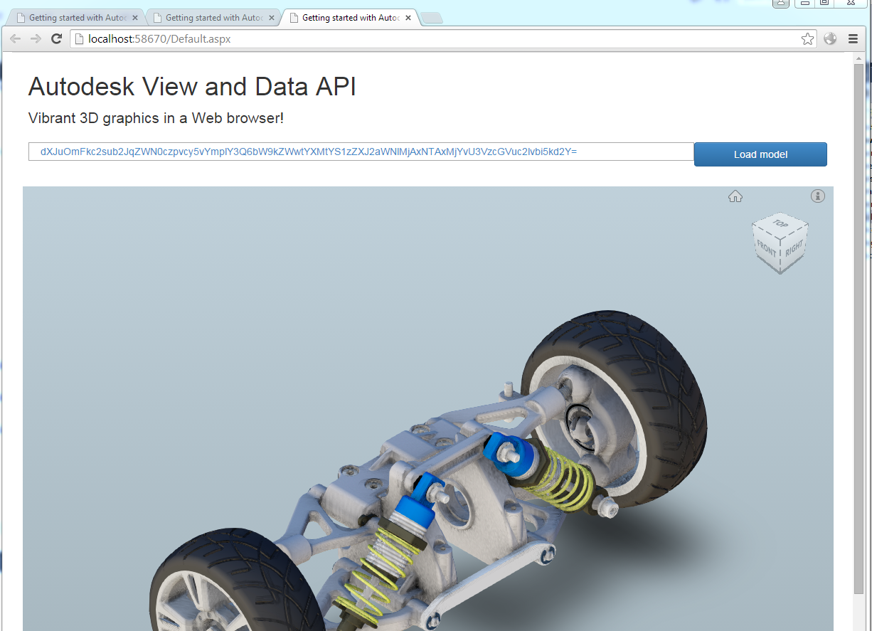

**TASK 2 – Create a simple extension**

Target: Create a viewer extension to output the properties of selected element on viewer

1. Add a new Js file in Script folder, name as BasicExtension.js
2. Copy the Extension skeleton snippet:

'use strict';  
   
//declare your namespaces  
AutodeskNamespace('MyCommpany.Extensions');  
   
   
MyCommpany.Extensions.BasicExtension = function (viewer) {  
   
    Autodesk.Viewing.Extension.call(this, viewer);  
   
}  
   
MyCommpany.Extensions.BasicExtension.prototype = Object.create(Autodesk.Viewing.Extension.prototype);  
MyCommpany.Extensions.BasicExtension.prototype.constructor = MyCommpany.Extensions.BasicExtension;  
   
//extension load  
MyCommpany.Extensions.BasicExtension.prototype.load = function () {  
   
    console.log('MyCommpany.Extensions.BasicExtension is loaded');  
    //get the viewer object

var oViewer = this.viewer;

//examine the viewer object in console  
    console.dir(oViewer);

//TODO: Add event listener for ‘selection’

//TODO: output the properties of selected element  
      
}  
   
//extension unload  
MyCommpany.Extensions.BasicExtension.prototype.unload = function () {  
   
}  
   
/**  
 * Register the extension with the extension manager.  
 */  
Autodesk.Viewing.theExtensionManager.registerExtension('BasicExtension', MyCommpany.Extensions.BasicExtension);

1. Go to Scripts\**viewer.js** , around line 23, change to following snippet, the differences is in bold.

viewer = new Autodesk.Viewing.Viewer3D(viewerElement, { **extensions: ['BasicExtension']** });

1. Go to **Default.aspx**, add following script reference before </body>

<script src="Scripts/BasicExtension.js"></script>

1. Debug and fix any issue.

If everything goes OK, go to console of Developer tools in Chrome, you should see the message is logged:

“MyCommpany.Extensions.BasicExtension is loaded”

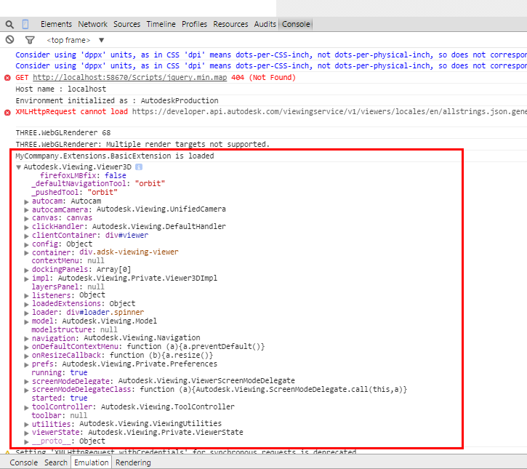

**Challenge: Select one element on model, display the properties in Chrome console:**

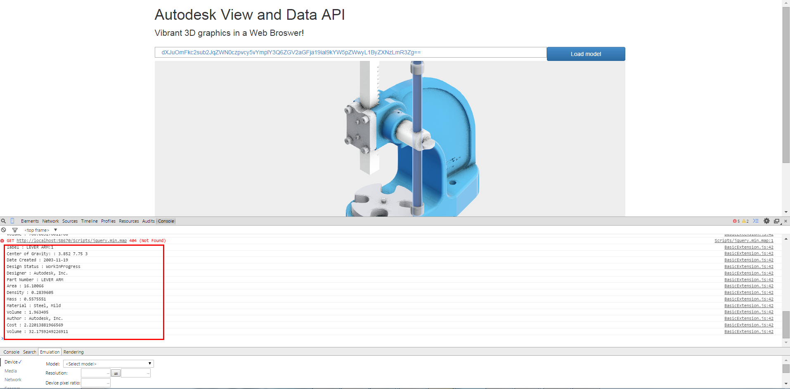

Solution for reference:

    oViewer.addEventListener('selection', function (event) {  
        var dbIdArray = event.dbIdArray;  
   
        for (var i = 0; i < dbIdArray.length; i++) {  
   
            var dbId = dbIdArray[i];  
   
            oViewer.getProperties(dbId, function (result) {  
                if (result.properties) {  
   
                    for (var i = 0; i < result.properties.length; i++) {  
   
                        var prop = result.properties[i];  
   
                        console.log(prop.displayName + ' : ' + prop.displayValue);  
   
                    }  
                }  
            });  
        }  
    });

**Help Documents:**

http://developer-dev.api.autodesk.com/documentation/v1/index.html