

Nationwide Health Information Network
Standards and Interoperability

DRAFT - SOA Lab Installation Guide



March 2012
Version 0.4

Document Change History
Version | Date | Items Changed Since Previous Version
0.1 | 3/7/2012 | Initial SOA Lab Installation Documentation
0.2 | 3/16/2012 | - “Connect Gateway Configuration” updated for RI3 , RI1-3.2 configurations  - “Install Database” corrections for Lab and RI-1-3.2 data load  - prerequisite corrections
0.3 | 3/22/2012 | - “Configure Database for ActiveMQ” updated for mysql bundle  - Removed ESB components dependencies in “Deploy the artifacts into Fuse ESB”
0.4 | 3/26/2012 | Formatting/title changes, header/footer corrections.

Table of Contents
1 Introduction 1
1.1 Document Definition 1
1.2 Document Objectives 2
1.3 Intended Audience 3
2 System Overview 3
2.1 ESB Components 4
2.2 Web Applications (User interface) 5
2.3 Gateway Agent 6
2.3.1 Methodology 6
1.1 Initiator scenario: Gateway Agents in focus in as part of the SOA solution 7
1.2 Responder scenario: Gateway Agents in focus in as part of the SOA solution 8
3 Prerequisites 9
4 Software Installation 10
4.1 Setup the development environment: 10
4.2 Java 10
4.3 SVN client 10
4.4 Download the NwHIN TestLab software 10
4.5 Apache Maven 10
4.6 Eclipse 11
4.7 Install Database 11
4.7.1 Install MySQL 11
4.7.2 Set up Lab Database 12
4.7.3 Load data for Lab Database (Naresh) 12
4.7.4 Load Documents in Reference Implementation Database 12
4.7.5 Load Documents in Participant Gateway Database 13
4.8 Fuse ESB 14
4.8.1 Install Fuse ESB 14
4.8.2 Install Karaf web console (optional) 14
4.8.3 Install ActiveMQ web console(optional) 14
4.8.4 Configure Database for ActiveMQ 15
4.9 Installation of ESB Components 16
4.9.1 Build and install the ESB Components in to Maven local repository 16
4.9.2 Deploy the artifacts into Fuse ESB 16
4.10 Installation of User Interface 17
4.10.1 Build and install Web Applications in to Maven local repository 17
4.10.2 Deploy the artifacts into Participant Gateway glassfish server 17
4.11 Install Gateway Agent 17
5 Appendix 1
5.1 Connect Gateway Configuration 1
5.1.1 Participant Configuration 1
5.1.2 Reference Implementation Configuration 1
5.2 Apache Tomcat 3
5.2.1 Assumption 3
5.2.2 Install tomcat 3
5.2.3 Set up certificate in tomcat 3
5.2.4 Copy third party jars to tomcat lib folder 4
5.2.5 Deploy the artifacts into Tomcat server 4
5.3 Import Projects in to Eclipse IDE 4
6 Glossary of Terms 7

Introduction

Document Definition
The Nationwide Health Information Network (NwHIN) is an interoperable health information infrastructure, developed for the purpose of securely connecting consumers, providers and others who have, or use, health-related data and services, while protecting the confidentiality of health information. The Onboarding process takes the candidate organization through several tests, namely conformance testing (testing to ensure the organization adheres to the specifications) and interoperability testing (testing to ensure the organization can communicate using various services with other NwHIN participants).
An automated test lab ensures candidates can quickly determine the results of these tests. The conformance and interoperability labs use event based gateways with initiator and responder scenarios, ensuring candidates possess the ability to communicate with other gateways. The main purpose of the NwHIN is to utilize a shared architecture (services, standards, and requirements) to interconnect health information exchanges and the participants / users supported. As the specifications for the NwHIN have evolved, the need for a test lab to easily support multiple gateways utilizing a Service-Oriented Architecture (SOA) has arisen.
Architectural improvements, such as the SOA implementation, were developed to stream line the maintenance of multiple gateways, reducing complexity of the architecture and enhancing usability. The current test lab is based on a SOA design, though it currently supports one customized version of the CONNECT 2.4.8 gateway. When other gateways interact with the lab, customization is required. The intent of the new architecture is to support numerous gateway types and versions, avoiding customization of code altogether. The success of a SOA deployment is measured by the level of reuse of the producer services (in this case producer services are gateways). A well thought out SOA is flexible, loosely coupled, and enables applications to rapidly integrate with published producer services.
This document describes the process and instructions for building the software and setting up a lab environment for executing and validating system test cases against CONNECT software using a SOA architecture. The document includes an overview of the architecture, hardware and software components and steps for installation of the environment.
The diagram below depicts the components of the SOA Test Harness. These components are further defined throughout the document.

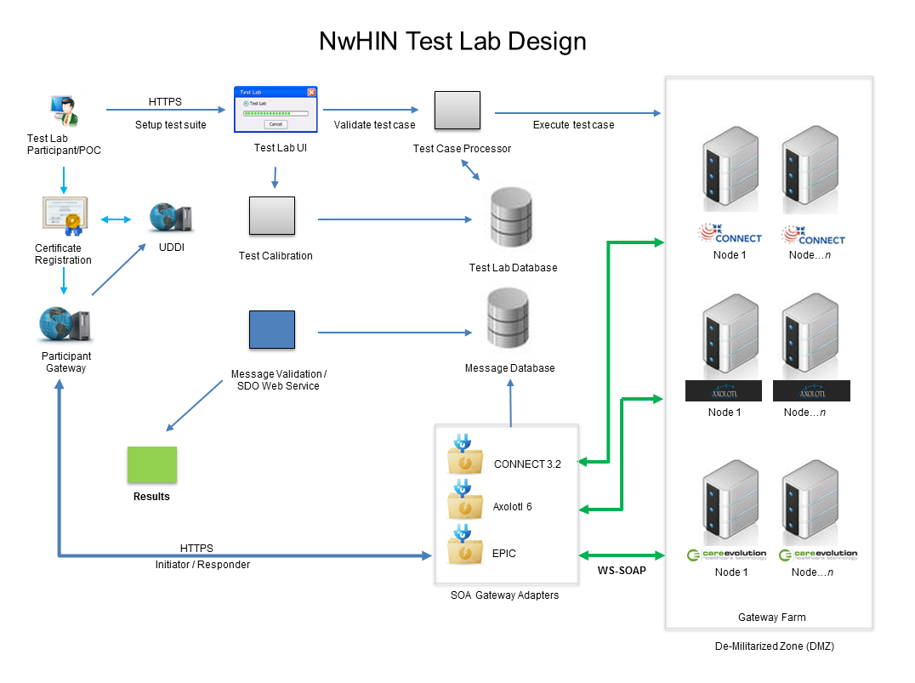
Figure 1.1 Lab Deployment diagram

Document Objectives
This document will allow developers to install and maintain the interoperability lab. This includes the understanding of the following items:
- The concept of a SOA environment for the NwHIN test lab
- The hardware and software infrastructure needed to support the lab
- The user interface which supports the lab
- The concept of a gateway agent
- Software Components: Java, SVN client, Apache Maven, Eclipse, Apache, SQL Server Database, Fuse ESB, Connect, Glassfish

Intended Audience
The intended audiences for the AEGIS LAB Architectural Documentation as follows:
- NwHIN Developers Participants and Organizations
- Developers and System Administrators
- Government Organizations (Onboarding Partners)

System Overview
The lab environment is divided into three major functional areas:
ESB Components: At the heart of the Lab environment, ESB components provide an integration platform using SOA architecture to support executing various testing scenarios against multiple versions and implementations of NHIN Gateways (CONNECT, Axolotl, EPIC etc).
Gateway Agents: Gateway agents provide a non-intrusive mechanism to intercept the cross gateway messages between NHIN Gateways thus providing an opportunity to capture and analyze the test case execution results.
Web Applications: Provide a centralized user interface for clients to create, manage, execute various test scenarios and validate the test results.
The directory structure of Lab software:
Directory | Description
NwHIN | Parent level project directory
ESBComponents | Contains all projects to be deployed to Fuse ESB server as well common projects used in Fuse ESB and User Interface  LabCore and LabCommons are common project for both ESBComponents and WebApps
Gateway/Agents | Universal Gateway Agent to capture all cross gateway messages
WebApps | User interface projects
Test | Used for testing ESB projects
Database | Contains Lab data base script file, clinical documents for QD, RD testing.
Documents | Contains reference documents and configuration files for ESBComponents and the internalConnectionInfo.xml for the Connect Gateway.

The Current source code project structure is shown below for reference.
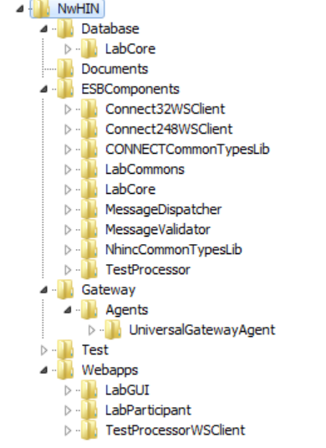

ESB Components
Fuse ESB is an open source, standards based integration platform. It reduces the complexity of integrating disparate applications by leveraging the SOA principles and standardized packaging frameworks. ESB acts as a shared messaging layer for connecting applications and other services and it supplements its core asynchronous messaging backbone with intelligent transformation and routing to ensure messages are passed reliably.
The Lab in SOA environment is the enhanced version on current Interoperability lab. The new SOA lab supports the existing functionality with additional features given below:
- Multiple gateway version support.
- Asynchronous processing.
- Capturing and validating the actual Inbound/Outbound cross gateway SOAP messages.
- Event based test case status updates.
- The source code for the ESB Components consists of the following projects
Project | Description
LabCore | DAO & Service component used in other components to access the Lab database.
MessageDispatcher | Service component that dispatch the test case parameters to the corresponding client based on the target gateway type.
LabCommons | Utility component used by all components.
MessageValidator | Service component that validates the Inbound/Outbound messages to determine the pass/fail status for the test case.
CONNECTCommonTypesLib | Connect 3.2 Commons library used by Connect32WSClient component
NhincCommonTypesLib | Connect 2.4.8 Commons library used by Connect248WSClient component
Connect32WSClient | Connect 3.2 web service client.
Connect248WSClient | Connect 2.4.8 web service client.
TestProcessor | Web Service component used to submit requests from GUI applications to the queues.

Web Applications (User interface)
The user interface contains all the Test Scenarios and their associated Test Cases to test an NwHIN Health Information Exchange's (NHIE) ability to interact with other NHIE gateways to exchange healthcare information on consumers. The Test Scenarios are categorized by NwHIN core service functionality. An NHIE must conduct tests as both an initiating gateway and a responding gateway and the interoperability user interface provides a platform for the NHIE participants to register and execute these Test Cases.
The source code for the User interface consists of the following web projects:

Project | Description
LabGUI | User Interface component for interoperability testing.
LabParticipant | User Interface component used to execute the test cases which is part of active service set.
TestProcessorWSClient | TestProcessor webService client used in LabGUI and LabParticipant.

Gateway Agent
This section introduces the concept of a gateway agent, its role in the Service Oriented Architecture (SOA) based lab, and provides bi-directional transaction scenarios on how it would interact with other components in the lab. This concept will allow us to completely eliminate customizations to a gateway product as well as the web service stack currently in place for the purpose of extracting cross gateway messages.

Methodology
A cross gateway transaction could be observed in two fundamental scenarios namely the initiator scenario and the responder scenario. The SOA diagram below presents the workflow steps identified in the sequential order based on two types of scenarios.

Initiator scenario: Gateway Agents in focus in as part of the SOA solution
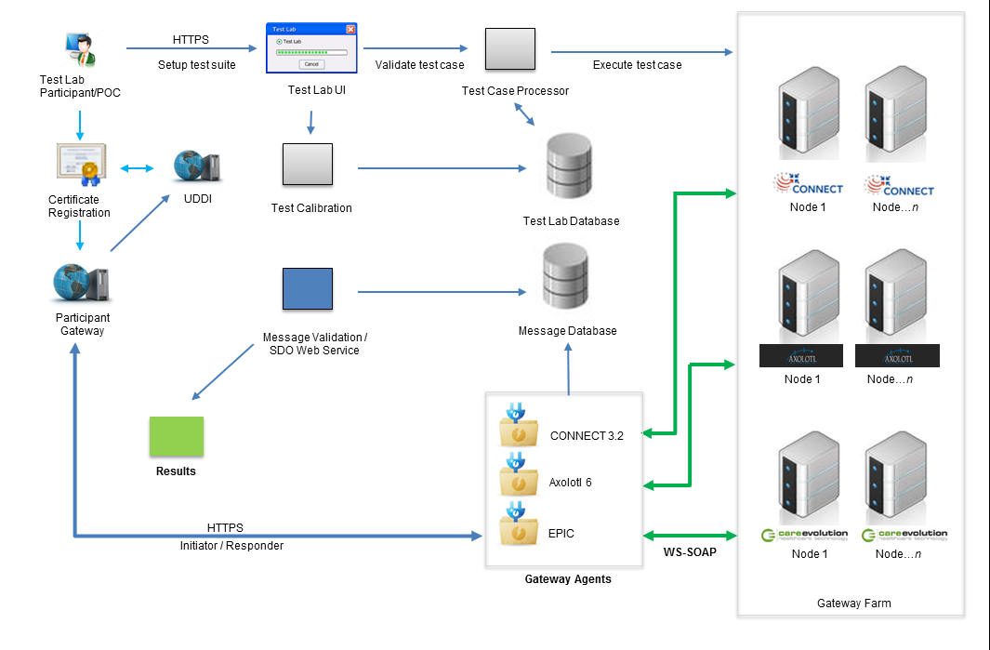
1
2
3
4
Figure 2
Step 1: In an initiator scenario the participant’s gateway initiates a request. This request is sent to a certain web service endpoint URL as found in the UDDI registry based on the HCID. This URL in the pre-SOA lab would be the endpoint of the actual gateway node in the test lab as defined in the test case. In the proposed SOA based lab, we would use an abstract endpoint to setup a URL in the UDDI that points to the agent’s hostname rather than the actual gateway that provides the web services. For each type of a gateway node an endpoint would be published using the gateway agent’s hostname distinguished by the node parameter. If needed agents could be deployed in a dedicated fashion to handle one node at a time as well.
Step 2: A request is submitted to a lab agent’s endpoint. When a message is en-route to its intended destination the gateway agent acts as a representative of the target gateway to help assist the message delivery to the actual gateway node. The focal point of the diagram (Figure ) is the Agent component and it portrays how it interacts with other components as part of the whole cross-gateway message exchange process.
Step 3: A request is handled by the gateway agent. When any type of transaction is handled by the agent, it would be recorded using a message queue which is later persisted into a database table. A gateway agent provides a rule based interceptor that takes the original agent’s endpoint and rewrites it to point to an actual gateway in the gateway farm.
Step 4: A lab gateway node receives a request. After the request has been processed by gateway node the response is sent back to the initiating gateway through the agent.

Responder scenario: Gateway Agents in focus in as part of the SOA solution
1
2
5
3
4
Figure 3
Step 1: In a responder scenario the request is initiated by a gateway within the gateway farm. The endpoint of the participant’s gateway is retrieved from the UDDI but it is encoded in a base 64 encoded form parameter to the agent.
Step 2: A gateway client will be used to prepare a request with the encoded URL as shown above.
Step 3: The gateway sends a cross-gateway request to the agent with an encoded URL.
Step 4: The agent would decode the encoded parameter as show below.
https://participant-gateway:443/NhinService/PatientDiscovery
Next, the request is sent to the participant’s gateway using the decoded URL.
Step 5: The participant gateway receives a message from the agent.

Prerequisites
Follow the below link to install Connect.
Reference document for connect installation can be found at public repository path “https://developer.connectopensource.org/display/NHINR24/Release+2.4+Home”
While the NwHIN lab setup can have ESB components and CONNECT installed on different physical machines, the instructions provided in this document assume both are installed on the same machine and CONNECT is installed before the ESB components. Connect must be installed prior to setting up any ESB components.
The Lab software comes with a pre-canned test scenarios prepared to test against a predefined network of CONNECT Gateways as listed below. User can either replicate the similar configuration of the CONNECT Gateways or modify the test scenarios to suite their CONNECT Gateways setup.
The hardware set up below is required to run test case scenarios and test cases. The set up below is what is currently available in the AEGIS lab.
It is recommended that set up participant gateway with both connect and NwHIN SOA Lab components on the same machine as connection status check functionality of SOA LAB is depending on connect code.

Environment/K3#p0ut]
Machine | Hardware/Software | HCID/AA | Description
RI1 Gateway  (required) | Win2003 Server; 5Gb RAM | 2.16.840.1.113883.0.101 | Connect 2.4.8 software
RI2 Gateway  (required) | Win2003 Server; 5Gb RAM | 2.16.840.1.113883.0.102 | Connect 2.4.8 software
RI3 Gateway  (required) | Win2003 Server; 5Gb RAM | 2.16.840.1.113883.0.103 | Connect 2.4.8 software
Participant Gateway  (recommended) | Win2003 Server; 6Gb RAM | 2.16.840.1.113883.0.200 | Connect 2.4.8 and NwHIN Lab software
RI1-3.2 Gateway  (required) | Win2003 Server; 5Gb RAM | 2.16.840.1.113883.0.104 | Connect 3.2 Gateway software

As part of the connect source code installation (on Windows), connect copies default internalconnection.xml, mpi.xml to <connect_server> and we need to modify both internalconnection.xml and uddiConnectionInfo.xml with above HCID as well as modify patient information in mpi.xml.
Reference: “5.1 Connect Gateway Configuration” in Appendix section for more information

Software Installation

Setup the development environment:
Download and install the following software. This should be done in the order specified below.

Java
Download and install Java Platform Standard Edition (Java SE) 6 Update 18.
Set the environment variable “JAVA_HOME”.
Update the system environment variable “PATH” as PATH=%JAVA_HOME%\bin;%PATH%
Open command prompt window and enter the command “java -version” to make sure it displays the correct version of java.
Reference: https://developer.connectopensource.org/display/NHINR24/Installing+Java

SVN client
- Download TortoiseSVN 1.6.12, Build 20536 - 64 Bit, Subversion 1.6.15
Reference: https://developer.connectopensource.org/display/NHINR24/Installing+a+Subversion+Client

Download the NwHIN TestLab software
Assumption: The SVN repository server or other source control tool will be available.
- Download the software from the CD into a location “C:\NwHIN” on the local file system and assume this directory as “<NwHIN_software_install_dir>”. It contains the source code, database and related documentation.

Note: A list of locations where the database password is used:
- Database\LabCore\readme.txt(58): mysql -v -uroot -pPASSWORD < lab_data_setup.sql
- Database\LabCore\readme_Dev.txt(47): mysql -v -uroot -pPASSWORD < lab_data_setup.sql
- ESBComponents\LabCore\src\main\resources\META-INF\config\hibernate.cfg.xml(12): <property name="connection.password">PASSWORD</property>
- Gateway\Agents\UniversalGatewayAgent\com.predic8.membrane.core\configuration\monitor-beans.xml(352): <property name="password" value="PASSWORD" />

Apache Maven
- Make sure that you have Apache Maven 2.2.1 installed, not 3.x version.
You can download Maven from http://maven.apache.org/.
Windows Version: http://www.apache.org/dyn/closer.cgi/maven/binaries/apache-maven-2.2.1-bin.zip

- Ensure that the M2_HOME environment variable is set to your Maven installation directory and also set the PATH=%PATH%\%M2_HOME%\bin;

- Increase the amount of memory available to Maven by setting the MAVEN_OPTIONS environment variable as follows:

Windows: set MAVEN_OPTS=-Xmx768m

- Open a Windows command prompt and run “mvn -version” to display the maven version installed.
- Maven uses the directory <user home directory>\.m2 as the default root directory for maintaining its local repository and configuration. So, create .m2 directory if doesn’t exist under user’s home directory.
Note: Windows may not allow creating a directory with name .m2 from the Windows explorer. If so, use Windows command prompt (<user home directory>mkdir .m2)
- Copy the settings.xml from <NwHIN TestLab software root dir>\Documents into <user home directory>\.m2. This file contains the necessary configuration used by Maven to download thirdparty jars from Fuse ESB repository

Eclipse
- Download Eclipse Java EE IDE for Web Developers. Version: Helios Service Release 2 from below URL http://www.eclipse.org/downloads/packages/eclipse-ide-java-ee-developers/heliossr2

Windows 64-bit version:
http://www.eclipse.org/downloads/download.php?file=/technology/epp/downloads/release/helios/SR2/eclipse-jee-helios-SR2-win32-x86_64.zip
- Unzip the contents into a location “C\Eclipse3.6” and assume eclipse installation directory “C\Eclipse3.6” as <eclipse_install_dir>.
- Go to <eclipse_install_dir> and create a shortcut for eclipse.exe and add it to the Start menu. An eclipse icon is added to the Start menu.
- Click on the eclipse icon to open eclipse IDE
Note: Refer Appendix “5.3 to import projects in to eclipse IDE”

Install Database

Install MySQL
- Follow connect reference document to install MySQL database
https://developer.connectopensource.org/display/NHINR24/Source+Code+Install+%28Windows%29#SourceCodeInstall%28Windows%29-Databasesetup

Set up Lab Database
Open command prompt and issue the following command (Note that since the MySQL install has made changes to the path environment variable, it will be necessary to open a new command window.):
cd <NwHIN_software_install_dir>\Database\labdb

mysql -v -uroot -pPASSWORD < lab_DDL.sql

Load data for Lab Database
- Open the file lab_DML.sql under <NwHIN_software_install_dir>\Database\labdb \ folder and update the set host name parameters values
set @hostname_participant := 'local.example.com';
set @hostname_RI1 := 'RI1.example.com ';
set @hostname_RI2 := 'RI2.example.com ';
set @hostname_RI3 := 'RI3.example.com ';
set @hostname_RI1_Connect32 := 'RI1_Connect32.example.com ';
- Open command prompt and issue the following command:
cd <NwHIN_software_install_dir>\Database\labdb

mysql -v -uroot -pPASSWORD < lab_DML.sql

Load Documents in Reference Implementation Database
- Log on to RI1 server
- Download RI1_patient_docs.sql to C:\DBScripts from the CD
  - NwHIN/Database
- Open command prompt and issue the following command:
  - C:\> cd DBScripts

  - C:\ DBScripts > mysql -v -uroot -pPASSWORD < RI1_patient_docs.sql
- Log on to RI2 server
- Download RI2_patient_docs.sql to C:\DBScripts from the CD
  - NwHIN/Database
- Open command prompt and issue the following command:
  - C:\> cd DBScripts

  - C:\ DBScripts > mysql -v -uroot -pPASSWORD < RI2_patient_docs.sql
- Log on to RI3 server
- Download RI3_patient_docs.sql to C:\DBScripts from the CD
  - NwHIN/Database
- Open command prompt and issue the following command:
  - C:\> cd DBScripts

  - C:\ DBScripts > mysql -v -uroot -pPASSWORD < RI3_patient_docs.sql
- Log on to RI1-3.2 server (Connect 3.2 Gateway)
- Download RI1_connect32_patient_docs.sql to C:\DBScripts from the CD
  - NwHIN/Database
  - Open the file and update the HCID value (set @HCID: = '2.16.840.1.113883.0.104';)
- Open command prompt and issue the following command:
  - C:\> cd DBScripts

  - C:\ DBScripts > mysql -v -uroot -pPASSWORD < RI1_connect32_patient_docs.sql

Load Documents in Participant Gateway Database
- Log on to Participant server
- Download Participant_patient_docs.sql to C:\DBScripts from the CD
  - NwHIN/Database
- Open command prompt and issue the following command:
  - C:\> cd DBScripts

  - C:\ DBScripts > mysql -v -uroot -pPASSWORD < Participant_patient_docs.sql

Fuse ESB

Install Fuse ESB
- Download Apache-Servicemix-4.4.0-Fuse-00-43 from http://fusesource.com/products/enterprise-servicemix/#download
- Unzip the downloaded zip file into a location on the local file system. Make sure the path doesn’t contain spaces. Let’s call FuseESB installation directory as FUSE_HOME.
- Open the file < FUSE_HOME >/etc/system.properties and update the property “org.osgi.service.http.port=7001”.
- Open the file < FUSE_HOME >/bin/servicemix.bat and append the following options to DEFAULT_JAVA_OPTS.
“-XX:PermSize=256m -XX:MaxPermSize=256m”
- Open a Windows command prompt and execute the following commands.
<FUSE_HOME>\bin\servicemix.bat --Launch FuseESB
karaf@root>list --List installed features and bundles
karaf@root>shutdown --Shutdown FuseESB

Karaf is a lightweight OSGi container that is bundled with ServiceMix and provides a console interface for managing the ServiceMix.

Install Karaf web console (optional)
- If you are not already running ServiceMix, open a Windows command prompt and execute the following commands.
<FUSE_HOME>\bin\servicemix.bat --Launch FuseESB
karaf@root>features:install webconsole
karaf@root>refresh
karaf@root>list

- To access Karaf console, open a browser and go to http://localhost:7001/system/console . Enter the login details user: smx and password: smx.

Install ActiveMQ web console(optional)
- Shutdown the ServiceMix if already running (karaf@root>shutdown)
- Edit <FUSE_HOME>\etc\system.properties and add the following configuration
webconsole.type=properties
webconsole.jms.url=tcp://localhost:61616
webconsole.jmx.url=service:jmx:rmi:///jndi/rmi://localhost:1099/karaf-root
webconsole.jmx.user=smx
webconsole.jmx.password=smx

<FUSE_HOME>\bin\servicemix.bat --Launch FuseESB
karaf@root> features:install activemq-web-console
karaf@root>refresh
karaf@root>list

To access the ActiveMQ web console, open a browser and go to the URL http://localhost:7001/activemqweb

Configure Database for ActiveMQ
- Create the database schema for ActiveMQ by executing the following commands.
mysql –uroot –p<password>
mysql> CREATE DATABASE `activemq` ;
mysql> GRANT ALL ON activemq.* TO 'nhincuser'@'localhost' IDENTIFIED BY 'nhincpass';
mysql> GRANT ALL ON activemq.* TO 'nhincuser'@'127.0.0.1' IDENTIFIED BY 'nhincpass';
mysql> GRANT ALL ON activemq.* TO 'nhincuser'@'{host name}' IDENTIFIED BY 'nhincpass';

- Copy < NwHIN_software_install_dir >\Documents\activemq-broker.xml to <FUSE_HOME>\etc.
- Install the JDBC driver in ServiceMix:
karaf>osgi:install -s mvn:com.mysql.jdbc/com.springsource.com.mysql.jdbc/5.1.6

- Install Apache commons dbcp in ServiceMix
karaf>osgi:install -s mvn:org.apache.servicemix.bundles/org.apache.servicemix.bundles.commons-dbcp/1.2.2_5

- Re-install the ActiveMQ broker in ServiceMix
karaf> features:uninstall activemq-broker
karaf> features:install activemq-broker

Verify that the following three tables are created under the schema “activemq”
activemq_acks, activemq_lock and activemq_msgs
Note: If the above tables are not created in MySQL, restart the Fuse server so it can pick up the new changes.
Note: The mysql-connector jar should be copied from connect third party to the following location C:\apache-servicemix\apache-servicemix-4.4.0-fuse-00-43\lib\endorsed if the jar is missing.

Installation of ESB Components

Build and install the ESB Components in to Maven local repository
- Open command line window and go to <NwHIN_software_install_dir>\ESBComponents and execute the following maven command.
mvn clean install
- Verify that the jar files are installed in maven local repository
.m2\repository\net\aegis\ LabCommons\1.0.0\ LabCommons-1.0.0.jar
.m2\repository\net\aegis\gateway\client\Connect248WSClient\1.0.0\ Connect248WSClient-1.0.0.jar
.m2\repository\net\aegis\gateway\client\Connect32WSClient\1.0.0\ Connect32WSClient-1.0.0.jar
.m2\repository\net\aegis\ TestProcessor \1.0.0\ TestProcessor -1.0.0.jar
.m2\repository\net\aegis\LabCore\1.0.0\LabCore-1.0.0.jar
.m2\repository\net\aegis\MessageDispatcher\1.0.0\MessageDispatcher-1.0.0.jar
.m2\repository\net\aegis\MessageValidator\1.0.0\MessageValidator-1.0.0.jar

Deploy the artifacts into Fuse ESB
- Copy features.xml from NwHIN/Documents/features.xml to “<FUSE_HOME>\etc\” folder
- Execute the following commands from the Karaf console.
karaf@root> features:addUrl file: <file path>/features.xml --Install the features file
Ex : features:addUrl file: <FUSE_HOME>/etc/features.xml
karaf@root> features:listUrl --Verify the installation of the file
karaf@root> features:install esb-components --Install the Lab ESB feature
karaf@root> features:list | grep esb-components --Verify the ESB feature
karaf@root>list

Installation of User Interface

Build and install Web Applications in to Maven local repository
- Open command line window and navigate to <NwHIN_software_install_dir>\ Webapps and execute the following command.

mvn clean process-resources -DbuildNumber="1" -DbuildVersion="2.0" install

Note: The buildNumber and buildVersion parameters need to be incremented for each build which will be used only in the LabGUI project.

- Make sure the jar files are installed in maven local repository
\.m2\repository\net\aegis\ TestProcessorWSClient \1.0.0\ TestProcessorWSClient -1.0.0.jar
\.m2\repository\net\aegis\LABGUI\1.0.0\ LABGUI-1.0.0.war
\.m2\repository\net\aegis\LabParticipant\1.0.0\ LabParticipant-1.0.0.war

Deploy the artifacts into Participant Gateway glassfish server
- Make sure environment variable is added “aegis.implementation.environment=dev” in order to pick the development data base.
- Deploy “LabGUI.war” from “<NwHIN_software_install_dir>\Webapps\LabGUI\target” to participant/candidate gateway server using Glassfish admin console.
- Deploy “LabParticipant.war” from “<NwHIN_software_install_dir>\Webapps\ LabParticipant \target” to participant/candidate gateway server using Glassfish admin console.

Note: If you want deploy the User interface projects to Tomcat server instead of participant gateway glassfish server, refer “Apache Tomcat” section in Appendix

Install Gateway Agent
Download contents from Gateway/Agents/UniversalGatewayAgent/bin.zip into a location “C:\NwHIN”
1. Unzip the downloaded zip file.
2. Set MEMBRANE_HOME to <install_path>\router\membrane-router-2.0.4\
Note: Folder structure may need to be created if it doesn’t exist.
Note: Copy stax2-api-3.0.1.jar, stax-api-1.0.1.jar, and woodstox-core-asl-4.0.5.jar if they are missing.
3. Edit monitor-beans.xml <install_path>\router\membrane-router-2.0.4\config
- Set database URL
4. Edit rules.xml under <install_path>\router\membrane-router-2.0.4\config
- Make sure the certificates and keystores are valid in rules.xml
- Make sure hostnames are set
- Make sure port numbers do no conflict
5. Update the service endpoint hostname and port number in InternalConnectionInfo.xml on the participant and RI's servers
- Participant_Hostname:portnumber -> agent_Hostname:portnumber
- Server_Hostname:portnumber -> agent_Hostname:portnumber
- Run memrouter.bat (May require admin privileges)
- Test by entering the updated endpoint with ?wsdl in a browser window.

Appendix

Connect Gateway Configuration
As part of the connect installation process, connect copies default configuration files to “<server>/domain/domain1/config/nhin” folder and we have modified these files as per Conformance and Interop test cases definition.
Below are the list of configuration files need to updated in participant and Reference Implement (RI) gateway servers
List of Configuration files
config/mpi.xml
config/nhin/ internalConnectionInfo.xml

Note:
- open internalConnectionInfo.xml in notepad and verify HCID and host names are correct
- Open mpi.xml in notepad and verify HCID value and patient identifiers.

Participant Configuration
- Navigate to “<NwHIN_software_install_dir>\Documents\Connect-Gateways\Participant” folder
- Copy “config” directory from “<NwHIN_software_install_dir>\Documents\Connect-Gateways\Participant to “<Participant -Server>/domain/domain1/config/nhin” directory using remote desktop option

Reference Implementation Configuration
RI1 configuration files:
Assumption: The format of “Unique Patient-Id” in mpi.xml is assumed as “RI1. <last 3 digits of HCID>.<5-digit-patientID>”
- Navigate to “<NwHIN_software_install_dir>\Documents\Connect-Gateways\RIs\RI1” folder path
- Copy “config” directory from “<NwHIN_software_install_dir>\Documents\Connect- Gateways\RIs\RI1” to “<RI1-server>/domain/domain1/config/nhin” directory using remote desktop option
RI2 configuration files:
Assumption: The format of “Unique Patient-Id” in mpi.xml is assumed as “RI2. <last 3 digits of HCID>.<5-digit-patientID>”
- Navigate to “<NwHIN_software_install_dir>\Documents\Connect-Gateways\RIs\RI2” folder path
- Copy “config” directory from “<NwHIN_software_install_dir>\Documents\Connect- Gateways\RIs\RI2” to “<RI2-server>/domain/domain1/config/nhin” directory using remote desktop option
RI3 configuration files:
Assumption: The format of “Unique Patient-Id” in mpi.xml is assumed as “RI3. <last 3 digits of HCID>.<5-digit-patientID>”
- Navigate to “<NwHIN_software_install_dir>\Documents\Connect-Gateways\RIs\RI3” folder path
- Copy “config” directory from “<NwHIN_software_install_dir>\Documents\Connect- Gateways\RIs\RI3” to “<RI3-server>/domain/domain1/config/nhin” directory using remote desktop option
RI1-3.2 configuration files:
Assumption: The format of “Unique Patient-Id” in mpi.xml is assumed as “RI1. <last 3 digits of HCID>.<5-digit-patientID>”
- Navigate to “<NwHIN_software_install_dir>\Documents\Connect-Gateways\RIs\RI1-3.2” folder path
- Copy “config” directory from “<NwHIN_software_install_dir>\Documents\Connect- Gateways\RIs\RI1-3.2” to “<RI1-3.2-server>/domain/domain1/config/nhin” directory using remote desktop option

Apache Tomcat

Assumption
Install the tomcat server on the connect participant gateway machine.

Install tomcat
- Download Apache Tomcat v6.0.35 from url “http://tomcat.apache .org/download-60.cgi#6.0.35”
Windows 64-bit
http://ftp.wayne.edu/apache/tomcat/tomcat-6/v6.0.35/bin/apache-tomcat-6.0.35-windows-x64.zip
- Unzip the contents into a location “C:\tomcat-6” and assume tomcat installation directory “C:\tomcat-6” as <tomcat_install_dir>
- Tomcat listens on the default port 8080. If this port is conflicting with any software that is running on the system for example CONNECT, change the default port 8080 to an unused port for example 8282 in <tomcat_install_dir>\conf\server.xml.

Set up certificate in tomcat
- Append java options for trust store and trust store password in <tomcat_install_dir>\bin\catalina.bat
-Djavax.net.ssl.trustStore="<connect_server>/config/cacerts.jks"
-Djavax.net.ssl.trustStorePassword="changeit"
Note: cacerts.jks contains all certificates information and the file will be available in participant connect gateway server path
Reference content of catalina.bat file is below:
set JAVA_OPTS=%JAVA_OPTS% -Djavax.net.ssl.trustStore="C:/Sun/AppServer/domains/domain1/config/cacerts.jks" -Djavax.net.ssl.trustStorePassword="changeit" %LOGGING_CONFIG%

Copy third party jars to tomcat lib folder
- Copy all jars from “<NwHIN_software_install_dir>\ThirdPartyJars\XStream” directory to “<tomcat_install _dir>\lib” folder

Deploy the artifacts into Tomcat server
- Make sure environment variable is added “aegis.implementation.environment=dev” in order to pick development data base.
- Copy “LabGUI.war” from “<NwHIN_software_install_dir>\Webapps\LabGUI\target” to “<tomcat_install _dir>\webapps” directory .
- Copy “LabParticipant.war “ from “<NwHIN_software_install_dir>\Webapps\ LabParticipant \target” to “<tomcat_install _dir>\webapps” directory
- Start the tomcat server from “<tomcat_install _dir>\bin\ startup.bat
- Open browser and type http://localhost:8080/LabGUI/security/SignOn to access login to LabGUI
Note: Verify the port number that is configured as part of tomcat installation step

Import Projects in to Eclipse IDE
- Open Eclipse IDE and chose work space for projects as “<NwHIN_software_install_dir>”(C:\NwHIN)
- Navigate to “File” menu and choose “import” sub menu under File which will open pop up window and choose “existing projects in workspace under General “ in pop up as below

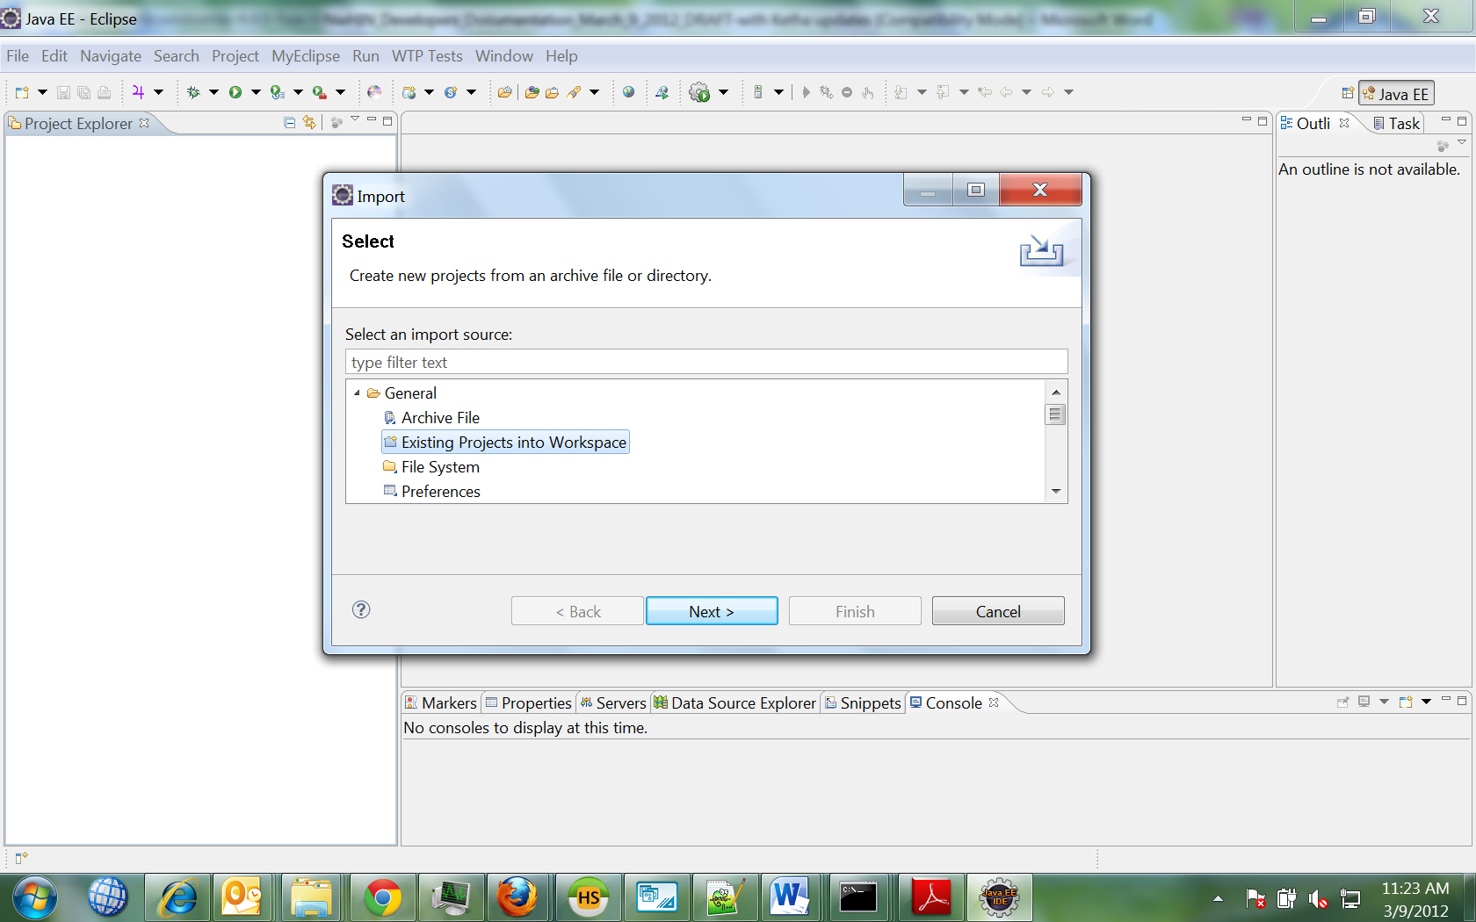
- Click Next to select the specific project
- Click the browse button to select specific project (Ex : LabCommons under ESBcomponents)
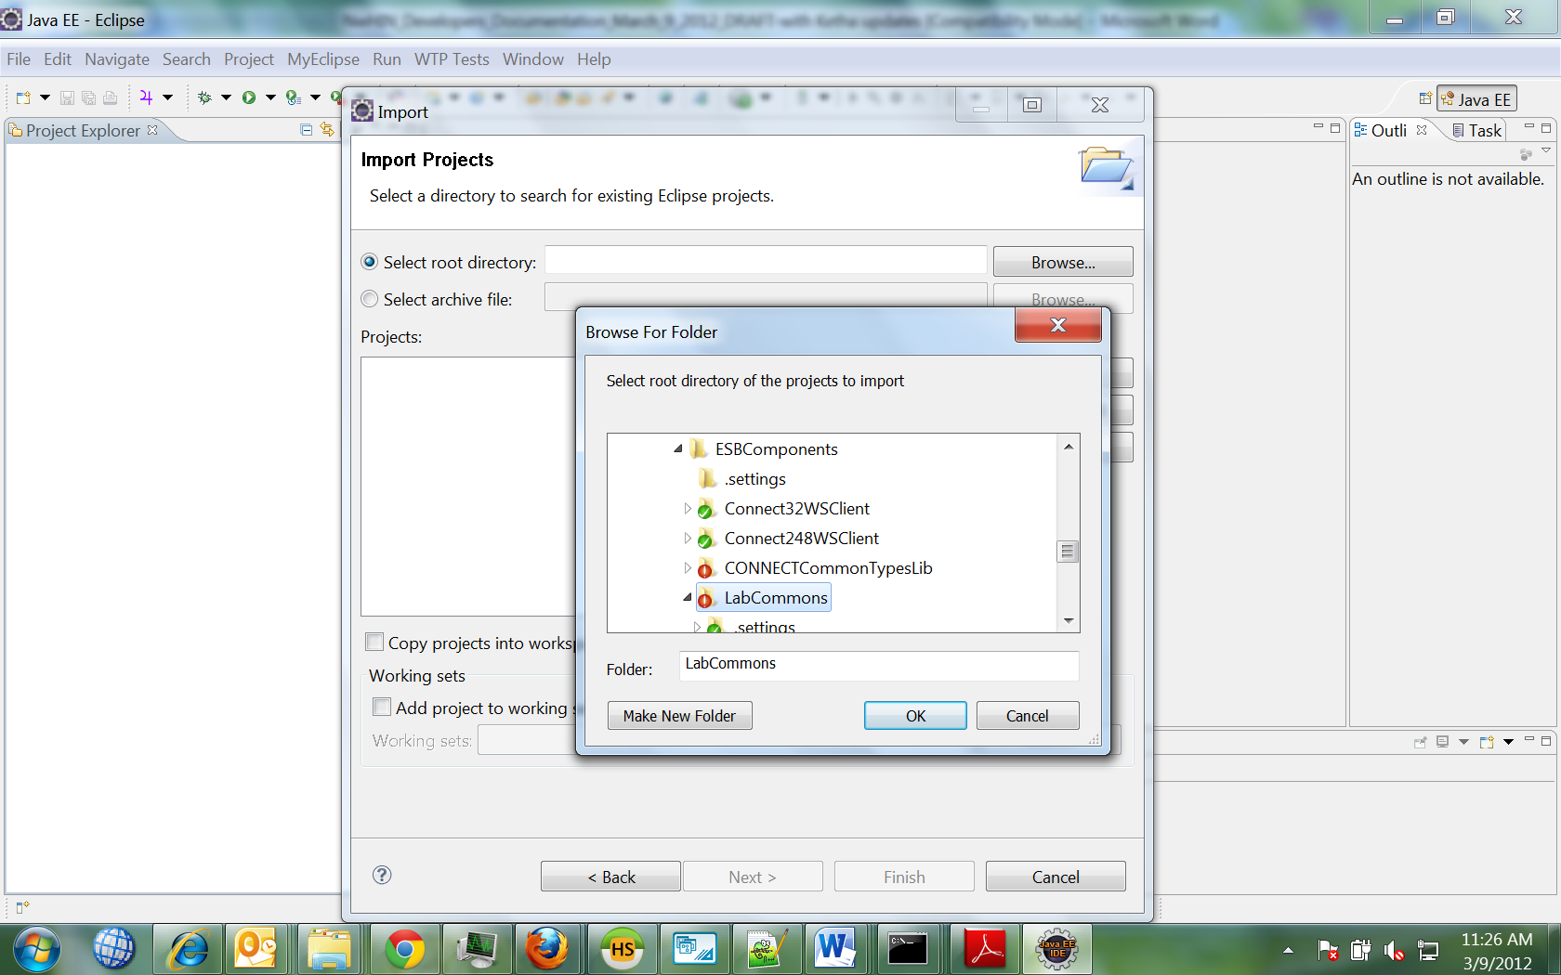
- Click OK button
- Click Finish Button to complete project import in to Eclipse IDE.
- Follow above steps to import all remaining projects under ESB Components and WebApps
Note: Restart Eclipse after importing projects if there are any errors with log4j.

Glossary of Terms
Apache Software Foundation - is a decentralized community of developers. The software they produce is distributed under the terms of the Apache License and is therefore free and open source software (FOSS). The Apache projects are characterized by a collaborative, consensus-based development process and an open and pragmatic software license. Each project is managed by a self-selected team of technical experts who are active contributors to the project. The ASF is a meritocracy, implying that membership to the foundation is granted only to volunteers who have actively contributed to Apache projects. The ASF is considered a second generation open-source organization.
CONNECT - is an open source software solution that supports health information exchange – both locally and at the national level. CONNECT uses Nationwide Health Information Network standards and governance to make sure that health information exchanges are compatible with other exchanges being set up throughout the country. This software solution was initially developed by federal agencies to support their health-related missions, but it is now available to all organizations and can be used to help set up health information exchanges and share data using nationally-recognized interoperability standards.
Eclipse is an open-source community that develops open platforms and products. The community says its projects "are focused on building an open development platform consisting of extensible frameworks, tools and runtimes for building, deploying and managing software across the lifecycle. The Eclipse Foundation is a non-profit corporation which acts as the steward of the Eclipse community.
Enterprise service bus (ESB) - is a software architecture model used for designing and implementing the interaction and communication between mutually interacting software applications in Service Oriented Architecture. As a software architecture model for distributed computing it is a specialty variant of the more general client server software architecture model and promotes strictly asynchronous message oriented design for communication and interaction between applications. Its primary use is in Enterprise Application Integration of heterogeneous and complex landscapes.
Gateway - is a network point that acts as an entrance to another network. On the Internet, a node or stopping point can be either a gateway node or a host (end-point) node. Both the computers of Internet users and the computers that serve pages to users are host nodes. The computers that control traffic within.
GlassFish - is an open-source application server project started by Sun Microsystems for the Java EE platform and now sponsored by Oracle Corporation. The supported version is called Oracle GlassFish Server. GlassFish is free software, dual-licensed under two free software licences: the Common Development and Distribution License (CDDL) and the GNU General Public License (GPL) with the classpath exception. GlassFish supports all Java EE API specifications (by definition since it is the Java EE Reference implementation), such as JDBC, RMI, e-mail, JMS, web services, XML, etc., and defines how to coordinate them. Java EE also features some specifications unique to Java EE for components. These include Enterprise JavaBeans, Connectors, servlets, portlets (following the Java Portlet specification), JavaServer Pages and several web service technologies. This allows developers to create enterprise applications that are portable and scalable, and that integrate with legacy technologies.
Java - refers to several computer software products and specifications from Sun Microsystems (which has since merged with Oracle Corporation), that together provide a system for developing application software and deploying it in a cross-platform environment. Java is used in a wide variety of computing platforms from embedded devices and mobile phones on the low end, to enterprise servers and supercomputers on the high end. While less common on desktop computers, Java applets are sometimes used to provide improved and secure functions while browsing the World Wide Web.
Maven - is a build automation tool typically used for Java projects. Maven serves a similar purpose to the Apache Ant tool, but it is based on different concepts and works in a profoundly different manner. It can also be used to build and manage projects written in C#, Ruby, Scala, and other languages. Maven is hosted by the Apache Software Foundation, where it was formerly part of the Jakarta Project. Maven uses an XML file to describe the software project being built, its dependencies on other external modules and components, the build order, directories, and required plug-ins. It comes with pre-defined targets for performing certain well-defined tasks such as compilation of code and its packaging.
Nation Wide Health Information Exchange (NwHIN) - Exchange has methods to perform universal patient lookup, document discovery and retrieval, and exchange between organizations and federal agencies (VA, DOD, CDC, SSA, plus 22 others). The organizations entering into an exchange with those federal agencies are typically sizable HIOs, HIEs or large IDNs. Participation in the NwHIN Exchange is currently limited to federal health agencies and healthcare organizations under ONC contract and other recipients of federal grants. There are technical teams devoted to the on-boarding process (validation and conformance testing), security, authentication, and adherence to the specifications/standards, including producing/accepting structured data in defined formats.
Reference Implementation - is, in general, an implementation of a specification to be used as a definitive interpretation for that specification. During the development of the conformance test suite, at least one relatively trusted implementation of each interface is necessary to (1) discover errors or ambiguities in the specification, and (2) validate the correct functioning of the test suite. Characteristics of a Reference Implementation: (1) Developed concurrently with spec and test suite; (2) Verifies that specification is implementable; (3) Enables the test suite to be tested; (4) Serves as Gold Standard against which other implementations can be measured; (5) Helps to clarify intent of specification where conformance tests are inadequate.
Service Orientated Architecture (SOA)- In software engineering, a Service-Oriented Architecture (SOA) is a set of principles and methodologies for designing and developing software in the form of interoperable services. These services are well-defined business functionalities that are built as software components (discrete pieces of code and/or data structures) that can be reused for different purposes. SOA design principles are used during the phases of systems development and integration.
Test Harness - In software testing, a test harness or automated test framework is a collection of software and test data configured to test a program unit by running it under varying conditions and monitoring its behavior and outputs. It has two main parts: the Test execution engine and the Test script repository. Test harnesses allow for the automation of tests. They can call functions with supplied parameters and print out and compare the results to the desired value. The test harness is a hook to the developed code, which can be tested using an automation framework. A test harness should allow specific tests to run (this helps in optimizing), orchestrate a runtime environment, and provide a capability to analyze results. The typical objectives of a test harness are to: Automate the testing process, Execute test suites of test cases, Generate associated test reports.
VisualSVNs is a Subversion (SVN) client, implemented as an add-in for Microsoft Visual Studio, that provides an interface to perform the most common revision control operations directly from inside the Visual Studio IDE. Visual SVN is a commercial program, with a free 30-day trial available. It uses Tortoise SVN to execute the Subversion commands.

