TECHNICAL ARCHITECTURE
& DESIGN SPECIFICATION

Technical Architecture & System Documentation

Employee Management System (EMS)
________________________________________

1. Infrastructure & Tech Stack Rationale

1.1 Core Architecture
The system follows a Decoupled Client-Server Architecture, ensuring that the Frontend and Backend can scale independently and communicate via a secure RESTful API.

1.2 The Stack
Component | Technology | Rationale
Backend | NestJS | Provides a robust, disciplined architecture with built-in support for Dependency Injection and modularity.
Frontend | Next.js 15 | App Router and React Server Components bring superior performance and SEO capabilities.
Build Tool | Turbopack | Hand-picked for the frontend to provide the fastest possible HMR and build speeds in a modern React environment.
ORM | Prisma | Offers unparalleled type safety and auto-generated clients, reducing runtime errors and boilerplate.
Database | SQLite | Chosen for local development to ensure zero-config setups and 100% portability via a single file (dev.db).
________________________________________

2. System Flow & Diagrams

2.1 High-Level System Architecture
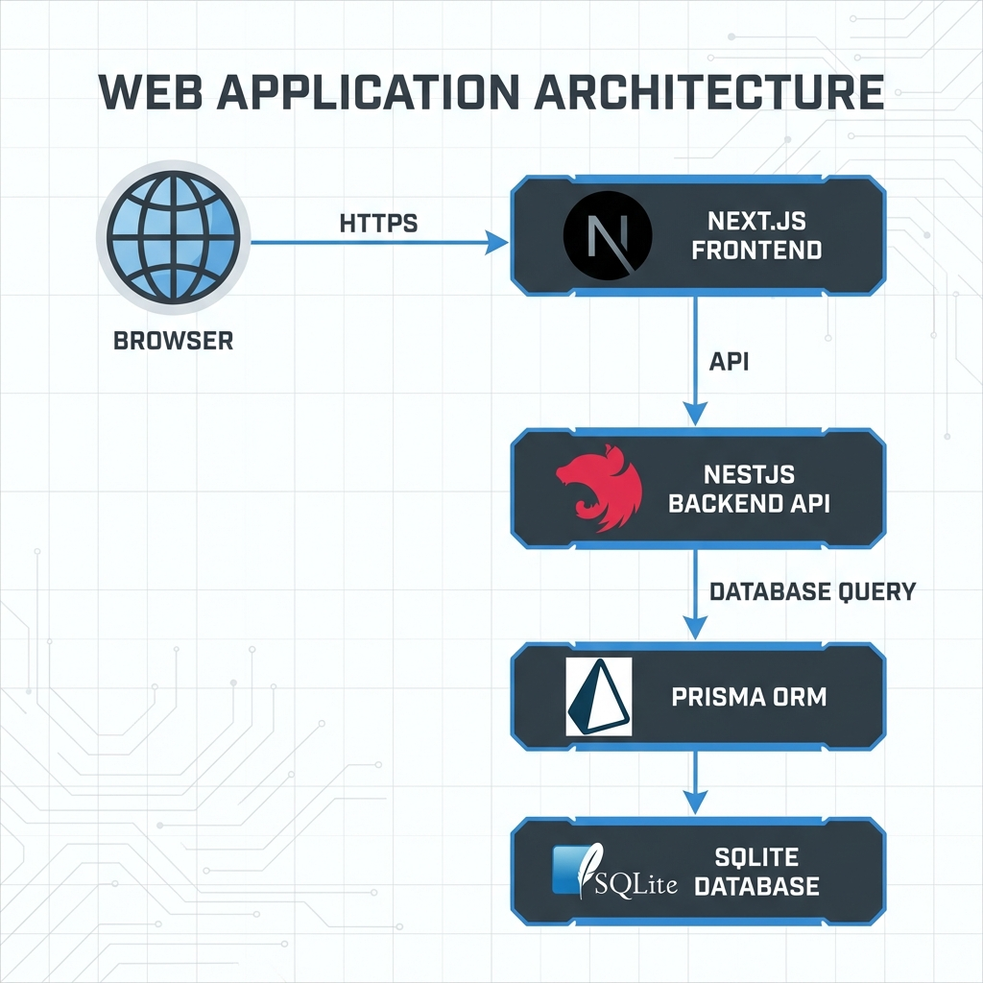

2.2 Functional Use Case Diagram
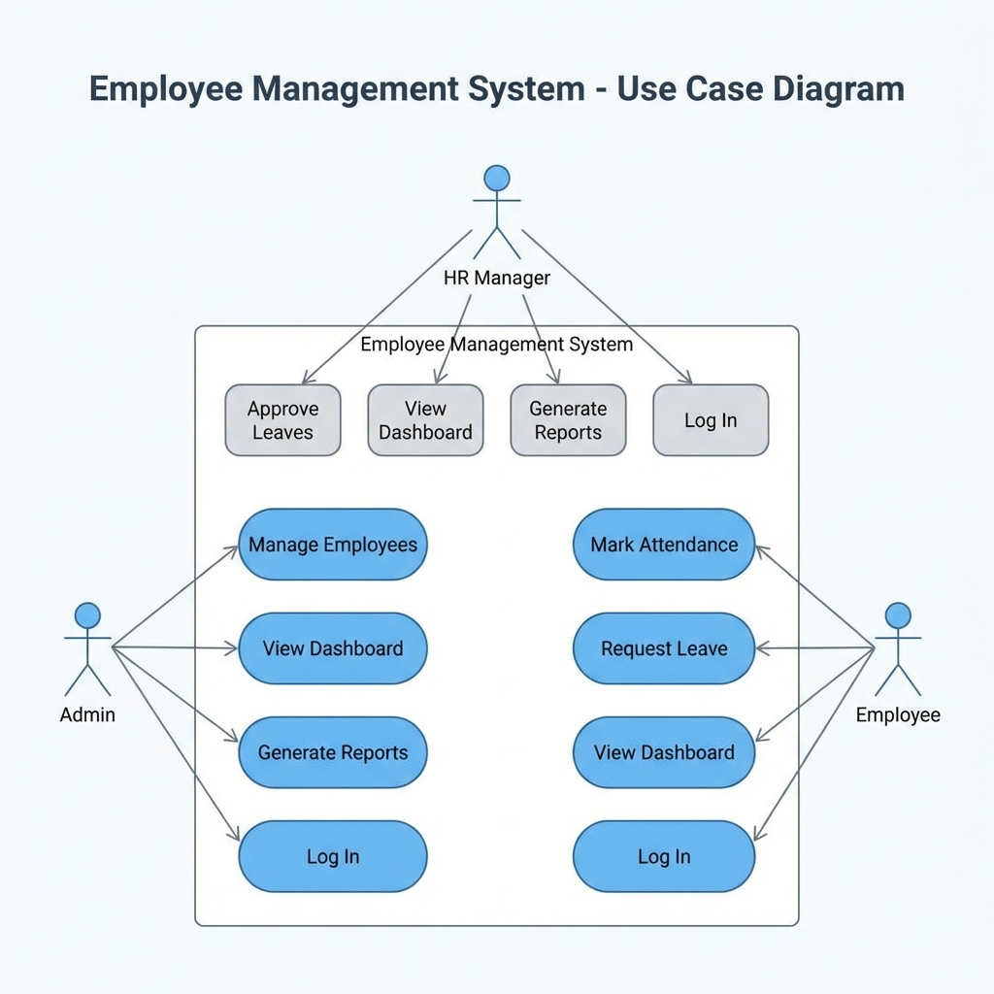

2.3 Database Entity Relationship (ER) Diagram
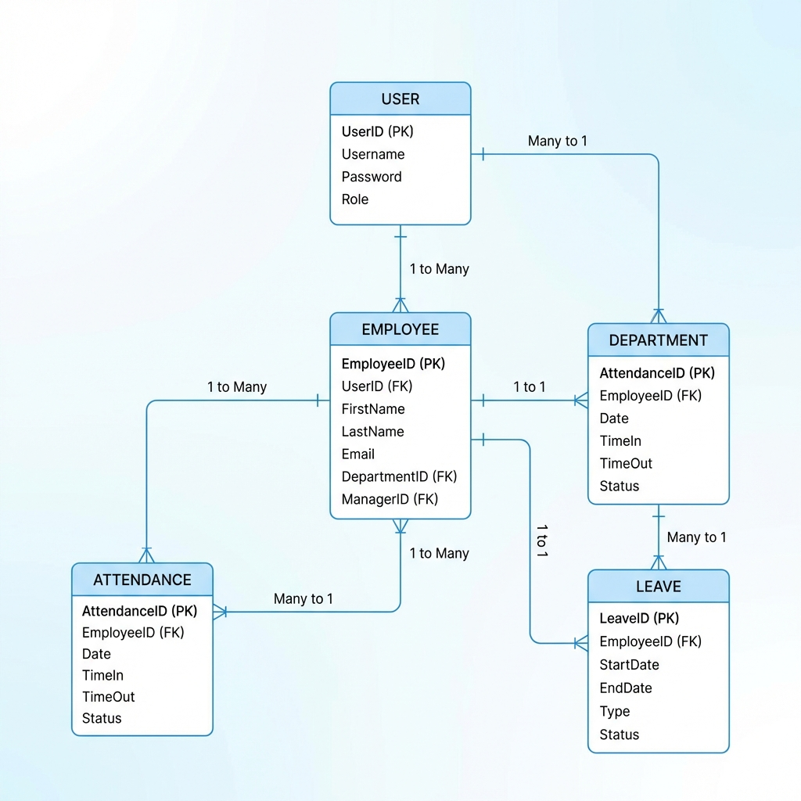

2.4 Authentication Flow (Sequence Diagram)
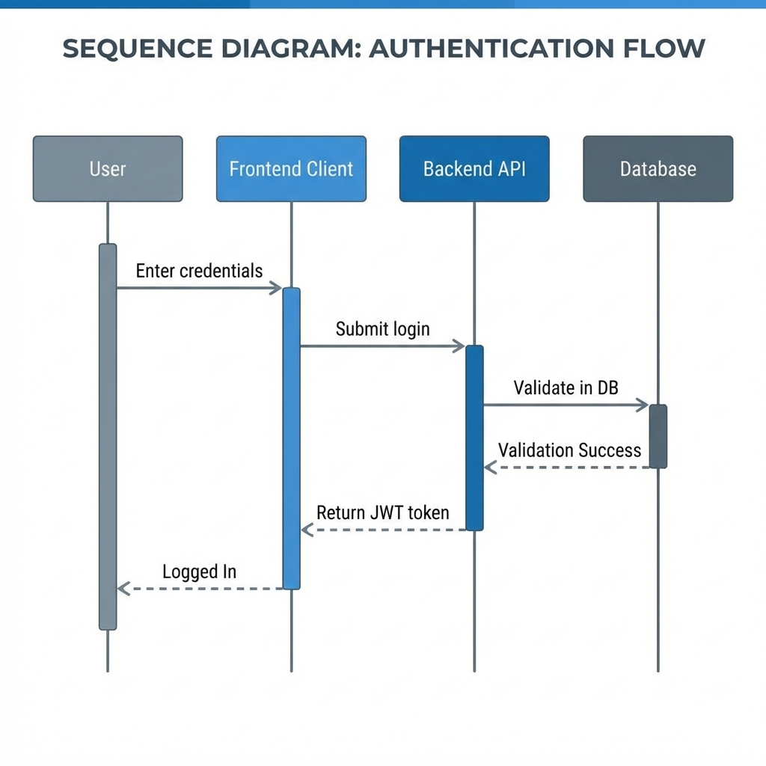
________________________________________

3. Core Logic Implementation

3.1 Role-Based Access Control (RBAC)
The system utilizes a custom @Roles() decorator and a RolesGuard. This ensures that sensitive operations (like deleting an employee or approving a leave) are strictly limited to authorized roles.
Access Matrix:
- - ADMIN: Global system access, user management, and configuration.
- - HR: Operational management including record tracking, attendance monitoring, and leave approvals.
- - EMPLOYEE: Personal dashboard access, attendance logging, and leave request submission.

3.2 Attendance Monitoring System
The attendance module implements a strict daily integrity constraint.
- - Automated Logging: Captures specific check-in and check-out timestamps.
- - Status Classification: Automatically assigns statuses based on time thresholds:
- PRESENT: On-time check-in.
- LATE: Check-in after the grace period.
- ABSENT: No check-in recorded for the operational window.

3.3 Leave Management Lifecycle
The leave system follows a state-machine workflow:
1. Submission: Employee submits request with type (SICK, ANNUAL, etc.) and reason.
2. Review: HR/Admin reviews the request in a centralized queue.
3. Decision: Request is either Approved or Rejected with relevant notes.
4. Audit: All actions are timestamped and signed by the reviewer for administrative accountability.
________________________________________

4. Performance & Scalability

4.1 Native Turbopack Optimization
By utilizing Next.js 15 with Turbopack, the frontend benefits from an incremental compilation engine. This results in 700x faster execution of changes during development compared to traditional Webpack setups.

4.2 Portable Database Strategy (SQLite to Enterprise)
The use of Prisma as an abstraction layer enables a "Zero-Friction" migration path. While we currently use SQLite for its zero-config benefits and portability, transitioning to a production-grade PostgreSQL or MySQL cluster requires only a single environment variable update.
________________________________________

5. Conclusion
This Employee Management System represents a fusion of modern performance tools (Turbopack, Next.js 15) and structured backend practices (NestJS, Prisma). It provides a secure, fast, and scalable foundation for corporate HR operations.

