Page 1- landing page:


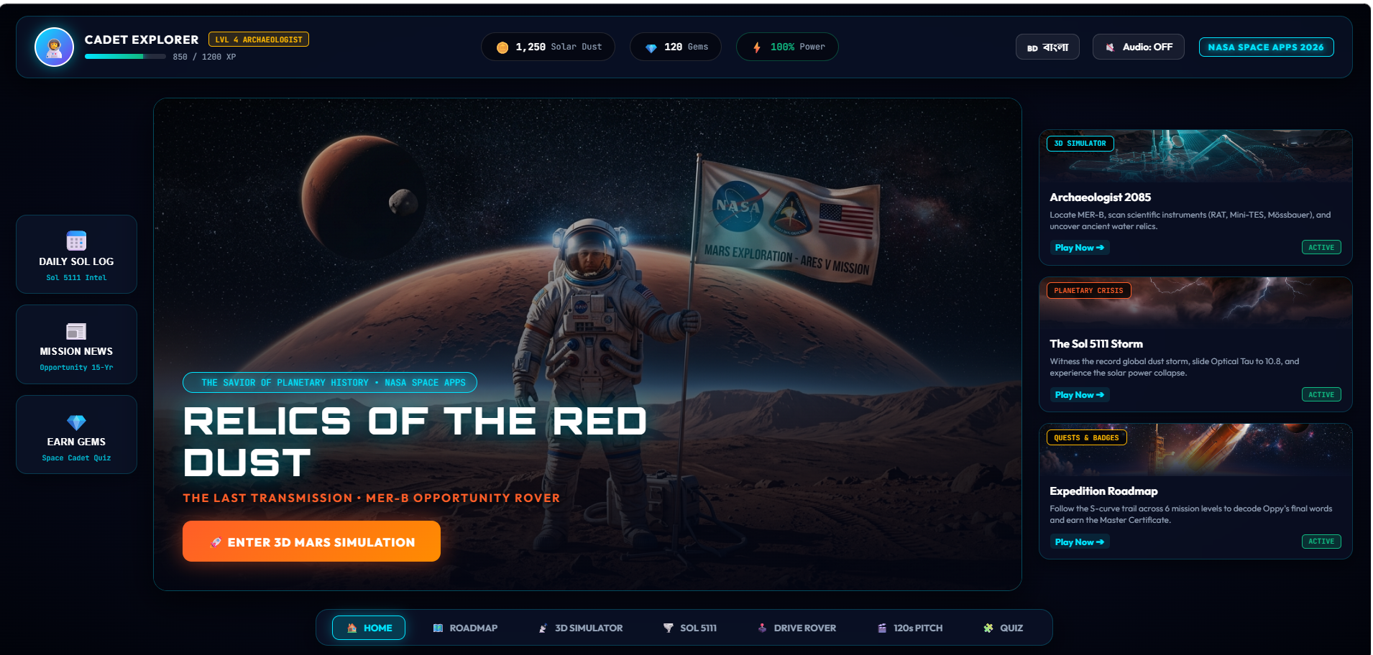

Button==Button arekta add hobe moon er zonno .

Ekhn first er ze lekha gula ogula overall er zonno change hobe . ekhane sudhu mars er zonno bola ache. normal kicchu lekha hobe

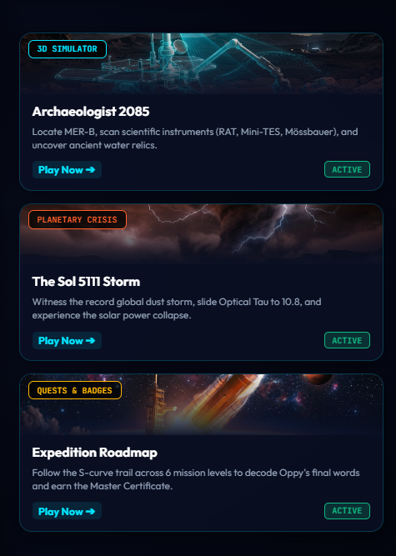 ekhane aro card add hobe , moon er game er zonno . up to down slide kora zabe emn format hobe.scroll down kora zabe.

Quiz== level wise hobe .
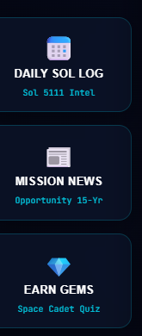

Mission news == FB er carousal ad er moto ,mission er news , rover za ache ogulo ki kaz koreche all .
Mission e duita split option thakbe . moon or mars . user zeno iccha moto dekhte pare .

Daily sol log== rover er daily activity,history,picture whatever za ache egula news akare hobe.

Ekta calendar add kora zay . zekhan e kichu significant date marked thakbe zekhane click korle show hobe oi din e special ki kaz korse.

ROADMAP==

Moon and mars er alada roadmap

3D Simulator==
Dropdown for mars and moon

Drive rover e drop down for moon and mars selection

120 pitch==
Ekhane ekhn mars er ta sudhu dewya . so moon er tao add korte hobe.

QUIZ== layer add(junior,intermediate,senior,expert)+ leader board


Ekhane freeze hoye thake .(XP bare ba kome na.)

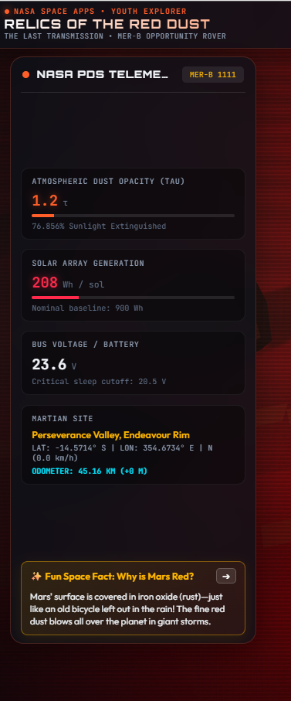

Sidebar use kora , zeno full screen dekha zay , gameplay will be smooth.

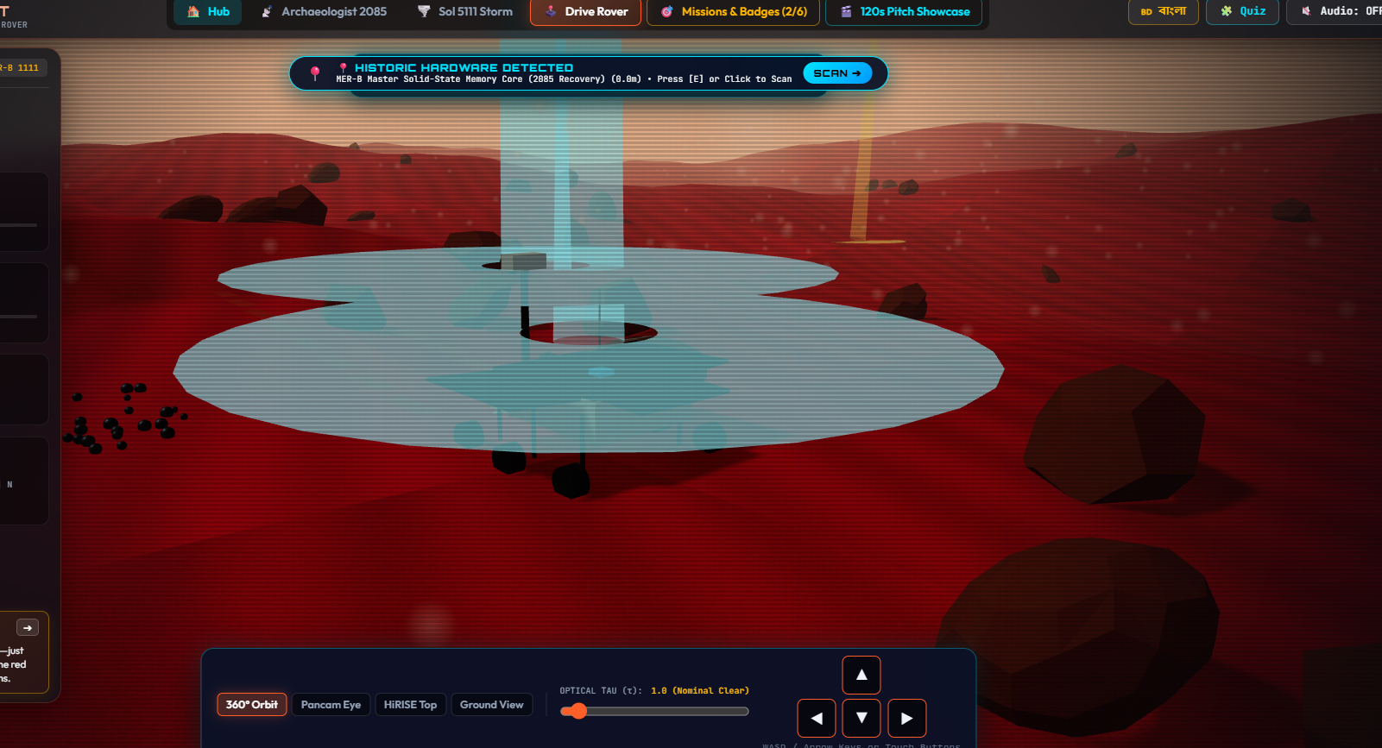

Left side e ekta transparent map hobe zeno kothay mission ache buzha zey .

MOVEMENT issue==

Up and down arrow ulta kaz kore.

Pancam e gele mazhe mazhe stuck hoye zay , PUBG er FPP er moto hote hobe .
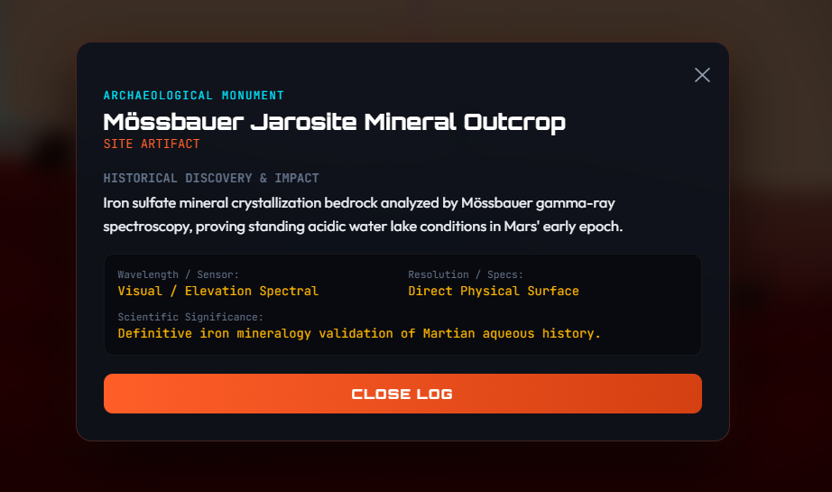

Mission complete er por ei section er ze lekha egula user friendly and interactive hole better . kichu image like oi zaygay ki discover korse emn kichu add kora .
Emn type rakha like rover ta boltese . ekhane ekdom normal lage. manush pore dekhte chaibe na .

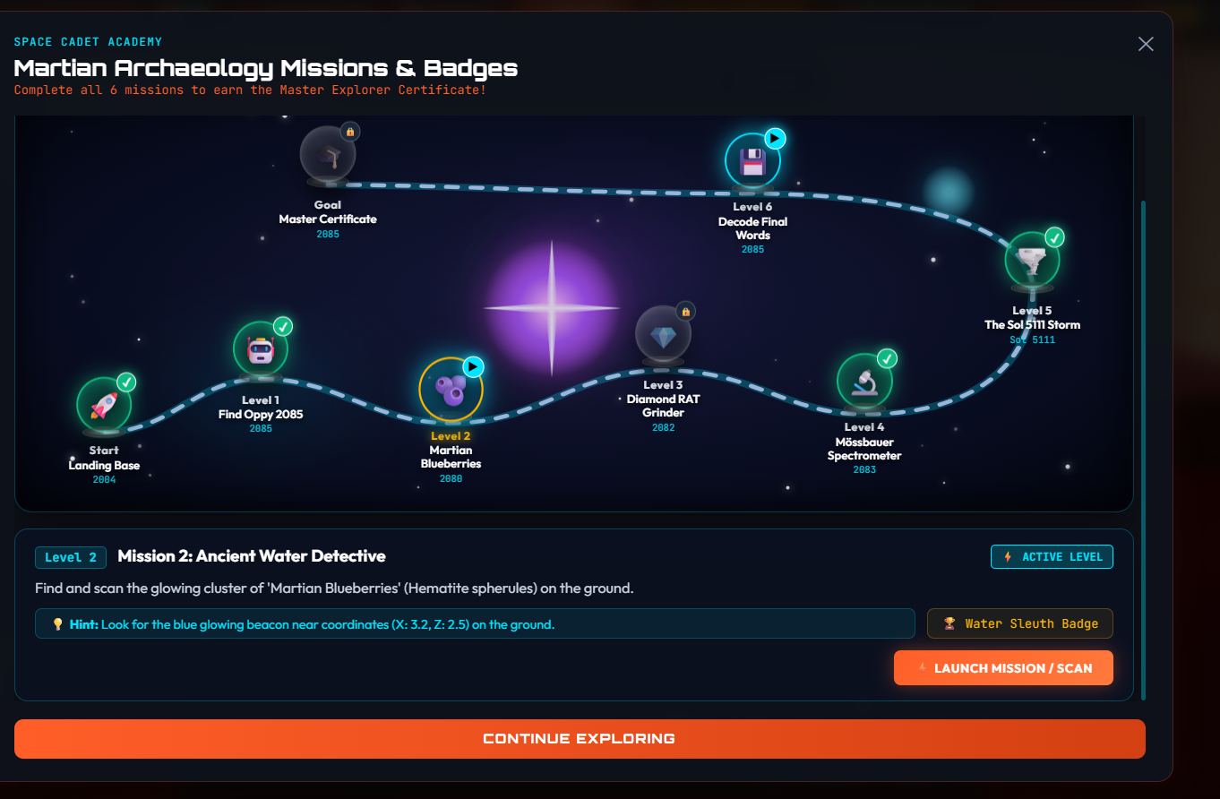

Badges==
Level wise badge hobe. And badge gula kothay kivabe asshbe emn ekta clear section .

Same for moon.

