Relics of the Cosmic Dust

30-Second Video — Script, Shot List and Production Guide
2026 NASA International Space Apps Challenge · Team Relics
Runtime | 0:30 exactly
Purpose | Our "30 Seconds of Glory" video for global nomination
Structure | Space Apps model: 0:00 introduce yourself → 0:02 lead us in → 0:05 name your solution → 0:10 describe your idea → 0:20 look into the future
Format | 1920 × 1080, 30 fps, H.264 MP4, stereo AAC audio
Voice | Shaikot on camera for the first 2 seconds, then voice-over; about 55 words
Captions | Burned-in English captions; every line also works as on-screen text with the sound off
Footage | Real game footage from the current build, plus a 2-second shot of Shaikot

1. Script
Time | Space Apps step | Visual | On screen (text) | Voice-over / spoken line
0:00 – 0:02 | Introduce yourself | Shaikot on camera, smiling, game hub softly blurred behind him. | Shaikot Kundu Akash · Team Relics, Bangladesh | On camera (Shaikot): "Hi, I'm Shaikot from Team Relics."
0:02 – 0:05 | Lead us in | Game footage: Opportunity resting on Mars as the rover rolls up. | NASA left machines on the Moon and Mars. | Voice-over (Shaikot): "NASA left machines on the Moon and Mars…"
0:05 – 0:10 | Name your solution | The hub; the cursor hovers Planet Mars and the 3D background flies to it. Title and tagline pop in. | RELICS OF THE COSMIC DUST · Find NASA's lost machines. Hear their true stories. | Voice-over (Shaikot): "…so we built Relics of the Cosmic Dust, where kids become space archaeologists."
0:10 – 0:20 | Describe your idea | Drive on the Moon (3 s) → scan Surveyor 1, press E (2 s) → relic log (2 s) → Voyager power lab (3 s). | Drive · Scan · Learn · Real NASA facts · Any browser · English + বাংলা | Voice-over (Shaikot): "Drive to a real relic, scan it, and learn its true story — then try real NASA science."
0:20 – 0:30 | Look into the future | Quiz answer and confetti (2 s) → quick montage of Moon, Mars, Voyager 1 (4 s) → end card (4 s). | Next: more relics, more languages, more classrooms · Not space junk — monuments. · Team Relics · NASA Space Apps 2026 | Voice-over (Shaikot): "Next: more relics, more languages, more classrooms. Not space junk — monuments."

Spoken words: about 55, under 2 words a second. Read it aloud with a stopwatch before recording; each line must finish before the next Space Apps mark.

Voice-over script (for recording)
Shaikot says line 1 on camera. Lines 2 – 5 are voice-over, recorded separately in a quiet room and laid over the game footage.
# | Time | Type | Line | Words
1 | 0:00 – 0:02 | On camera | "Hi, I'm Shaikot from Team Relics." | 6
2 | 0:02 – 0:05 | Voice-over | "NASA left machines on the Moon and Mars…" | 8
3 | 0:05 – 0:10 | Voice-over | "…so we built Relics of the Cosmic Dust, where kids become space archaeologists." | 13
4 | 0:10 – 0:20 | Voice-over | "Drive to a real relic, scan it, and learn its true story — then try real NASA science." | 17
5 | 0:20 – 0:30 | Voice-over | "Next: more relics, more languages, more classrooms. Not space junk — monuments." | 11

Lines 2 and 3 are one sentence: record them in one take and split the audio at 0:05 on the cut to the hub. Leave about 1 second of music only before the end card at 0:26.

2. Why each part is there
Space Apps asks… | Our answer
What is your name and your team's name? | Shaikot, Team Relics, Bangladesh — on camera, so judges see a real person.
What topic does your solution address? | NASA's machines left on the Moon and Mars.
A title and tagline that catch attention; what people gain; what problem it solves | Relics of the Cosmic Dust — Find NASA's lost machines. Hear their true stories. Kids gain real space history through play instead of dense archives.
How does it work? Show the prototype, the user's experience, and how data and technology make it possible | Real gameplay: drive → scan → relic log → science lab. On screen: real NASA facts, any browser, English and Bengali.
What will it change? What could it be? | More relics from every space agency, more languages, more classrooms — ending on our message: not space junk, monuments.

3. Storyboard
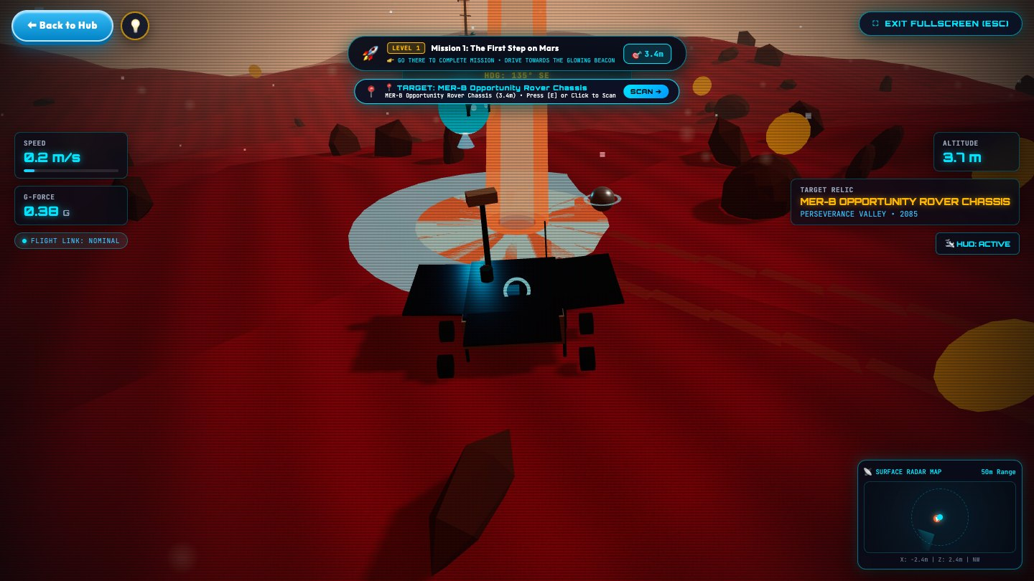
0:02 – 0:05 · Lead us in — Opportunity on Mars as the rover arrives.
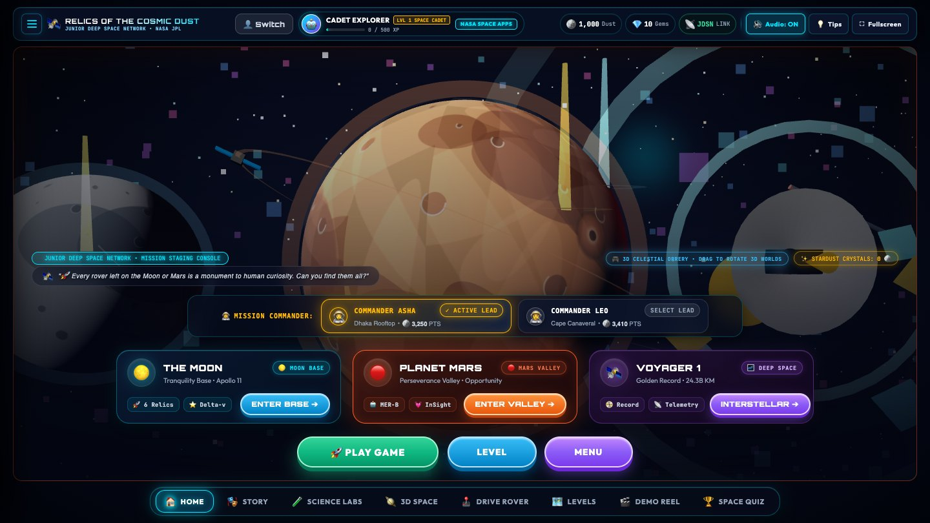
0:05 – 0:10 · Name your solution — the hub, with the title and tagline over it.
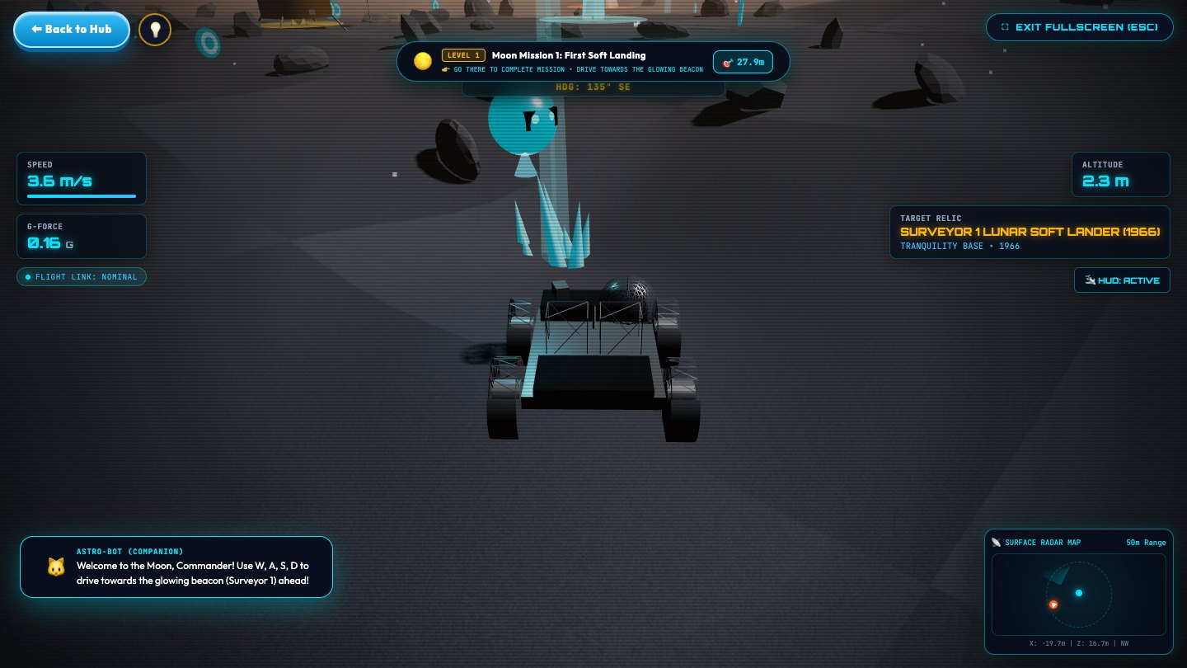
0:10 – 0:13 · Describe your idea — driving toward the beacon on the Moon.
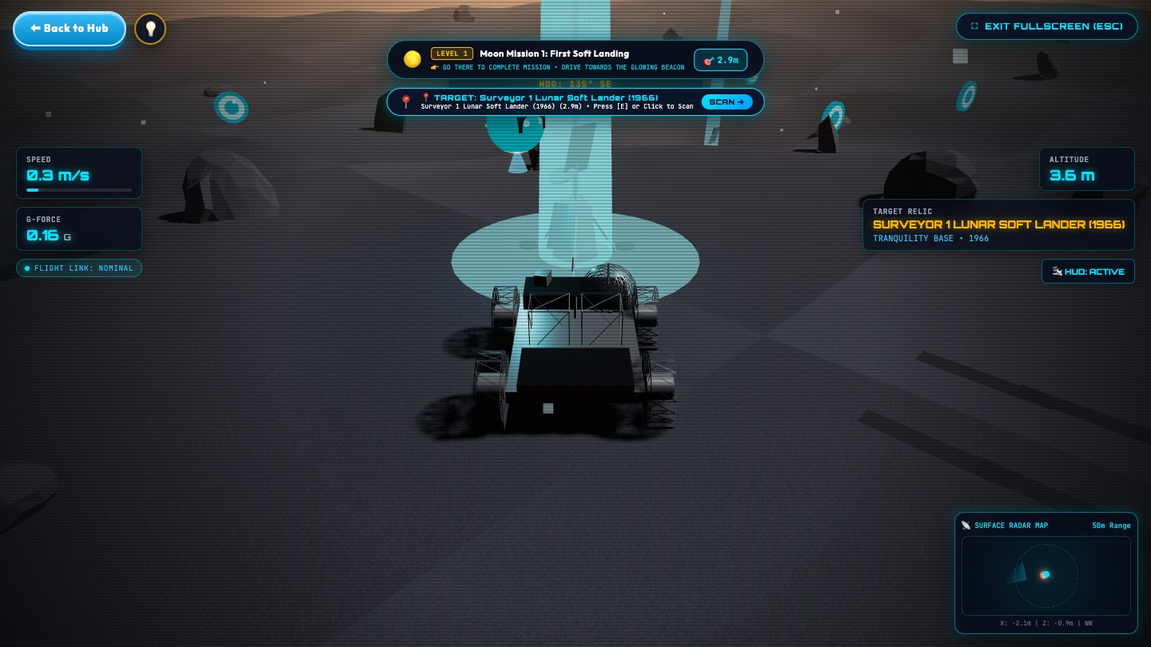
0:13 – 0:15 · Describe your idea — the scan prompt next to Surveyor 1.
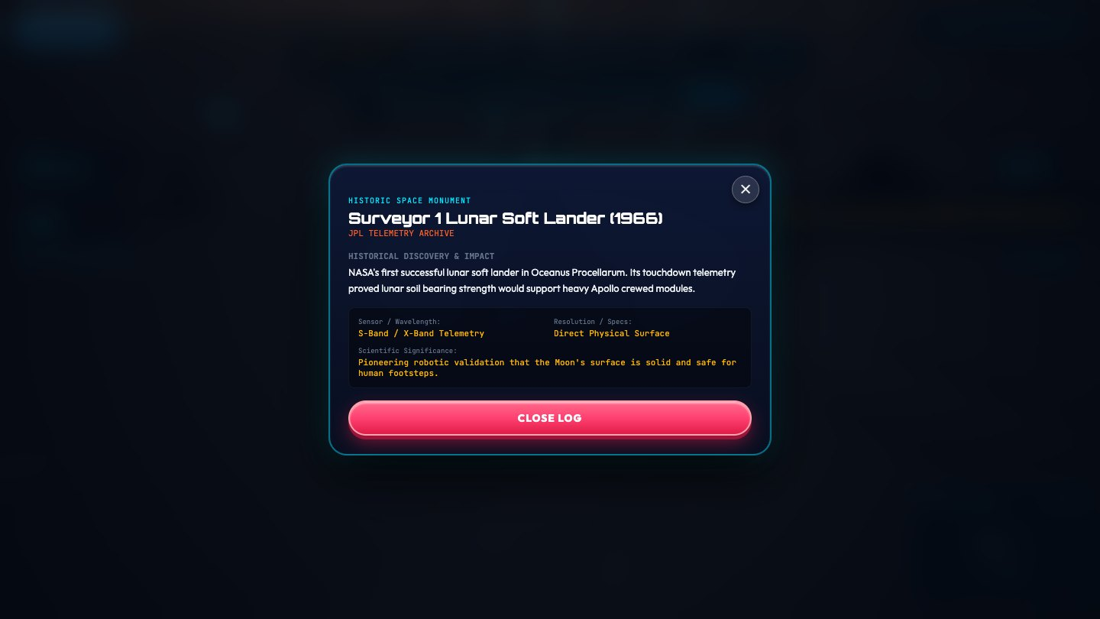
0:15 – 0:17 · Describe your idea — the relic log (record the Surveyor 1 log).
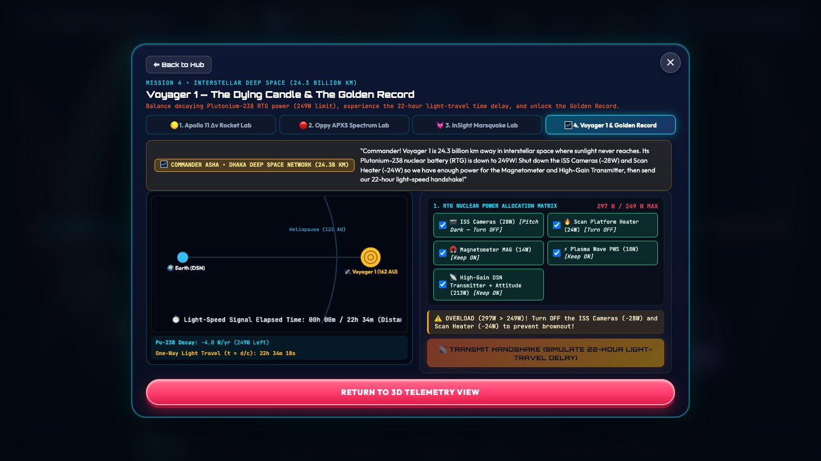
0:17 – 0:20 · Describe your idea — the Voyager 1 power lab.
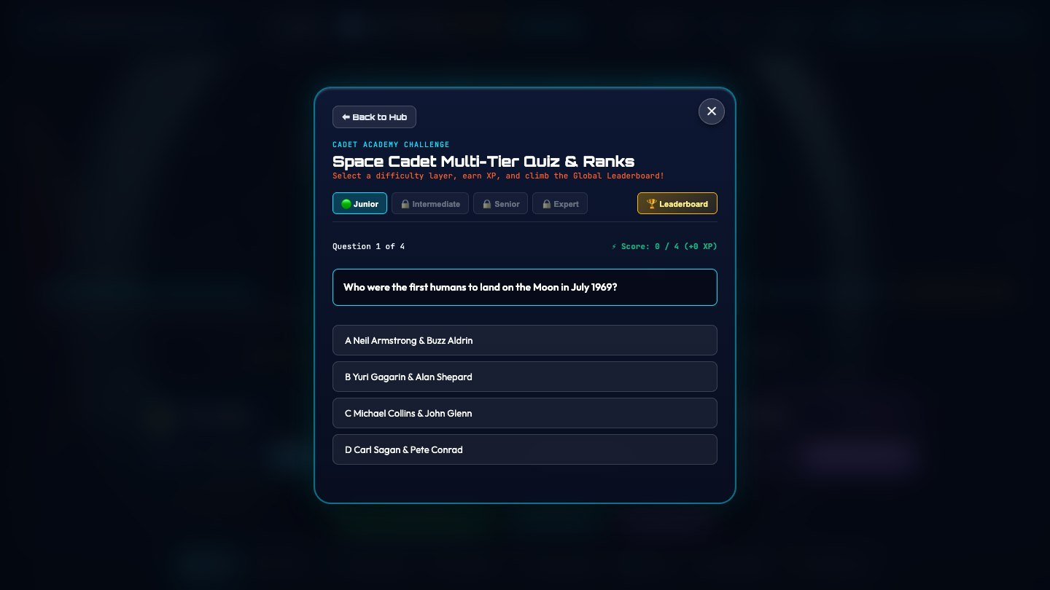
0:20 – 0:22 · Look into the future — a correct quiz answer, then the montage and end card.

4. Sound
Time | Music and effects
0:00 – 0:02 | Room tone only, so Shaikot's on-camera line is clear; music starts on the cut at 0:02, when the voice-over begins.
0:02 – 0:05 | Soft Martian wind under the music.
0:05 – 0:10 | Whoosh as the background flies to Mars; a bright hit as the title lands.
0:10 – 0:20 | Rover motor, scan sweep exactly on E, transmission beeps in the lab.
0:20 – 0:30 | Confetti pop, music builds, resolves on the end card.

Keep music about 18 dB under the voice-over (0:02 – 0:30).

5. Recording
Setting | Value
Presenter shot | Shaikot at eye level, soft front light, quiet room, phone or camera at 1080p; game hub on a screen behind him, slightly out of focus
Browser window | Chrome, full screen (F11), 1920 × 1080
Recorder | OBS Studio, 1920 × 1080, 30 fps
Voice-over | Lines 2 – 5 from Section 1, recorded by Shaikot on a phone or USB mic in a quiet room, WAV or high-quality MP3; three takes of each line
Cursor | Visible only in the hub hover
Fresh start | Log out to the Start screen and register a new cadet, so the Moon and Mars start at Mission 1
Tips | Press Don't show tips again on the first tip so no tips appear in the shots

Shot | What to do in the game | Record
Lead us in | Enter Valley (Mars); drive slowly up to Opportunity. | 8 s
Name your solution | On the hub, move the cursor slowly onto Planet Mars and hold. | 8 s
Drive | Enter Base (Moon); drive toward the beacon with W, steering with A/D. | 8 s
Scan + relic log | Stop when the prompt names Surveyor 1; pause 1 s; press E; hold on the log. | 8 s
Voyager lab | Back to Hub → Science Labs → tab 4; switch off two instruments, press Transmit. | 8 s
Quiz | Space Quiz → choose the correct answer to the first question. | 4 s
Montage | 2 s each of the Moon, Mars and Voyager 1 (Interstellar) with the rover or probe moving. | 3 × 4 s

Record each shot longer than needed; the editor trims to the timing in Section 1.

6. Delivery checklist
- Runtime is exactly 0:30, and each step starts on its Space Apps mark (0:00, 0:02, 0:05, 0:10, 0:20).
- Name and team are on screen during the first 2 seconds.
- Title and tagline are readable for at least 3 seconds.
- The on-camera line (0:00 – 0:02) and all four voice-over lines (0:02 – 0:30) are in place and finish before the next mark.
- Every voice line is also on screen as text (large, high-contrast).
- No browser bars, bookmarks, notifications or tips visible in the footage.
- Facts match the game: Surveyor 1 (1966), Voyager 1 lab, English and Bengali.
- Export: H.264 MP4, 1920 × 1080, 30 fps, about 10–16 Mbps, AAC 192 kbps.

Team Relics · 2026 NASA International Space Apps Challenge

