115.109 Introduction to Business Analytics
Sustainable Retailing:
Consumer Sustainability Literacy, Attitudes and Behaviour
19 October 2026
Prepared by: Mishal Joytishna Charan (ID: 26013944) & Savnit Prasad (ID: 26019118) — Group 5

Client Brief
This report was commissioned to answer three questions about New Zealand consumers for a large retailer:
- How does self-reported sustainability literacy vary across subgroups of survey respondents (Task 1, Section 3)?
- How does sustainability literacy interact with measures of sustainability attitudes and behaviour (Task 2, Section 4)?
- What should a large New Zealand retailer do about these literacy levels, attitudes and behaviours (Task 3, Section 6)?
Countdown (Woolworths New Zealand) is used as the client retailer, one of the two retailers most frequently associated with sustainability by survey respondents, alongside The Warehouse.

Executive Summary
New Zealand retailers face growing consumer expectations to operate sustainably. This report uses survey data from 1,042 New Zealanders collected in Perceptive’s July 2020 Omnibus survey (Perceptive, 2020a) to assess consumers’ self-reported sustainability literacy, to examine how literacy relates to sustainability attitudes and behaviour, and to recommend actions for Countdown, one of the two retailers respondents most associated with sustainability.
Self-reported literacy is moderate (3.47 on a 1-5 scale) and varies across subgroups: females score slightly higher than males, consumers aged 18-34 score higher than those aged 55 and over, while income differences are small. Literacy is strongly linked to attitudes and behaviour. Consumers with higher literacy rate every retail sustainability domain as more important, are twice as likely to buy sustainable products often (71% versus 36%), and are more than twice as likely to pay a premium for them (71% versus 22%).
Five recommendations are made for Countdown, centred on building customer literacy, keeping sustainable products affordable, and providing infrastructure such as packaging take-back that makes sustainable behaviour easy for all customers.

1.0 Introduction
Sustainability has moved from a peripheral concern to a central issue for New Zealand retailers, driven by regulation such as the 2019 plastic bag ban and by customers who increasingly scrutinise the environmental and social record of the brands they buy from (Retail NZ, 2019). Sustainable retailing now spans sourcing, packaging, store operations and community engagement (Vozza, 2018). For a retailer, the commercial question is whether customers understand, care about and act on sustainability enough for it to shape where they shop and what they pay.
This report addresses that question using data from Perceptive’s July 2020 Omnibus survey of 1,042 New Zealanders, weighted to match the national population (Perceptive, 2020a, 2020b). Respondents rated nine statements measuring sustainability literacy, the importance of 25 retailer sustainability practices grouped into seven domains, their purchase behaviour and willingness to pay. Composites were compared across subgroups using t-tests and one-way analysis of variance (ANOVA).

2.0 Literature Review: Consumer Attitudes to Sustainability
Academic interest in sustainable retailing has grown rapidly. Jones et al. (2005) argued that retailers sit between producers and consumers and so carry particular responsibility for promoting sustainable consumption, while Ruiz-Real et al. (2018) document the global expansion of research linking sustainability with retail strategy.
A consistent theme is that consumer knowledge is a precondition for sustainable purchasing: Meise et al. (2014) show that sustainability-related product information shapes value perceptions only when it is noticed and understood. Moser (2016) found attitudes alone translate weakly into German consumers’ purchases, with knowledge a moderating factor, and Wei et al. (2018) report that willingness to pay more for green products depends on consumer characteristics such as involvement.
Retailers themselves shape behaviour. Tsarenko et al. (2013) show that retailer initiatives and peer influences drive environmentally conscious consumption, and Kauppinen-Räisänen et al. (2014) show that environmental cues in servicescapes convey conscientiousness to shoppers. Format innovations such as package-free shopping (Fuentes et al., 2019) and the supermarket of the future (van Giesen & Leenheer, 2019) embed sustainability in the shopping experience itself. Overall, literacy, attitudes and behaviour appear linked but unevenly distributed, leaving retailers an active role in closing the gap.

3.0 Sustainability Literacy Levels
Respondents rated nine 1-5 agreement statements covering sustainability knowledge and perceived ability to contribute to a sustainable future. The literacy composite is each respondent’s mean across the nine items. Overall literacy is moderate: 3.47 (SD = 0.71), just above the scale midpoint, and the three knowledge items alone average only 2.93, indicating many New Zealanders feel under-informed.
Table 1 and Figure 1 summarise literacy across subgroups. Female respondents report slightly higher literacy (3.51) than males (3.41), a difference that is statistically significant though small (t(1038) = -2.36, p = .019). Age shows a clearer pattern: consumers aged 18-34 average 3.59 against 3.37 for those aged 55 and over (F(2,1038) = 8.50, p < .001). Income differences are weak: nominally significant (F(2,862) = 3.75, p = .024) but with no monotonic pattern, the middle band ($50,001-$100,000) highest and the upper barely above the lower.
In short, literacy is highest among younger consumers and women, but is unrelated to household resources; full outputs appear in Appendices A and B.
Table 1: Sustainability literacy by subgroup (1-5 scale)
Subgroup | n | Mean | SD
Gender
Female | 591 | 3.51 | 0.68
Male | 449 | 3.41 | 0.75
Age group
18-34 | 334 | 3.59 | 0.71
35-54 | 362 | 3.44 | 0.72
55+ | 345 | 3.37 | 0.69
Household income
Lower (up to $50,000) | 283 | 3.43 | 0.67
Middle ($50,001-$100,000) | 351 | 3.58 | 0.72
Upper (over $100,000) | 231 | 3.46 | 0.74
Note: t-test compares females with males; ANOVAs compare groups within each block; “rather not say” income excluded.
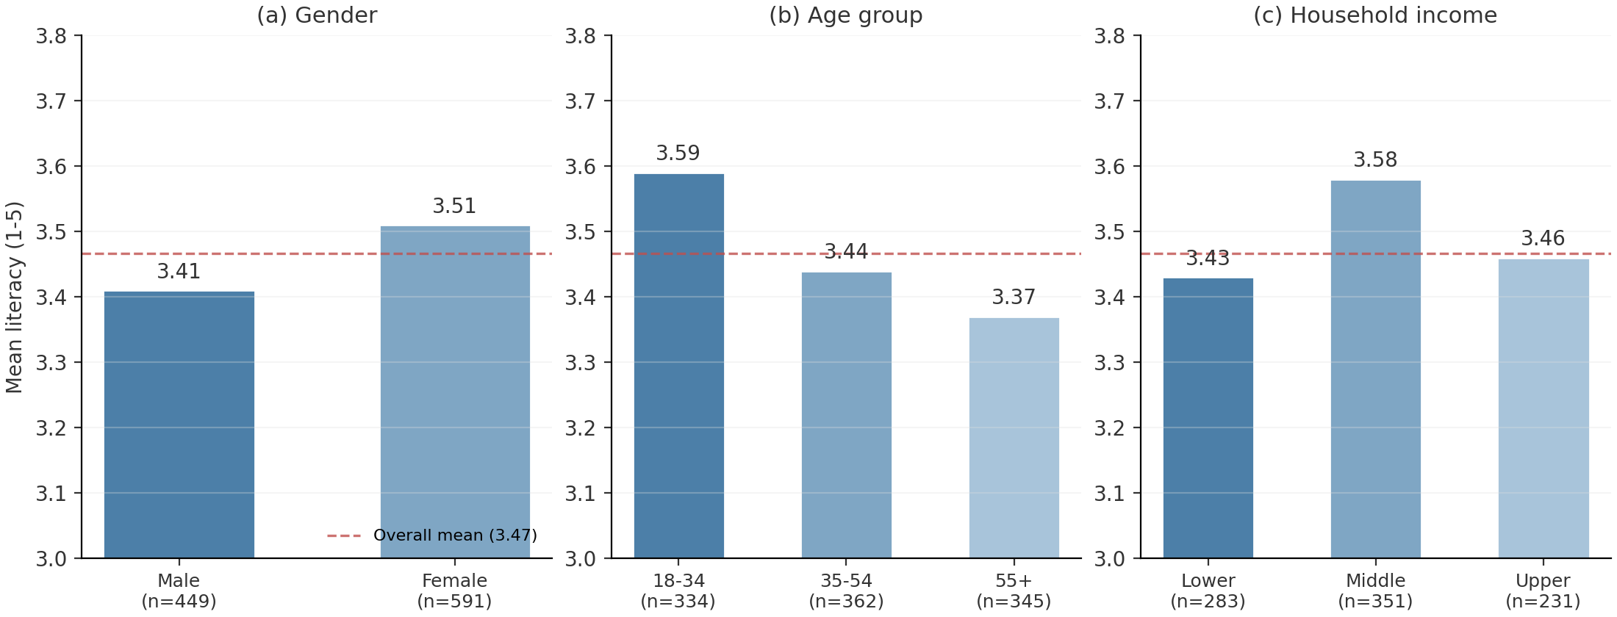
Figure 1: Mean literacy by gender, age and income
Source: Perceptive (2020a).

4.0 Literacy, Attitudes and Behaviour
Respondents were split at the overall literacy mean (3.466) into higher- (n = 511) and lower-literacy (n = 531) groups; mean ratings were compared using pooled two-sample t-tests.
Table 2 and Figure 2 show strikingly consistent results. Consumers with higher literacy rate all seven retail sustainability domains as more important, every difference significant at p < .001. The gap is widest for the customer domain (4.37 versus 3.67) — opportunities to act, traceability and ethical products — followed by the societal domain (3.85 versus 3.19). The employee domain is rated most important by both groups (4.52 and 4.11).
Table 2: Importance, behaviour and attitude ratings by literacy group (1-5 scale)
Measure | Higher literacy  mean (SD) | Lower literacy  mean (SD) | t-statistic | p-value
Societal domain | 3.85 (0.63) | 3.19 (0.70) | 15.94 | < .001
Environmental domain | 4.47 (0.54) | 3.86 (0.78) | 14.70 | < .001
Supplier domain | 4.30 (0.61) | 3.74 (0.74) | 13.36 | < .001
Shareholder domain | 4.32 (0.58) | 3.80 (0.73) | 12.67 | < .001
Community domain | 4.20 (0.59) | 3.62 (0.71) | 14.05 | < .001
Employee domain | 4.52 (0.58) | 4.11 (0.79) | 9.38 | < .001
Customer domain | 4.37 (0.54) | 3.67 (0.73) | 17.49 | < .001
How often buys sustainable products | 3.95 (0.83) | 3.14 (1.09) | 11.54 | < .001
Likelihood of paying more | 3.76 (0.87) | 2.86 (0.93) | 16.10 | < .001
Willing to spend more on sustainable products | 3.74 (0.88) | 2.81 (0.93) | 16.59 | < .001
Packaging take-back | 4.13 (0.93) | 3.48 (1.06) | 10.65 | < .001
Bottle deposit scheme | 4.48 (0.70) | 3.97 (1.07) | 9.11 | < .001
Note: higher n = 511, lower n = 531; “how often buys” excludes 301 “don’t know” responses (n = 429 and 312; df = 739, otherwise 1,040).
Behaviour shows the same pattern. Higher-literacy respondents buy sustainable products more often (3.95 versus 3.14, t(739) = 11.54, p < .001): 71% buy often against 36%. They are also far more willing to pay a premium (3.76 versus 2.86; 71% versus 22%), and more supportive of packaging take-back (4.13 versus 3.48) and bottle deposits (4.48 versus 3.97).
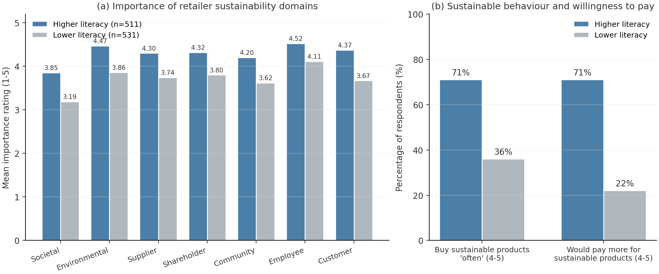
Figure 2: Domain importance and behaviour by literacy group
Source: Perceptive (2020a).
The association also runs from behaviour to attitudes: customer domain importance rises from 3.19 among those who never buy sustainable products to 4.38 among the most frequent buyers (F(4,736) = 23.71, p < .001; Appendix B), consistent with knowledge and engagement reinforcing each other (Meise et al., 2014; Moser, 2016). As cross-sectional data, these results establish association, not causation.

5.0 Data Quality Considerations
Several features of the data affect confidence. The sample came from Perceptive’s national online panel, weighted to census figures for gender, age and region (Perceptive, 2020b), so it is broadly representative, though online panels under-represent people without internet access; further breakdowns appear in the crosstabs (Perceptive, 2020c). Literacy is self-reported, measuring perceived rather than tested understanding, and the July 2020 timing, a year after the plastic bag ban and during the COVID-19 pandemic, may have heightened environmental awareness. The 301 respondents (29%) answering “don’t know” to the purchase-frequency question were excluded from that analysis. Finally, the cross-sectional design supports association, not causation.

6.0 Recommendations for Countdown
Countdown (Woolworths New Zealand) is the recommended client: it and The Warehouse were the retailers most recalled when respondents thought of sustainability (about 90 mentions each, far ahead of any other retailer), matching Perceptive’s (2020b) findings, and Countdown is the better fit because the survey captures everyday grocery purchasing. Treating respondents as Countdown’s potential customers, five actions follow.
1. Build customer literacy in-store and online. Literacy is the strongest discriminator of attitudes and behaviour, and the customer domain shows the widest gap. Shelf-edge labels, simple icons and QR codes linking to “farm-to-fork” traceability would appeal to the 30% who selected traceability, since consumers value information they can understand (Meise et al., 2014).
2. Keep sustainable options affordable. Only 46% of respondents are likely to pay more, and barely 22% of the lower-literacy half. Price, not indifference, is the barrier, so an affordable own-brand sustainable range would widen the offer’s reach (Wei et al., 2018).
3. Provide infrastructure that makes action easy. Support for take-back (3.48 to 4.13) and bottle deposits (3.97 to 4.48) is high across both groups; in-store collection points and deposit-scheme participation give every customer a low-effort way to act (Tsarenko et al., 2013).
4. Target communications by segment. Younger and female customers have higher literacy and respond to detail, suiting digital traceability information; customers aged 55 and over have lower literacy but still rate engagement opportunities highly, so simple trust cues serve them better than technical claims (Kauppinen-Räisänen et al., 2014).
5. Innovate store formats. Package-free aisles and visible waste-reduction initiatives make the shopping experience itself communicate sustainability (Fuentes et al., 2019; van Giesen & Leenheer, 2019).

7.0 Conclusion
This report assessed the sustainability literacy of New Zealand consumers, its relationship with attitudes and behaviour, and the implications for a large retailer. Literacy is moderate and unevenly distributed: higher among women and younger consumers, unrelated to household income. Where literacy is higher, consumers attach more importance to every dimension of retailer sustainability and are roughly twice as likely to act. For Countdown, the opportunity is to convert passive goodwill into literacy and behaviour through education, affordable ranges and take-back infrastructure, reinforcing its position among the retailers most associated with sustainability.

References
Fuentes, C., Enarsson, P., & Kristoffersson, L. (2019). Unpacking package free shopping: Alternative retailing and the reinvention of the practice of shopping. Journal of Retailing and Consumer Services, 50, 258-265. https://doi.org/10.1016/j.jretconser.2019.05.016
Jones, P., Hillier, D., Comfort, D., & Eastwood, I. (2005). Sustainable retailing and consumerism. Management Research News, 28(1), 34-44. https://doi.org/10.1108/01409170510784760
Kauppinen-Räisänen, H., Rindell, A., & Åberg, C. (2014). Conveying conscientiousness: Exploring environmental images across servicescapes. Journal of Retailing and Consumer Services, 21(4), 520-528. https://doi.org/10.1016/j.jretconser.2014.04.001
Meise, J. N., Rudolph, T., Kenning, P., & Phillips, D. M. (2014). Feed them facts: Value perceptions and consumer use of sustainability-related product information. Journal of Retailing and Consumer Services, 21(4), 510-519. https://doi.org/10.1016/j.jretconser.2014.03.013
Moser, A. K. (2016). Consumers’ purchasing decisions regarding environmentally friendly products: An empirical analysis of German consumers. Journal of Retailing and Consumer Services, 31, 389-397. https://doi.org/10.1016/j.jretconser.2016.05.006
Perceptive. (2020a). Sustainability survey data from the July 2020 Omnibus Survey [Data set]. Perceptive Research Ltd.
Perceptive. (2020b). Massey University sustainability in retail: Omnibus report, July 2020. Perceptive Research Ltd.
Perceptive. (2020c). Sustainability survey crosstab analysis report. Data analysed and provided by Perceptive Research Ltd.
Retail NZ. (2019, July 11). Sustainability. http://www.retail.org.nz/advocacy/sustainability
Ruiz-Real, J. L., Uribe-Toril, J., Gázquez-Abad, J. C., & de Pablo Valenciano, J. (2018). Sustainability and retail: Analysis of global research. Sustainability, 11(1), 1-18. https://doi.org/10.3390/su11010014
Tsarenko, Y., Ferraro, C., Sands, S., & McLeod, C. (2013). Environmentally conscious consumption: The role of retailers and peers as external influences. Journal of Retailing and Consumer Services, 20(3), 302-310. https://doi.org/10.1016/j.jretconser.2013.01.006
van Giesen, R., & Leenheer, J. (2019). Towards more interactive and sustainable food retailing: An empirical case study of the supermarket of the future. International Journal of Retail & Distribution Management, 47(1), 55-75. https://doi.org/10.1108/IJRDM-11-2017-0280
Vozza, S. (2018, April 5). Sustainability in retail: What it looks like and why it matters for your business. Shopify Blog. https://www.shopify.co.nz/retail/sustainability-in-retail-what-it-looks-like-and-why-it-matters
Wei, S., Ang, T., & Jancenelle, V. E. (2018). Willingness to pay more for green products: The interplay of consumer characteristics and customer participation. Journal of Retailing and Consumer Services, 45, 230-238. https://doi.org/10.1016/j.jretconser.2018.08.015

Appendix A: t-Test for Literacy by Gender (Two-Sample Assuming Equal Variances)
 | Male | Female
Mean | 3.4066 | 3.5112
Variance | 0.5609 | 0.4565
Observations | 449 | 591
Pooled variance | 0.5016
Hypothesized mean difference | 0
Degrees of freedom | 1038
t-statistic | -2.3593
P(T≤t) one-tail | 0.0092
t critical one-tail (α = 0.05) | 1.6463
P(T≤t) two-tail | 0.0185
t critical two-tail | 1.9623
Source: Perceptive (2020a) data analysed in Excel (Analysis ToolPak layout).

Appendix B1: ANOVA - Literacy by Age Group (18-34, 35-54, 55+)
Group statistics
Groups | Count | Mean | Variance
18-34 | 334 | 3.5888 | 0.5032
35-54 | 362 | 3.4414 | 0.5153
55+ | 345 | 3.3700 | 0.4694
ANOVA
Source of Variation | SS | df | MS | F | P-value | F crit
Between Groups | 8.433 | 2 | 4.217 | 8.498 | 0.0002 | 3.004
Within Groups | 515.063 | 1038 | 0.496
Total | 523.496 | 1040

Appendix B2: ANOVA - Literacy by Household Income (Lower, Middle, Upper)
Group statistics
Groups | Count | Mean | Variance
Lower (up to $50,000) | 283 | 3.4299 | 0.4436
Middle ($50,001-$100,000) | 351 | 3.5768 | 0.5134
Upper (over $100,000) | 231 | 3.4637 | 0.5531
ANOVA
Source of Variation | SS | df | MS | F | P-value | F crit
Between Groups | 3.761 | 2 | 1.881 | 3.752 | 0.0238 | 3.006
Within Groups | 431.993 | 862 | 0.501
Total | 435.754 | 864

Appendix B3: ANOVA - Employee Domain by How Often Buys Sustainable Products
Group statistics
Groups | Count | Mean | Variance
1 (Not at all) | 33 | 3.9293 | 0.9636
2 | 53 | 4.1572 | 0.5154
3 | 240 | 4.3000 | 0.5140
4 | 261 | 4.2963 | 0.4401
5 (Very often) | 154 | 4.5216 | 0.3427
ANOVA
Source of Variation | SS | df | MS | F | P-value | F crit
Between Groups | 12.943 | 4 | 3.236 | 6.857 | 0.00002 | 2.384
Within Groups | 347.328 | 736 | 0.472
Total | 360.271 | 740

Appendix B4: ANOVA - Customer Domain by How Often Buys Sustainable Products
Group statistics
Groups | Count | Mean | Variance
1 (Not at all) | 33 | 3.1894 | 1.1642
2 | 53 | 3.9717 | 0.5040
3 | 240 | 3.9906 | 0.4892
4 | 261 | 4.1063 | 0.3807
5 (Very often) | 154 | 4.3815 | 0.3490
ANOVA
Source of Variation | SS | df | MS | F | P-value | F crit
Between Groups | 42.878 | 4 | 10.720 | 23.709 | < 0.001 | 2.384
Within Groups | 332.765 | 736 | 0.452
Total | 375.643 | 740

