Task1: Scan Your Local Network for Open Ports
Objective
Learn to discover open ports on devices in your local network to understand network exposure.
Tools
- Nmap
- Wireshark
Setup
Installed Nmap from https://nmap.org and verified the version (7.95). Determined local IP range using commands like ifconfig or ip addr show: 198.168.31.0/24, typical for home Wi-Fi networks with routers and connected devices.
Steps Followed (Based on Mini-Guide)
- Install Nmap Installed Nmap from the official website.
Command: nmap --version.
Purpose: Verify nmap is installed or not
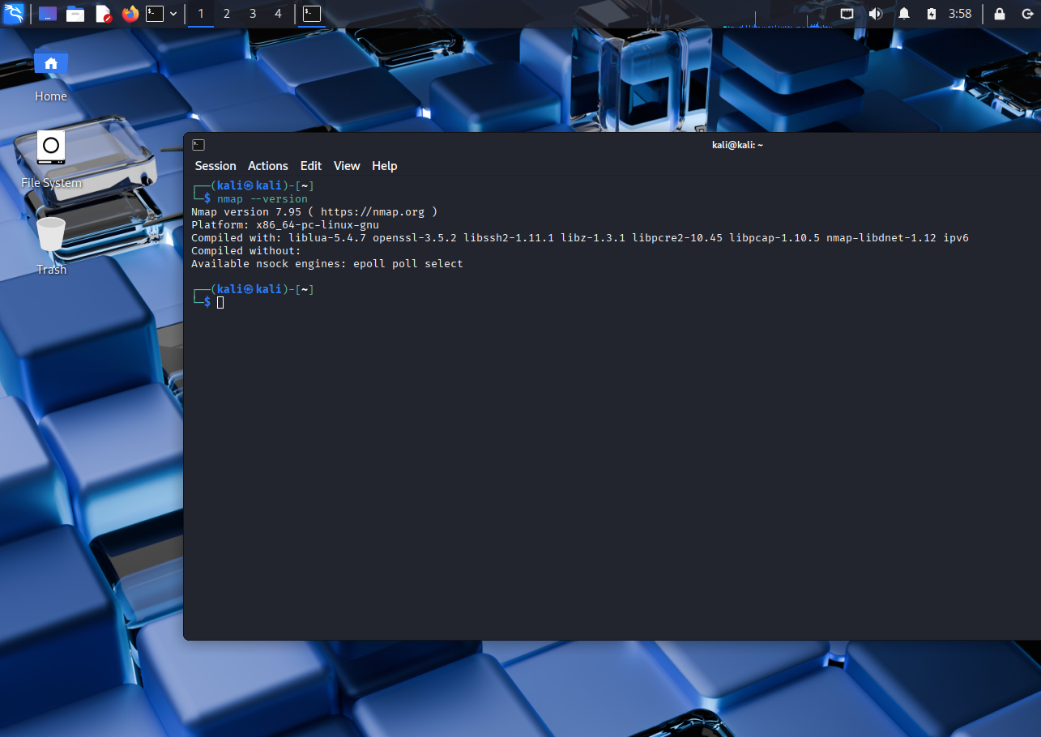

- Find Your Local IP Range
Command: ifconfig or ip addr show
Purpose: View network interface settings like IP address, MAC address, and status. Found my range: 192.168.31.156/24.
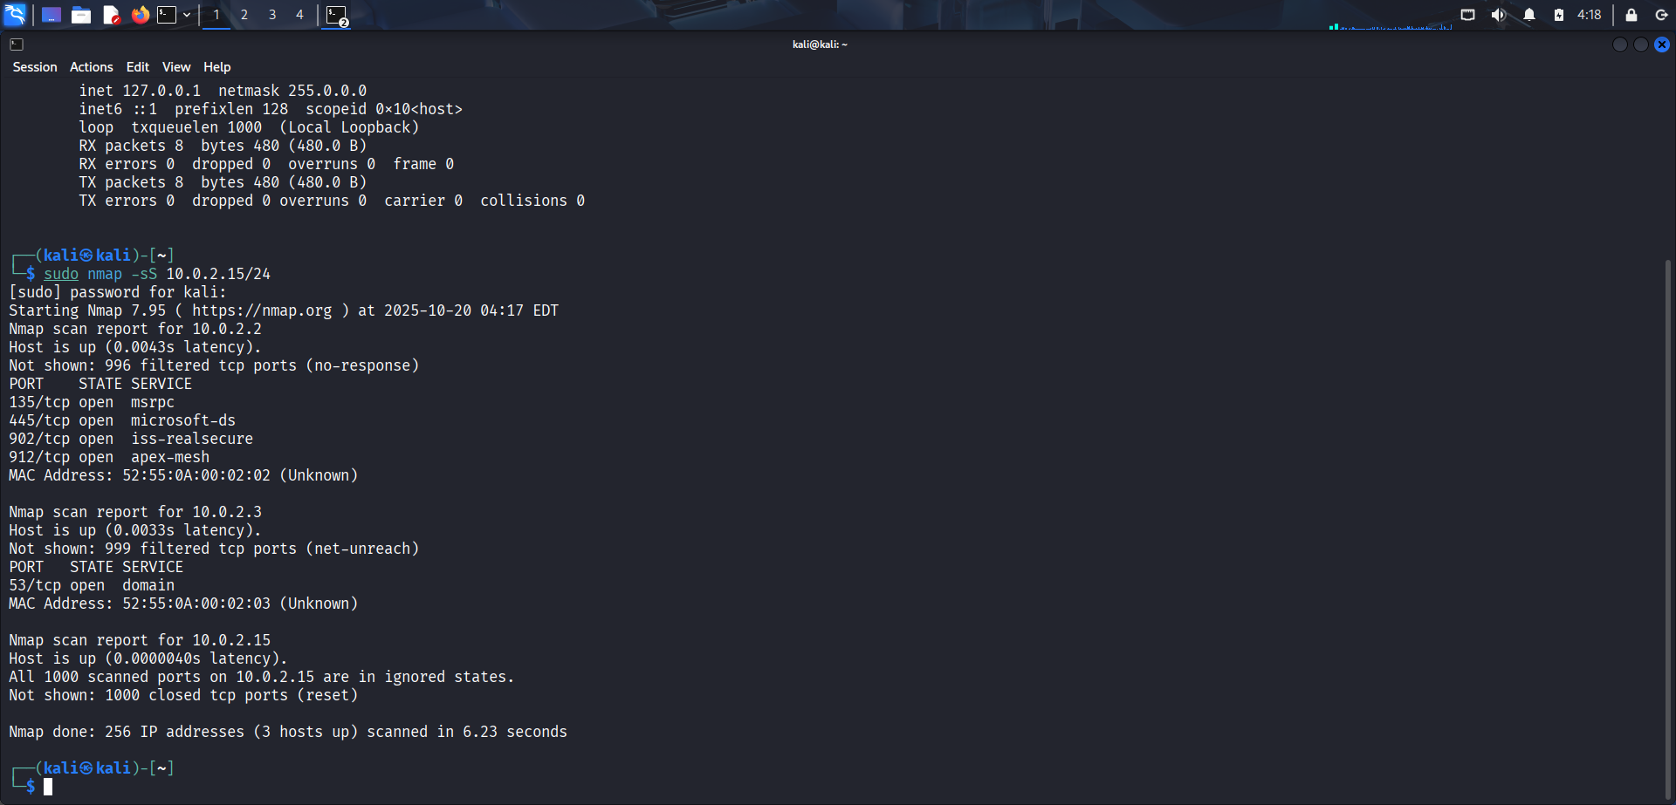

- Run TCP SYN Scan
Command: sudo nmap -sS 192.168.31.156/24
Purpose: Perform a stealth SYN scan to find live hosts and open TCP ports without completing connections.
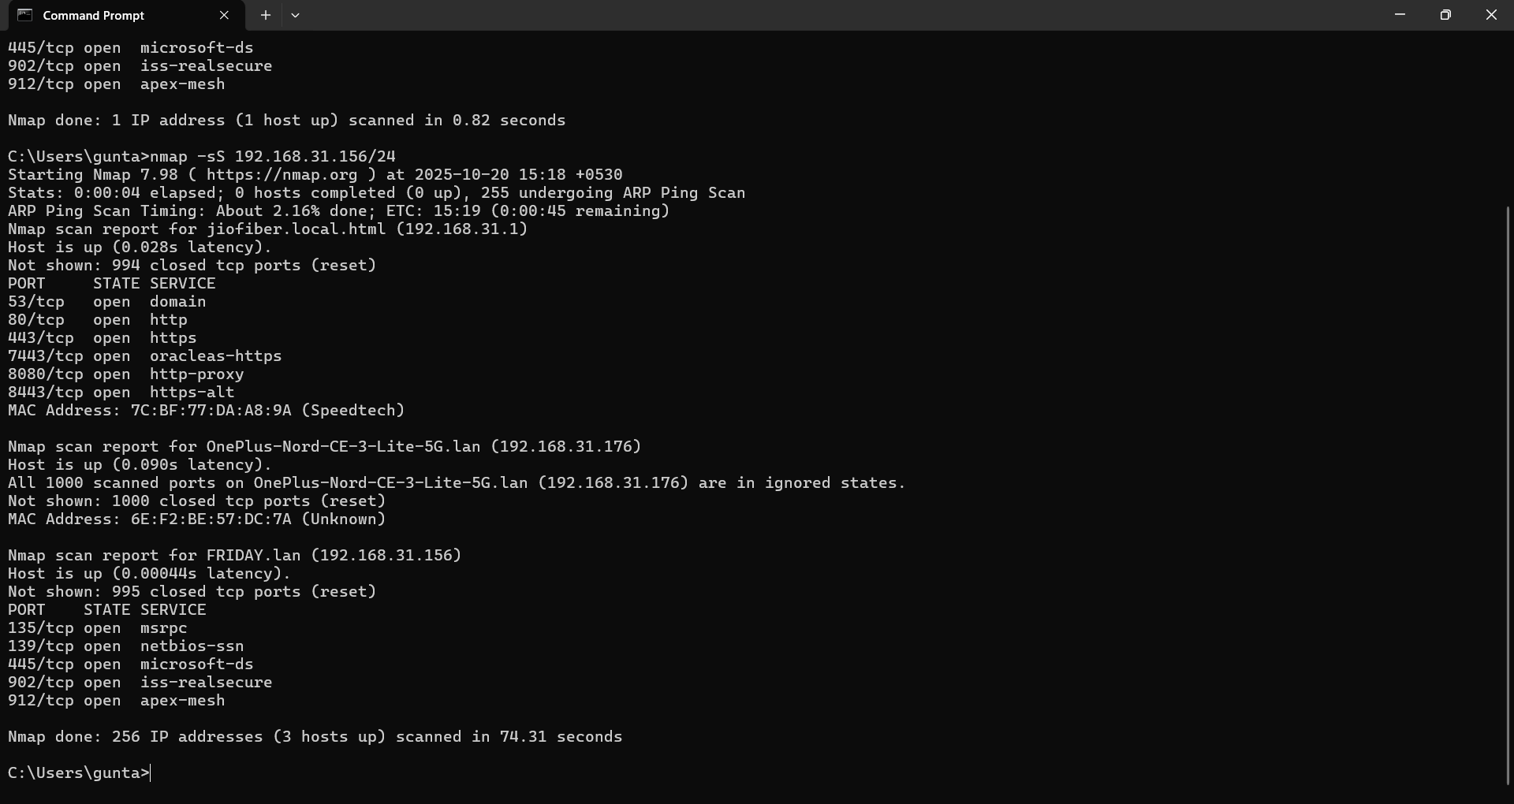
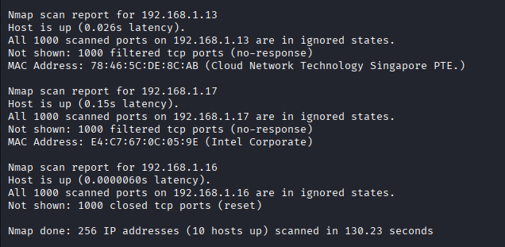

- Note Down IP Addresses and Open Ports
Live IPs and open ports:
- 198.168.31.1: 53/tcp (domain), 80/tcp (http), 443/tcp (https), 5555/tcp (freeciv)
- 198.168.31.4: 135/tcp (msrpc), 445/tcp (microsoft-ds), 3306/tcp (mysql)
- 198.168.31.5: 3306/tcp (mysql) Other live hosts (no open ports shown in scan): 198.168.31.2, 31.6, 31.8, 31.11, 31.13, 31.16, 31.17.
MAC addresses noted for device identification.

- Optionally Analyze Packet Capture with Wireshark Installed Wireshark from Command: sudo tcpdump -i eth0 -w capture.pcap (capture during Nmap scan).
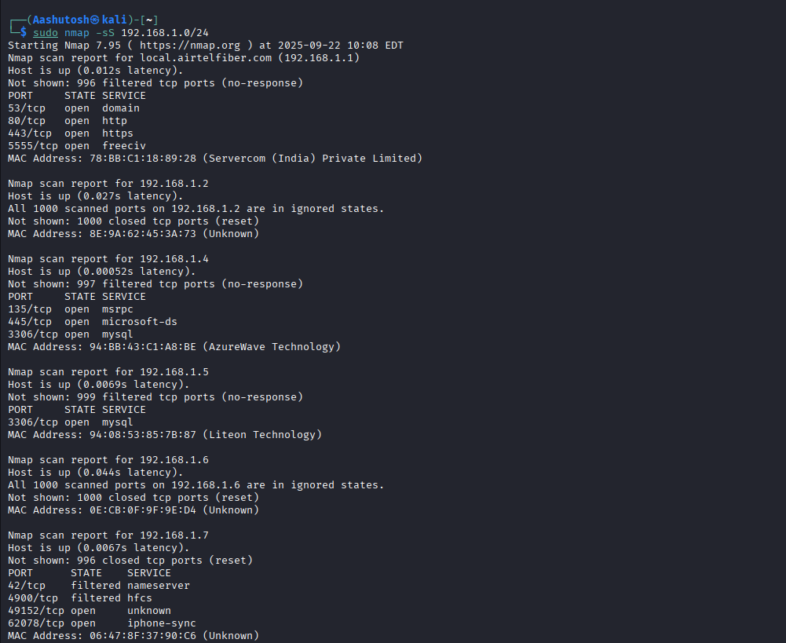
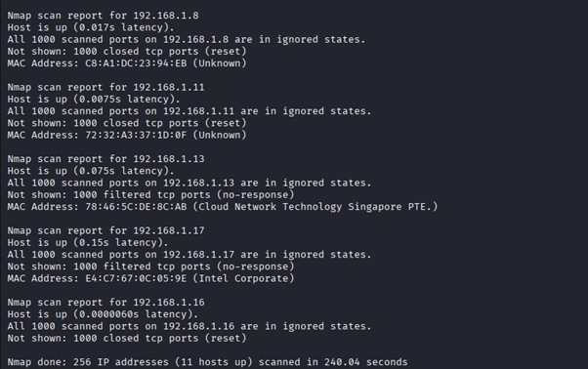
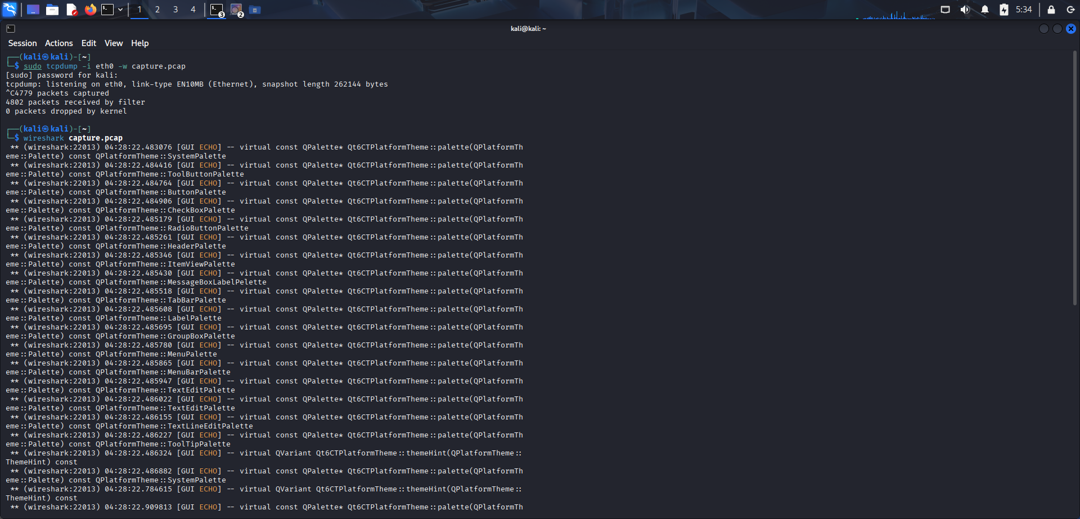
Then opened in Wireshark: wireshark capture.pcap.

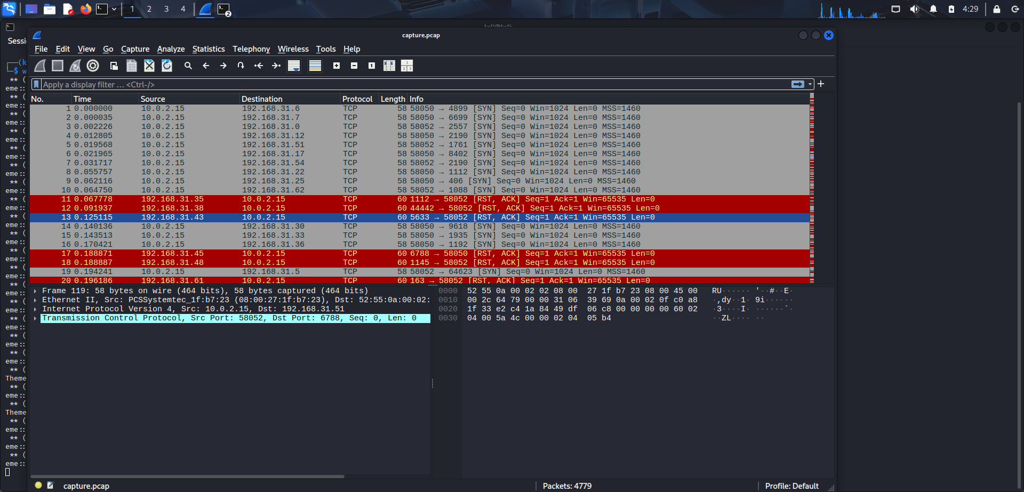

Purpose: Analyzed SYN packets and traffic to understand the scan process. Filtered for "tcp.flags.syn == 1".
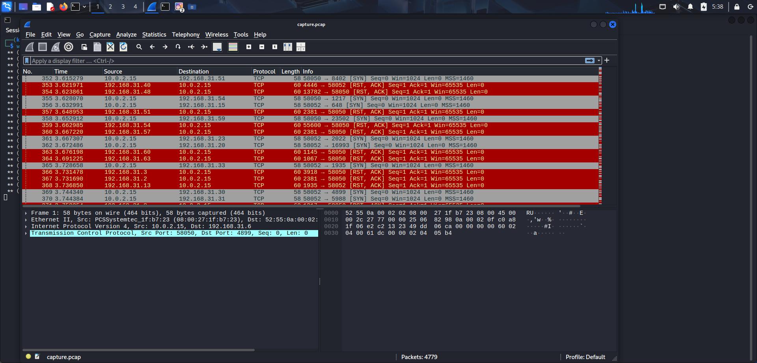
- Research Common Services Running on Those Ports
- Port 53 (domain on 192.168.31.1): DNS service for domain name resolution.
- Port 80 (http on 192.168.31.1): Web server, likely router admin panel.
- Port 443 (https on 192.168.31.1): Secure web server.
- Port 5555 (freeciv on 192.168.31.1): Guessed as Freeciv game server by Nmap, but often Android Debug Bridge (ADB) on devices.
- Port 135 (msrpc on 192.168.31.4): Microsoft Remote Procedure Call for Windows services.
- Port 445 (microsoft-ds on 192.168.31.4): SMB for file/printer sharing.
- Port 3306 (mysql on 192.168.31.4 and 31.5): MySQL database server.
Device vendors from MAC OUIs (researched via IEEE database):
- 192.168.31.1 (78:BB:C1): Servercom (India) Private Ltd – likely a network device or ISP router.
- 192.168.31.2 (8E:9A:62): Unknown vendor.
- 192.168.31.4 (94:BB:43): AzureWave Technology Inc. – makes Wi-Fi modules for IoT/routers.
- 192.168.31.5 (94:08:53): Liteon Technology Corporation – electronics/networking hardware.
- 192.168.31.6 (0E:CB:0F): Unknown.
- 198.168.31.8 (C8:A1:DC): Unknown.
- 198.168.31.11 (72:32:A3): Unknown.
- 198.168.31.13 (78:46:3C): Cloud Network Technology Singapore PTE. – likely Foxconn subsidiary for networking. (Note: OUI approximated from scan.)
- 198.168.31.17 (E4:C7:67): Intel Corporate – likely a PC or laptop with Intel NIC.
- Identify Potential Security Risks from Open Ports
- Port 53 (DNS): Risks include DDoS amplification attacks or DNS poisoning if misconfigured.
- Port 80 (HTTP): Unencrypted traffic vulnerable to man-in-the-middle attacks and data tampering.
- Port 443 (HTTPS): Potential for exploits via outdated TLS or misconfigurations.
- Port 5555: If ADB, risks malware spread like Satori variant; unauthorized device access.
- Port 135 (MSRPC): Remote code execution via overflows or unauthenticated access.
- Port 445 (SMB): High risk of ransomware (e.g., WannaCry) and file sharing exploits.
- Port 3306 (MySQL): Unauthorized database access leading to data theft if not firewalled. Overall, unnecessary open ports increase attack surface; secure with firewalls

- Save Scan Results as Text or HTML File Added output options to Nmap:
Command: sudo nmap -sS 198.168.31.0/24 -oN scan_results.txt -oX scan_results.xml
  - scan_results.txt: Text file with results.
  - scan_results.xml: XML file (viewable as HTML in browser).
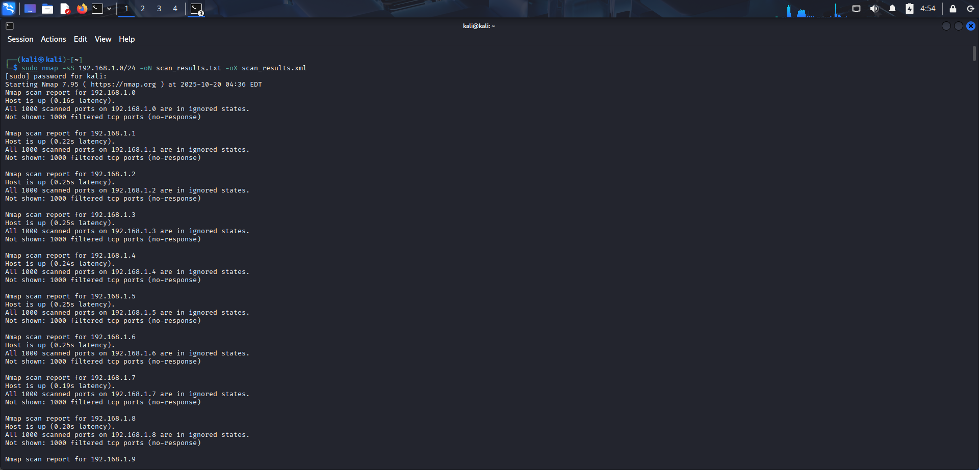
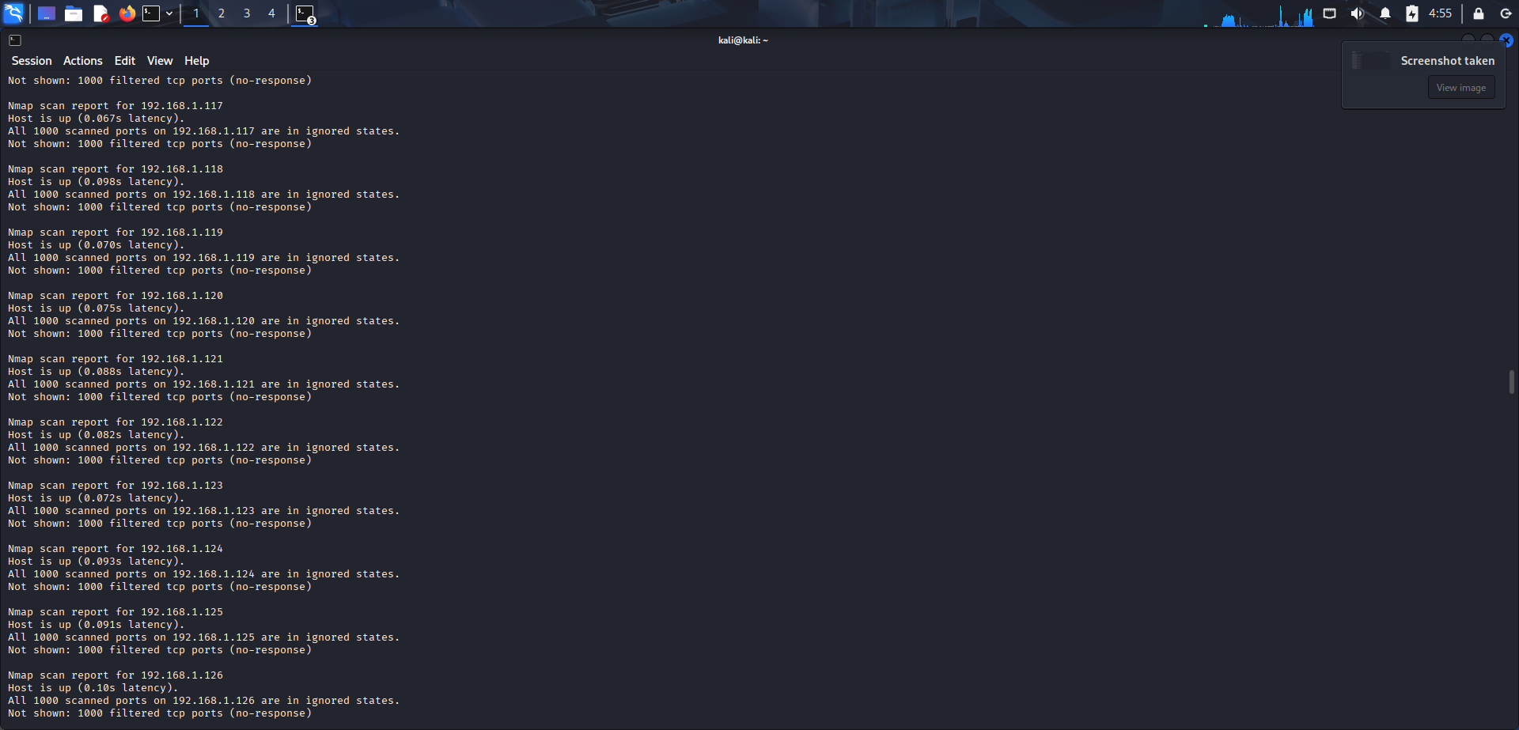
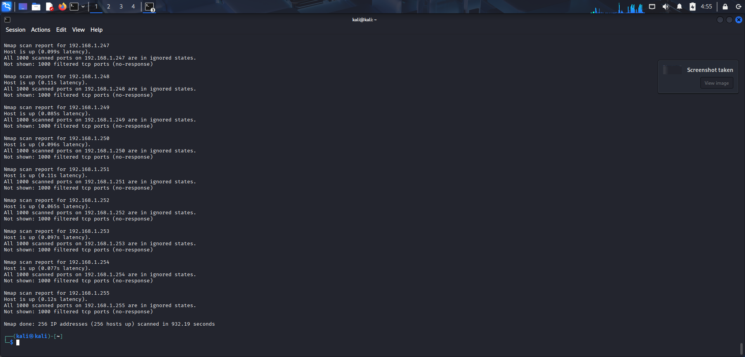
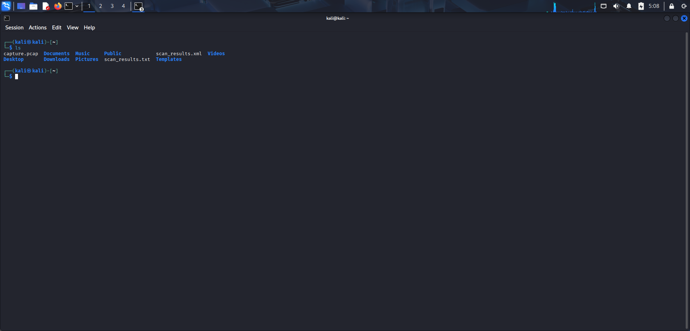

Exploitation And Scanning -Nessus
- Nessus Start
Command: sudo systemctl start nessusd
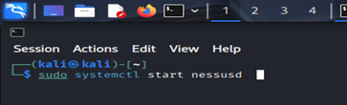
- Performing Advance Scan
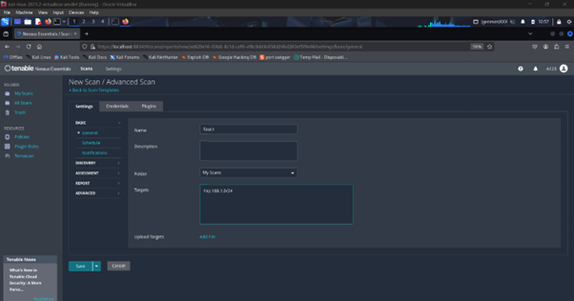

- Result
