SecureContract + FundingSecured

Evidence-grounded chat retrieval system

STATUS  Proposed |  | OWNER  Product engineering |  | LAST UPDATED  August 18, 2026

Authors | SecureContract / FundingSecured
Reviewers | Product and engineering
Related docs | Existing collection and NVIDIA NIM implementation
Scope | Chat retrieval, context, response, and operational boundaries.

1. Abstract
This design replaces single-prompt chat with bounded conversational retrieval for public contracts and funding opportunities. Each answer is grounded in a small, reranked set of current records, their collected evidence, and official source URLs. The system carries only recent conversational intent, never unbounded transcript history.
The design supports record-specific analysis and open-database discovery. It does not verify legal eligibility, scrape private data, or allow chat history to become evidence.

2. Goals and Non-Goals
Ground answers in live collected records | Do not make eligibility or award decisions
Keep only six recent turns of intent | Do not use conversation as evidence
Return official URLs and source passages | Do not browse arbitrary pages at chat time
Cache safe repeat work | Do not retain secrets in browser context
Roll out behind a reversible feature flag | No model-only decision is treated as authoritative

3. Background and Problem Statement
The prior assistants sent only the newest user message to the server. Follow-up questions lost decision context, broad queries returned weak lexical matches, and model output could be vacuous or malformed.
The new boundary separates conversation intent, retrieval, evidence, and generation. Retrieval narrows the saved open records first; the model receives only that bounded context and official links; quality gates replace weak output with a transparent evidence-first shortlist.

4. Proposed Architecture

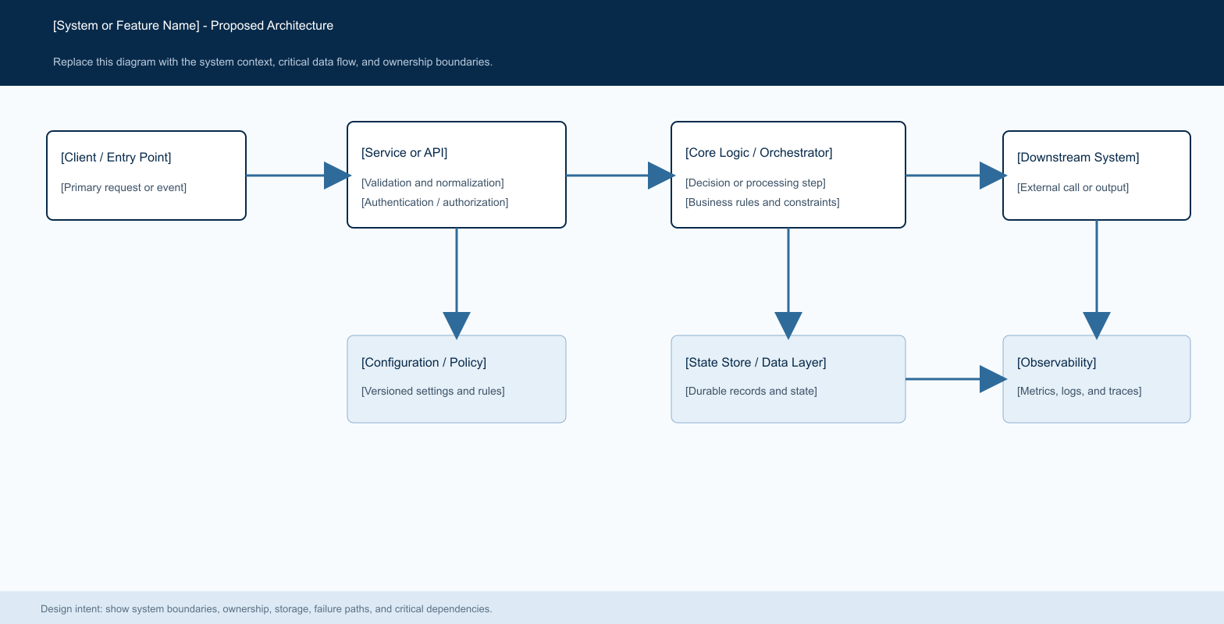
Figure 1. Bounded conversational retrieval: UI → validation → cached reranking → record/evidence context → NVIDIA NIM → quality gate → cited response.

Core components

Client chat | Fixed composer; scrollable response history | Browser memory | Shows an actionable error
Retrieval service | Validate, cache, rank open records | In-memory TTL cache | Returns no-match rather than unrelated records
Context builder | Bound record/evidence/URL payload | Normalized opportunity store | Omits missing fields
NVIDIA NIM adapter | Generate structured answer | NVIDIA NIM | Timeout or malformed JSON falls back
Response gate | Validate citations and answer quality | Response cache | Returns source-linked shortlist
[Component E] | [Describe metrics, logs, traces, and alerting responsibilities.] | [Telemetry and analytics backend] | [Describe degraded-mode monitoring and escalation.]

5. Request Lifecycle
- 1. The client submits the newest prompt plus at most six short prior turns.
- 2. The API validates sizes and roles; conversation is treated as intent only, never as collected evidence.
- 3. The service checks a five-minute retrieval cache, then searches open records with title, buyer/funder, taxonomy, scope, and evidence weighting.
- 4. The top eight candidates are normalized into a compact model context with source and official detail URLs.
- 5. The API records the candidate IDs, source evidence IDs, model selection, and response-cache key before returning a response.
- 6. NVIDIA NIM runs with a bounded timeout. Rate limits, malformed JSON, and weak answers use the deterministic, source-linked fallback.
- 7. The response returns answer text, linked records, citations, searched/read counts, and cacheable result metadata.

6. API and Data Contracts

Primary data contract

question | string | Yes | Newest user request; size-limited.
history | turn[] | No | At most six short intent turns.
candidateIds | string[] | Yes | Reranked saved open records.
evidenceIds | string[] | No | Collected passages permitted for citations.
sourceUrl | URL | Yes | Official source or detail link.
profileVersion | string | Funding | Invalidates profile-sensitive answer cache.
model | string | Yes | NIM model used for the response.
field_name_7 | [Type] | [Yes / No] | [Describe how this field affects system behavior.]

Contract guarantees

- Validation completes before retrieval or model invocation.
- A normalized question, profile version where applicable, and candidate IDs identify a cached answer.
- Responses retain record IDs, evidence IDs, source URLs, model name, and the selected record set for replay.
- Official sources remain authoritative; chat is an interpretation layer over collected records.
The versioned schema or interface definition is published at
[Link to interface or schema] and update it with each contract release.

7. Consistency, Idempotency, and Replay

Retrieval and answer caches are time-bounded and keyed by normalized question plus stable profile/record context. Repeated prompts may return a cached answer. Collection updates invalidate naturally through changed record selection or profile version; chat does not perform external side effects.
Repeated prompt | Return cached validated answer | Avoids repeat model use
No direct lexical match | Return explicit no-match guidance | Avoids unrelated recommendations
NIM timeout, 429, or malformed JSON | Return deterministic linked shortlist | Preserves evidence boundary
Record changes during request | Use selected snapshot | Keeps response replayable
[Configuration changes during execution] | [Describe which version remains authoritative.] | [Explain how mid-request behavior changes are prevented.]

8. Security and Privacy Considerations

- NVIDIA and Bright Data credentials remain server-side. The browser never receives provider keys.
- Only the selected profile fields, records, evidence excerpts, URLs, and last six turns are sent to the model. Logs must not include secrets.
- Environment-backed credentials are required for NVIDIA NIM and Bright Data access.
- Fallbacks are evidence-only and do not claim eligibility, compliance, or award probability.
- Stored opportunities follow the collection retention policy; conversation is ephemeral unless explicitly persisted later.

9. Operational Readiness
Grounded answer rate | Track cited response share | Engineering | Required
Retrieval latency | Track cache and rerank duration | Engineering | Required
Fallback rate | Alert on model failure or weak output | Engineering | Required
Context size | Reject over-budget payloads | Engineering | Required
Synthetic follow-up test | Verify prior intent without evidence leakage | Engineering | Recommended
Rollout constraint: launch behind the existing local flows; validate source links and no-match behavior before widening. | [Synthetic or sampled validation cadence and target] | [Owning team] | [Required / Recommended]
Rollout constraint: [Describe dry-run, canary, feature-flag, validation, rollback, and promotion requirements before production launch.]

10. Alternatives Considered

Unbounded transcript | Simple memory | Leaks stale intent and inflates context
Full database in prompt | No retrieval implementation | Slow, noisy, and hard to cite
Model-only web search | Broader discovery | Breaks collected-record and evidence boundaries
External vector database now | Semantic recall | Deferred until lexical metrics prove the need
[Alternative 4] | [Describe the consistency or implementation appeal.] | [Describe the technical boundary that makes it unsuitable.]

11. Open Questions
- Should answer caches be shared per user or held only in process for the demonstration?
- What relevance threshold should require a “no direct match” answer versus a broader related-record search?
- When should embeddings supplement lexical ranking for specialized procurement terminology?
- Which owner approves changes to retrieval weights and prompt contracts?

12. Decision and Next Steps
Approve bounded conversational retrieval for both applications. Implement and test record-specific and discovery flows first, measure citation coverage and weak-answer fallbacks, then tune ranking weights from observed queries before widening rollout.
M1 | Bounded history and weighted retrieval | Follow-up and no-match tests pass
M2 | Structured response and quality gate | Malformed/weak outputs recover safely
M3 | Local rollout | Official links and citations are visible
M4 | Tuning and broader rollout | Latency and fallback metrics meet launch targets
M4 | [Broader customer or workload rollout] | [SLOs met, rollback tested, and approvals complete]

Use footnotes for definitions, assumptions, or terms that need precision without interrupting the main narrative.

