**OPERATING SYSTEM LAB1**

**17BCE0437**

**ABHIRUPA MITRA**

**AIM: To understand the usage of linux basic commands**

1. cd: Change to new directory

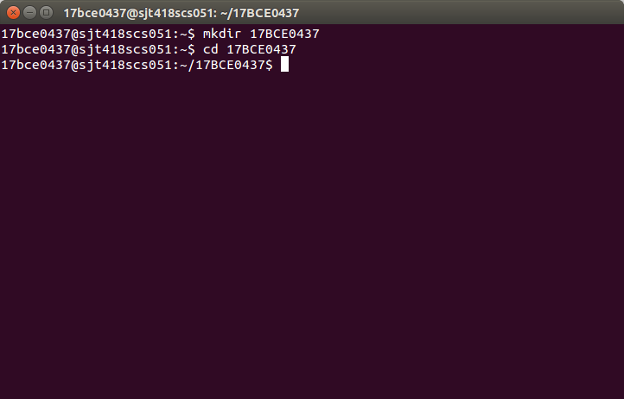

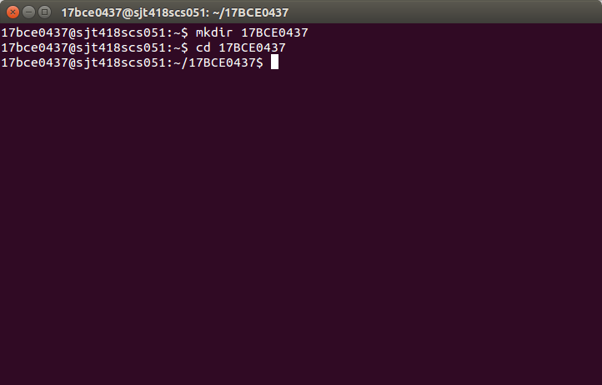2. mkdir :Create new directory

3. rmdir : remove empty directory (remove files first)

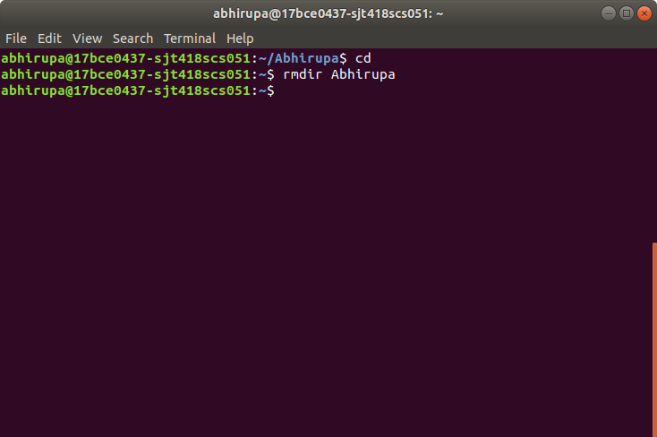

4. mv :Change name of directory

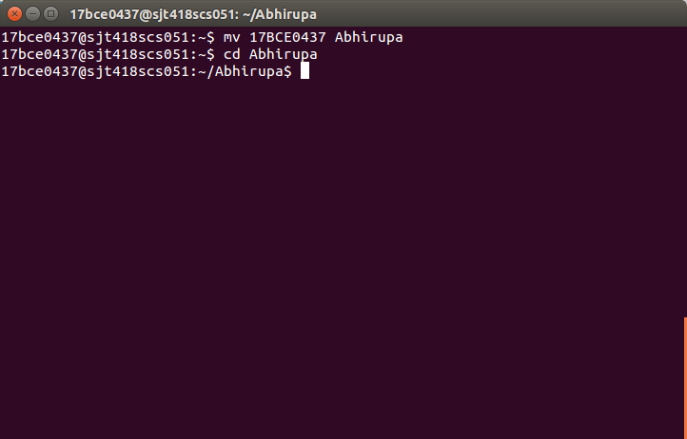

5. pwd :Show current directory

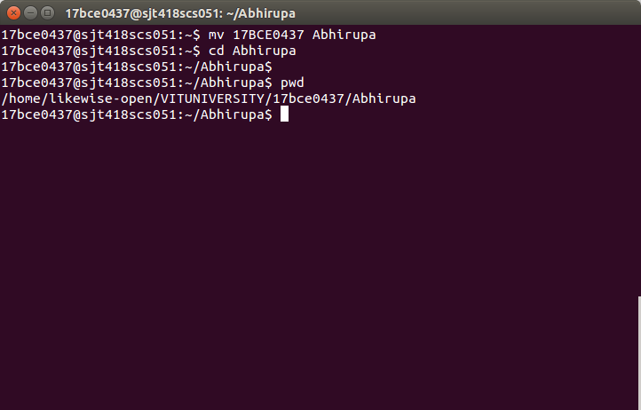

6. date :Show date and time

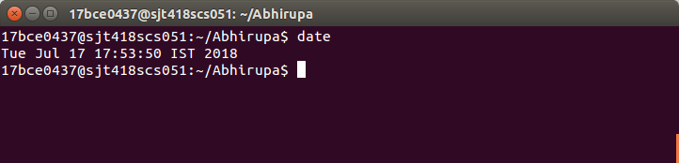

7. history :list of previously executed commands

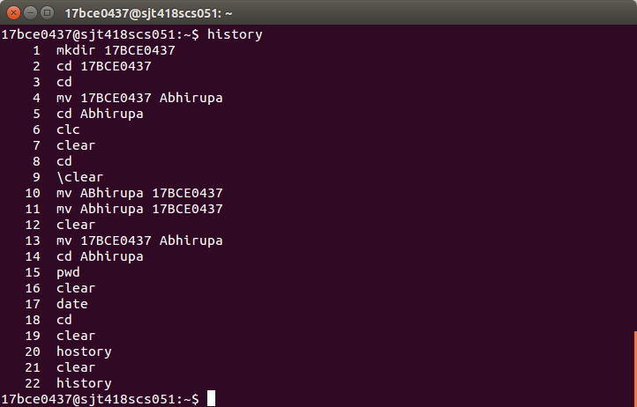

8. cal month year: Prints a calendar for the specified month of the specified year.

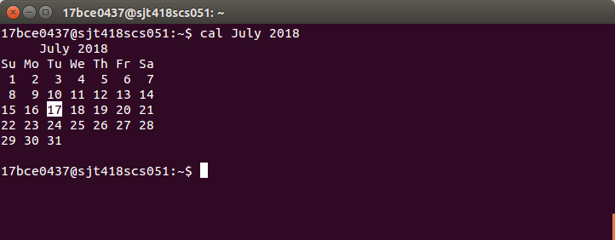

9. man :show online documentation by program name

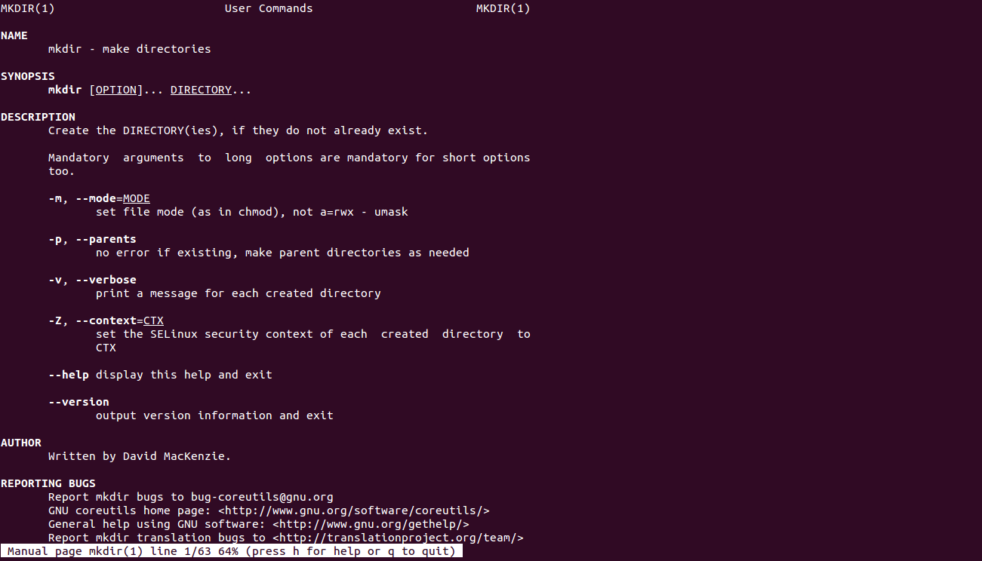

10. w, who :who is on the system and what they are doing

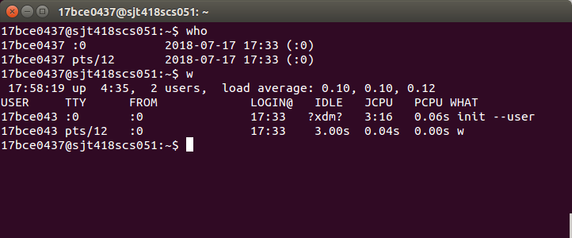

11. who am i :who is logged onto this terminal

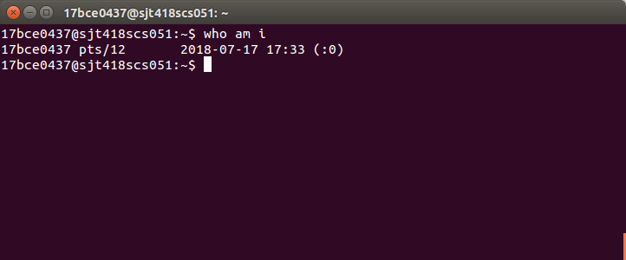

12. uptime: show one line summary of system status

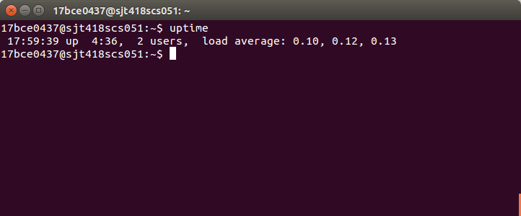

13. tty :know the terminal name.

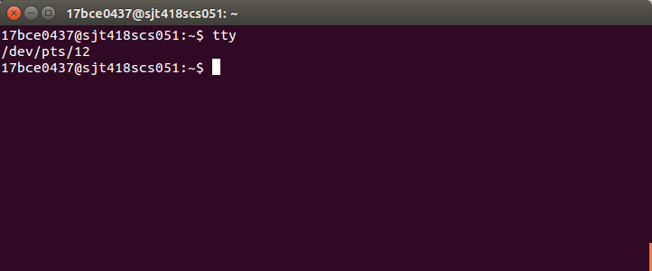

14. uname :print system information

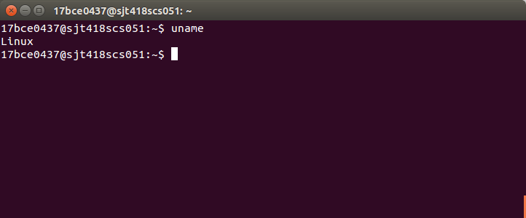

15. cat :view files

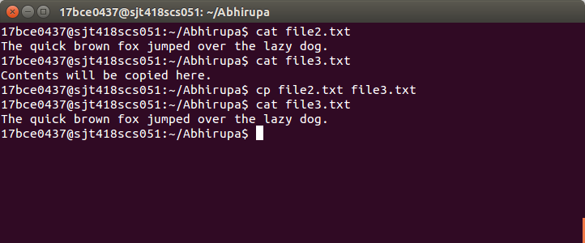

16. cp :copy files



17. ls :list files in a directory and their attributes

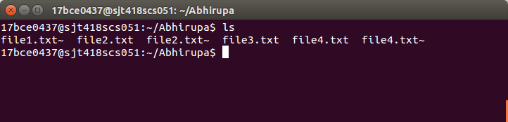

18. mv :change file name or directory location

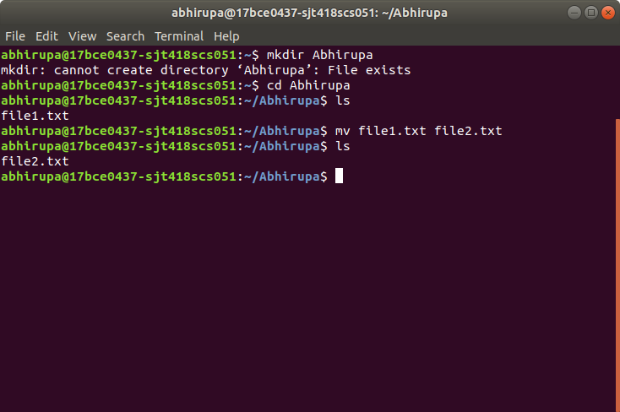

19. rm: Removes files from a directory

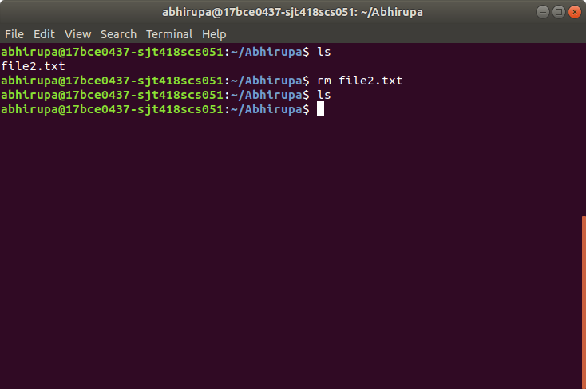

20. head :show first few lines of a file(s)

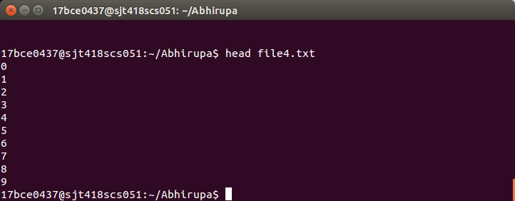

21. tail :show last few lines of a file; or reverse line order

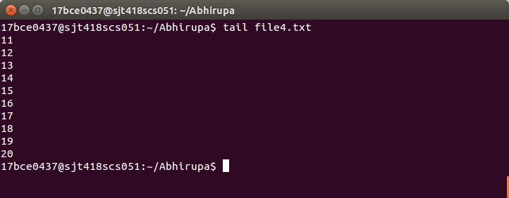

22. vi: full-featured screen editor for modifying text files

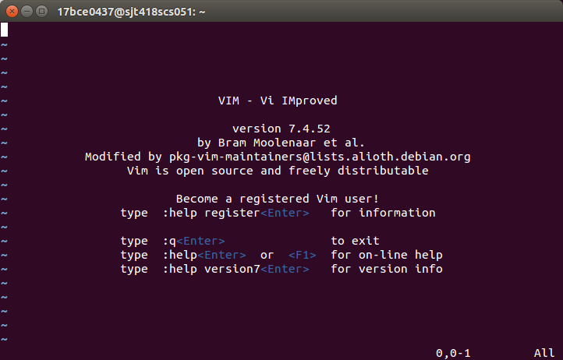

23. echo $$ :process id of current shell.

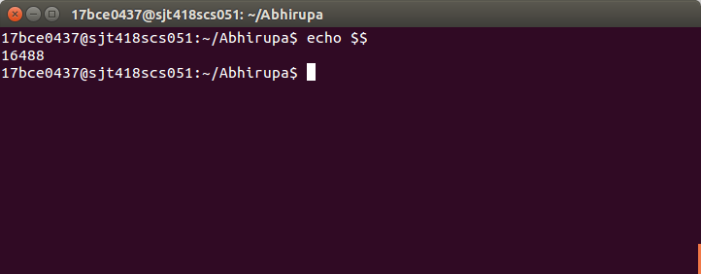

24. ps:Shows the current process status

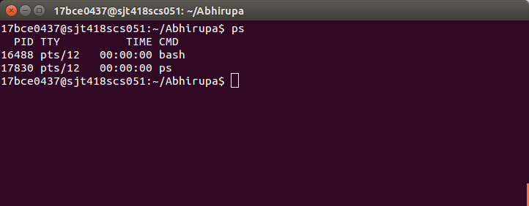

25. kill: Kill background job or previous process...

