Haskell Programming Assignment: Various Computations
Written by David Hennigan

Learning Abstract
This assignment played an important role in cultivating my understanding of Haskell. Throughout this assignment 8 tasks were completed each sequential task requiring slightly more knowledge of Haskell. Task 7 was my favorite task of this assignment, I got to use Haskell to build a mathematical function (nPVI) from the ground up.
Task 1 – Mindfully Mimicking the Demo
Demo
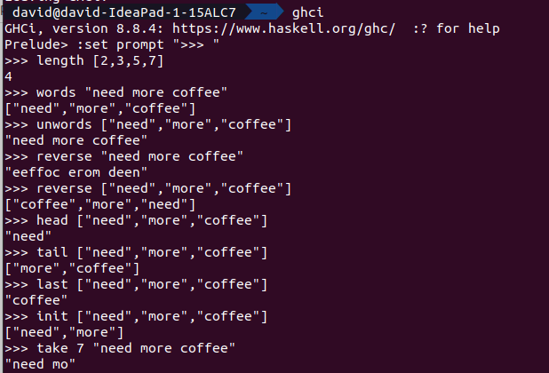
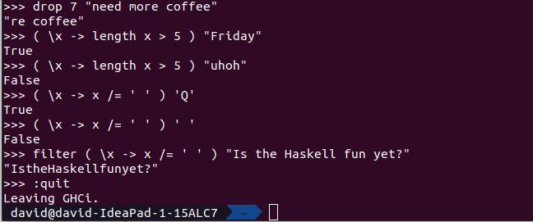
Task 2 – Numeric Function Definitions
Function Definitions
-------------------------------------------------------------------------
--- ha.hs houses task 2 of the haskell assignment

-------------------------------------------------------------------------
--- squareArea :: takes one real number representing the side length
--- of a square and returns the area of the square with the given side
--- length

squareArea x = x * x

-------------------------------------------------------------------------
--- circleArea :: takes one real number representing the radius of a circle
--- and returns the corresponding circles area

circleArea r = pi * r ^ 2

-------------------------------------------------------------------------
--- blueAreaOfCube :: takes the length of one edge of the cube and computes
--- the area of the cube that is equivalent to the cube's area minus a
--- centered dots area ( on each side of the cube )
--- with a radius 1/4 the edges length.

blueAreaOfCube el = (6 * el ^ 2) - (6 * pi * ( el / 4 ) ^ 2)

-------------------------------------------------------------------------
--- paintedCube1 :: takes the order of a n by n by n cube where n is
--- equal to order and returns the number of cubes that are painted once
--- when the entire cube is painted

paintedCube1 order = if order < 3 then 0 else 6 * (( order - 2 ) ^ 2)

-------------------------------------------------------------------------
--- paintedCube2 :: takes the order of a n by n by n cube where n is equal
--- to order and returns the number of cubes that are painted twice when the
--- entire cube is painted

paintedCube2 order = if order < 3 then 0 else 12 * ( order - 2 )
Demo
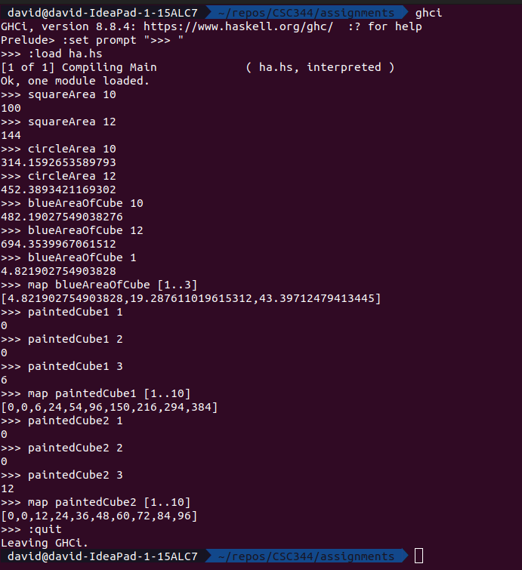
Task 3 – Puzzlers
Function Definitions
-------------------------------------------------------------------------
--- reverseWords :: reverses the words of a string

reverseWords wordString = unwords ( reverse ( words wordString ) )

-------------------------------------------------------------------------
--- averageWordLength :: takes a string of words and returns the average
--- word length

averageWordLength wordString = fromIntegral ( sum letterCountList ) / fromIntegral wordCount
where wordList = words wordString
wordCount = length wordList
letterCountList = map length wordList
Demo
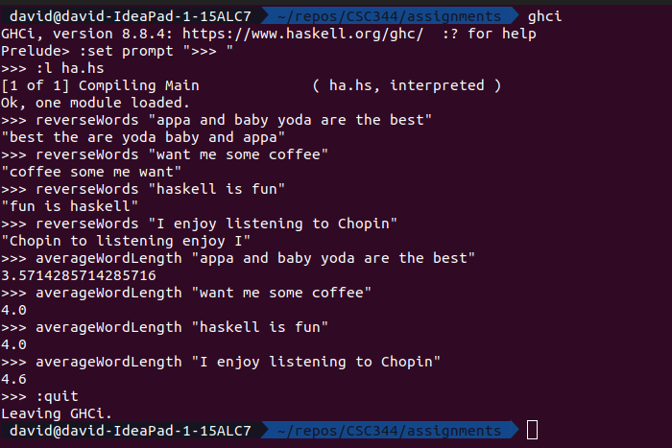
Task 4 – Recursive List Processors
Function Definitions
-------------------------------------------------------------------------
--- list2set :: takes a list and turns it into a set

list2set l = if (length l) == 0 then [] else (if elem (head l) set then set else (head l) : set)
where set = list2set(tail l)

-------------------------------------------------------------------------
--- isPalindrome :: checks to see if a list is a palindrome

isPalindrome l = if (length l) < 2 then True else (if (head l) == (last l) then (isPalindrome (tail (init l))) else False)

-------------------------------------------------------------------------
--- collatz :: takes a number as an input and generates a list containing
--- the corresponding collatz sequence

collatz :: Integer -> [Integer]
collatz num = if num == 1 then [1] else ( num : l )
where nextNum = if ( rem num 2 ) == 0 then (div num 2) else (3 * num + 1)
l = ( collatz nextNum )

Demo
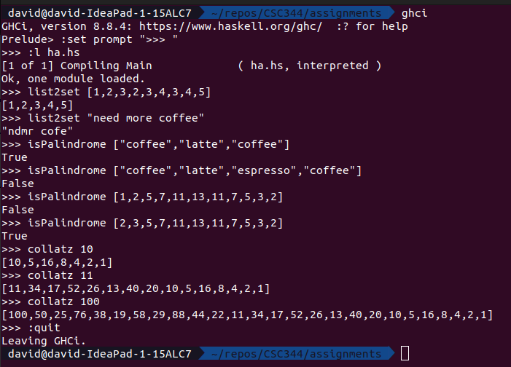
Task 5 – List Comprehensions
Function Definitions
-------------------------------------------------------------------------
--- count :: takes an object and a list of objects then returns the amount
--- of times the object appears within the list.

count object objects = length [ x | x <- objects, x == object]

-------------------------------------------------------------------------
--- freqTable :: takes a list of objects and returns a list of ordered
--- pairs each consisting of an element of the list together with the number
--- of times it occured

freqTable objects = [ (x,y) | x <- (list2set objects), y <- [(count x objects)]]

Demo
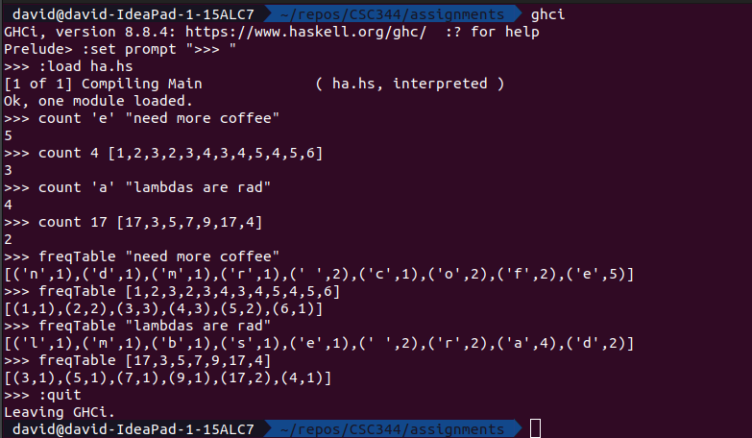
Task 6 – Higher Order Functions
Function Definitions
-------------------------------------------------------------------------
--- vowelCount :: takes a string of lower case letters and returns the number
--- of lowercase vowels that appear in the string

vowelCount str = length (filter (\x -> (x == 'a' || x == 'e' || x == 'i' ||
x == 'o' || x == 'u')) str)

-------------------------------------------------------------------------
--- lcsim :: takes a function for mapping, a predicate for filtering, and
--- a list of elements and returns the same value as:
--- [f x | x <- xs, p x]

lcsim mapFunc pred elems = map (mapFunc) (filter (pred) elems)

Demo
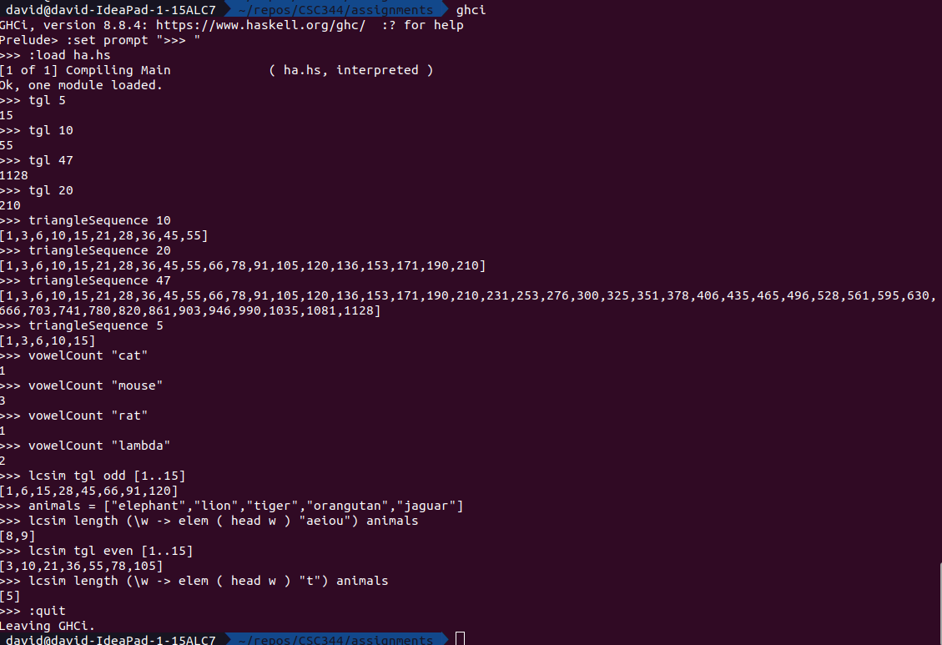

Task 7 – An Interesting Statistic: nPVI
Task 7a – Test data
Function Definitions
-------------------------------------------------------------------------
--- Test data

a :: [Int]
a = [2,5,1,3]

b :: [Int]
b = [1,3,6,2,5]

c :: [Int]
c = [4,4,2,1,1,2,2,4,4,8]

u :: [Int]
u = [2,2,2,2,2,2,2,2,2,2]

x :: [Int]
x = [1,9,2,8,3,7,2,8,1,9]
Demo
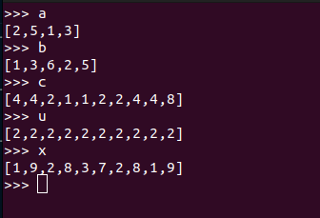
Task 7b – The pairwiseValues function
Function Definitions
-------------------------------------------------------------------------
--- pairwiseValues

pairwiseValues :: [Int] -> [(Int,Int)]
pairwiseValues listOfInts = zip (init listOfInts) (tail listOfInts)

Demo
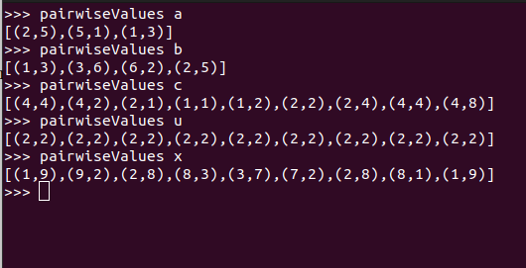
Task 7c – The pairwiseDifferences function
Function Definitions
-------------------------------------------------------------------------
--- pairwiseDifferences

pairwiseDifferences :: [Int] -> [Int]
pairwiseDifferences listOfElements = map (\(x,y) -> x - y ) (pairwiseValues listOfElements)

Demo
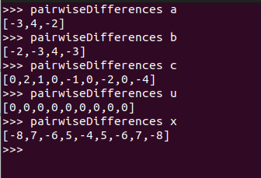
Task 7d – The pairwiseSums function
Function Definitions
-------------------------------------------------------------------------
--- pairwiseSums

pairwiseSums :: [Int] -> [Int]
pairwiseSums listOfElements = map (\(x,y) -> x + y ) (pairwiseValues listOfElements)

Demo

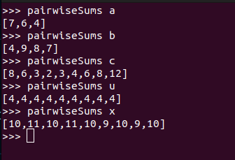
Task 7e – The pairwiseHalves function
Function Definitions
-------------------------------------------------------------------------
--- half

half :: Int -> Double
half number = ( fromIntegral number ) / 2

-------------------------------------------------------------------------
--- pairwiseHalves

pairwiseHalves :: [Int] -> [Double]
pairwiseHalves numbers = map (half) numbers

Demo
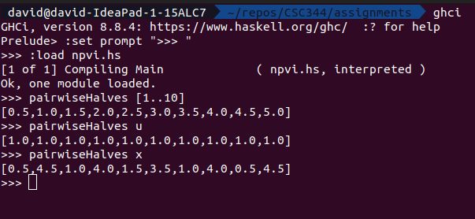

Task 7f – The pairwiseHalfSums function
Function Definition
-------------------------------------------------------------------------
--- pairwiseHalfSums

pairwiseHalfSums :: [Int] -> [Double]
pairwiseHalfSums numbers = pairwiseHalves ( pairwiseSums numbers )

Demo
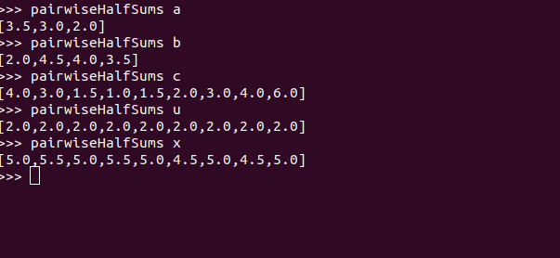
Task 7g – The pairwiseTermPairs function
Function Definition
-------------------------------------------------------------------------
--- pairwiseTermPairs

pairwiseTermPairs :: [Int] -> [(Int,Double)]
pairwiseTermPairs numbers = zip (pairwiseDifferences numbers) (pairwiseHalfSums numbers)

Demo
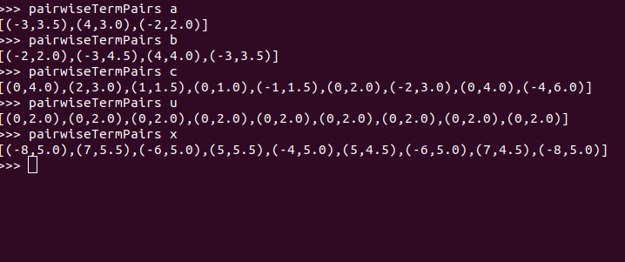
Task 7h – The pairwiseTerms functional
Function Definitions
-------------------------------------------------------------------------
--- term

term :: (Int,Double) -> Double
term ndPair = abs (fromIntegral ( fst ndPair ) / ( snd ndPair ) )

-------------------------------------------------------------------------
--- pairwiseTerms

pairwiseTerms :: [Int] -> [Double]
pairwiseTerms numbers = map (term) (pairwiseTermPairs numbers)

Demo
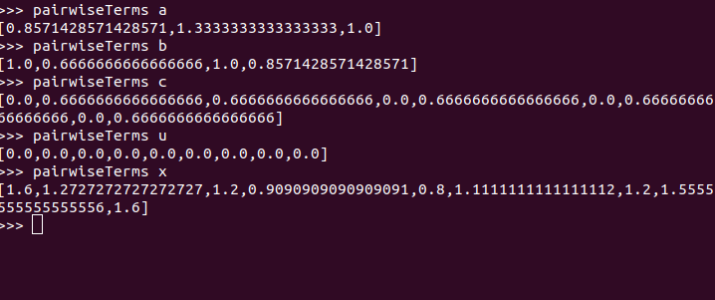
Task 7i – The nPVI function
Function Definition
-------------------------------------------------------------------------
--- nPVI

nPVI :: [Int] -> Double
nPVI xs = normalizer xs * sum ( pairwiseTerms xs )
where normalizer xs = 100 / fromIntegral ( (length xs ) - 1 )
Demo
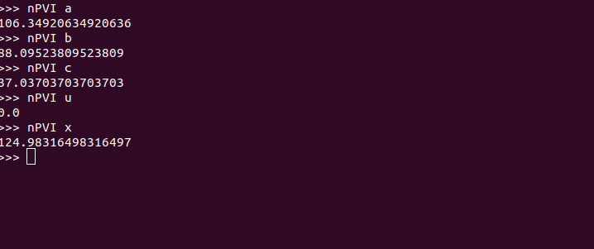
Task 8 – Historic Code: The Dit Dah Code
Subtask 8a
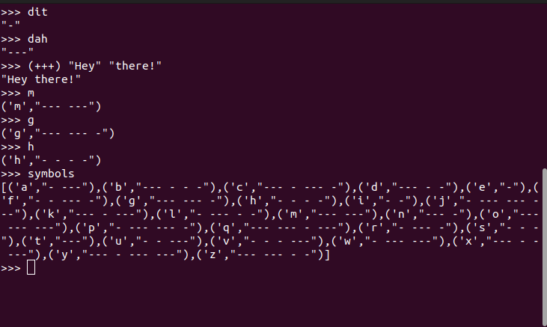
Subtask 8b
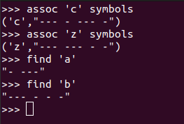

Subtask 8c
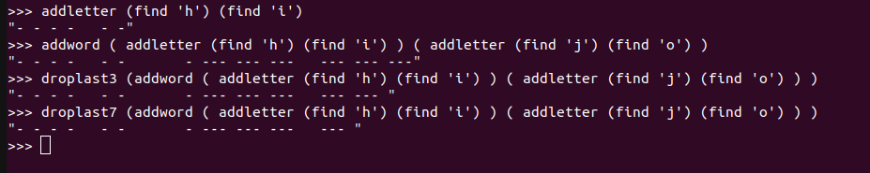
Subtask 8d
