Racket Assignment #2: Interactions, Definitions, Applications
Written by David Hennigan

Learning Abstract
In this assignment tasks were completed which helped further my understanding of Racket. A variety of functions revolving around shapes were used. The problems in this assignment allowed for a great deal of expression and creativity.

Task 1: Interactions – Scrap of Tin

Arithmetic Expressions
> 5
5
> 5.3
5.3
> ( * 3 10 )
30
> ( + ( * 3 10 ) 4 )
34
> ( * 9 9 9 9 9 9 9 9 9 9 9 9 9 9 9 9 9 9 9 9 )
12157665459056928801

Solve a Simple Problem (Area of Scrap)
> pi
3.141592653589793
> side
. . side: undefined;
cannot reference an identifier before its definition
> ( define side 100 )
> side
100
> ( define square-area ( * side side ) )
> square-area
10000
> ( define radius ( / side 2 ) )
> radius
50
> ( define circle-area ( * pi radius radius ) )
> circle-area
7853.981633974483
> ( define scrap-area ( - square-area circle-area ) )
> scrap-area
2146.018366025517
Rendering an Image of the Problem Situation
> ( require 2htdp/image )
> ( define side 100 )
> ( define the-square ( square side "solid" "silver" ) )
> the-square

> ( define radius ( / side 2 ) )
> ( define the-circle ( circle radius "solid" "white" ) )
> ( define the-image ( overlay the-circle the-square ) )
> the-image


Task 2: Definitions – Inscribing/Circumscribing Circles/Squares

cs-demo

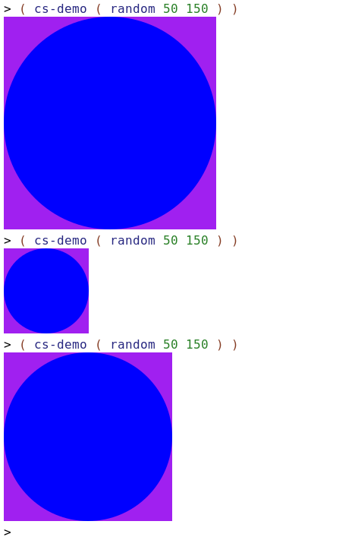
cc-demo
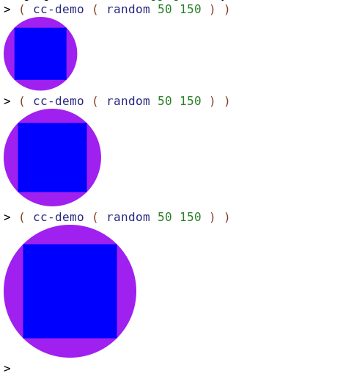
ic-demo
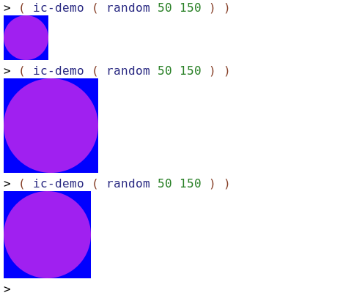
is-demo
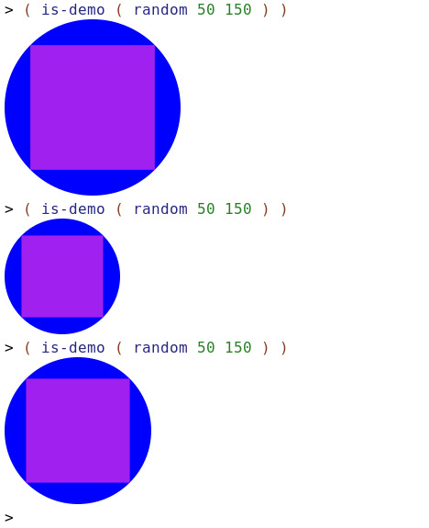
The Code
#lang racket
( require 2htdp/image )

( define ( cs radius )
( * radius 2 )
)

( define ( cc side )
( * ( / side 2 ) ( sqrt 2 ) )
)

( define ( ic side )
( / side 2 )
)

( define ( is radius )
( * ( / radius ( sqrt 2 ) ) 2 )
)

( define ( cs-demo radius )
( define c ( circle radius 'solid 'blue ) )
( define s ( square ( cs radius ) 'solid 'purple ) )
( overlay c s )
)

( define ( cc-demo side )
( define s ( square side 'solid 'blue ) )
( define c ( circle ( cc side ) 'solid 'purple ) )
( overlay s c )
)

( define ( ic-demo side )
( define s ( square side 'solid 'blue ) )
( define c ( circle ( ic side ) 'solid 'purple ) )
( overlay c s )
)

( define ( is-demo radius )
( define c ( circle radius 'solid 'blue ) )
( define s ( square ( is radius ) 'solid 'purple ) )
( overlay s c )
)

Task 3: Inscribing/Circumscribing Images

Image 1 Demo

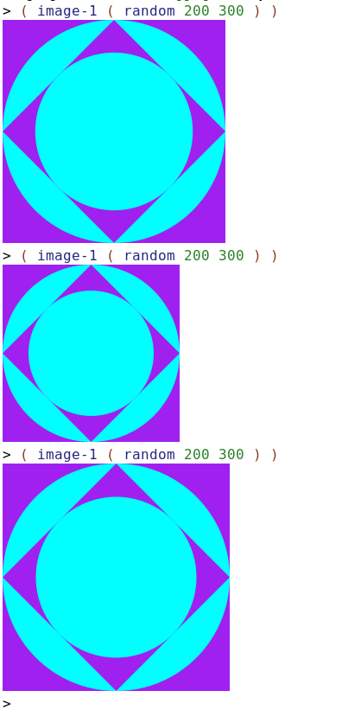
Image 2 Demo
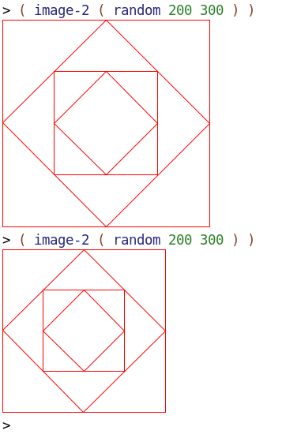
Warholesque Image
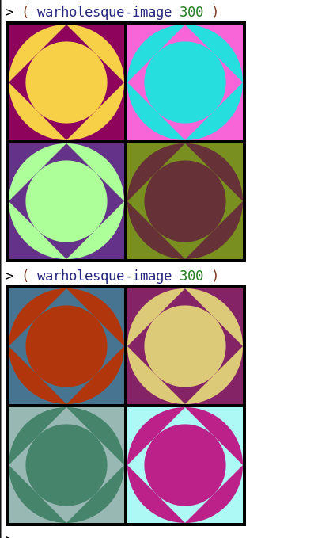
The Code
( define ( image-1 side )
( define outer-s ( square side 'solid 'purple ) )
( define outer-radius ( ic side ) )
( define outer-c ( circle outer-radius 'solid 'cyan ) )
( define inner-side ( is outer-radius ) )
( define inner-s ( square inner-side 'solid 'purple ) )
( define inner-s-rotated ( rotate 45 inner-s ) )
( define inner-c ( circle ( ic inner-side ) 'solid 'cyan ) )
( define inner-shape ( overlay inner-c inner-s-rotated ) )
( define outer-shape ( overlay outer-c outer-s ) )
( overlay inner-shape outer-shape )
)

( define ( image-2 side )
( define outer-s ( square side 'outline 'red ) )
( define side-outer-rotated ( is (/ side 2 ) ) )
( define rotated-outer-s ( rotate 45 ( square side-outer-rotated 'outline 'red ) ) )
( define inner-side ( is (/ side-outer-rotated 2) ) )
( define inner-s ( square inner-side 'outline 'red ) )
( define side-inner-rotated ( is (/ inner-side 2 ) ) )
( define rotated-inner-s ( rotate 45 ( square side-inner-rotated 'outline 'red ) ) )
( define inner ( overlay rotated-inner-s inner-s ) )
( define outer ( overlay rotated-outer-s outer-s ) )
( overlay inner outer )
)

( define (warholesque-image outer-side )
( define ( image-part side )
( define ( rgb ) ( random 0 256 ) )
( define color-1 ( color ( rgb ) ( rgb ) ( rgb ) ) )
( define color-2 ( color ( rgb ) ( rgb ) ( rgb ) ) )
( define outer-s ( square side 'solid color-1 ) )
( define outer-radius ( ic side ) )
( define outer-c ( circle outer-radius 'solid color-2 ) )
( define inner-side ( is outer-radius ) )
( define inner-s ( square inner-side 'solid color-1 ) )
( define inner-s-rotated ( rotate 45 inner-s ) )
( define inner-c ( circle ( ic inner-side ) 'solid color-2 ) )
( define inner-shape ( overlay inner-c inner-s-rotated ) )
( define outer-shape ( overlay outer-c outer-s ) )
( overlay inner-shape outer-shape )
)
( define outer-horz-rect ( rectangle (- (/ outer-side 2) 6) 4 'solid 'black ) )
( define inner-horz-rect ( rectangle (- (/ outer-side 2) 6) 2 'solid 'black ) )
( define outer-vert-rect ( rectangle 4 (/ outer-side 2 ) 'solid 'black ) )
( define inner-vert-rect ( rectangle 2 (/ outer-side 2 ) 'solid 'black ) )
( define inner-side ( - ( / outer-side 2) 6 ) )

( define top-left ( image-part inner-side) )
( define top-left-with-border ( beside outer-vert-rect ( beside ( above outer-horz-rect ( above top-left inner-horz-rect ) ) inner-vert-rect ) ) )

( define bottom-left ( image-part inner-side) )
( define bottom-left-with-border ( beside outer-vert-rect ( beside ( above inner-horz-rect ( above bottom-left outer-horz-rect ) ) inner-vert-rect ) ) )

( define top-right ( image-part inner-side) )
( define top-right-with-border ( beside inner-vert-rect ( beside ( above outer-horz-rect ( above top- right inner-horz-rect ) ) outer-vert-rect ) ) )

( define bottom-right ( image-part inner-side) )
( define bottom-right-with-border ( beside inner-vert-rect ( beside ( above inner-horz-rect ( above bottom-right outer-horz-rect ) ) outer-vert-rect ) ) )

( define left-side ( above top-left-with-border bottom-left-with-border ) )
( define right-side ( above top-right-with-border bottom-right-with-border ) )
( beside left-side right-side )
)
Task 4: Permutations of Randomly Colored Stacked Dots
Demo
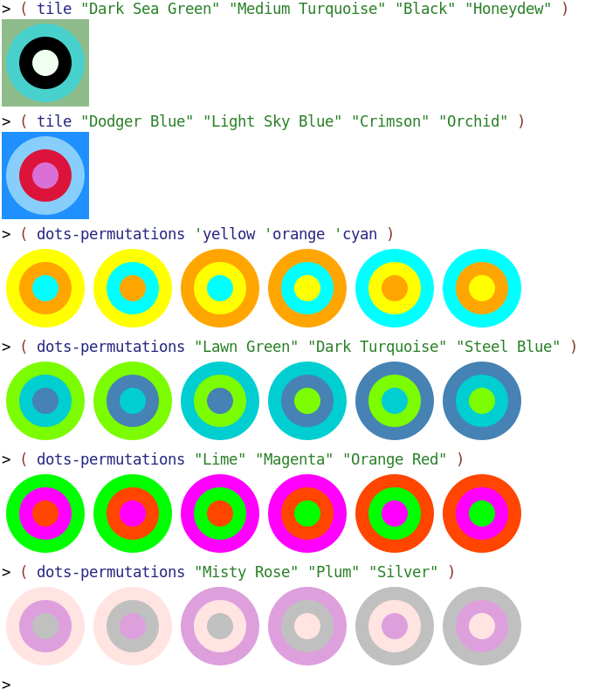

Code
#lang racket

( require 2htdp/image )

( define ( tile background-color c1-color c2-color c3-color )
( define tile-background ( square 100 'solid background-color ) )
( define c1 ( circle 45 'solid c1-color ) )
( define c2 ( circle 30 'solid c2-color ) )
( define c3 ( circle 15 'solid c3-color ) )
( overlay c3 c2 c1 tile-background )
)

( define ( dots-permutations color1 color2 color3 )
( define dot1 ( tile 'white color1 color2 color3 ) )
( define dot2 ( tile 'white color1 color3 color2 ) )
( define dot3 ( tile 'white color2 color1 color3 ) )
( define dot4 ( tile 'white color2 color3 color1 ) )
( define dot5 ( tile 'white color3 color1 color2 ) )
( define dot6 ( tile 'white color3 color2 color1 ) )
( beside dot1 dot2 dot3 dot4 dot5 dot6 )
)

