Racket Assignment #3: Recursion in Racket
Written by David Hennigan

Learning Abstract
This assignment is composed of 5 programming tasks all utilizing recursion. The tasks were varying in difficulty with the assignment becoming more involved in the final tasks. During this assignment I was able to make my own recursive random color list generator which I enjoyed making quite thoroughly. The overarching goals of the assignment were to develop some important recursion practices and to further familiarize with Racket.
Task 1: Counting Down, Counting Up
Code
#lang racket

( define ( count-down n )
( cond
( ( > n 0 )
( display n ) ( display "\n" )
( count-down ( - n 1 ) )
)
)
)

( define ( count-up n )
( cond
( ( > n 0 )
( count-up ( - n 1 ) )
( display n ) ( display "\n" )
)
)
)

Demo
> ( count-down 5 )
5
4
3
2
1
> ( count-down 10 )
10
9
8
7
6
5
4
3
2
1
> ( count-down 20 )
20
19
18
17
16
15
14
13
12
11
10
9
8
7
6
5
4
3
2
1
> ( count-up 5 )
1
2
3
4
5
> ( count-up 10 )
1
2
3
4
5
6
7
8
9
10
> ( count-up 20 )
1
2
3
4
5
6
7
8
9
10
11
12
13
14
15
16
17
18
19
20

Task 2: Triangle of Stars
Code
( define ( line-of-stars n )
( cond
( ( > n 0 )
( display "*" )
( line-of-stars ( - n 1 ) )
)
)
)

( define ( triangle-of-stars n )
( cond
( ( > n 0 )
( triangle-of-stars ( - n 1 ) )
( line-of-stars n )
( display "\n" )
)
)
)

Demo
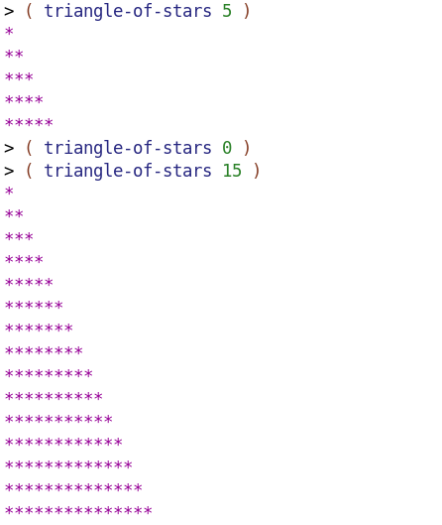
Task 3: Flipping a Coin

Code
( define ( flip-coin )
( define rv ( random 2 ) )
( cond
( ( = rv 0 ) 'h )
( ( = rv 1 ) 't)
)
)

( define ( flip-for-difference stopping-point )
( flip-for-difference-helper stopping-point ( * stopping-point 2 ) )
)

( define ( flip-for-difference-helper current-value stopping-point )
( cond (
( not ( or ( = current-value 0 ) ( = current-value stopping-point ) ) )
( define outcome ( flip-coin ) )
( display outcome ) ( display " " )
( cond (
( eq? outcome 'h )
( flip-for-difference-helper ( - current-value 1 ) stopping-point)
)

(
( eq? outcome 't )
( flip-for-difference-helper ( + current-value 1 ) stopping-point )
)
)
)
)
)
Demo
> ( flip-for-difference 1 )
t
> ( flip-for-difference 1 )
h
> ( flip-for-difference 1 )
t
> ( flip-for-difference 1 )
h
> ( flip-for-difference 2 )
t t
> ( flip-for-difference 2 )
t h t t
> ( flip-for-difference 2 )
h h
> ( flip-for-difference 2 )
h t h h
> ( flip-for-difference 2 )
h t t t
> ( flip-for-difference 2 )
t t
> ( flip-for-difference 3 )
h h h
> ( flip-for-difference 3 )
h h h
> ( flip-for-difference 3 )
h h h
> ( flip-for-difference 3 )
h h h
> ( flip-for-difference 3 )
t h h t t t t
> ( flip-for-difference 3 )
h t t h t t t
> ( flip-for-difference 4 )
t h h t h t h t t t t t
> ( flip-for-difference 4 )
t h t t t t
> ( flip-for-difference 4 )
t h h h h h
> ( flip-for-difference 4 )
t t t t
> ( flip-for-difference 4 )
h t t t t t
> ( flip-for-difference 4 )
t t t h h h t t t h t h h t h h t h h h t h h h
> ( flip-for-difference 4 )
t h h t t t t h h h t h h t t h h t t t h t t t
> ( flip-for-difference 4 )
t t t t
Task 4: Laying Down Colorful Concentric Disks
CCR Demo
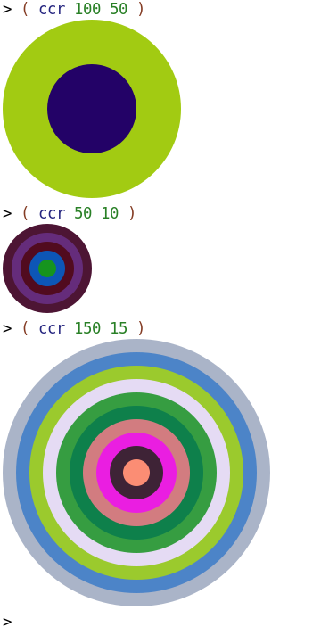
CCA Demo
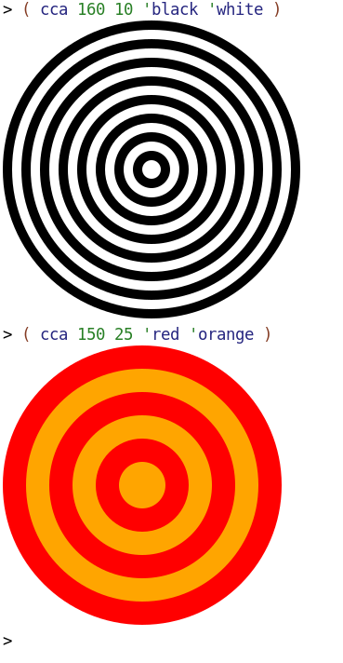
CCS Demo 1
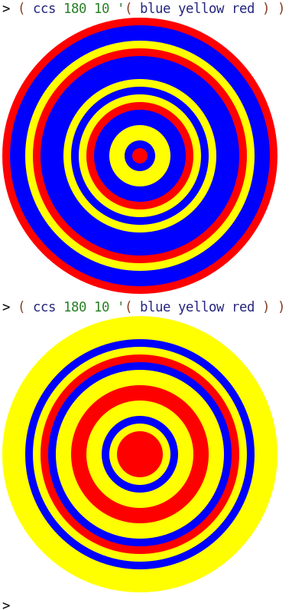
CCS Demo 2
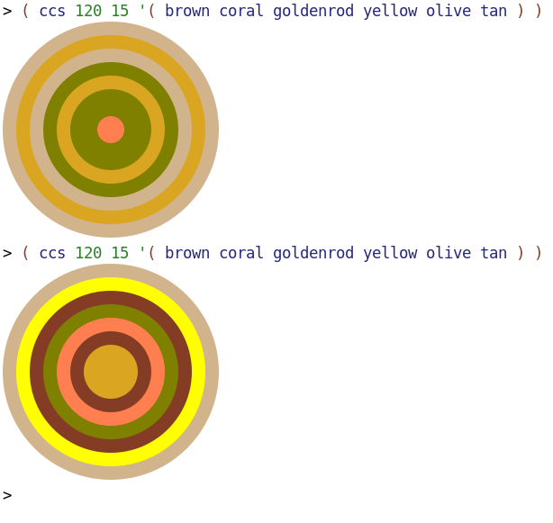
Code
( define ( ccr radius difference )
( cond (( > radius 0 )
( define ( rgb ) ( random 0 256 ) )
( define ( rc ) ( color ( rgb ) ( rgb ) ( rgb ) ) )
( overlay ( ccr ( - radius difference ) difference) ( circle radius 'solid ( rc ) ) )
)
( ( = radius 0 ) empty-image )
)
)

( define ( cca radius difference color1 color2 )
( cca-helper radius difference color1 color2 1 )
)

( define ( cca-helper radius difference color1 color2 current-color-num )
( cond ( ( > radius 0 )
( cond ( ( = current-color-num 1 )
( overlay ( cca-helper ( - radius difference ) difference color1 color2 2 )
( circle radius 'solid color1 ) ) )
( ( = current-color-num 2 )
( overlay ( cca-helper ( - radius difference ) difference color1 color2 1 )
( circle radius 'solid color2 ) ) )
)
)
( ( = radius 0 ) empty-image )
)
)

( define ( ccs radius difference colors )
( define numColors ( length colors ) )
( ccs-helper radius difference colors numColors )
)

( define ( ccs-helper radius difference colors numColors )
( cond (( > radius 0 )
( define ( colorNum ) ( random numColors ) )
( define color ( list-ref colors ( colorNum ) ) )
( overlay ( ccs-helper ( - radius difference ) difference colors numColors )
( circle radius 'solid color ) )
)
( ( = radius 0 ) empty-image )
)
)

Task 5: Variations on Hirst Dots
Random Colored Tile Demo
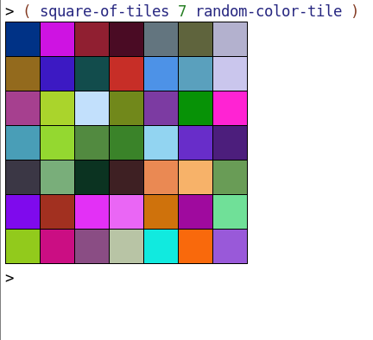
Hirst Dots Demo
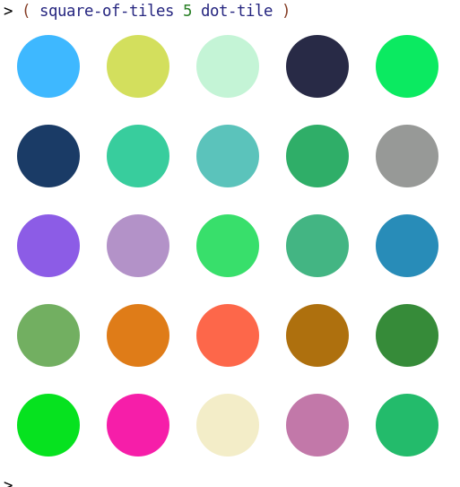
CCS Dots Demo
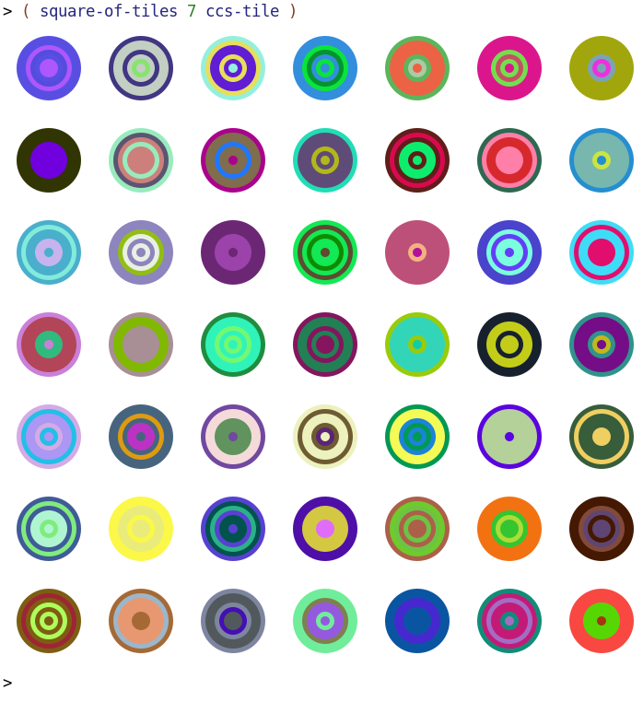
Nested Diamonds Demo
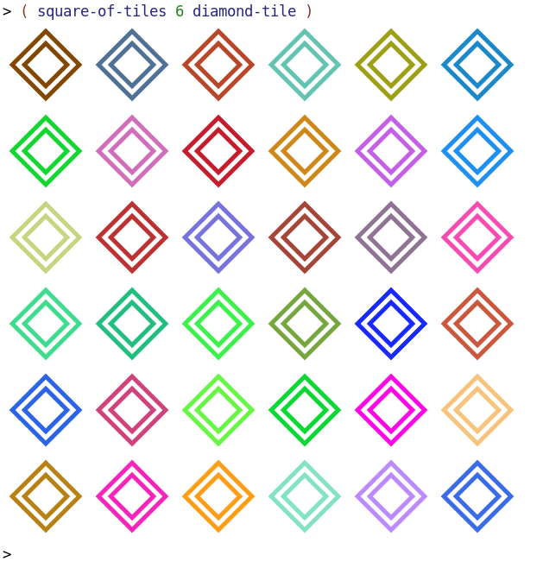
Unruly Squares Demo
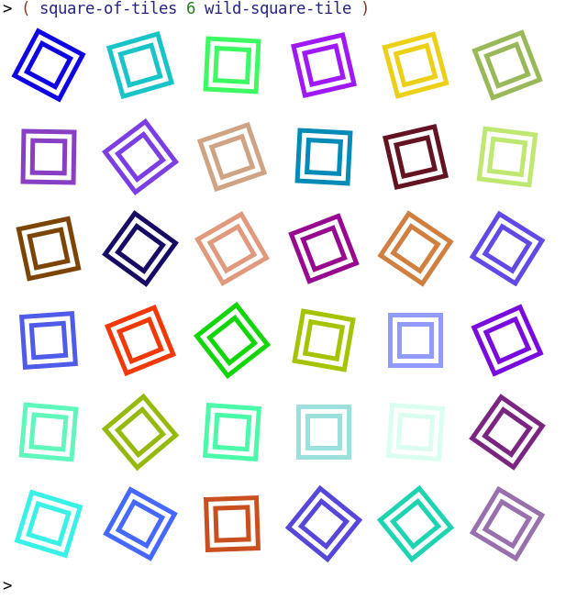
Code
; Generate a rectangle of tiles of a specified row count, column count,
; and tile type

( define ( rectangle-of-tiles r c tile )
( cond
( ( = r 0 )
empty-image
)
( ( > r 0 )
( above
( rectangle-of-tiles ( - r 1 ) c tile ) ( row-of-tiles c tile ) )
)
)
)

; Generate a square of tiles of a specified side length and tile type

( define ( square-of-tiles n tile )
( rectangle-of-tiles n n tile )
)

; Generator for a randomly colored tile

( define ( random-color-tile )
( overlay
( square 40 "outline" "black" )
( square 40 "solid" ( random-color ) )
)
)

; Generator for a random color

( define ( random-color )
( define ( rgb ) ( random 0 256 ) )
( color ( rgb ) ( rgb ) ( rgb ) )
)

; Generator for a randomly colored dot tile

( define ( dot-tile )
( overlay
( circle 35 "solid" ( random-color ) )
( square 100 "solid" "white" )
)
)

; Generator for a ccs tile

( define ( ccs-tile )
( define colors ( random-colors 3 ) )
( overlay
( ccs 35 5 colors )
( square 100 "solid" "white" )
)
)

; randomly generate a list of colors of size n

( define ( random-colors n )
( cond ( ( > n 0 )
( cons ( random-color ) ( random-colors ( - n 1 ) ) )
)
( ( = n 0 ) empty )
)
)

; generates a randomly colored diamond tile

( define ( diamond-tile )
( define diamondColor ( random-color ) )
( overlay ( rotate 45 ( square 30 "solid" "white" ) )
( rotate 45 ( square 40 "solid" diamondColor ) )
( rotate 45 ( square 50 "solid" "white" ) )
( rotate 45 ( square 60 "solid" diamondColor ) )
( square 100 "solid" "white" )
)
)

; generates a randomly colored and angled square within a white tile

( define ( wild-square-tile )
( define squareColor ( random-color ) )
( define angle ( random 0 90 ) )
( overlay
( rotate angle ( square 30 "solid" "white" ) )
( rotate angle ( square 40 "solid" squareColor ) )
( rotate angle ( square 50 "solid" "white" ) )
( rotate angle ( square 60 "solid" squareColor ) )
( square 100 "solid" "white" )
)
)

( define ( ccs radius difference colors )
( define numColors ( length colors ) )
( ccs-helper radius difference colors numColors )
)

( define ( ccs-helper radius difference colors numColors )
( cond (( > radius 0 )
( define ( colorNum ) ( random numColors ) )
( define color ( list-ref colors ( colorNum ) ) )
( overlay ( ccs-helper ( - radius difference ) difference colors numColors ) ( circle radius 'solid color ) )
)
( ( = radius 0 ) empty-image )
)
)

