Racket Assignment #4: Lambda and Basic Lisp
Written by David Hennigan

Learning Abstract
This assignment introduced creating lambda functions in Racket and helped develop basic Lisp skills.
Task 1 - Lambda

Task 1a – Three ascending integers
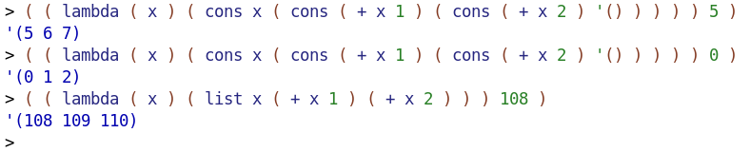
Task 1b – Make list in reverse order
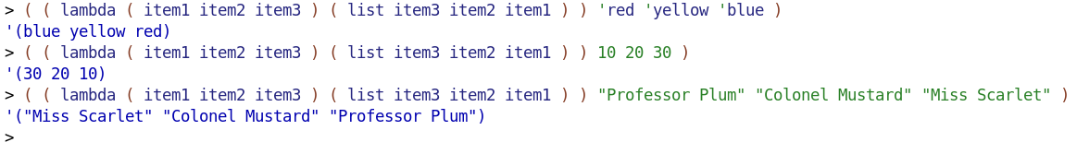
Task 1c – Random number generator
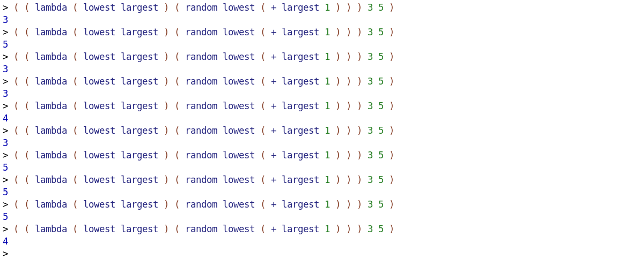
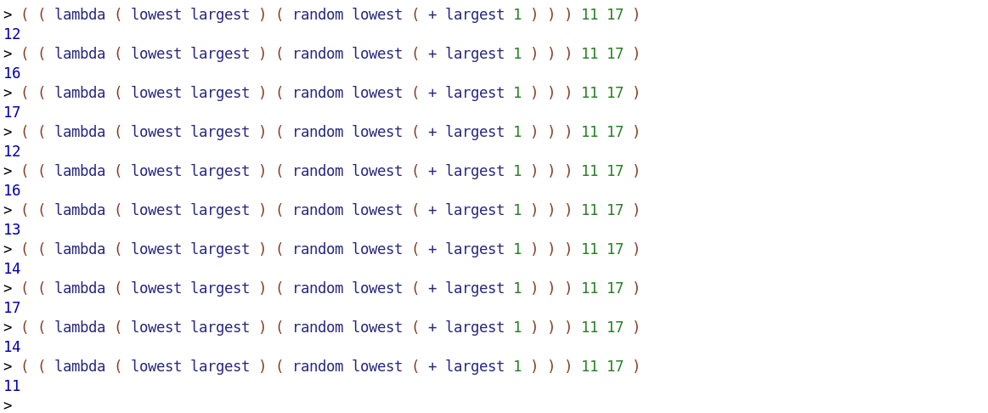
Task 2 – List Processing Referencers and Constructors
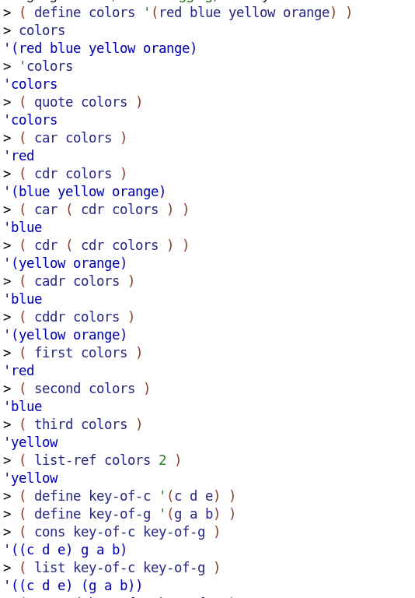
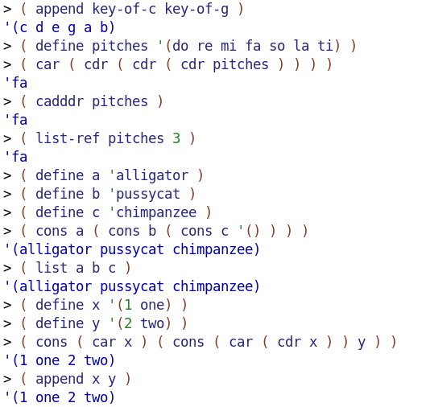
Task 3 – The Sampler Program
demo
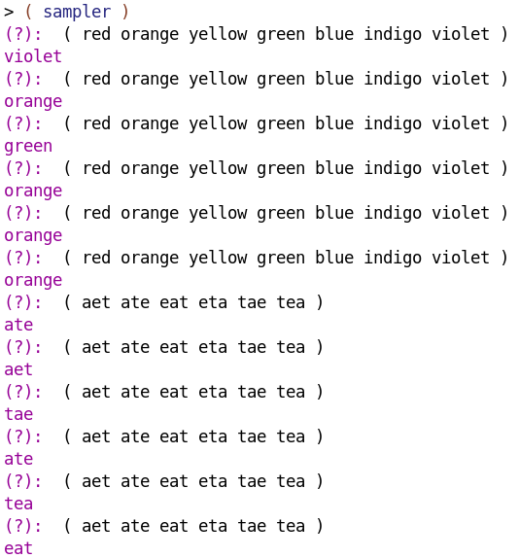
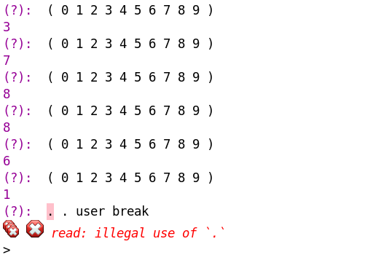
code
#lang racket

( define ( sampler )
( display "(?): " )
( define the-list ( read ) )
( define the-element
( list-ref the-list ( random ( length the-list ) ) )
)
( display the-element ) ( display "\n" )
( sampler )
)

Task 4 – The Card Playing Example
demo
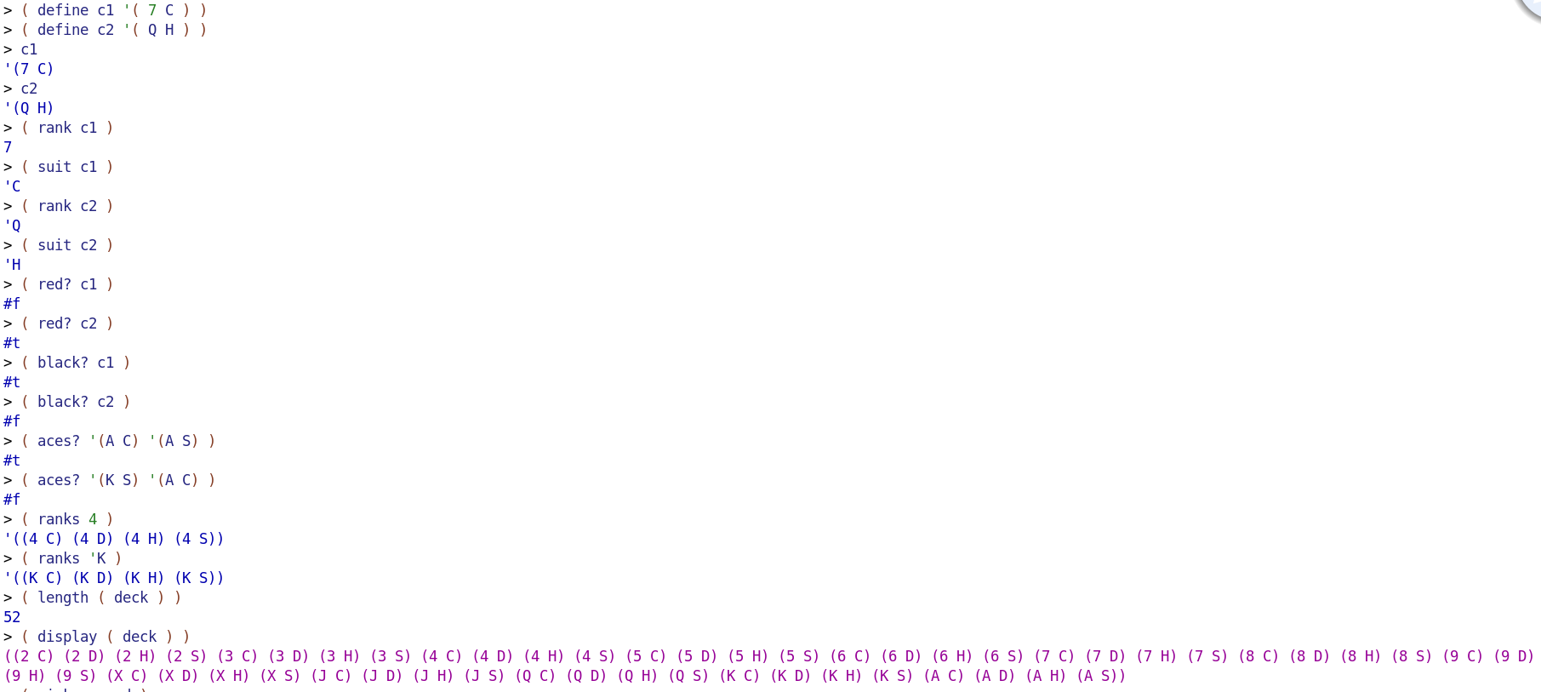
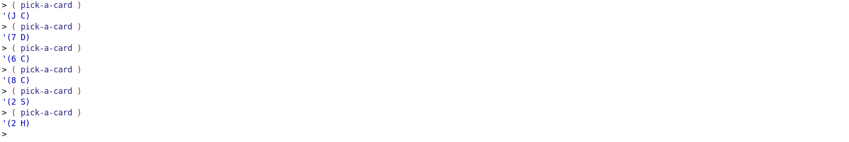
code
#lang racket

( define ( ranks rank )
( list
( list rank 'C )
( list rank 'D )
( list rank 'H )
( list rank 'S )
)
)

( define ( deck )
( append
( ranks 2 )
( ranks 3 )
( ranks 4 )
( ranks 5 )
( ranks 6 )
( ranks 7 )
( ranks 8 )
( ranks 9 )
( ranks 'X )
( ranks 'J )
( ranks 'Q )
( ranks 'K )
( ranks 'A )
)
)

( define ( pick-a-card )
( define cards ( deck ) )
( list-ref cards ( random ( length cards ) ) )
)

( define ( show card )
( display ( rank card ) )
( display ( suit card ) )
)

( define ( rank card )
( car card )
)

( define ( suit card )
( cadr card )
)

( define ( red? card )
( or
( equal? ( suit card ) 'D )
( equal? ( suit card ) 'H )
)
)

( define ( black? card )
( not ( red? card ) )
)

( define ( aces? card1 card2 )
( and
( equal? ( rank card1 ) 'A )
( equal? ( rank card2 ) 'A )
)
)

