Racket Assignment #5: RLP and HoFs
Written by David Hennigan

Abstract
This assignment includes 7 tasks, all utilizing either recursive list processing, high order functions, or some combination of both. Task 4 was my personal favorite, involving the generation of music via recursive list generation and the high order function of mapping generated numbers to keys.
Task 1 – Simple List Generators
Task 1a – iota
Function Definition
( define ( iota n )
( cond
( ( = n 0 ) '() )
( else
( snoc n ( iota ( - n 1 ) ) )
)
)
)

( define ( snoc n l )
( cond
( ( empty? l )
( list n )
)
( else
( cons ( car l ) ( snoc n ( cdr l ) ) )
)
)
)
Demo
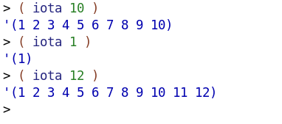
Task 1b – Same
Function Definition
( define ( same n obj )
( cond
( ( = n 0 ) '() )
( else
( cons obj ( same ( - n 1 ) obj) )
)
)
)
Demo
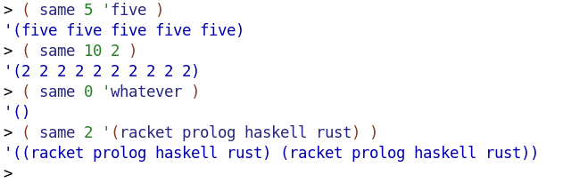
Task 1c – Alternator
Function Definition
( define ( alternator n l )
( cond
( ( = n 0 ) '() )
( else
( cons ( car l ) ( alternator ( - n 1 ) ( snoc ( car l ) ( cdr l ) ) ) )
)
)
)

( define ( snoc n l )
( cond
( ( empty? l )
( list n )
)
( else
( cons ( car l ) ( snoc n ( cdr l ) ) )
)
)
)
Demo
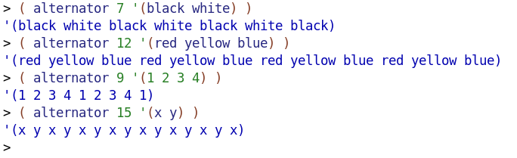
Task 1d – Sequence
Function Definition
( define ( sequence n num )
( map ( lambda (x) ( * x num ) ) ( iota n ) )
)
Demo
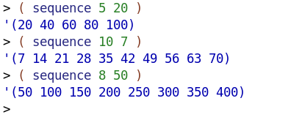
Task 2 – Counting
Task 2a – Accumulation Counting
Function Definition
( define ( a-count l )
( cond
( ( empty? l) '() )
( else
( append ( iota ( car l ) ) ( a-count ( cdr l ) ) )
)
)
)

Demo
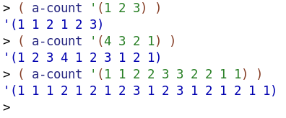
Task 2b – Repetition Counting
Function Definition
( define ( r-count l )
( cond
( ( empty? l ) '() )
( else
( append ( same ( car l ) ( car l ) ) ( r-count ( cdr l ) ) )
)
)
)
Demo
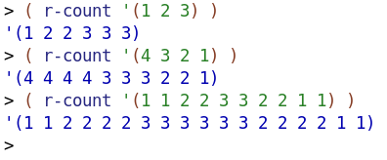

Task 2c – Mixed Counting Demo
Demo
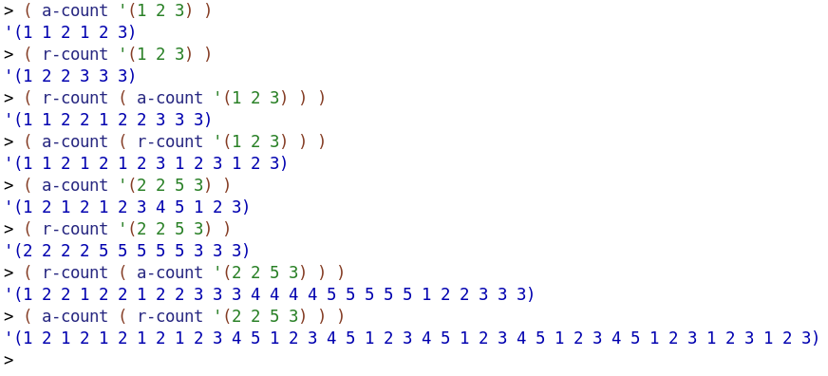
Task 3 – Association Lists
Task 3a – Zip
Function Definition
( define ( zip l1 l2 )
( cond
( ( empty? l1 ) '() )
( else
( cons ( list* ( car l1 ) ( car l2 ) ) ( zip ( cdr l1 ) ( cdr l2 ) ) )
)
)
)

Demo
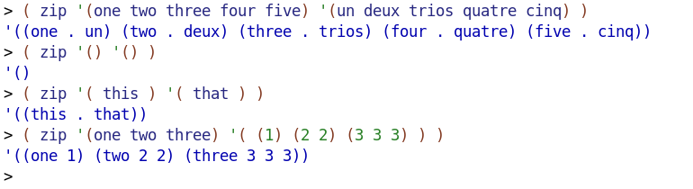
Task 3b – Association
Function Definition
( define ( assoc obj l )
( cond
( ( empty? l ) '() )
( ( eq? obj ( caar l ) ) ( car l ) )
( else ( assoc obj ( cdr l ) ) )
)
)
Demo
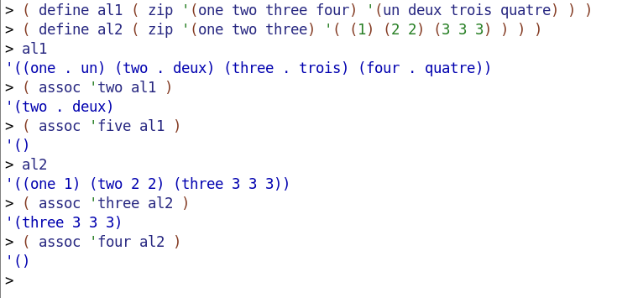
Task 3c – Establishing some Association Lists
Code
( define scale-zip-CM
( zip ( iota 7 ) '("C" "D" "E" "F" "G" "A" "B") )
)

( define scale-zip-short-Am
( zip ( iota 7 ) '("A/2" "B/2" "C/2" "D/2" "E/2" "F/2" "G/2") )
)

( define scale-zip-short-low-Am
( zip ( iota 7 ) '("A,/2" "B,/2" "C,/2" "D,/2" "E,/2" "F,/2" "G,/2") )
)

( define scale-zip-short-low-blues-Dm
( zip ( iota 7 ) '("D,/2" "F,/2" "G,/2" "_A,/2" "A,/2" "c,/2" "d,/2") )
)

( define scale-zip-wholetone-C
( zip ( iota 7 ) '("C" "D" "E" "^F" "^G" "^A" "c") )
)
Demo
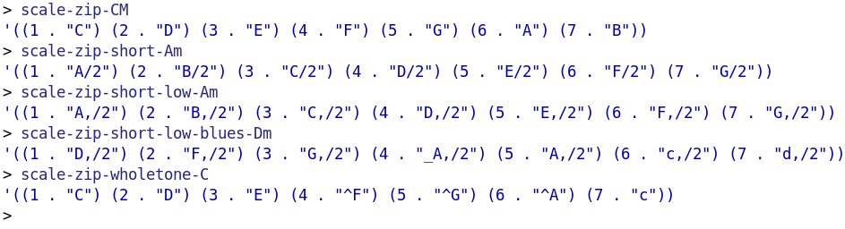
Task 4 – Numbers to Notes to ABC
Task 4a – nr→note
Function Definition
( define ( nr->note n al )
( cond
( ( eq? n ( caar al ) ) ( cdar al ) )
( else ( nr->note n ( cdr al ) ) )
)
)
Demo
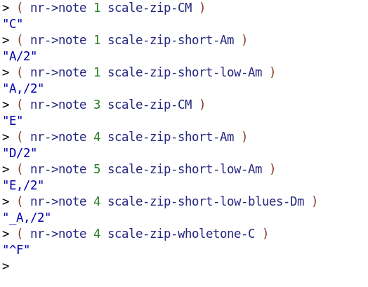
Task 4b – nrs→notes
Function Definition
( define ( nrs->notes nl al )
( map ( lambda (x) ( nr->note x al ) ) nl )
)
Demo
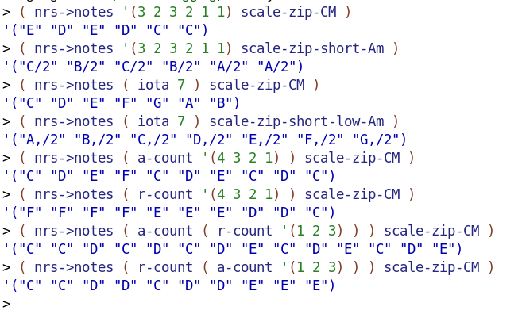
Task 4c – nrs → abc
Function Definition
( define ( nrs->abc nl al )
( string-join ( nrs->notes nl al ) )
)
Demo
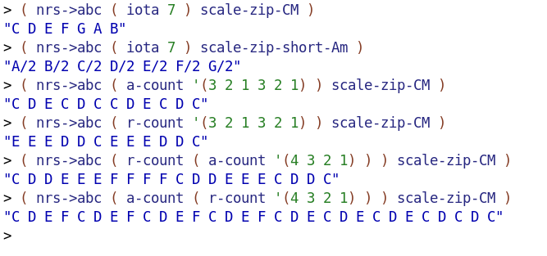
Task 5 Stella
Function Definition
( define ( stella al )
( foldr overlay empty-image ( map ( lambda (x) ( square ( car x ) 'solid ( cdr x ) ) ) al ) )
)
The Three Demos
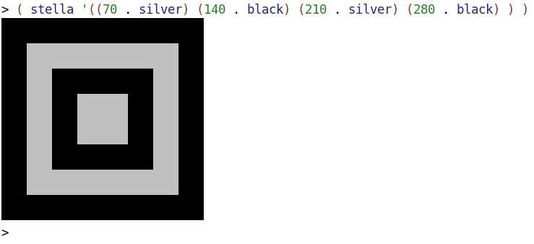

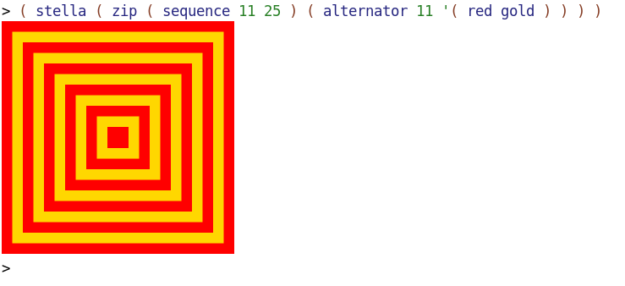
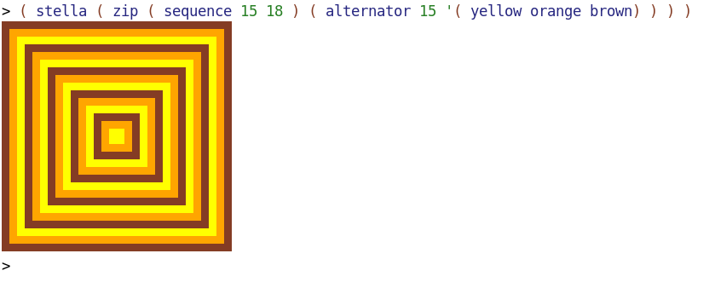
Task 6 - Chromesthetic Renderings
Code
( define pitch-classes '( c d e f g a b ) )
( define color-names '( blue green brown purple red yellow orange ) )

( define ( box color )
( overlay
( square 30 'solid color )
( square 35 'solid 'black )
)
)

( define boxes
( list
( box "blue" )
( box "green" )
( box "brown" )
( box "purple" )
( box "red" )
( box "gold" )
( box "orange" )
)
)

( define pc-a-list ( zip pitch-classes color-names ) )
( define cb-a-list ( zip color-names boxes ) )

( define ( pc->color pc )
( cdr ( assoc pc pc-a-list ) )
)

( define ( color->box color )
( cdr ( assoc color cb-a-list ) )
)

( define ( play pitches )
( foldr beside empty-image ( map ( lambda (c) ( color->box c ) ) ( map ( lambda (pitch) ( pc->color pitch ) ) pitches ) ) )
)
Demo
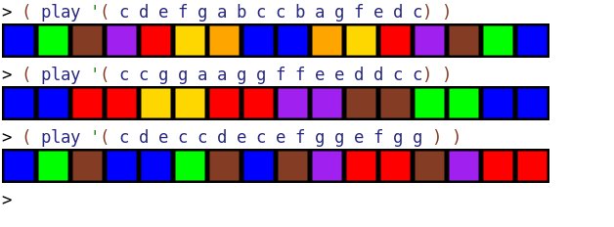
Task 7 – Grapheme to Color Synesthesia
Code
( define AI ( text "A" 36 "orange" ) )
( define BI ( text "B" 36 "red" ) )
( define CI ( text "C" 36 "blue" ) )
( define DI ( text "D" 36 "green" ) )
( define EI ( text "E" 36 "Cornflower Blue" ) )
( define FI ( text "F" 36 "Firebrick" ) )
( define GI ( text "G" 36 "Pink" ) )
( define HI ( text "H" 36 "Yellow" ) )
( define II ( text "I" 36 "Maroon" ) )
( define JI ( text "J" 36 "Cornsilk" ) )
( define KI ( text "K" 36 "Medium Sea Green" ) )
( define LI ( text "L" 36 "Dodger Blue" ) )
( define MI ( text "M" 36 "Light Cyan" ) )
( define NI ( text "N" 36 "Tomato" ) )
( define OI ( text "O" 36 "Black" ) )
( define PI ( text "P" 36 "Hot Pink" ) )
( define QI ( text "Q" 36 "Gold" ) )
( define RI ( text "R" 36 "Dark Khaki" ) )
( define SI ( text "S" 36 "Turquoise" ) )
( define TI ( text "T" 36 "Dark Magenta" ) )
( define UI ( text "U" 36 "Light Grey" ) )
( define VI ( text "V" 36 "Rosy Brown" ) )
( define WI ( text "W" 36 "Dark Slate Blue" ) )
( define XI ( text "X" 36 "Green Yellow" ) )
( define YI ( text "Y" 36 "Dark Orange" ) )
( define ZI ( text "Z" 36 "Navajo White" ) )

( define alphabet '(A B C D E F G H I J K L M N O P Q R S T U V W X Y Z) )
( define alphapic ( list AI BI CI DI EI FI GI HI II JI KI LI MI NI OI PI QI RI SI TI UI VI WI XI YI ZI ) )

( define ( zip l1 l2 )
( cond
( ( empty? l1 ) '() )
( else
( cons ( list* ( car l1 ) ( car l2 ) ) ( zip ( cdr l1 ) ( cdr l2 ) ) )
)
)
)

( define ( assoc obj l )
( cond
( ( empty? l ) '() )
( ( eq? obj ( caar l ) ) ( car l ) )
( else ( assoc obj ( cdr l ) ) )
)
)

( define a->i ( zip alphabet alphapic ) )

( define ( letter->image letter )
( cdr ( assoc letter a->i ) )
)

( define ( gcs letters )
( foldr beside empty-image ( map ( lambda (letter) ( letter->image letter ) ) letters ) )
)
Demo 1

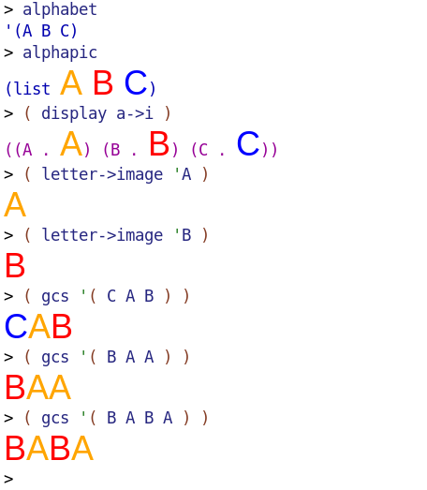
Demo 2
