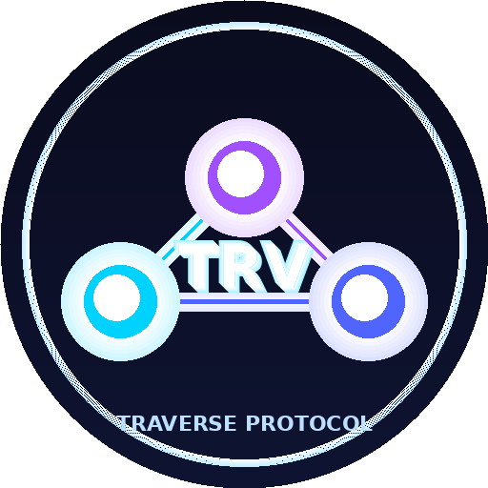
TRAVERSE PROTOCOL
TRV Tokenomics
Fair-launched on Solana via pump.fun
Version 2.0 | October 2026
traverse-protocol.netlify.app | x.com/TRVProtocol | discord.gg/xA6KsAnhM

1. Summary
TRV is the token of Traverse Protocol, an intent-based cross-chain liquidity router. TRV was fair-launched on Solana through pump.fun on October 27, 2026. There was no presale, no private round, no team allocation and no initial creator buy: every TRV in circulation is acquired on the open bonding curve or, after graduation, on the open market.
This document replaces Tokenomics v1.0 (June 2026), which described an ERC-20 token on Base with team, investor and treasury allocations under vesting. That model was not used. The protocol's on-chain utilities for TRV (solver staking, governance, fee discounts) are planned, not live, and depend on the roadmap in Section 5.
Official contract address (Solana)
AqYxQFndwosnbXeQXXnqyJUw471YddxbZqkwosDvpump
Any other token called "TRV" is not affiliated with Traverse Protocol. Always verify the CA in the official Discord #announcements channel.

2. Token Parameters
Parameter | Value
Name / Ticker | Traverse Protocol / TRV
Network | Solana (SPL token)
Contract address | AqYxQFndwosnbXeQXXnqyJUw471YddxbZqkwosDvpump
Launch venue | pump.fun bonding curve, October 27, 2026
Total supply | 1,000,000,000 TRV (fixed)
Decimals | 6 (pump.fun standard)
Mint / freeze authority | Revoked at creation by pump.fun (verifiable on-chain)
Team / investor allocation | None pre-allocated. Creator buy at launch: 0 TRV
Disclosed team holdings | Creator wallet 3q2URVEc95XScuN8g15FndYjntNshgiCMHT7B8ZDHDgN bought ~6.22M TRV (~0.62%) on the open curve on Oct 27, 2026, after launch. Not locked
Creator account | pump.fun profile "BasedWaveWolf"

3. Distribution
pump.fun tokens follow a fixed, public launch mechanism. The figures below reflect pump.fun's standard parameters at launch and should be verified on-chain.
Bucket | Approx. TRV | Approx. % | How it is distributed
Bonding curve sale | ~793,100,000 | ~79.3% | Sold to anyone on the pump.fun curve; price rises with each purchase
Liquidity reserve | ~206,900,000 | ~20.7% | Paired with SOL raised on the curve and migrated to a pump.fun AMM pool when the curve completes ("graduation")
Team, investors, treasury, airdrop | 0 | 0% | No pre-allocation exists

3.1 Bonding curve and graduation
- The curve starts at a market cap of roughly 28 SOL and completes when about 85 SOL has been raised, at a market cap of roughly 410 SOL.
- At graduation the liquidity reserve and raised SOL are moved to an AMM pool under pump.fun's standard migration process.
- Prices in USD depend on the SOL price at the time and are not fixed.

3.2 Team position policy
At launch the creator held 0 TRV. After launch, the creator bought ~6.22M TRV (~0.62% of supply) on the open bonding curve, at the same price available to everyone, from wallet 3q2URVEc95XScuN8g15FndYjntNshgiCMHT7B8ZDHDgN. This position is not locked. If any team member acquires more TRV, the team will disclose the wallet address, the amount and any lock or vesting terms publicly on X and in Discord #announcements. Team wallets will not be split to hide concentration.

4. Creator Fees and Treasury
pump.fun pays the coin creator a share of trading fees, in SOL. These creator fees are currently the project's only revenue. There is no pre-minted treasury of TRV.
Planned use of creator fees | Description
Security | Independent audit of the router, staking and governance contracts before any mainnet deployment
Development | Infrastructure, testnet, solver reference implementation, bridge integration
Liquidity & community | Liquidity support and community programs, announced in advance
Reporting | Periodic public summary of creator fees received and spent

5. Utility Roadmap
The Traverse contracts (router, staking, governor, treasury) are written for EVM chains and currently target Base. TRV lives on Solana. To give TRV on-chain utility, the plan is to make TRV usable on Base without creating new supply.
Phase | Status | What happens
0. Community token | Live | TRV trades on Solana. No on-chain protocol utility yet
1. Protocol testnet | In progress | Router, staking and governance on Base Sepolia, using a test token
2. Bridge TRV to Base | Planned | Lock-and-mint or burn-and-mint bridge (e.g. a native token transfer standard) so total supply stays 1B across chains
3. Audit | Planned | Independent audit of contracts and bridge configuration
4. Utility activation | Planned | Solver staking, governance and fee discounts enabled with bridged TRV on mainnet

5.1 Planned utilities (proposed parameters)
All parameters below are proposals. They are not live and can change before activation and, afterwards, through governance.
Utility | Proposed design
Solver staking | Solvers lock at least 10,000 TRV as slashable collateral against bad or late execution
Governance | 1 staked TRV = 1 vote. Proposal threshold 1,000,000 TRV; quorum 4% of supply; 48h timelock
Fee discount | Holding TRV lowers the 0.05% routing fee: 1k TRV 10%, 10k 25%, 50k 40%, 250k+ 50%
Fee distribution | Proposed split of protocol fees: 70% stakers, 20% treasury, 10% operations. Any distribution to holders is subject to legal review and governance approval

6. Risks
Risk | Description | Mitigation
No utility yet | TRV has no on-chain protocol function until Phases 2-4 are delivered | Public roadmap; status reported honestly in official channels
Volatility | pump.fun tokens are highly volatile and can lose most or all value | Clear disclaimers; no promises of price or returns
Concentration | Large holders can move the price | Team disclosure policy; holders visible on-chain
Smart contract | Protocol contracts are unaudited | Audit before mainnet; bug bounty planned
Bridge | Bridges add technical risk | Use an established bridge standard; audit configuration
Impersonation | Fake "TRV" tokens and scam DMs | Single official CA in #announcements; team never DMs first
Regulatory | Token rules vary by jurisdiction | Legal review before enabling any fee distribution

7. Disclaimer
This document is for information only. It is not an offer or solicitation to buy or sell any asset, not investment, legal or tax advice, and not a prospectus. TRV carries no promise of return, profit, dividend or price. Planned features may change, be delayed or never be delivered. Crypto assets can lose all their value. Only use funds you can afford to lose and consult qualified advisors.

