Finest LMS Software Design Document

1. Project Overview

Project Name
FINEST LMS

Description
FINEST LMS is a cloud-based Learning Management System
that enables instructors to create, manage, and publish
courses while allowing students to purchase, enroll,
learn, complete assessments, and earn certificates.
The platform supports role-based access control,
video streaming, assessments, analytics,
payments, notifications, and course progress tracking.

2. Business Objectives
• Provide scalable online learning platform
• Support multiple instructors
• Deliver video-based learning
• Generate revenue through paid courses
• Track learner progress
• Issue certificates
• Provide analytics for instructors

3. Stakeholders
Students
Instructors
Admins
Support Team
Product Owner
Management Team

4. Functional Requirements

Authentication
Register User
Login User
Logout User
Refresh Token
Forgot Password
Reset Password
Email Verification
Role Management

Course Management
Create Course
Update Course
Delete Course
Publish Course
Archive Course
Course Approval Workflow

Section Management
Create Section
Update Section
Delete Section
Reorder Sections

Lecture Management
Upload Video
Delete Video
Update Video
Preview Video
Attach Resources

Enrollment
Enroll Student
Unenroll Student
View Enrollments
Track Enrollment Status

Progress Tracking
Track Lecture Completion
Track Course Completion
Calculate Progress %
Resume Learning

Quiz Management
Create Quiz
Update Quiz
Delete Quiz
Attempt Quiz
Auto Evaluation

Reviews
Add Review
Edit Review
Delete Review
Rate Course

Wishlist
Add Course
Remove Course
View Wishlist

Cart
Add Course
Remove Course
Checkout

Payments
Create Order
Verify Payment
Generate Invoice
Refund Payment

Certificates
Generate Certificate
Download Certificate
Verify Certificate

Notifications
Email Notifications
In-App Notifications
Push Notifications

Analytics
Revenue Analytics
Enrollment Analytics
Course Analytics
Instructor Analytics
Student Analytics

5. Non Functional Requirements

Performance
Response Time < 500ms

Scalability
100,000+ Users
10,000 Concurrent Users

Availability
99.9% Uptime

Security
JWT Authentication
Refresh Tokens
RBAC
HTTPS
Rate Limiting

Reliability
Data Backup
Recovery Strategy
No Single Point Of Failure

6. User Roles

Student
Browse Courses
Purchase Courses
Watch Videos
Take Quizzes
Download Certificates

Instructor
Create Courses
Manage Courses
View Analytics
Manage Students

Admin
Manage Users
Manage Courses
Manage Categories
Manage Payments
Generate Reports

7. Permission Matrix
Feature Student Instructor Admin
Create Course ❌ ✅ ✅
Purchase Course ✅ ❌ ❌
Publish Course ❌ ✅ ✅
Delete Course ❌ ❌ ✅
Manage Users ❌ ❌ ✅
View Analytics ❌ ✅ ✅

8. Module Breakdown
Authentication Module
User Module
Course Module
Category Module
Section Module
Lecture Module
Enrollment Module
Progress Module
Quiz Module
Review Module
Wishlist Module
Cart Module
Order Module
Payment Module
Certificate Module
Notification Module
Analytics Module
Admin Module

9. User Journey

Student
Landing Page
↓
Register
↓
Login
↓
Browse Courses
↓
Course Details
↓
Add To Cart
↓
Checkout
↓
Payment
↓
Enrollment
↓
Learning
↓
Quiz
↓
Certificate

Instructor
Login
↓
Create Course
↓
Add Sections
↓
Add Lectures
↓
Upload Videos
↓
Publish Course
↓
View Analytics

10. High Level Architecture
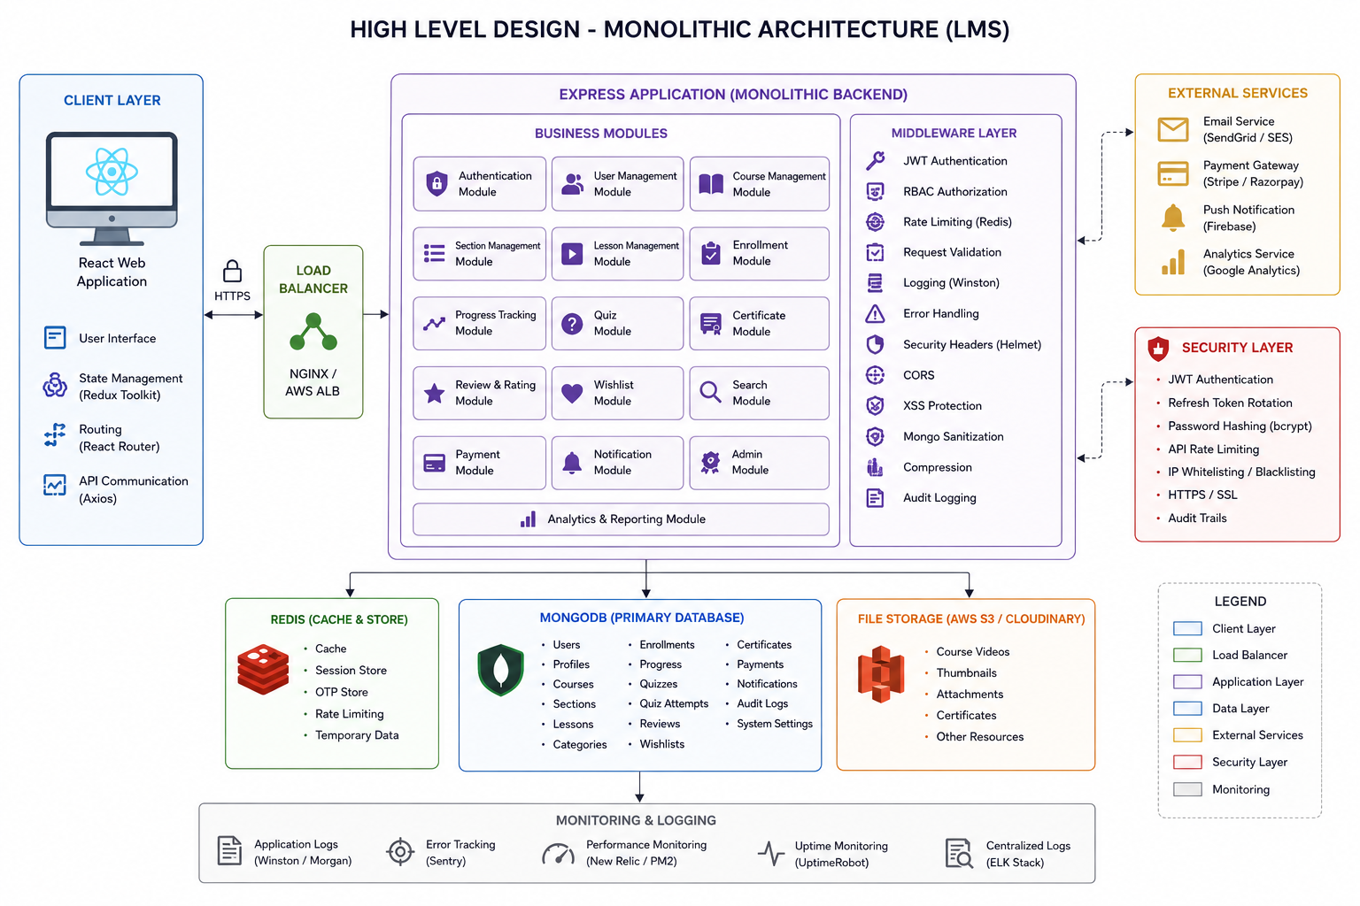
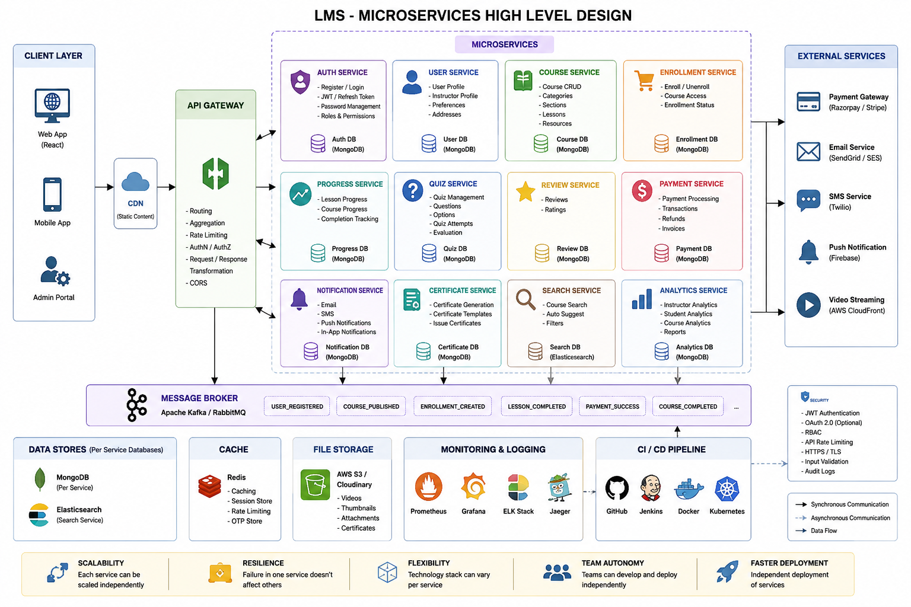

11. Low Level Architecture
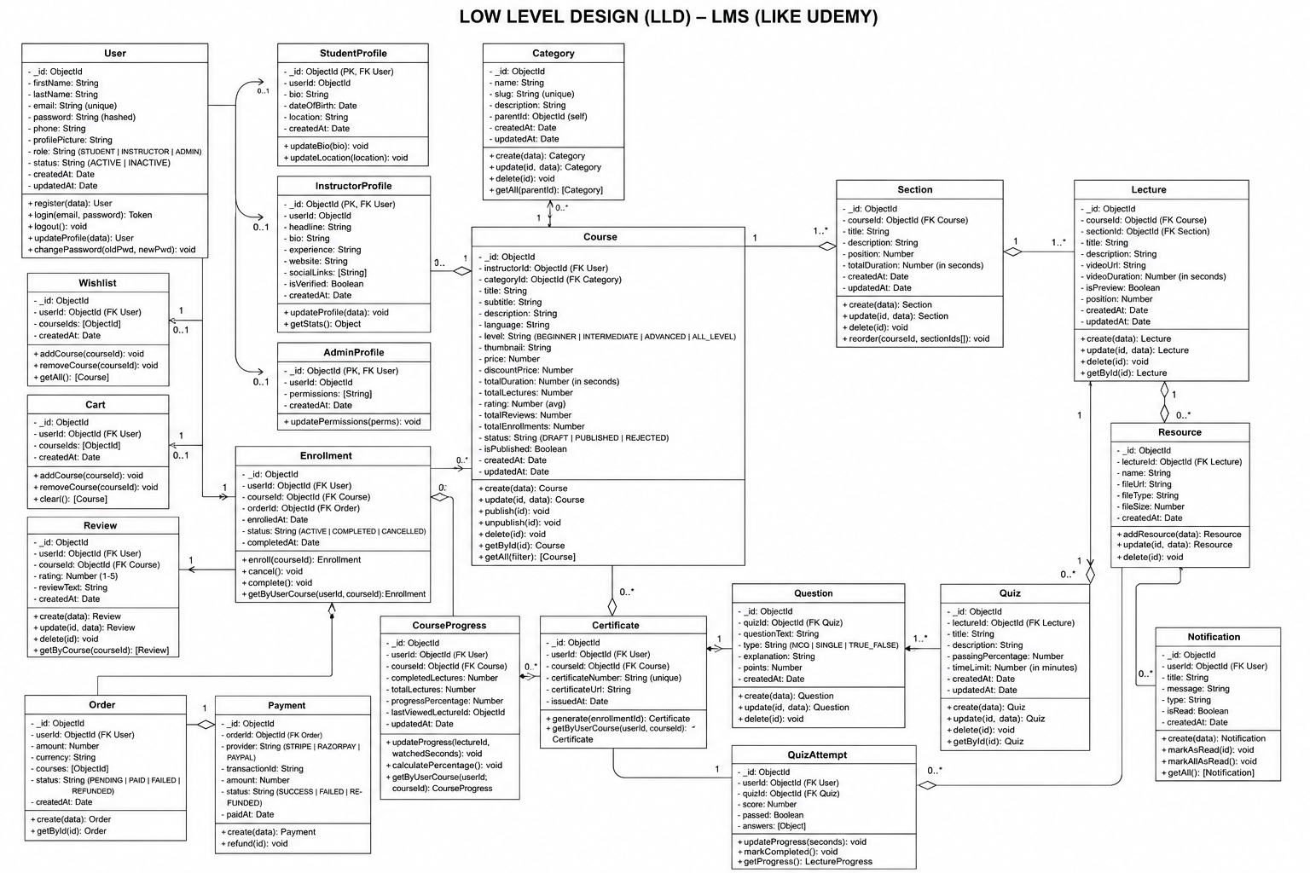

12. MongoDB Collections

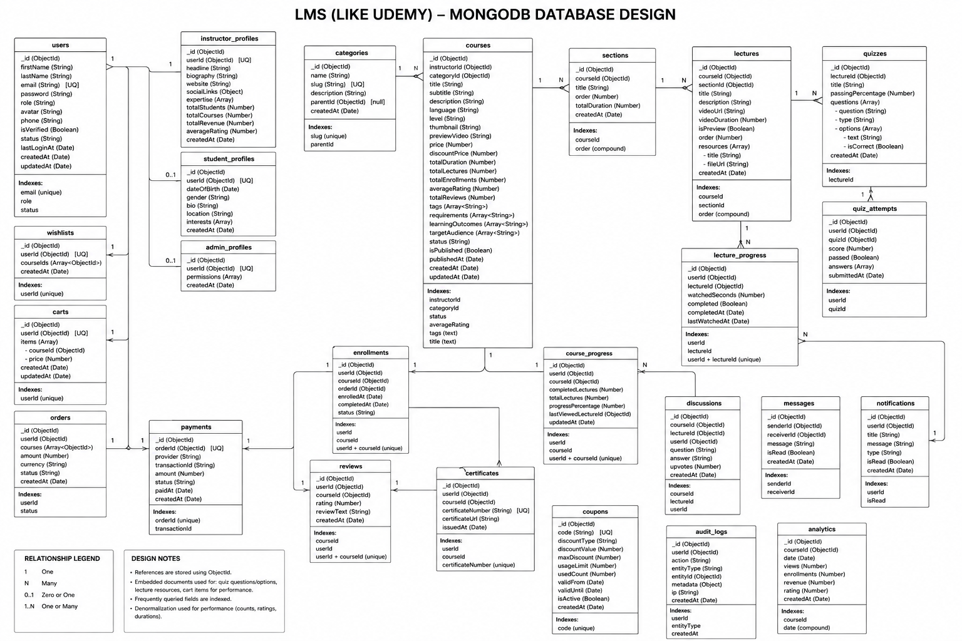
13. Database Relationships
User
├── InstructorProfile (1:1)
├── Enrollment (1:N)
├── Review (1:N)
├── Wishlist (1:1)
├── Cart (1:1)
├── Notification (1:N)
└── Order (1:N)
Course
├── Section (1:N)
├── Enrollment (1:N)
├── Review (1:N)
├── Certificate (1:N)
├── Discussion (1:N)
└── Analytics (1:1)
Section
└── Lecture (1:N)
Lecture
├── Quiz (1:N)
└── LectureProgress (1:N)
Quiz
└── QuizAttempt (1:N)
Order
└── Payment (1:1)

14. API Structure
/api/auth
/api/users
/api/courses
/api/categories
/api/sections
/api/lectures
/api/enrollments
/api/progress
/api/quizzes
/api/reviews
/api/wishlist
/api/cart
/api/orders
/api/payments
/api/certificates
/api/notifications
/api/admin

15. Security Architecture

Authentication
JWT Access Token
Refresh Token Rotation
Email Verification
Forgot Password Flow

Authorization
Role Based Access Control
Student
Instructor
Admin

Protection
Helmet
CORS
Rate Limiting
XSS Protection
Mongo Sanitization
Request Validation
Audit Logging

16. Rate Limiting
Login API
5 Requests / 15 Minutes
Register API
3 Requests / Hour
Forgot Password
3 Requests / Hour
General APIs
100 Requests / Minute
Video APIs
300 Requests / Minute

17. Logging & Monitoring

Logging
Winston
Morgan

Monitoring
Prometheus
Grafana

Error Tracking
Sentry

18. Deployment Architecture
React App
│
CloudFront
│
NGINX
│
Node.js App
│
Redis
│
MongoDB Atlas
│
AWS S3

19. CI/CD Pipeline
Developer
↓
GitHub
↓
Pull Request
↓
Code Review
↓
GitHub Actions
↓
Build Docker Image
↓
Run Tests
↓
Deploy To Staging
↓
Deploy To Production

20. Testing Strategy

Unit Testing
Jest

Integration Testing
Supertest

API Testing
Postman

End To End Testing
Playwright

21. Future Enhancements
Live Classes
Course Bundles
Affiliate Marketing
AI Course Recommendations
AI Quiz Generation
Discussion Forums
Learning Paths
Instructor Payout System
Multi Language Support
Mobile Application

