**Overview of e-commerce website**

**Amazon**

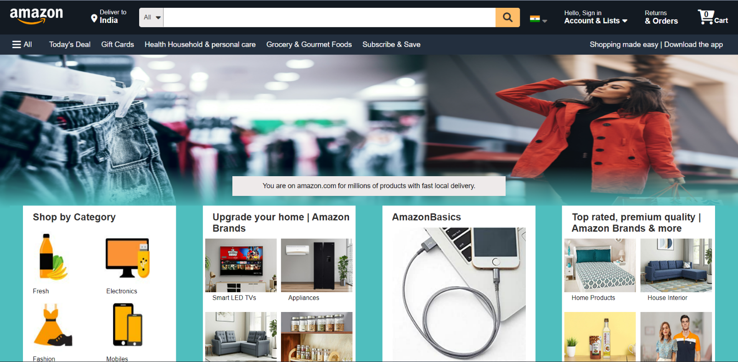

Navigation Bar:

* Logo
* Search bar
* Location selection
* Login / create account
* Add to cart

Menu Bar:

* All/side bar
* Today’s deal
* Gift cards
* Household items etc.

Product cards {1}:

Such as different categories of products in cards like the format In a container as:-

* Shop by category.
* Top rated premium quality products.
* Amazon brands
* Gym equipments & many more.

Slide product bar:

* Left to right & right to left slide bar with different electronics products.
* Navigation button

Product cards {2}:

* Glassware & dinner sets
* Smartwatches
* Perfumes
* Toys , Books & many more

Back to top button:

About section:

* Many more tabs
* Social media links & many more.

Footer:

* copyright

**Raw STRUCTURE**

