1. U-235 is an incredibly abundant element on the earth. It is one of the few elements that can go through induced fission. When a neutron is added to it, it will disperse and produce energy.
2. Nuclear fission is when an atom is split in two, releasing energy. E=mc2 comes into this because it the equation that shows how much energy is produced.
3. 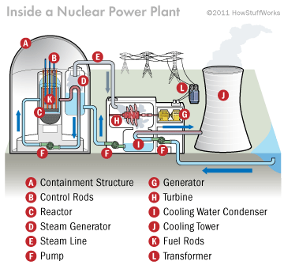

A- Holds all of the parts and stops the radiation for contaminating the environment  
 B-Absorb atoms from the Uranium  
 C-Where energy is created  
 D-Where steam is created from the heat hitting the water  
 E-Where the steam travels to its next destination  
 F-Pumps back water to the Steam Generator  
 G-Turns kinetic energy from the reaction into electrical energy  
 H-Turbine gets spun from the steam and creates kinetic energy for the generator  
 I-Captures the water going through condensation  
 J-Cools incoming water  
 K-Holds the Uranium  
 L-Electricity is sent to the public

1. Critical mass is the least amount of mass needed for a sustained nuclear reaction. Supercritical is any substance and pressure above its critical points. For a nuclear bomb, you would want Supercritical. For a nuclear reactor, you would want Critical mass.
2. Human Error, Terrorist Attacks, Cost, and Radioactive Waste
3. Ore- A type of rock that contains minerals including metals  
   Tailings- Residue separated in the preparation of various products  
   Mining- Excavation of materials from the Earth’s crust  
   Things that are mined- Gold, Iron, Lead, Uranium, etc.
4. Surface Mining- When soil and rock covering a mineral deposit are removed  
    Ex: Strip mining, Mountaintop Removal, Open-pit mining  
   Sub-Surface Mining- Digging tunnels and holes to reach buried ore deposits  
    Ex: Shaft mining, Slope mining, Drift mining  
   In-situ Leech Mining- Drilling and using explosives to get to an ore deposit  
    Ex: Uranium and Copper
5. A- Uranium is 40 times more common than silver  
   B- Uranium has very long half-lives

C- All Uranium isotopes are radioactive

D- Uranium is extremely heavy

1. The mine is in Weld County, Colorado. I don’t think this is a very creditable source. Powertech company looks like they are trying to get you to believe there is Uranium.
2. I think it is a creditable site due to the fact that it is presenting articles from actual events with citizens in the area