



REPUBLIC OF THE PHILIPPINES PROVINCE OF LAGUNA
MUNICIPALITY OF LOS BANOS BARANGAY MALINTA
OFFICE OF THE SANGGUNIANG BARANGAY

BARANGAY CERTIFICATION
REQUEST FOR ASSISTANCE

This is to certify that Mr./Ms. {{NAME}} {{NATIONALITY}}, a legal age, is a Bonafide resident of
{{ADDRESS}}, has been residing in this barangay for {{YEARS}} year/s.

This is to further certify that the above-mentioned name individual belongs to the indigent
community of the said Barangay and is a member of the URBAN POOR.

This certification is being issued for the purpose of requesting for {{PURPOSE_CHECKS}}
from the Municipal Government of Los Baños.

Under penalty of perjury and other applicable laws, I hereby certify that the above
information provided here in are true and correct.

Issued on {{DAY_ORD}} day of {{MONTH}} {{YEAR}}.

Certified By:
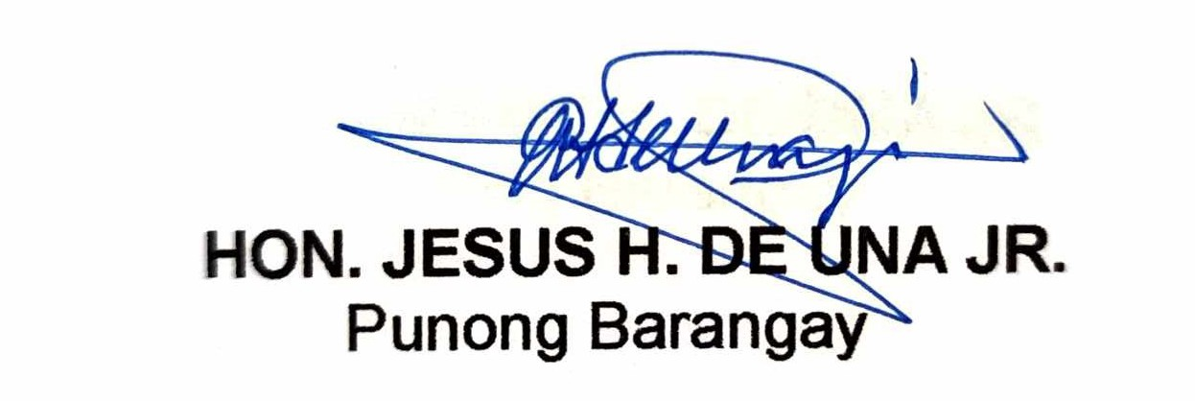

HON. JESUS H. DE UNA JR. PUNONG BARANGAY
NOT VALID WITHOUT DRY SEAL

ADDRESS:
SAN LUIS AVENUEPUROK 2, BARANGAY MALINTA,LOS BAÑOS, LAGUNA 4030
TEL. NO. (049) 502-4396

